

INTEGRATED

Microsoft Dynamics

Enabling a Real-World Approach to Service-Oriented Architecture

White Paper

Date: November 2009

Contents

Introduction 3

What is Real-World SOA? 4

**The Business Benefits of Microsoft Dynamics and Service-Oriented Architecture** 6

How Microsoft Dynamics Enables Real-World SOA 7

**Expose** 8

**Web Services** 9

**Application Integration Framework for Microsoft Dynamics** 10

**Prepackaged Connectors and Adapters** 10

**Compose** 10

**Microsoft Dynamics and Microsoft Office SharePoint Server** 11

**Microsoft Dynamics and Microsoft BizTalk Server** 12

**Consume** 14

**Microsoft Dynamics Client for Microsoft Office and SharePoint Server** 14

Real-World SOA in Action 17

Conclusion 21

For More Information 22

# Introduction

Businesses need to connect processes, people, and information both within the organization and across organizational boundaries. Service-oriented architecture (SOA) is an emerging architectural style that helps meet these demands. SOA projects designed to quickly and iteratively deliver on business goals are referred to as a “real-world” approach to service orientation. This real-world approach to SOA enables organizations to align their IT assets with changing business needs.

This paper discusses the tools and technologies that enable real-world service orientation. The purpose of this paper is to share the value of real-world SOA and a few success stories from customers who have taken on real-world SOA projects to support their business vision.

# What is Real-World SOA?

|  |
| --- |
| An Incremental, Iterative Approach to SOA Projects |
| *Service-oriented architecture (SOA) projects in the past have traditionally been driven from the top down, whereby a project no longer maps to business needs by the time it is complete. In other cases, such projects are driven from the bottom up by developers, in many cases not mapping to any well-defined business need. At the core of the real-world approach to SOA is the objective of connecting business vision with software while it is still relevant. Real-world SOA is about taking a pragmatic approach to systems integration so that businesses can quickly deploy new solutions that involve the sharing of data and processes across multiple systems.* |

Organizations rely increasingly on information technology (IT) infrastructure to facilitate business processes and drive success. Streamlining business operations is at the top of everyone’s mind. Everyone wants to do more with less, whether that means adjusting to an increased workload without additional staff or using existing IT assets to meet changing business requirements. Streamlining operations, however, relies heavily on the establishment of an agile IT infrastructure. In an agile business, the free flow of information within and across organizational boundaries, coupled with the ability to adapt to changing business requirements, is essential.

When systems are connected, business decisions can be based on real-time information. In such environments, costs decrease while customer satisfaction increases; it is easier to comply with regulatory requirements; and worker productivity increases with easy access to information. At the same time, IT can respond quickly and effectively to changing business needs.

So how does an organization that relies heavily on IT achieve business agility? The answer is simple: it takes a “real-world” approach to SOA. SOA is a design approach to organizing existing IT assets so that a heterogeneous array of distributed, complex systems and applications can be transformed into a network of integrated, simplified, and highly flexible resources. SOA enables IT departments to quickly and effectively tie existing technology to the changing demands of business. As a result, companies can more easily take advantage of new business opportunities.

However, SOA by itself is not sufficient to guarantee the alignment of business needs with IT. Building SOA for the sake of SOA without reference to business context typically lacks organization and guidance, and can result in a chaotic implementation with no business relevance.

SOA projects have limited success when they are driven from the bottom up by developers, while a top-down approach can require enormous investments in time and resources. By the time such a project is complete, the solution no longer maps to business needs. In contrast, successful SOA initiatives are supported by a strategic vision and clearly defined business drivers, and are realized through incremental, iterative SOA projects that deliver on business goals. This middle-out approach is what we call a real-world approach to SOA.

|  |
| --- |
| Connecting Systems to People and Processes |
| *People are at the heart of any business. The degree to which IT architecture enables people to connect with the information they need and to the actions they must take has a significant influence on the success of the project. With such a close connection among people, processes, and technology, it is no wonder that a lack of integration among IT assets can significantly hinder operations. Research and development groups from Microsoft have conducted extensive research to create the Customer Model for Microsoft Dynamics business management software, which helps Microsoft design software and services that support the ways people achieve their business goals. The processes and process orchestration that are built into Microsoft Dynamics are based on this in-depth customer research. As a result, businesses gain the advantage of software that fits a range of systems and processes.* |

At the core of the real-world approach to SOA is the objective of connecting business vision with software while it is still relevant. The goal of any SOA project should not be to rip and replace the entire IT infrastructure. A successful real-world SOA project takes a pragmatic approach to systems integration so businesses can quickly deploy new solutions that involve the sharing of data and processes across multiple systems.

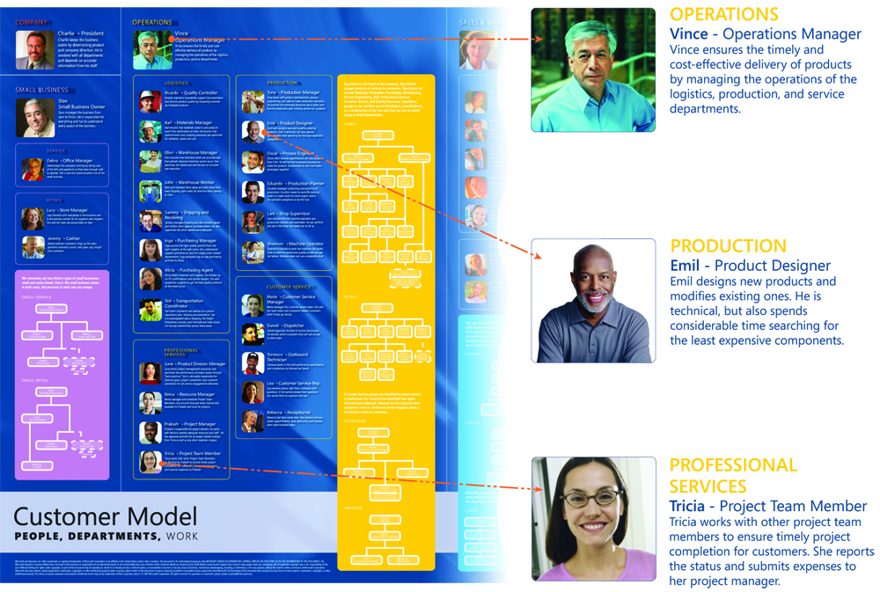With a real-world approach to SOA, time to value is much more immediate because projects do not require a complete overhaul of existing technologies and business processes.   
Just as the name implies, real-world SOA strives to unlock the real-world value from existing assets wherever applicable. An IT infrastructure built around interoperable technologies and Web services facilitates the establishment of an agile IT infrastructure. As a result, businesses can focus on clearly defining business drivers and developing incremental solutions that meet such needs.

By exposing data and business processes as Web services, Microsoft Dynamics® business management software enables other systems to integrate seamlessly with its product lines. As part of the “integrated innovation” vision of Microsoft, the Microsoft platform can help further reduce the amount of time and money that businesses need to spend on customizing systems to align with business processes, meet changing market conditions, and support new opportunities.

## **The Business Benefits of Microsoft Dynamics and Service-Oriented Architecture**

Microsoft has made investments in Web services and other SOA technologies across product lines to help organizations take a real-world approach to SOA and align their IT assets with changing business needs. By adopting this approach, organizations can realize greater benefits from their investment in IT.

**Enhanced business decision making.** By combining access to business services from different sources and by providing relevant information faster, Microsoft Dynamics enables people, processes, and systems spanning multiple organizations to be more readily mapped into a single unified view. This helps organizations react more quickly to problems as they arise.

**Greater individual productivity.** By providing streamlined access to systems and information, in the form and presentation factor that meets the needs of individuals in different roles, Microsoft Dynamics enables employees to focus their energies on value-added processes rather than conforming to the limitations and restrictions of the underlying IT systems.

**Stronger connections with customers and suppliers**. Real-world SOA and Microsoft Dynamics help companies integrate different systems and applications, which tightens relationships with customers and suppliers, strengthens internal supply chain processes, and increases profitability of mergers and acquisitions.

# How Microsoft Dynamics Enables Real-World SOA

Microsoft Dynamics business management software facilitates the success of real-world service-oriented architecture (SOA) projects and offers a practical framework for the conceptualization and execution of such projects.

A real-world SOA approach enables you to quickly link employees with the data and functionality that they need to do their jobs. By clearly identifying business drivers and orchestrating processes across organizational boundaries, you can achieve enhanced business insight and quickly effect incremental changes to meet ever-changing business requirements.

Microsoft products and technologies have core service orientation capabilities built in, helping developers implement real-world SOA quickly and easily. These core capabilities are complemented by an integrated set of development and management tools, and server-based solutions for composing and integrating applications, helping you orchestrate solutions that work the way you need them to. The tools and technologies that enable service orientation in Microsoft Dynamics are listed in the following table.

|  |  |  |
| --- | --- | --- |
| Stage | Description | Example |
| Expose | Web services make applications and processes available through standards-based protocols. For existing technology assets that cannot communicate using Web services, interoperability is attained through the use of adapters. | Microsoft Dynamics, built on the Microsoft® .NET Framework, will be completely Web service-enabled with a potential of over 1,600 Web services out of the box. Developers can add new Web services and extend existing ones with the tools in Microsoft Dynamics. |
| Compose | Services are orchestrated into larger business processes or workflows. Server technologies, including Microsoft Office SharePoint® Server and Microsoft BizTalk® Server, help organizations compose new applications from existing services and orchestrate services to execute new business processes. | In conjunction with Office SharePoint Server, Microsoft Dynamics uses Web services to enable workflow, the search of data, out-of-the-box dashboards, and list or profile pages for individual employees or roles within the portal. Microsoft Dynamics also uses the workflow engine in Office SharePoint Server to offer more visibility into common business activities, such as order review and approval, issue tracking, and signature collection. |
| Consume | Composite applications use the underlying services and processes. Employees interact with these applications and processes through Microsoft Dynamics Client for Microsoft Office and SharePoint Server. | Microsoft Dynamics Snap for Business Data Lookup enables a user to search their Microsoft Dynamics system records from within Microsoft Office Word, Microsoft Office Excel®, or Microsoft Office Outlook®. |

Aligning business needs with IT through real-world SOA involves creating a clear definition of business drivers, and then following the three stages of the service orientation life cycle: expose, compose, and consume. The following sections elaborate upon these stages in more detail.

## **Expose**

Business agility stems from an organization’s ability to maintain a flexible IT infrastructure. Being able to quickly adapt to changing business requirements requires not only ingenuity on the part of developers, it requires an IT infrastructure that accommodates timely, incremental changes. The expose phase of the real-world approach to SOA readies an IT environment for the often unpredictable future demands of business. This readiness is achieved by identifying services to create from underlying applications and determining how the services will be implemented.

By exposing existing IT resources as services that communicate through standardized messaging formats, organizations can access information isolated in older systems. This extends the useful life of these legacy systems, reduces dependence on specialized IT skill sets, and avoids the costs associated with replacing outdated technology.

For example, the Swiss group, sia Abrasives Holding, was using many local enterprise resource planning (ERP) systems across its many divisions. This resulted in redundant processes; for example, orders had to be entered twice during order processing. To standardize and consolidate its disparate local systems, the sia Group implemented Microsoft Dynamics AX in eight diverse sia Group companies—from an Austrian sales company with five users to a United Kingdom manufacturing company with 65 users. To orchestrate processes between systems and automate intercompany business, the sia Group implemented the Commerce Gateway module in Microsoft Dynamics AX together with Microsoft BizTalk® Server. As a result, the company has streamlined processes and standardized companywide procedures. In addition, the company has gained functionality across the organization on an international scale, saved in development and training costs, and achieved a technology infrastructure that grows with the needs of the business.

Service creation can be fine grained (a single service that maps to a single business process) or coarse grained (multiple services come together to perform a related set of business functions). The most common way to implement services is through Web services. In addition to exposing data and business processes through Web services, Microsoft Dynamics provides prepackaged connectors, adapters, and tools to create new services. The following three sections summarize the different tools and technologies that help with the expose phase of a real-world SOA project.

### **Web Services**

Web services help enable technology-neutral, standards-based communication both within the organization and across organizational boundaries. Through Web services, companies can integrate disparate systems, centralize business information, and gain real-time access to information for decision making. Web services help take advantage of existing IT resources and keep technology aligned with business processes. Rather than having to rip and replace old systems, companies can expose the functionality they need and bring it to people through custom applications—even through familiar office applications, such as Microsoft Office Excel® and Microsoft Office Word—helping people get the business information that they need in a way that is easy to use, and ultimately most effective for the task at hand.

|  |
| --- |
| *“Our project required very little time for integration, and as the next versions of [Microsoft] Dynamics continue to evolve, Web services give LinPepCo the best insurance for a future-proof solution. We also noticed a drop in go-live support time due to the stability of Web services and our integration technique.”*  *Travis Smith, Founder and CTO, Appolis* |

LinPepCo distributes beverages and other supplies via their own dedicated fleet of delivery trucks from three distribution centers in the Midwest. Their customers range from large retail chains to individual vending machines. When LinPepCo needed a solution that would automate many aspects of load planning, picking, and updating any changes to orders, the company took full advantage of Web services. The company engaged with Quadis Technologies and Microsoft Gold Certified Partner Appolis to integrate wireless handhelds used for picking and scanning products with Microsoft Dynamics GP using the Web services provided natively by the solution. This enabled the seamless integration and automation of load planning. From the date the contract was signed to the moment the solution went live, the implementation took about 90 days. Enhanced automation of the once labor-intensive, manual process increased operational efficiency. LinPepCo expects annual savings of US$40,000 with implementation across all facilities.

Standardizing the way applications and systems communicate eases development. Web services are based on a core set of communication standards, including extensible markup language (XML) for representing data, the simple object access protocol (SOAP) for data exchange, and the Web services description language (WSDL) to describe the capabilities of a Web service.

To accelerate the success of organizations that engage in Web services projects, Microsoft has built its entire next generation developer platform around Web services using the Microsoft .NET Framework. The extended components of the Microsoft .NET Framework 3.0 for building and using Web services are Windows® Communication Foundation, Windows Workflow Foundation, Windows CardSpace™, and Windows Presentation Foundation. Windows Communication Foundation takes Web services to the next level by providing developers with a highly productive framework for building secure and reliable applications for Web services that interoperate across platforms.

Built on the .NET Framework, Microsoft Dynamics greatly simplifies real-world SOA projects with its service orientation capabilities. These capabilities include integration with Microsoft SQL Server®, Microsoft BizTalk Server, Windows SharePoint® Services, and Microsoft Office SharePoint Server. Data and business processes within Microsoft Dynamics are exposed as Web services, making the integration process with other applications easy. Web services for Microsoft Dynamics streamline data entry, helping employees perform complex processes. Web services enable the smooth flow of information to and from a Web storefront, legacy systems, or back-office applications.

### **Application Integration Framework for Microsoft Dynamics**

The Application Integration Framework (AIF) for Microsoft Dynamics uses XML for the exchange of data with other systems. AIF is designed to support a number of business-to-business scenarios, including order-to-cash and procure-to-pay cycles, in addition to application-to-application integration scenarios that include hub and spoke deployments. With AIF, developers with limited Web experience can easily create their own Web services, without writing a single line of code. This helps users quickly adapt to changing business processes and requirements by creating and customizing the services that they need.

AIF also provides a rich framework for establishing business policies, such as regulating access and information visibility with respect to the data and actions associated with a process.

For example, a manufacturer may decide to expose inventory data to its vendors. The manufacturer may also want to differentiate the information provided to preferred vendors and standard vendors. AIF enables the manufacturer to establish the business policies that cater to their specific needs and provides a range of flexibility with respect to regulating data and associated actions. Through XML-based transaction and document-oriented interfaces, AIF enables the free flow of information across organizational boundaries through Web services.

### **Prepackaged Connectors and Adapters**

Prebuilt connectors and adapters play an important role in helping achieve seamless interoperability across different systems. Microsoft Dynamics, which provides Web services natively, also provides a standard connector to BizTalk Server that defines the data mappings and process flows into and out of Microsoft Dynamics. With 23 applications and technology adapters delivered out of the box, BizTalk Server helps deliver connectivity to third-party applications and legacy systems. To unlock the value of existing assets that may not natively speak Web services, adapters and connectors play a key role in providing interoperability.

## **Compose**

After services are exposed, the next phase is to integrate and orchestrate processes during the compose phase. Exposed services are composed into larger business processes or workflows. The compose phase facilitates greater business flexibility and agility by enabling processes to be added or changed without constraint by systems and applications. Expedited by IT resources that are exposed as Web services, the compose phase also reduces development time and cost, ultimately leading to a quicker time to benefit.

For Stream Solutions, Australia's leading print management company, the composition of larger business processes through Web services ultimately led to the development of an application that aligned with business needs. To frame the situation, Stream Solutions offers a Web portal for the printing industry. Through the portal, buyers can publish their requirements and sellers can offer quotations for work. On acceptance, the system builds the purchase and sales transactions as required. It also handles the logistics of deliveries and dispatches in warehouses. Stream Solutions engaged with Acumen Business Solutions to design a system that is extensible. Sales-order-processing and purchase-order-processing transactions from the portal were committed to Microsoft Dynamics GP via Web services. Acumen further customized the Web services for the company’s specific requirements. A further application creates, prints, and automatically files PDF invoices. The system also uses Microsoft SQL Server Reporting Services to render, print, and file the documents. Stream Solutions now has a reliable and extensible platform.

Microsoft provides technologies that support the flexible design, automation, management, and optimization of business processes. BizTalk Server and Office SharePoint Server represent two of the key server technologies for the orchestration of processes. The following summary illustrates how Microsoft Dynamics and the server technologies work together in composing and orchestrating processes.

### **Microsoft Dynamics and Microsoft Office SharePoint Server**

Designed to help optimize the way people work within and across organizations, Microsoft Office SharePoint Server helps users take advantage of workflows to automate and orchestrate business processes. Office SharePoint Server also includes dashboards and portal functionality, both of which instill collaboration across the enterprise. By utilizing the workflow engine of Office SharePoint Server, Microsoft Dynamics provides increased visibility into common business activities, such as order review and approval, issue tracking, and signature collection.

Through Web services, Microsoft Dynamics takes advantage of the powerful functionality of Office SharePoint Server, including workflow, the search of structured data, dashboards, and list or profile pages for key roles within the portal. This integration helps users easily define and compose their own processes using familiar applications in the Microsoft Office system.

Through native Web services, Microsoft Dynamics CRM provides both data integration with other applications and process integration. Microsoft Dynamics CRM is built on the .NET Framework. Through Web services, it provides users the ability to integrate and orchestrate processes with Office SharePoint Server or any other application, adapting easily to existing business workflows and helping to streamline business processes.

For Oncology Hematology Associates (OHA) of Southwest Indiana, the ease of use and integration of Microsoft Dynamics GP with Office SharePoint Server was key. Headquartered in Evansville, Indiana, OHA has three locations from which it delivers laboratory, radiation, and chemotherapy services to cancer patients. OHA wanted to find a way to integrate its multiple business processes to improve efficiency, support collaboration, serve patients better, and increase profitability. OHA took advantage of Microsoft Dynamics GP to manage accounts receivable, general ledger, purchase orders, and accounts payable. OHA developed an electronic health record for its patients’ charts and deployed BizTalk Server and Microsoft BizTalk Accelerator for HL7, an industry-standard protocol for electronic data exchange of healthcare information. With this solution, OHA can exchange patient data—in real time—among its practice management software, its internal billing system and laboratory system, and an external lab facility. OHA also deployed Microsoft Office SharePoint Portal Server 2003 and set up a portal site for sharing information. With this collaborative solution, OHA gained improved efficiency and data accuracy. As a result, the practice’s revenue and patient load have both grown by 15 to 20 percent in just 18 months. Other benefits include easier collaboration among doctors and facilities, the ability to serve more patients with existing staff, improved business processes, and data accuracy.

### **Microsoft Dynamics and Microsoft BizTalk Server**

Together, Microsoft Dynamics and BizTalk Server enable customers to conduct the compose phase of a real-world SOA project. BizTalk Server functions as the management layer that orchestrates Web services, controlling the flow and aggregating individual services into a larger composite solution. With its core architecture based on XML and the .NET Framework, BizTalk Server supports all the open standards upon which Web services are built.

Through the use of the adapters that BizTalk Server offers, businesses can use existing IT assets, making the functionality of legacy systems and applications available throughout the organization. In addition, BizTalk Server allows the addition of customer-created business rules to alert users when a situation requires attention or intervention. Integrating BizTalk Server with Microsoft Dynamics provides agile integration, intelligent real-time process visibility, and adaptive business process orchestration within the enterprise and across the entire value chain, helping to deliver a fully connected business. In addition, BizTalk Server provides native electronic data interchange (EDI) and radio frequency identification (RFID) capabilities that businesses can use as valuable building blocks in their real-world SOA projects.

The pairing of Microsoft Dynamics and BizTalk Server is critical to the continued success of the Derby City Council (DCC). Rated among the best local authorities in England and Wales by the Audit Commission, the DCC provides 230,000 people with more than 600 public services. To overcome departmentalized service delivery and fragmented views of citizens and their needs, the DCC sought a customer relationship management (CRM) system.

Built on the strategic IT framework at the DCC, the solution incorporates Microsoft Dynamics CRM 3.0 for essential CRM processes, and Microsoft BizTalk Server 2006 to orchestrate processes between agencies. Microsoft Office InfoPath® 2003 and SharePoint Portal Server 2003 ensure that customer service agents and departmental specialists can share public records effectively.

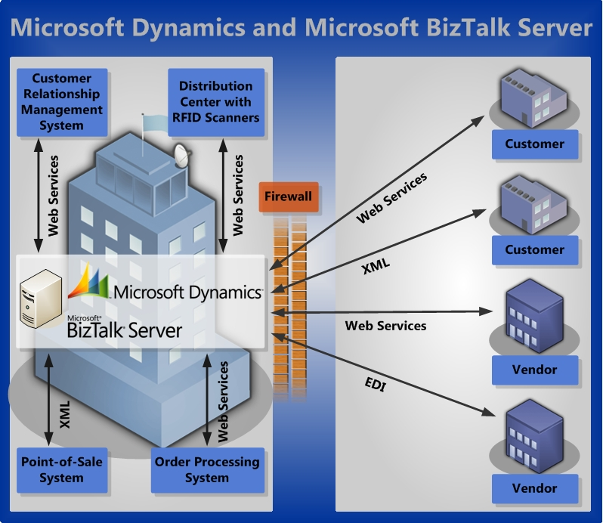The orchestration functions of BizTalk Server 2006 are used to send e-mail messages to the appropriate customer teams, helping them respond to calls effectively. BizTalk Server also updates case records in Microsoft Dynamics CRM with links to InfoPath 2003 forms in SharePoint Portal Server 2003. This ensures that every customer-facing council employee shares one view of the client’s call. BizTalk Server 2006 also monitors case histories to detect completion and updates Microsoft Dynamics CRM when queries are resolved.

The new framework fully supports the agenda of the DCC for streamlining public services by placing accurate, up-to-date information at agents’ fingertips. Benefits include improved quality of service and more effective use of departmental specialist expertise.

## **Consume**

The exposed services and composed processes deliver business value only when they connect people to the work they do. The goal of the consume phase is to take the composed processes and workflows and create applications that help increase worker productivity and enhance insight into business operations. The consume phase provides people with the functionality that they need, in the way that is most effective for the task at hand. For example, Microsoft Dynamics enables organizations to deliver applications that align with each employee’s or department’s role at a company, from the warehouse to sales. Connecting disparate systems and business areas in this manner promotes collaboration across an organization, while helping to save time and money as information is centralized and manual tasks are automated.

Microsoft Dynamics consumes Web services directly from other products, providing relevant information from multiple, otherwise unconnected, sources. The Microsoft Dynamics Client for Microsoft Office and SharePoint Server provides an agile platform for the consumption of services. The following section summarizes the use of the Microsoft Dynamics Client for Microsoft Office and SharePoint Server.

### **Microsoft Dynamics Client for Microsoft Office and SharePoint Server**

Microsoft Dynamics Client for Microsoft Office and SharePoint Server serves as a platform to consume multiple services and create composite applications that deliver greater business value. This client consists of several self-service applications that are built to plug into the Microsoft Office system and Office SharePoint Server. Using applications in the Microsoft Office system, including Microsoft Office Excel and Microsoft Office Word, employees in roles such as sales, marketing, or operations can search financial, human resources, or supplier records within their back-end systems and incorporate relevant information directly into the spreadsheet or document they are working on. For instance, Microsoft Dynamics Snap for Business Data Lookup enables a user to search system records in Microsoft Dynamics from within a document, spreadsheet, or e-mail message, as seen in the following diagram. Applications in the Microsoft Office system also have built-in support for consuming Web services: InfoPath 2003 includes support for binding to data through Web services, and Microsoft Office Visio® has support for consuming database-driven Web services, such as Web services exposed by the relational database of SQL Server.

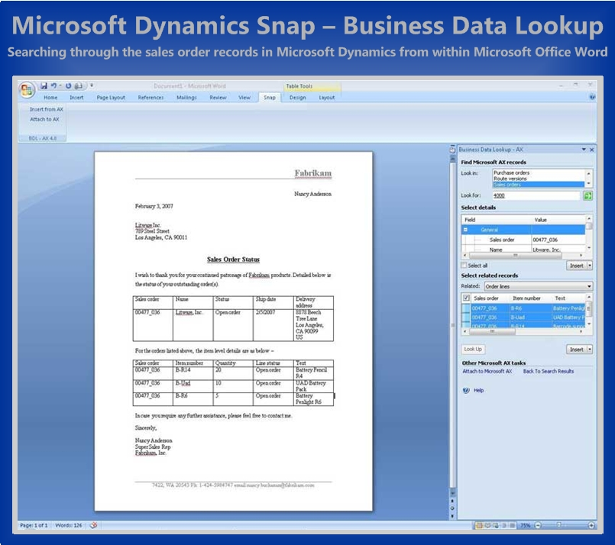Portals for Microsoft Dynamics that are built using technology in Office SharePoint Server help share information easily, providing a strong collaboration platform. Through the use of portals, Microsoft Dynamics Client for Microsoft Office and SharePoint Server can provide employees with direct access to the most up-to-date business information by consuming Web services exposed by Microsoft Dynamics applications and other sources.

|  |
| --- |
| *“We now have the visibility we need to analyze critical business data from start to finish. The bottom line is that we can sell more, do more, and protect our profit margins through this integrated real-world SOA solution.”*  *Joe Divona, Director of Information Technology, AES2* |

For example, Advanced Electronic Solutions2 (AES2), a construction-options integrator that installs an array of electronic and high-tech equipment in residential and commercial buildings, was on the lookout for an end-to-end enterprise system that would help automate its construction fulfillment cycle. The ease of customization and standards-based integration provided by Microsoft Dynamics CRM and its Web services, together with Microsoft Dynamics GP, impressed the company. Orchestration and consumption of services provided by BizTalk Server and Windows SharePoint Services made the automation of the construction fulfillment cycle a reality. AES2 was able to achieve a 360-degree view of all facets of its business, from floor plans to subdivision plots to previous projects. The company achieved real-time project visibility through portals by integrating Windows SharePoint Services with Microsoft Dynamics. By using the unified solution stack from Microsoft, AES2 has developed a congruent, highly integrated solution that resulted in a 151 percent overall growth in the business and a 21 percent increase in profitability.

# Real-World SOA in Action

Although this white paper has showcased the real-world service-oriented architecture (SOA) solutions of several global organizations, the success of real-world SOA projects does not stop there. Using the tools and technologies that enable service orientation, described in the previous section, companies have pursued real-world SOA projects across a range of industries. The following section provides a brief overview of 15 real-world SOA projects. To read more about each of these stories, follow the link to the full case study on [www.microsoft.com/casestudies](http://www.microsoft.com/casestudies).

|  |  |
| --- | --- |
| Company: Derby City Council (DCC) | |
| Industry | Government agencies |
| Business Need | The DCC wanted a customer relationship management (CRM) system to overcome departmentalized service delivery and fragmented views of citizens and their needs. |
| Real-World SOA Solution | The DCC implemented Microsoft Dynamics CRM 3.0 and Microsoft BizTalk® Server 2006 to orchestrate processes between agencies. |
| Benefits | * Services streamlined with accurate, up-to-date information at agents’ fingertips * Quality of service from Derby Direct increased * Effective use of departmental specialist expertise |
| Link to Full Case Study | <http://www.microsoft.com/casestudies/casestudy.aspx?casestudyid=1000003935> |
| Company: Jet Support Services (JSSI) | |
| Industry | Aerospace |
| Business Need | JSSI wanted to expand its aircraft maintenance services business around the world, but its employees, vendors, and customers were hampered by labor-intensive and disjointed processes. |
| Real-World SOA Solution | JSSI implemented Microsoft Dynamics GP, Microsoft SQL Server®, BizTalk Server, Business Portal for Microsoft Dynamics GP, and the Microsoft Office system. |
| Benefits | * Sales increased 20 percent in one year, while operating costs remained flat * Time required to create invoices and make payment against them has gone from 10 days to 10 seconds per invoice * 20 days cut from the vendor invoice analysis process, saving at least US$60,000 annually * Cash receipts processes expedited by a minimum of US$2 million per month * Audit fees reduced by more than 25 percent * Time required to produce supporting financial backup reduced |
| Link to Full Case Study | <http://www.microsoft.com/casestudies/casestudy.aspx?casestudyid=201335> |
| Company: Killdeer Mountain Manufacturing (KMM) | |
| Industry | High-tech and electronics manufacturing |
| Business Need | To stay competitive, KMM needed to modernize and automate its supply chain communications to increase efficiency, provide information in real time, and reduce human error. |
| Real-World SOA Solution | KMM deployed an RFID-enabled supply chain network based on Microsoft Dynamics GP and BizTalk Server. |
| Benefits | * Cycle time cut in half * Increase efficiency and productivity * Customer service improved * Inventory visibility enhanced * Need for a third party, value-added network eliminated |
| Link to Full Case Study | <http://www.microsoft.com/casestudies/Case_Study_Detail.aspx?casestudyid=4000002239> |
| Company: Lads Pet Supplies | |
| Industry | Distribution |
| Business Need | Faced with shrinking margins and intense competitive pressures, Lads needed a cutting-edge software solution that could increase warehouse efficiency and propel the company securely into the future. |
| Real-World SOA Solution | Lads extended Microsoft Dynamics GP by integrating WithoutWire Warehouse (WoW)—a wireless management system developed by Appolis using industry standards and Web services for Microsoft Dynamics GP. |
| Benefits | * Processes automated for inventory adjustments, ticket printing, and route assignments * Quick, easy access to sales order processing, purchase order processing, and WoW information * Real-time view into business-critical information * Efficient retrieval of data from outside sources without data loss and without compromising data integrity * Efficiency of daily operations increased * Customer satisfaction increased |
| Link to Full Case Study | <http://www.microsoft.com/casestudies/casestudy.aspx?casestudyid=4000000443> |
| Company: Lantmännen Unibake | |
| Industry | Consumer goods manufacturing |
| Business Need | Lantmännen Unibake in Poland planned a rapid expansion of its market with new production lines. It needed a business management system that could handle a quickly growing workload and streamline their business processes. |
| Real-World SOA Solution | Lantmännen Unibake implemented Microsoft Dynamics AX and BizTalk Server. Industrial automation devices were integrated with Microsoft Dynamics AX. In the warehouse, a Wi-Fi network connects the warehouse module to wireless terminals placed on forklifts. |
| Benefits | * Manufacturing flexibility increased * Revenue growth by 43 percent * Strict food quality systems enforced * Employee efficiency and motivation increased * Warehouse waste eliminated * Product returns reduced |
| Link to Full Case Study | <http://www.microsoft.com/casestudies/casestudy.aspx?casestudyid=1000003869> |
| Company: MW Brands | |
| Industry | Consumer nondurables |
| Business Need | The goal at MW Brands was to implement a high-performance supply chain integration solution that would support the requirements of the new enterprise, but cause no disruption to existing orders entering the business from key customers. |
| Real-World SOA Solution | MW Brands decided to pursue a real-world SOA solution, comprised of Microsoft Dynamics NAV, BizTalk Server, and the GXS Trading Grid. |
| Benefits | * Operating costs reduced * Manual order checking eliminated * Scalable, world-class ERP and B2B infrastructure achieved * No customer disruption during migration |
| Link to Full Case Study | <http://www.microsoft.com/casestudies/casestudy.aspx?casestudyid=4000000145> |
| Company: Oncology Hematology Associates (OHA) | |
| Industry | Healthcare provider |
| Business Need | OHA wanted to find a way to integrate its multiple business processes to improve efficiency, support collaboration, serve patients better, and increase profitability. |
| Real-World SOA Solution | OHA uses several accounting applications based on Microsoft Dynamics GP to manage accounts receivable, general ledger, purchase orders, and accounts payable. OHA developed an electronic health record for its patients’ charts and deployed BizTalk Server and Microsoft BizTalk Accelerator for HL7, an industry-standard protocol for electronic data exchange of healthcare information. OHA also deployed Microsoft Office SharePoint Portal Server 2003 and set up a portal site for sharing information. |
| Benefits | * Revenue and patient load have both grown by 15–20 percent in just 18 months * Easier collaboration among doctors and facilities * Increased patient load can be handled with existing staff * Improve business process and data accuracy |
| Link to Full Case Study | <http://www.microsoft.com/casestudies/casestudy.aspx?casestudyid=201320> |
| Company: Roland DGA | |
| Industry | High-tech and electronics manufacturing |
| Business Need | To support and develop working relationships with dealers of its wide-format inkjet printers, vinyl cutters, 3-D scanning and milling equipment, and engravers, Roland DGA needed a comprehensive customer relationship management system. |
| Real-World SOA Solution | Roland DGA deployed Microsoft Dynamics CRM and an Axonom-developed solution called Powertrak, an add-in that extends Microsoft Dynamics CRM functionality. |
| Benefits | * Comprehensive data visibility achieved * Processes streamlined * Time to fulfill literature requests reduced by 10 to 20 hours a week * Lead routing process time reduced from weeks to within 48 hours |
| Link to Full Case Study | <http://www.microsoft.com/casestudies/casestudy.aspx?casestudyid=200427> |
| Company: sia Abrasives Holding AG | |
| Industry | Automotive and industrial manufacturing  Industrial distribution |
| Business Need | The sia Group wanted to standardize and consolidate all eight of its small ERP systems with an integrated ERP system that supported its international presence. |
| Real-World SOA Solution | The sia Group implemented Microsoft Dynamics AX across eight of its diverse companies. Process orchestration and the automation of intercompany business were achieved through the Commerce Gateway module in Microsoft Dynamics AX together with BizTalk Server. |
| Benefits | * Sales and purchasing information electronically exchanged * Processes streamlined and companywide procedures standardized * International functionality gained * Development and training costs reduced * Flexible technology infrastructure achieved |
| Link to Full Case Study | <http://www.microsoft.com/casestudies/casestudy.aspx?casestudyid=48487> |
| Company: Advanced Electronic Solutions2 | |
| Industry | Specialty trade contractors |
| Business Need | AES2 needed a scalable, cost-effective, end-to-end enterprise resource planning (ERP) system that would help automate its construction fulfillment cycle. |
| Real-World SOA Solution | AES2 deployed Microsoft Dynamics CRM and its Web services, together with Microsoft Dynamics GP. The orchestration and consumption of services was provided by Microsoft BizTalk Server and Windows SharePoint Services. |
| Benefits | * 360-degree view of operations * Real-time project visibility * 151 percent overall growth in the business * 21 percent increase in profitability |
| Company: Dixon Hughes | |
| Industry | Accounting services |
| Business Need | Dixon Hughes needed to ensure a seamless information flow from its customer relationship management system to its other systems. |
| Real-World SOA Solution | Dixon Hughes chose an add-on software plus service (S+S) application from ExactTarget that is integrated with Microsoft Dynamics CRM through Web services. |
| Benefits | * E-mail process eased with reduced server load and removal of need for complicated HTML editors * Ability to track results and perform analysis achieved |
| Company: LinPepCo Corporation | |
| Industry | Distribution |
| Business Need | LinPepCo needed a solution that would automate many aspects of load planning, picking, and updating any changes to orders. |
| Real-World SOA Solution | Using Web services provided by Microsoft Dynamics GP, the company integrated wireless handhelds used for picking and scanning products. |
| Benefits | * Fast implementation, only 90 days * Expected annual savings of US$40,000 * Seamless integration and automation of load planning |
| Company: Stream Solutions | |
| Industry | Professional services |
| Business Need | Stream Solutions needed an extensible business management system that could handle information from its Web portal for the printing industry. |
| Real-World SOA Solution | Sales-order-processing and purchase-order-processing transactions from the company’s portal were committed to Microsoft Dynamics GP via Web services. A further application allows PDF invoices to be created, printed, and filed automatically. Their system also uses Microsoft SQL Server Reporting Services to render, print, and file the documents. |
| Benefits | * Functionality extended to meet changing business requirements * More reliable information routed throughout the organization |

# Conclusion

A real-world approach to SOA, beginning with a focused understanding of business problems, enables organizations to align their IT assets with changing business needs and deliver on business goals. Microsoft empowers customers to realize their business vision by adopting this approach.

Microsoft Dynamics business management software greatly simplifies real-world SOA projects by building core service orientation capabilities into the individual applications and by taking advantage of the service orientation inherent in the Windows platform and Microsoft technologies, including Microsoft SQL Server®, Microsoft BizTalk® Server, Windows SharePoint Services, and Microsoft Office SharePoint Server. In addition to Web services for Microsoft Dynamics, the core capabilities of service orientation are complemented with connectors, adapters, and server-based solutions that support seamless integrations and the free flow of information.

Companies of all sizes have increased operational efficiency, facilitated collaboration across boundaries, and enhanced user experience by using the real-world approach to SOA. Success stories, including those included in this white paper, reiterate the ease of customization and standards-based integration provided through an underlying architecture. Learn more about the tools and technologies offered and take on real-world SOA projects with confidence.

# For More Information

To learn more about real-world service-oriented architecture (SOA) and the Microsoft products and technologies that enable such an approach, please visit the following links:

How the Cloud Stretches the SOA Scope:

<http://msdn.microsoft.com/en-us/architecture/aa699420.aspx>

Working with Web Services:

<http://msdn.microsoft.com/en-us/library/dd355036.aspx>

Enabling Real-World SOA Through the Microsoft Platform:

<http://www.microsoft.com/biztalk/solutions/soa/whitepaper.mspx>

To learn more about how Microsoft Dynamics promotes worker productivity, please visit the following link:

Microsoft Dynamics RoleTailored Business Productivity White Paper

<http://www.microsoft.com/dynamics/en/us/familiar.aspx>

mslogo

The information contained in this document represents the current view of Microsoft Corporation on the issues discussed as of the date of publication. Because Microsoft must respond to changing market conditions, this document should not be interpreted to be a commitment on the part of Microsoft, and Microsoft cannot guarantee the accuracy of any information presented after the date of publication.

This White Paper is for informational purposes only. MICROSOFT MAKES NO WARRANTIES, EXPRESS, IMPLIED, OR STATUTORY, AS TO THE INFORMATION IN THIS DOCUMENT.

Complying with all applicable copyright laws is the responsibility of the user. Without limiting the rights under copyright, no part of this document may be reproduced, stored in or introduced into a retrieval system, or transmitted in any form or by any means (electronic, mechanical, photocopying, recording, or otherwise), or for any purpose, without the express written permission of Microsoft Corporation.

Microsoft may have patents, patent applications, trademarks, copyrights, or other intellectual property rights covering subject matter in this document. Except as expressly provided in any written license agreement from Microsoft, the furnishing of this document does not give you any license to these patents, trademarks, copyrights, or other intellectual property.

© 2009 Microsoft Corporation. All rights reserved.

Microsoft, BizTalk, Excel, InfoPath, Microsoft Dynamics, the Microsoft Dynamics Logo, Outlook, SharePoint, Visio, Windows, and Windows CardSpace are either registered trademarks or trademarks of Microsoft Corporation in the United States and/or other countries.

Microsoft Dynamics is a line of integrated, adaptable business management solutions that enables you and your people to make business decisions with greater confidence. Microsoft Dynamics works like and with familiar Microsoft software, automating and streamlining financial, customer relationship and supply chain processes in a way that helps you drive business success.

United States and Canada Toll Free 1 (888) 477-7989

Worldwide (1) (701) 281-6500

[www.microsoft.com/dynamics](http://www.microsoft.com/dynamics)