Brief

Licensing the Core CAL Suite and the Enterprise CAL Suite January 2008

**Corporate, Government, and Academic** ♦ All Volume Licensing Programs

# Summary

Microsoft offers two Client Access License (CAL) Suites, the Microsoft® Core CAL Suite and the Microsoft Enterprise CAL Suite, which provide access rights for a number of server products and online services. The Enterprise CAL Suite includes all of the components of the Core CAL Suite. This means customers interested in the components unique to the Enterprise CAL Suite do not need to license both the Core CAL Suite and the Enterprise CAL Suite. Customers can acquire the Enterprise CAL Suite upfront or as a step-up from the Core CAL Suite.

**What’s New in this Brief**

* This brief replaces a previous version published in December 2006.
* Significant changes in this new version include:
* Updated product names and availability dates
* Clarification of Management Server Rights and additional minor corrections throughout.

**Details**

**CAL Suites**

A CAL Suite is a single license that provides use rights equivalent to multiple licenses. Like other CALs, CAL Suites can be licensed on either a per-user or per-device basis. CAL Suites simplify licensing and tracking by reducing the number of licenses necessary to access Microsoft servers, CAL Suites may also provide pricing that is more attractive than licensing the equivalent components individually. However, since a suite is a single license—the sum of individual CALs—CAL Suites cannot be divided among more than one user or device.

CAL Suites sometimes provide use rights equivalent to licenses that are not CALs. For instance, the Enterprise CAL Suite provides rights to several management server products and several online services subscriptions. In all cases, under a CAL Suite, the customer’s use rights with respect to a particular product or online service are the same as if that component was licensed separately. The only exception is that both per-user and per-device options are available in CAL Suites even when both options are not available outside the suite. For instance, Microsoft System Center Configuration Manager 2007 has per-device use rights as part of Core CAL Suite and Enterprise CAL Suite, even though it is offered under a per-operating system environment license individually.

**Use Rights**

Because CAL Suites contain licenses to products that are released independently, CAL Suites are version-less. CAL Suites are only offered with Software Assurance coverage, and accordingly give customers the right to use the most recent version of every product in the suite. If Software Assurance coverage lapses and the customer is vested with perpetual rights, use rights are determined by the latest version of the products in effect prior to the lapse in coverage. For example, if a customer’s Software Assurance coverage for the Core CAL Suite expired on October 1, 2006, the customer has perpetual rights equivalent to the most recent version of the Core CAL Suite’s components as of that date. This customer would not have rights to versions of components released after October 1, 2006 or to products added to the CAL Suite after that date.

**Core CAL Suite and Enterprise CAL Suite**

The Core CAL Suite is equivalent to the following licenses: Windows Server® CAL, Microsoft Exchange Server Standard CAL, Microsoft Office SharePoint® Server Standard CAL, Microsoft System Center Configuration Manager 2007 Client Management License.

The Enterprise CAL Suite is equivalent to the following licenses: All of the components of the Core CAL Suite listed above, all of the components of the Microsoft Forefront™ Security Suite[1], Exchange Server Enterprise CAL, Office SharePoint Server Enterprise CAL, Microsoft Office Communications Server Standard CAL, Microsoft Office Communications Server Enterprise CAL, Windows® Rights Management Services CAL, and Microsoft System Center Operations Manager 2007 Client Management License.

The diagram below shows what components are initially being offered in the Core CAL Suite and Enterprise CAL Suite as of October 1, 2007. Related server software licenses and subscription licenses are not included.

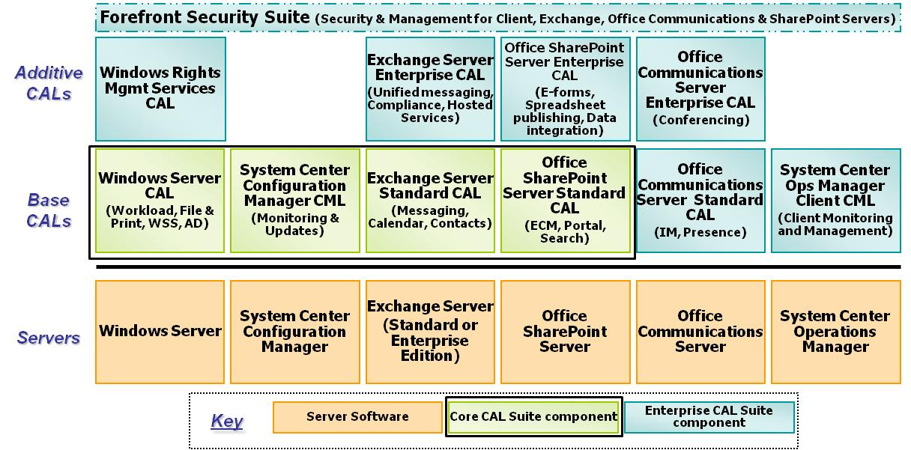

**Management Server Rights**

The Core CAL Suite provides rights equivalent to the System Center Configuration Manager 2007 Client Management License, and Enterprise CAL Suite provides rights equivalent to the System Center Operations Manager 2007 Client Management License. CAL Suites licensed on a per-device basis extend these rights to multiple operating system environments deployed on the same device, consistent with Server/CAL per-device licensing. Other Management Server licensing restrictions particular to these products must be observed, such as System Center Configuration Manager 2007 Client Management License’s limitation to systems running client operating systems.

**Online Services Components**

The Enterprise CAL Suite includes an online services component. While customers normally subscribe to online services separately, the Enterprise CAL Suite services component subscription is integrated with the Software Offering cost. As with a lapse in an online services subscription, with a lapse in Software Assurance coverage on a CAL Suite, rights to access the online services components will lapse as well.

**Component Availability**

At the time of its launch, not all of the components of Enterprise CAL Suite had been released. Customers with active Software Assurance at the time of component releases automatically acquire rights equivalent to those components. For instance, when Office Communications Server Enterprise CAL launched, Enterprise CAL Suite licensees with active Software Assurance were entitled to equivalent access rights.

**Obtaining Enterprise CAL Suite Licenses**

Customers may choose to license the Enterprise CAL Suite upfront or as a step-up from Core CAL Suite licenses. Having the Enterprise CAL Suite is like having both the Core CAL Suite and the components that are unique to the Enterprise CAL Suite. This means, unlike the customer who is licensing the same products under individual licenses, the customer licensing the Enterprise CAL Suite is not required to also maintain a separate Core CAL Suite. For instance, to license the Exchange Server Enterprise CAL outside the Enterprise CAL Suite, a customer must obtain both an Exchange Server Standard CAL (or Core CAL Suite, which provides equivalent rights to Exchange Server Standard CAL) and the Exchange Server Enterprise CAL. Alternatively, a customer may obtain rights equivalent to the Exchange Server Standard CAL and the Exchange Server Enterprise CAL by licensing only the Enterprise CAL Suite, because it also provides rights equivalent to all of the components of the Core CAL Suite.[2]

**Frequently Asked Questions**

**Is there a difference between the Enterprise CAL Suite and an Enterprise CAL? Is it an important distinction?**

Yes. The Enterprise CAL Suite provides rights equivalent to 11 licenses, including Exchange Server Enterprise CAL, Office SharePoint Server Enterprise CAL, and Office Communications Server Enterprise CAL. Additionally, the Enterprise CAL Suite provides rights equivalent to other licenses, including System Center Operations Manager 2007 Client Management License.

**Can I apply an Enterprise CAL Suite Step-up to a Core CAL Suite with expired Software Assurance coverage?**

No. You must have active Software Assurance to benefit from the ability to migrate lower edition offerings to higher editions like migrating from the Core CAL Suite to the Enterprise CAL Suite.

**If I can step up from the Core CAL Suite to the Enterprise CAL Suite, can I step up from components of the suites into one of the CAL Suites?**

While there are not programmatic step-up licenses from one or more individual components to the full suite, Microsoft will be providing migration solutions. Please ask your Microsoft Volume Licensing representative for migration options.

**Do the Core CAL Suite and Enterprise CAL Suite provide downgrade rights for their equivalent components?**

Yes. Unlike use rights for most product suites, the use rights for the Core CAL Suite and Enterprise CAL Suite permit customers to downgrade components individually. The downgrade rights for the components of the Core CAL Suite and Enterprise CAL Suite are the same as those for the individual components. For instance, an Enterprise CAL Suite license may be used to access an Exchange Server 2000 server.

**Does the Enterprise CAL Suite provide the right to access all Microsoft Server Products?**

No. The Enterprise CAL Suite provides rights equivalent to a broad selection of Microsoft server products to provide information workers access to functionality, including communication, collaboration, and compliance—presence and synchronous communications (IM), enterprise content management, information rights management, client security, server and Web security, client and server real-time monitoring and updates, conferencing, Web-based forms solutions, and business data connectors. However, the Enterprise CAL Suite does not provide rights equivalent to other CALs, including CRM and SQL Server®.

**Will new products be added to the Enterprise CAL Suite in the future?**

At this time, Microsoft has not announced plans to add rights equivalent to other CALs into the Enterprise CAL Suite. However, if a product is added to the Enterprise CAL Suite in the future, licenses with active Software Assurance would receive equivalent rights.

**How does the Enterprise CAL Suite relate to the Enterprise Desktop platform offering?**

The Enterprise CAL Suite, the Windows Vista™ Enterprise operating system, and Microsoft Office Enterprise 2007 comprise the Enterprise Desktop platform offering.

**Can I license the Enterprise CAL Suite’s components individually?**

Yes. All Enterprise CAL Suite components are available individually.

**What server editions do CAL suites provide access to? For instance, does the Enterprise CAL Suite provide access to Exchange Server Standard Edition or Exchange Server Enterprise Edition?**

Like other CALs, the Enterprise CAL Suite and Core CAL Suite license access to any edition of a server that requires a CAL. Therefore, Enterprise CAL Suite and Core CAL Suite license access to both Exchange Server Standard Edition and Exchange Server Enterprise Edition.

**Does the Enterprise CAL Suite include rights to access SQL Server 2005?**

No. SQL Server CALs must be obtained separately from the Enterprise CAL Suite or Core CAL Suite.

**My Software Assurance cost for Enterprise CAL Suite looks higher than the normal rate. Has Microsoft raised the cost of Software Assurance?**

No. Online Services subscription fees are reflected in the Enterprise CAL Suite’s annual cost, which includes both online services subscription costs and Software Assurance. These costs are part of both the new and renewal offerings and, as a result, the relationship between the new and renewal price varies from that normally associated with our License and Software Assurance offerings.

1. A subscription to Forefront Security Suite currently consists of coverage under the following online services: Forefront Client Security, Forefront Security for Exchange Server, Forefront Security for SharePoint Server, Forefront Security for Office Communications Server, and Exchange Hosted Filtering.
2. For more information on licensing Additive CALs, please see the Microsoft Volume License Brief, “*Base and Additive Client Access Licenses: An Explanation*.”