Manage Product Keys Using Volume Activation Management Tool 2.0

As an IT administrator in a medium or large organization, you are responsible for managing product keys, often for multiple products that are acquired from multiple sources. Sometimes it can be challenging to keep track of these keys and prevent their leakage to unauthorized personnel. Microsoft’s free [Volume Activation Management Tool (VAMT) 2.0](http://go.microsoft.com/fwlink/?LinkId=183042) can help with key management.

VAMT 2.0 enables you to manage the following product key types, for Windows 7, Windows Vista, Windows Server 2008 R2, Windows Server 2008, Office 2010 client suites and applications, Visio 2010 and Project 2010:

* Key Management Service (KMS) host keys (CSVLK)
* KMS client setup keys (GVLK)
* Multiple Activation Key keys (MAK)
* Retail keys

VAMT 2.0 supports these keys regardless of how your organization obtained them. VAMT handles keys acquired through a Microsoft volume license agreement(s), subscription programs such as MSDN, TechNet or Microsoft Partner Network, or the retail channel. VAMT cannot manage other key types such as volume license “bypass” keys (VLKs), or keys installed by an OEM. VAMT 1.2, available as part of the [Windows Automated Installation Kit](http://go.microsoft.com/fwlink/?LinkId=136976) (AIK), supports MAK and GVLKs but not CSVLK or retail keys.

Let’s run through how you can manage product keys in VAMT 2.0. The process is the same for KMS host keys, MAKs and retail keys. KMS client keys are already embedded in VAMT so you never need to add them.

Contents

Add a key to VAMT 1

Determine remaining activations on a MAK 2

Delete a product key 3

Save product key data in the CIL 4

Protect access to the CIL 5

More *Using VAMT 2.0* Guidance 5

# Add a key to VAMT

Before you can install a key in a product, you need to add it to VAMT.

1. Type in the product key and verify it
   1. In the left pane of VAMT’s UI, click the **Product Keys** node.
   2. In the center pane, type the 25-character key without the hyphens. VAMT adds these automatically. In the example below, we added a MAK for Windows 7 Enterprise/Professional. We blocked out much of the actual key data. See Figure 1.
   3. Click **Verify**. The **Edition**, official key **Description**, and **Key Type** fields populate after the key is verified.
2. Enter a description for the key and add it to VAMT
   1. In **Remarks**, enter a description for the key that is meaningful to you and your organization. Our example key has been assigned to a development department. See Figure 1.
   2. Click **Add Product Key** to add the key to VAMT. The key is now added to VAMT and can be used. See Figure 2.

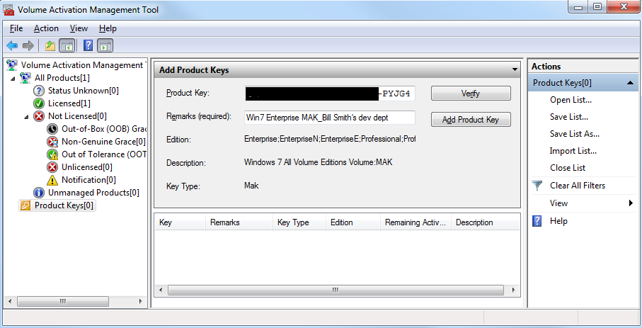

**Figure 1. Entering a key and description**

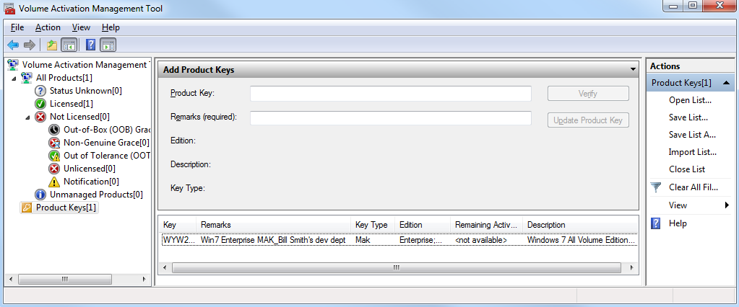

**Figure 2. The product key is added to the list of keys.**

# Determine remaining activations on a MAK

A handy piece of information to check is the number of remaining activations on a MAK. It’s a good idea to refresh the MAK’s activation count before you deploy it on a large number of systems. This feature is not available for KMS host or retail keys.

1. Select the MAK and then **Refresh Product Key Data Online**. VAMT connects to Microsoft and retrieves the number of remaining activations. See Figure 3.
2. If you need more activations, [call your Microsoft Activation Center](http://www.microsoft.com/licensing/resources/vol/numbers.mspx) to request an increase.

**Figure 3. Refresh MAK remaining activations data**

# Delete a product key

There may be times when you need to delete a key from VAMT. Deleting a key that has been installed in a product and activated will have no effect on the product or its status.

1. To remove a product key from the list, click **Product Keys** in the left pane.
2. Select the key in the list and click Delete from the Action menu.
3. Click OK to confirm deletion of the product key. See Figure 4.

**Figure 4. Delete a product key**

# Save product key data in the CIL

VAMT stores data in the Computer Information List, or CIL, an XML file created when you save or export data. In this step, you will save the Computer Information List (CIL) for backup and future use.

1. Choose **Save List** or **Save List As** from the **Actions** menu. VAMT will display Save the Computer Information List dialog box. See Figure 5.
2. Enter a desired CIL file name or select a directory and then enter a CIL file name such as “DevelopmentDept.CIL”.
3. Click **Save**.

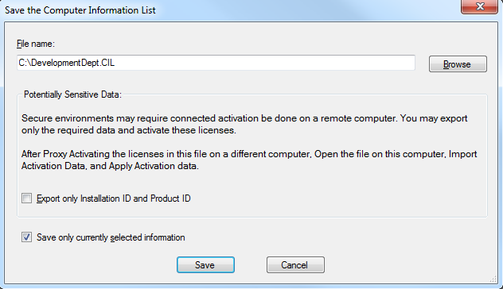

**Figure 5. Save the CIL**

# Protect access to the CIL

To prevent key leakage, you should limit access to VAMT and the CIL to only those personnel with a reason to see the product keys and activate products. Secure access to the CIL file on the local hard drive by encryption or set permissions for the folder where the CIL is stored. Make sure that you similarly protect the backup location if you create a back up file e.g. for disaster recovery.

# More *Using VAMT 2.0* Guidance

Check out the other [*Using VAMT 2.0*](http://go.microsoft.com/fwlink/?LinkId=184609) documents:

* Product Activation Using VAMT 2.0
* Reporting Activation Information Using VAMT 2.0
* Activation in Disconnected Environments Using VAMT 2.0

You can watch video demos of several VAMT tasks at [www.technet.com/volumeactivation](http://www.technet.com/volumeactivation).[1] The Helpfile in the [VAMT 2.0 download](http://go.microsoft.com/fwlink/?LinkId=183042) has detailed information on how to perform many tasks using the tool.

1. Several of these demos use VAMT 1.2 but the process is the same using VAMT 2.0.