Enabling Teamwork and Collaboration with Microsoft Office System
What you will do:
- Learn how to create a Windows SharePoint Services Web site
- Add members to your SharePoint site
- Create an Events and Task List
- Create a Document Workspace for collaborating
- Use SharePoint document properties to manage the collaborative process
- Use the Shared Workspace task pane to check document status and communicate with others
- Customize a site survey

Educator Tutorial Series

Tutorial Series
As Chickering and Gamson point out in their article “Seven Principles for Good Practice in Undergraduate Education,” learning is not a spectator sport. Nor should it be a solo race. “Good learning,” these authors maintain, “is collaborative and social, not competitive and isolated. Working with others increases involvement in learning. Sharing one’s ideas and responding to others’ reactions sharpens thinking and deepens understanding.”
Fostering an interactive learning community to enable such collaboration, therefore, is an important part of an educator’s job. Not only does cooperation among students enhance their learning, it can also teach them to respect diverse talents and ways of learning, another principle of good education cited by Chickering and Gamson. When students work together, they have the opportunity to “show their talents” and also to “learn in new ways that do not come so easily” for them.
Unfortunately, many obstacles, including poor communication, dissimilar work styles, and different schedules, stand in the way of effective collaboration among students.
Technology, used effectively, can facilitate your efforts to develop a collaborative learning environment. In this tutorial, you’ll learn about how you can use Microsoft® Windows® SharePoint™ Services, along with Microsoft Office Word 2003 and Microsoft Office Outlook® 2003, to foster an interactive and collaborative learning community.
Windows SharePoint Services enable you to create a collaborative space on the Web where you and your students can easily share information, keep up to date on class initiatives, and coordinate efforts on group projects. Following are just some of the ways that you can use Windows SharePoint Services in an educational context to facilitate effective collaboration and communication:
- Work on conference presentations with colleagues or have your students work together on final papers by using Document Workspaces. Consolidating different people’s input into a document stored in a Document Workspace is much simpler, thanks to document version control features available from SharePoint.
- Keep up to date on changes to a document or to the status of your project by using Alerts and the Shared Workspace. You can set up an Alert to be notified by an e-mail message when documents, events, or other lists on the site are modified. You can view project information related to a document from within the document by using Shared Workspace.
- Identify all the tasks associated with a class project or institutional initiative, and then assign owners to each task. You can manage your workload and monitor the progress of a project by using the Task list available in SharePoint.
- Schedule class events, including tests, conferences, and library days, on the SharePoint Events Calendar. You and your students will always have access to the most up-to-date information, and you can use side-by-side calendar views in Outlook to synchronize your class calendar with your other professional obligations.
It doesn’t take long to learn how to set up and use a SharePoint site, and in the process, you’ll discover many tools for building a collaborative classroom.

Introduction to Windows SharePoint Services
While you are probably already familiar with many of the programs included in the Microsoft Office System, Windows SharePoint Services may be new to you.

To learn more about the Microsoft Office System programs, go to http://www.microsoft.com/office/preview/default.asp

Also, check out some of the free online training available on the Web at Microsoft Office Online!
Windows SharePoint Services are a set of services that enable you to create and maintain a SharePoint site, which you can access through a Web browser.
A SharePoint site extends the opportunities for you and your students to work together by enabling you to share resources, communicate about class issues and events, and collaborate on projects without requiring you to be in the same room or even on the same schedule. A SharePoint Web site opens up new possibilities for interaction.
While you must have access to Microsoft Windows Server™ 2003 running Windows SharePoint Services to create a SharePoint site, you need nothing more than a Web browser to access and contribute resources to the site. You will discover, however, that integration with Microsoft Office makes it even easier to fully benefit from the site. If you are using Office XP, you can create a SharePoint site from within an Office program, and you can save documents to the site or open documents stored on the site from within the Office program. In addition to these tasks, when you use Office 2003, you can create a Document Workspace, synchronize the personal events and tasks that you have stored in Outlook with the class or departmental events and tasks stored on the site, and view and update document information, member status, and lists on the site from the Shared Workspace available in your Office 2003 program.
Following are some of the ways in which a SharePoint site can help you and your students work effectively together:
- Collaborate on documents. New features in Office 2003 enable you to create a Document Workspace on your SharePoint site where you can share documents with others, give and receive feedback, and manage changes to document content. Document Workspaces can be especially helpful for students with different class and work schedules who require a centralized place for managing their work.
- Keep up to date on changes. Specialized Alerts can help you to stay informed when any item on the site is changed. When you add an Alert to an item, you are notified by an e-mail message when the item is changed. You can be notified whenever your students post an update to a project that they are working on. Your students can be alerted whenever you change the syllabus, class readings, or assignment due dates.
- Help you schedule events. Because SharePoint integrates effectively with Office programs, you can now view a calendar posted on a SharePoint site next to your personal calendar from within Outlook. This integration can make it much easier to plan your schedule. For example, if your department posts a schedule of departmental meetings on the SharePoint site, you can open it in Outlook side by side with your own calendar, and then drag and drop events in the SharePoint calendar into your own calendar.

Before You Begin
Before you begin this tutorial, make sure that you have access to all the necessary software required to complete the tutorial procedures. This tutorial requires that you have:
Words to know:
Browser—A program that allows you to view HTML-formatted documents. One example of a browser is Microsoft Internet Explorer.
HTML—Hypertext Markup Language. The language used to format Web pages.

URL—Uniform Resource Locator. The name and location of a file or Web page that appears in the form: http://www.domain.com/

Document Workspace—An area on a Windows SharePoint Services server that stores documents, controls access to them, and provides version control, among other things.
IP Address—A unique numerical identifier that specifies the location of a Web site. It typically appears in the form 123.123.12.2.
- Office 2003 installed on your local computer.
- Windows Server 2003 installed on your local computer or on your local area network.
- Administrative access to an existing SharePoint site.
In addition to these system requirements, the tutorial assumes that you are familiar with using Word and Outlook, and that you are adept at navigating Web sites and Windows Explorer. If you want to learn more about using Word in the classroom, see “Creating and Publishing Research Documents Using Word” at www.microsoft.com/education/?ID=Word2003Tutorial

To learn more about using Outlook, see “Collaborating with Others Using Outlook 2002 and Exchange 2000” at http://www.microsoft.com/education/default.asp?ID=Outlook2002Tutorial

Getting Started
To learn about the benefits of using Windows SharePoint services in conjunction with the Microsoft Office System, imagine that you are teaching a course in which you require small groups of students to work together on a major research project and final presentation. Group projects, as you know, often frustrate students because they have difficulty coordinating work and ensuring that all the group members participate in and contribute to the project.
You decide to set up a SharePoint site for the class so that your students have a place where they can share information, coordinate work, and manage their projects. The site also enables you to monitor their progress on the project.

Navigating a SharePoint Site
Before you create a SharePoint site, take some time to familiarize yourself with the elements of a SharePoint site.
All top-level SharePoint Web sites include a set of links referred to as the Top Link bar.
The Top Link bar provides links to the Home page, SharePoint Help, and, if appropriate, to the top-level team site. The Top Link bar also includes links to the:
- Documents and Lists page. Use this page to view all the libraries, lists, discussion boards, and surveys in the site. You can also create a new library or list from this page.
- Create page. Use this page to add a new library, list, discussion board, or Web page to your site.
- Site Settings page. Use this page to add new members to your site, to customize how your site looks, and to update your personal settings.
The following illustration shows the Home page of a SharePoint site.
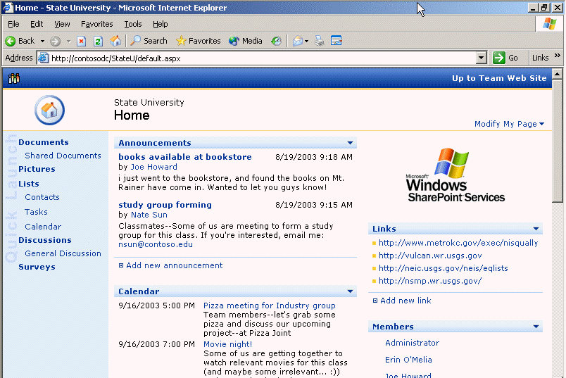
Figure 1: Home page of a SharePoint site
The elements included in a SharePoint site depend on the template that you select for your site, but the standard Team site is automatically populated with the following pages:
- Home. Describes your site, and includes a snapshot of Announcements, Events, and Links. Of course, you can customize the Home page to include exactly the information that you require.
- Documents. Store important class materials, such as the syllabus and copies of each class assignment, in a Document Library.
- Pictures. Stores pictures that you want to share. You can choose how you want pictures to display and select download options from a Picture library.
- Lists. The List page is a repository for important information. By default, it includes Announcements, Contacts, Events, Links, and Tasks. For a departmental Web site, you might include faculty meetings and academic conferences in the Events list. For a class Web site, you could broadcast changes to an assignment or details about a guest lecturer in the Announcements list. In the Links list, you could include links to reputable source sites that your students can use to conduct class research.
- Discussions. Use the discussion board as a forum for discussing class readings or having your students respond to questions about issues that come up in class discussion.
- Surveys. Use this page when you want to poll the members of your site for their opinions or get feedback on class activities.
You can, of course, customize your site at any time by adding elements to it that are not included in the template, or by eliminating elements that you do not want.

Setting Up Your Site
You have three options for creating a SharePoint site using Windows SharePoint Services:
If you do not have access to a top-level SharePoint site, see “Create a top-level Web site from SharePoint Central Administration” in SharePoint Help for information about how to set one up.

- You can use the SharePoint Central Administration pages or the Self-Service Site Creation page for creating top-level Web sites. You must be an administrator of the server computer on which the site will reside to use the SharePoint Central Administration pages.
- You can use the Create page or the Site Administration page on an existing SharePoint site to set up a sub-site for your class.
- You can create a Document Workspace or a Meeting Workspace, a private sub-site within an existing site, from within Word or Outlook.
Deciding upon which method to use for creating a site depends on the context in which you are working and your purposes in setting up the site. If your institution or department already has a top-level site to which all faculty have been given administrator privileges, you can set up a site for your class from the top-level site by using the Create page.
The following illustration shows the Create page of a SharePoint site.
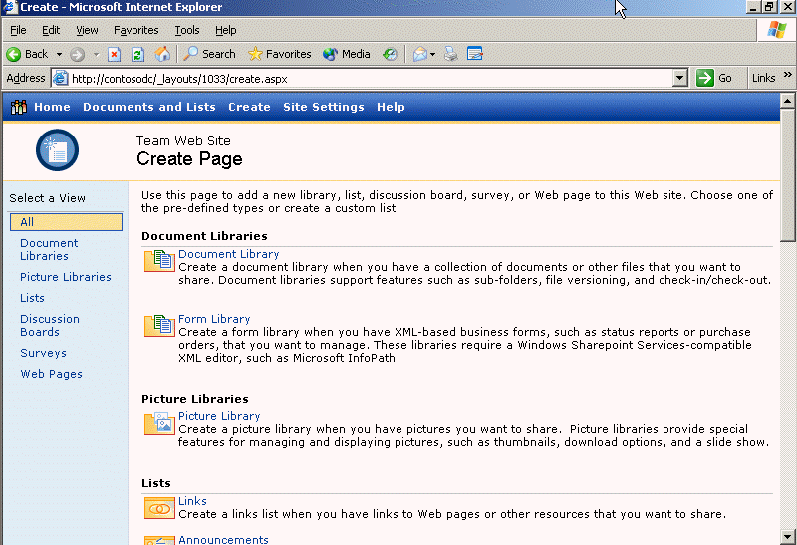
Figure 2: Create page of a SharePoint site
If you want to create a simple site to manage the development of a shared document, such as a conference presentation, you can create a Document Workspace site from within a Word file. A Document Workspace site provides a Document Library to share the file and to track issues related to its completion. For more information about this option, see “Creating a Document Workspace” in this tutorial.
You decide to create a site for your class from the top-level site at your institution. To do this, you must have the IP address or URL of that site. You must also have a user name and password to access the site.

To create a SharePoint Web site
- Open Microsoft Internet Explorer, and in the Address field, type the IP address or URL of the top-level SharePoint Web site where you will create your site.
Note: You must be a member of the Administrator site group to create a new sub-site.
- On the Top Link bar, click Create.
- In the Web Pages section, click Sites and Workspaces.
- In the Title and Description boxes, type a name and description for the new site.
- In the Web Site Address section, type the Web address (URL) that users must use to go to the new site. For example, you may want to type myclass.
Note: The first part off the address is provided for you.
- To set the accounts and roles information for your site, in the Permissions section, click Use Unique Permissions. This will enable you to modify the site permissions later from the Site Settings page.
Note: When you want your site to use the same accounts and roles information as the top-level site, click Use same permissions as parent site.
- Click Create.
- If you are prompted, type your user name and password, and then click OK.
- Under Template, click Team Site, and then click OK.
Naturally, you want to protect your course materials and any work that your students complete from being viewed or modified by unauthorized individuals. Fortunately, SharePoint sites are private Web sites by design: only people who have been granted permission can visit a SharePoint site, and each site member must provide a user name and password to authenticate their identity.
When you create a SharePoint site, you specify who can access the site and what they can do on the site. For example, you may want your students to be able to view and add documents to the Document Library, but you probably do not want them to add new members to the site or to modify the site structure. You may want a colleague or the head of your department to have all the same administrative privileges that you do.
To control what users can do on the site, you assign them to site groups. The site group determines whether a user can simply view information on the site, add to that information, or modify it, among other things. There are four different site groups to which you can assign users:
You can create new site groups, such as student, teaching assistant, or instructor to customize permissions for types of members. To create custom site groups, on the Home page of your SharePoint site, click Site Settings, click Go to Site Administration, and then click Manage Site Groups.

- Reader. Has read-only access to the Web site.
- Contributor. Can add content to Document Libraries and lists.
- Web Designer. Can create lists and Document Libraries and customize pages in the Web site.
- Administrator. Has full control of the Web site. In addition to the rights of other site groups, an administrator can create custom site groups, add new members, and create shared workspaces within a site.
You decide to assign your students to the Contributor site group. When you assign users to a role, they receive an e-mail message with your custom greeting, the address of the site, and a user name and password.

To assign users to a site group
- From the Home page of your site, click Site Settings, and then under Administration, click Manage users.
- Click Add Users, and then type the e-mail address of each person whom you want to invite to the site.
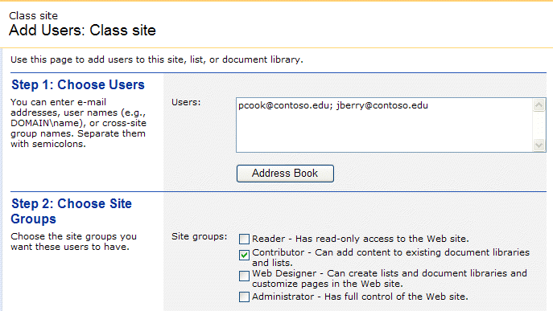
To add users to the site quickly from your list of Outlook contacts, click Address Book.

- Under Site groups, select the check box next to the site group that you want these users to belong to.
- Click Next. After you verify that the e-mail addresses are correct, type your e-mail message in the Personal Greeting box.
- When you are satisfied with your invitation, click Finish.

Creating an Events Calendar
If you have a SharePoint Web services-compatible Web page editor such as Microsoft FrontPage 2003, you can customize the layout and format of your Web site.

Now that you have created a SharePoint site and added your students as members, you can customize the site contents using nothing more than your Web browser.
You can use the Events list to provide your students with a snapshot of class exam dates, assignment due dates, and other course scheduling information. An electronic dateline stored on the site can be especially beneficial when you know that you want to add events, such as student presentations or additional quizzes, over the course of the quarter or semester.
The SharePoint site provides several predefined views of Events:
- Calendar view provides a display of events by month.
- All Events view shows all the events included on the site.
- Current Events view shows only the events that have not already occurred.
Any events that have not already occurred also appear by default on the Home page of your SharePoint site, so they are readily accessible to all the members of your site.

To create an Events list
- From the Home page, click Create.
- Under Lists, click Events.
- In the Name field, type the name Class Events for the Events list.
- In the Description box, type text that describes the purpose of the Events list.
- In the Navigation section, click Yes to create a hyperlink for this list on the Quick Launch bar.
- Click Create.

To add items to an Events list
When you create an event, you can attach documents associated with the event to the event item. For example, you may want to attach review notes to the final exam event, or an agenda to a faculty meeting event.

- From the Home page, on the Quick Launch bar under Lists, click Class Events.
- On the Quick Launch bar, under Select a View, click the view you prefer, and then click New Item.
- In the Title box, type a name for the event.
- In the Begin box, type the date when you want the event to start, and then click the time that you want the event to start from the drop down lists.
- If the event lasts longer than a day, in the End box, type the date when you want the event to end, and then click the time that you want the event to end.
- If you want, type text in the Description and Location boxes.
- If this is a recurring event, under Recurrence, click the frequency with which you want the event to recur, and then specify the day and range of recurrence.
- At the top of the page, click Save and Close.
After you have put together a schedule of Events for your class, you and your students can view the class calendar posted on the Web site side by side with a personal Outlook calendar. You can even drag and drop events posted on the site calendar to your personal calendar. The first step is to make the class calendar available for viewing in your Outlook account.
Note: To complete the following procedures, you must be using Outlook as your e-mail client.
With Outlook 2003, you and your colleagues can share your calendars with each other. When you share calendars, you can view your colleague’s calendar side by side with your personal calendar, and, depending on the permissions granted by the calendar owner, you may be able to edit or add events to the calendar.
To use this feature, your e-mail provider must be running Microsoft Exchange Server 2003.

To add the team calendar to Outlook
- On the Top Link bar of the Web site, click Documents and Lists, and then click Events.
- In the left pane, under Select a View, click Calendar.
- Click Link to Outlook.
- When prompted, click Yes to add the Windows SharePoint Services calendar to Outlook.

To copy events to your personal calendar
- In Outlook, click Calendar.
- Under Other Calendars, select the check box for the Windows SharePoint Services calendar that you want to view.
- On the Windows SharePoint Services calendar, open the entry that you want to add to your personal calendar.
- On the Actions menu, click Copy to Personal Calendar, or click the item and drag and drop it onto your Outlook calendar.

Creating a Task list
SharePoint provides a Task list where you can keep track of all the work that you need to do on a particular project. For example, you might want to specify all the assignments in a class and the due date for each assignment on the Task list. A Task list, however, is more than a simple To Do list.
You can create and manage a Shared Task list using Outlook 2003. With the proper permissions, you and your colleagues can view each other’s Task list and edit or assign tasks to each other.

Consider how a Task list can help your students work together more effectively on group projects. Creating a Task list at the outset of a project prompts students to think through the scope of the project. By assigning owners to each task, they learn to delegate responsibilities clearly. They can add notes to any task on the Task list to communicate with each other and with you about the status of their work.
Like your students, you and your colleagues might also find that a Task list helps you collaborate effectively. You can use such a list to orchestrate a team teaching effort or a conference presentation with a colleague.
SharePoint provides several views of the Task list to help you get a clear picture of the progress of a project:
- To see all the items on the Task list, click All Tasks.
- To see all the tasks assigned to you, click My Tasks.
- To see all the tasks assigned to another person, click By Assigned To.
You can also create a custom filter to view the Task list. Simply click Filter, and then click the due date, status, priority, and other items that you prefer from the lists at the top of each column in the Task list.

To create a Task list
- On the Top Link bar, click Create.
Notice how similar it is to create a Task list and an Events list? You can create a list of Issues, a list of Links, and a list of Announcements for your SharePoint site by following the same basic procedure.

- Under Lists, click Tasks.
- In the Name field, type the name Project Tasks for the Task list.
- In the Description box, type text that describes the purpose of the Task list.
- If you want a hyperlink to this list to appear on the Quick Launch bar, in the Navigation section, click Yes.
- Click Create.

To add tasks to the Task list
- From the Home page, under Lists, click Project Tasks.
- At the top of the list, click New Item.
You can add tasks stored on your SharePoint site to your personal Task list in Outlook.

- In the Title box, type a heading for the task.
- In the Priority list, click a priority level for the task.
- In the Status list, click the appropriate status for the task.
- In the Assigned To list, click the user to whom you want to assign the task. If you do not want to assign the task to a specific person, leave the default None.
- In the Description box, type a description of the task.
- In the Start Date box, type a date, and then click the hour and minute that you want the task to start.
- In the Due Date box, type a date, and then click the hour and minute that you want the task to be completed.
- To save the task, click Save and Close.

Sharing Documents
There are two options for sharing documents on a SharePoint site. You can post documents in a Document Library, or you can create a Document Workspace that stores one or more documents and information related to the documents. Though the two options are similar in terms of what they enable you to do with shared documents, the method for setting up and storing data is different. The following sections describe each option and provide guidelines for using them.
To add documents to a Document Library, users must belong to the Contributor, Web Designer, or Administrator site group. To create a Document Workspace, users must belong to the Web Designer or Administrator site group.

Creating a Document Library
One option for sharing documents is to create a Document Library. A Document Library is an excellent option when you simply want a single location for sharing related documents, such as your syllabus, course reading list, and writing assignments.
Just like a real library, you can check documents in and out of a Document Library and track the history of a document. This feature is especially useful when you are working on document with others, for example, when you are writing an article with a colleague, or your students are collaborating on a presentation. For more information about document control, see “Collaborating on Documents” in this tutorial.
A SharePoint site also includes a Picture Library where you can store images. In an Art History class, for example, you could include graphics of famous artwork, sorted by period. See the Microsoft Office Online Clip Art to download images for your Picture Library.

You can add any type of document to a Document Library, including Word files, PDFs, and HTML pages, and you can create multiple libraries for different types of material. For example, you may have one Document Library where your students can post papers that they’ve written in response to class readings, and another library where you store articles that you want your students to read.
After you have created a Document Library, you and your students can upload documents to the library from your hard drive. You can also create folders within a Document Library to organize files, just as you organize files in Windows Explorer.

To add documents to a Document Library
- From the Home page, under Documents, click Shared Documents.
- Click Upload Document.
- Click Browse, browse to the location on your hard disk where the file is stored, click the file, and then click Open.
If you want to add more than one document to your Document Library, click Upload Multiple Documents…
- To save the document to the Document Library, click Save and Close.

To create folders in a Document Library
- From the Document Library, click New Folder.
- In the Name box, type a name for your folder, and then click Save and Close.

Creating a Document Workspace
Another option for sharing documents on your SharePoint site is to create a Document Workspace. Like a Document Library, a Document Workspace provides a location where you can share one or more documents with your colleagues, students, or others. A Document Workspace can also include information related to a document, such as a Task list specifying work related to the document, links to important Web sites used in researching the document, and contact information for people working on the document.
In essence, a Document Workspace centralizes all the components of a work in progress to help you and your students collaborate on projects.
There are many ways to create a Document Workspace:
- For a document already stored in a Document Library, rest your pointer on the document, click the triangle, and then select Create Document Workspace.
- For a document that you want to share with others immediately, send the document as a Shared Attachment using Outlook 2003. When you send the document by e-mail message as a Shared Attachment, a Document Workspace is automatically set up with all the recipients of the message as users.
You do not need a SharePoint site to create a Document Workspace. As long as you know the IP address or domain name of the top-level SharePoint site, you can create a stand-alone Document Workspace just by sending a Shared Attachment.
- For a document that you are currently working on, use the Shared Task pane of a document. For more information about this option, see “Using the Shared Workspace” in this tutorial.
A Document Workspace is the perfect option for students working together on a final class project and presentation. If your students have the appropriate permissions, they can set up their own Document Workspace on the class SharePoint site. Otherwise, you can set up a workspace for your students by sending the assignment as a Shared Attachment to each group of students. Each time you send the Shared Attachment, a Document Workspace is automatically created on your SharePoint site with you and the student recipients as members.
Note: To complete the following procedure, you must be using Outlook as your e-mail client, and your e-mail provider must be running Microsoft Exchange Server 2003.

To send a Shared Attachment
- In Outlook, start a new e-mail message.
- In the To box, type the e-mail addresses of the students who you want to be members of the Document Workspace site.
Note: Recipients on the To and Cc lines are automatically given permission to contribute to the site. Recipients on the Bcc line are not granted automatic access to the site and need to request permission.
- In the Subject box, type a subject for your message, such as Group Project.
- On the Insert menu, click File.
- Click the document that you want to insert, and then click Insert.
When you want to ensure that highly confidential material, such as grades and student evaluations, doesn’t fall into the wrong hands, use new Information Rights Management (IRM). IRM enables you to control how a document gets used after it leaves your hands. You can control whether documents can be printed, forwarded, and modified by setting permissions with IRM.
- If the Attachment Options task pane is not visible, click Attachment Options.
- In the Attachment Options task pane, click Shared attachments, and in the Create Document Workspace at box, click or type the Web address (URL) of the Windows SharePoint Services Web site where the Document Workspace site will be located.
- When prompted, type your password to authenticate on the site where the Document Workspace will be located.
Note: The Document Workspace will be created as a sub-site of the Windows SharePoint Services site, so you must be assigned to an appropriate site group (such as administrators) to create Document Workspaces at this Web site.
- Type a personalized e-mail message if you want, and then click Send.
When you send the e-mail message, the attached file is automatically added to the Document Workspace, and each recipient of your e-mail message receives a link pointing to the Document Workspace site. The document attached to the e-mail message is connected to the master copy of the Document Workspace site.

Collaborating on Documents
Whether you use a Document Library or a Document Workspace, SharePoint provides you with a variety of tools for working together with students and colleagues on documents. You can:
- Use Version control features to coordinate team efforts in creating, modifying, and updating documents.
- Use SharePoint Alerts to stay up to date on changes to project files.
- Use the Shared Workspace available in Office programs to communicate with team members, view updated information posted on the SharePoint site, and update information on the site.
Version control features, such as document check-in and check-out, streamline the oftentimes messy process of co-authoring documents. Typically, when two or more people work on a file together, they pass the file between team members, add comments and make additions, and hope for the best in reconciling all the changes into one master document.
When you store documents in a Document Library or Document Workspace on a SharePoint site, team members must check a file out to modify the master copy. This ensures that more than one person isn’t working on a file at the same time, which can create problems when a team must reconcile multiple versions of a document.
You can also specify whether the site maintains a backup copy, or version, of a file each time it is modified. Keeping versions of a file enables you to track the development of a document and rollback to a previous version if necessary.
You can also create a discussion space for specific issues related to the document. After you create a discussion board, any member of the group can contribute to the thread that you have started; the discussion is saved independently of the document.
You can access these and other document features on a menu that appears when you rest the pointer on a document, and then click the down arrow.

To check a file out
- From the Home page of your SharePoint site, browse to the Document Workspace that you created.
- Rest the pointer on the document that you want to check out, click the triangle on the bar that appears, and then click Check Out on the menu that appears.
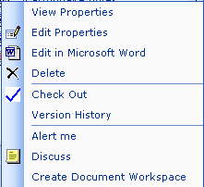
- Click the triangle again to open the document for editing.
After you have checked out a file from a Document Workspace, you can use the Shared Workspace to check the document back into the Document Workspace and to view and update information in the Document Workspace. For more information, see “Using the Shared Workspace” in this tutorial.
In addition to updating documents yourself, you may also want to know when team members modify a document. Your students, for example, may want to know when team members have added information to a group presentation, and you may want to monitor their progress on a presentation. To keep up to date on document changes, you can set up an Alert. Alerts notify you by e-mail message when a document or library has been modified. You can customize an Alert to meet your needs, for example, by requiring a daily Alert or just a weekly summary of changes.

To set up an Alert for a document
- From the Home page of your SharePoint site, browse to the Document Library or Document Workspace where your document is stored.
- Rest the pointer on the file, click the triangle on the bar that appears, and then click Alert Me on the menu that appears.
Alerts are not just for SharePoint documents. You can establish a SharePoint Alert to be notified when an Event or Task list has been modified, when a new Contact has been added to a Contact list, or when a new contribution has been made to a Discussion.
If you have access to Microsoft Office SharePoint Portal Services, you can set Alerts for search results.
- In the Send alert to section, confirm that the destination e-mail address is correct.
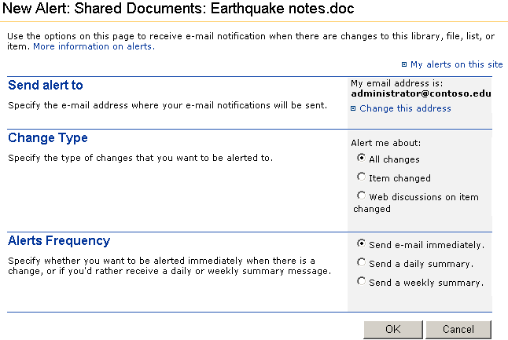
You can also set up an Alert for an entire Document Library by clicking Alert Me under Actions in the Quick Launch bar.

- In the Change Type section, click Item changed to be notified when the item or file has been changed or deleted, or click All changes to be notified whenever any type of change occurs. For documents in libraries, you can be notified when comments in Web Discussions have been added, deleted, or edited.
- In the Alerts Frequency section, click the option that identifies how often you want to be notified of changes, and then click OK.
After you create the Alert, you will receive an e-mail message confirming that you have successfully created an Alert for the particular item.
Note: You can also create Alerts for items in a list or for entire lists.
You can use Outlook rules to manage your Alerts. For example, you can create a rule that moves Alert messages notifying you of changes made to items in the Shared Documents Document Library to a folder in your Outlook Inbox.
Note: To complete the following procedure, you must be using Outlook as your e-mail client.

To establish rules for Alerts
- In Outlook, click the Mail folder.
- On the Tools menu, click Rules and Alerts…, and then click the Manage Alerts tab.
- Click the Alert for which you want to create a rule, and then click Create Rule…
- Specify the parameters for the rule you want, and then click OK.

Using the Shared Workspace
Moving back and forth between your documents, your e-mail, and a Web browser can be disruptive to your work. Now, you no longer have to shift your focus to get the information you need. The new Shared Workspace task pane facilitates a smooth workflow process by enabling you to view and share all the information you need without leaving your active document. You can even create a Document Workspace from the Shared Workspace task pane.
The following illustration shows one view of the Shared Workspace task pane.
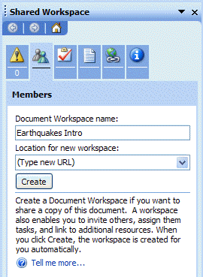
Figure 3: Shared Workspace Task pane
There are six different tabs in the Shared Workspace task pane:
- Status. This tab lists important information about the current document, such as whether you are viewing the most current version of the document, whether it conflicts with another member’s copy of the document, and whether the document is currently checked out of the Document Workspace. This tab also identifies your Information Rights Management permissions, if they have been set on the document.
- Members. This tab shows all the members of the Document Workspace and whether they are currently online. If a member is online, you can send an e-mail or instant message to him or her. You can also add new members to the workspace from this tab if you have administrative privileges.
- Tasks. This tab shows the list of shared tasks for the team. You can add a new task or create an Alert for a specific task from here.
- Documents. This tab shows all the documents in the Document Workspace. You can add a new document or folder from this tab, or create an Alert for a specific document.
- Links. This tab identifies all the links in the Document Workspace.
- Document Information. You can read a summary of the active document history from this tab, including who created the document and when it was last modified. You can also restrict permissions for a document from this pane, if you have Information Rights Management.
Let’s say that a group of students in your class has decided to conduct a survey as part of the research for their final project. They have recorded a list of survey questions in a Word document. Without ever leaving the document, they can create a Document Workspace where they can store the survey questions and other information about their project.

To create a Document Workspace from Word
- On the Tools menu of the Word document, click Shared Workspace.
- In the Document Workspace name box, type a name for the workspace.
- In the Location for new workspace box, type the URL of the team Web site where you want to create the Document Workspace.
- Click Create.
The group then delegates tasks for completing the survey to each of the team members by using the Task List tab available from the Shared Workspace.

To add a task from the Shared Workspace
- In the Shared Workspace task pane, click the Tasks tab or clipboard icon.
- Click Add new task…
- In the Title box, type a heading for the task.
- In the Status list, click the appropriate status for the task.
- In the Priority list, click a priority level for the task.
- In the Assigned To list, click the user to whom you want to assign the task. If you do not want to assign the task to a specific person, leave the default None.
- In the Description box, type a description of the task.
- In the Due Date box, type a date, and then click the hour and minute that you want the task to be completed.
- Click OK.
The team agrees that the highest priority task is to add a survey to the site based on the list of questions they have generated. They assign this task to one of the students in the group.

To create a survey
You can use surveys on a SharePoint site to solicit feedback from your students about class activities or to collect demographic information. If you need more sophisticated forms for your surveys, consider using new Microsoft Office InfoPath™ 2003. For more information about InfoPath, see http://www.microsoft.com/office/preview/infopath/default.asp

- In the Shared Workspace, click Open site in browser.
- On the Top Link bar, click Create.
- On the Create page, under Surveys, click Survey.
- In the Name box, type a name for the survey.
- In the Description box, type text that describes the purpose of the survey.
- If you want a link to this survey to appear on the Quick Launch bar, in the Navigation section, click Yes.
- If you want respondents' names to be visible when a site member views the survey results, in the Survey Options section, click Yes under Show user names in survey results?.
- If you want to allow site members to respond more than once to the survey, click Yes under Allow multiple responses?, and then click Next.
- On the Add Question page, in the Question box, type a question, and then click the type of answer that you want.
- Enter any optional settings that you want for your question, and then, at the bottom of the page, click Next Question to add additional questions or Finish to complete the survey.
When the student finishes creating the survey, he clicks the Members tab of the Shared Workspace. From the Members tab, he can do the following:
- Send e-mail to all the members of his team to let them know the survey is on the site, by clicking Send e-mail to all members…
- Enable students to respond to the survey by clicking Add new members, and granting them permission to access the site.
- View the online status of team members, and send an Instant Message to those who are currently online.
After a sufficient number of students have responded to the survey, the team decides to export the survey data into an Excel spreadsheet so that they can begin to analyze and chart the results.

To export site data into Excel
You can add a query to an Excel spreadsheet so that it automatically synchronizes with the latest information on the SharePoint site. This way, you do not have to repeatedly export information from the site while a survey is still live.
- Browse to the page that displays the survey.
- At the top of the survey, click Export Results to a Spreadsheet, browse to the location where you want to save the file, type in a title, and then click Save.
The team can store the survey results in their Document Workspace, and update it each week with the latest survey information. Then, they can use Version history to compare how survey data changed over time.
For educators and students using Windows SharePoint Services, the work process is organized, communication is seamless, and the potential for collaboration is limitless.
You can also import data that you have on a spreadsheet into a list on your SharePoint site. For example, you may have a list of all the students in your class, including their e-mail addresses. Instead of having to type that information manually into the Contact list, you can simply import it from the Excel spreadsheet.

Taking it Further
For more information about Windows SharePoint Services and a copy of the trial software, see http://www.microsoft.com/WindowsServer2003/technologies/sharepoint/default.mspx
For more information about using Microsoft FrontPage® to customize a SharePoint site, see http://www.microsoft.com/frontpage/sharepoint
For more information about how to use the new Microsoft Office System, see http://www.microsoft.com/office/preview/editions/online.asp
For more ideas about how to use Microsoft technologies in the classroom, see http://www.microsoft.com/education

Information in this document, including URL and other Internet Web site references, is subject to change without notice. The names of actual companies and products mentioned herein may be trademarks of their respective owners. Names and data used in examples herein are fictitious unless otherwise noted.
© 2003 Microsoft Corporation. All rights reserved.
Microsoft Corp. retains sole ownership of all published In and Out of the Classroom materials. Microsoft grants permission for educational institutions and Microsoft OEMS and Solution Partners to reproduce these materials for staff development purposes (only). Altering materials or reselling materials is strictly prohibited.
Microsoft, FrontPage, Internet Explorer logo, Office logo, Windows, Outlook, SharePoint, InfoPath, and Windows Server are either registered trademarks or trademarks of Microsoft Corporation in the United States and/or other countries.
Other product and company names mentioned herein may be the trademarks of their respective owners.

Chickering, Arthur, and Gamson, Zelda. “Seven Principles for Good Practice in Undergraduate Education.” http://www.hcc.hawaii.edu/intranet/committees/FacDevCom/guidebk/teachtip/7princip.htm

