

Microsoft Office XP Business Solution


West Group Uses Smart Tags to Dramatically Speed Up the Time It Takes Legal Researchers to Find and Cite Relevant Legal Information
Published: March 2001
Solution Overview

Industry
West Group was formed in 1996 from the merger of Thomson Legal Publishing and West Publishing. One of the largest providers of legal content in the world, West Group makes its content available via books, CDs, and online products. Its primary customers are attorneys and those working with attorneys in government and education.

Business Situation
To alleviate the time-consuming, error-prone task of identifying and retrieving citations, the latest version of CiteLink, a COM add-in for Microsoft Word 2002, uses Microsoft Office XP smart tag technology to identify citations as a user types. The smart tag associated with a citation may then be used to access the case or related information directly through the user’s browser.

Solution
CiteLink reduces a process that used to take hours or days to seconds, and improves the accuracy of the citations.

Products Used
Microsoft Office XP Developer
Microsoft Visual C++® 6.0
Microsoft Word version 2002
Microsoft Visual C++

Using smart tags, a new Microsoft® Office XP technology, West Group saves legal knowledge workers countless hours and headaches by dramatically speeding up the time it takes to find and evaluate relevant legal information.
It’s the bane of every attorney: searching through countless documents for cases that may prove relevant to his or her client’s situation. Gone are the days when attorneys had to disappear into stacks of books at law libraries, but the electronic age still meant spending significant time on legal research services looking up cases and checking them to be sure they were still good law. Now, thanks to West Group’s use of the smart tags in an add-in to Microsoft Word 2002, legal professionals can identify relevant cases faster than ever and insert detailed, accurate citations with a single mouse click.

Business Challenge
Finding and evaluating relevant cases and statutes when examining electronic copies of legal briefs and memos is a recurrent, often time-consuming task for legal professionals. As attorneys assemble arguments for a case, they frequently read memos on similar work done in the past, briefs from opposing counsel, and other legal information. Within the memos and briefs are citations to particular cases, statutes, and explanatory treatises and journal articles. To understand what the cases and statutes cited say, the attorney or legal professional must first retrieve a copy of each case, and then verify whether the case is still good law (typically by examining the case’s citator result). Finally, when building their arguments, attorneys want to find out who else has cited a particular case, and in what depth and manner.
In the past, these steps required the attorney to make a list and go to a legal library, look up and copy each case, and then spend hours going through various specialized indexes to evaluate whether the case was still good. With the advent of electronic legal research, users still had to make the list, but instead of going to the library, they logged on to a legal research service like Westlaw, entered the case citations one by one, retrieved the documents, and checked their validity.
This is an error-prone process, because it requires the user to step outside the word processor into a browser, initiate a research session, navigate to the right tools, and then type in or perform a cut-and-paste of case citations or titles, finally reading or downloading the results.

Solution Detail
“With the smart tag functionality in Microsoft Office XP, CiteLink has finally achieved its original vision: fully automating the process of research and citation in legal filings.”
Doug Rosenoff
Manager of Customization Architecture
West Group

In January 1997, West Group introduced CiteLink for Microsoft Word. This Component Object Model (COM) add-in found each legal citation in a Word document and inserted a hyperlink pointing to the appropriate case on Westlaw. One shortcoming was that limitations of the then-current technology required that users initiate the scan for citations themselves rather than having the scan take place automatically. CiteLink was a significant step forward, but still required the attorney to work with two copies of a document (one without links, one with) if it was to be submitted to a court or other legal body.
With the advent of smart tag technology in Office XP, the latest version of CiteLink has achieved its original vision. Citations within a document are now found and labeled automatically instead of requiring the user to manually run a scan job.

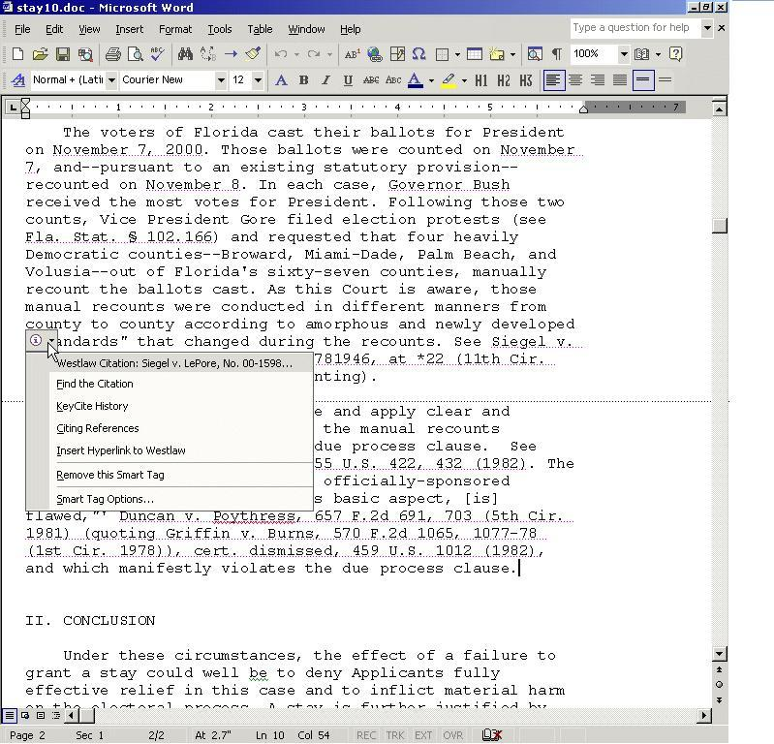
With CiteLink 3.0—Now Integrated with Smart Tags—Running in Word 2002, Legal Citations Are Automatically Recognized
Now, a user simply clicks on a highlighted citation to view a list of possible actions.
Because smart tags allow multiple operations to be defined against a particular citation, the user may select to pull a copy of the case, examine the citator result or the citing cases, or transform the citation into a permanent hyperlink. Because the smart tags are not permanently embedded in the document, users no longer need to maintain a separate version of a document with the hyperlinks removed; yet the full functionality of the previous tools are maintained.

Rapid Development
The inherent extensibility of the smart tag architecture enabled West Group to integrate the new functionality into CiteLink 3.0 on an extremely rapid development cycle. Building on the existing CiteLink architecture allowed West Group programmers to develop and test CiteLink smart tags in less than 24 hours of developer time. All development was completed using Microsoft Visual C++ 6.0. Because of the existing persistent Uniform Resource Locator (URL) structure and the existing COM architecture, porting the existing application to Office XP was straightforward and posed no particular difficulties.

Benefits
Using this new Office XP technology saves considerable time and effort for individuals who must evaluate a legal brief or other document. The citations are found automatically, and the user can choose which operation they wish to perform against the citation. Also, because citations are identified and linked automatically, using plain English identifiers, users always pull the right case or citator result the first time.
“Attorneys and their staff are very busy people,” says Doug Rosenoff, one of the inventors of CiteLink. “CiteLink smart tags save them time, effort, and money by being able to access the correct cases inside their word processor. They can explore a case’s validity without having to interrupt their work to initiate and complete a separate legal research task in another application. West Group is excited to use this new technology to help attorneys work more efficiently and to better serve their clients’ needs.”

For More Information
For more information about Microsoft products or services, call the Microsoft Sales Information Center at (800) 426-9400. In Canada, call the Microsoft Canada Information Centre at (800) 563-9048. Outside the 50 United States and Canada, please contact your local Microsoft subsidiary. To access information via the World Wide Web, go to: http://www.microsoft.com/
For more information on West Group products or services, visit http://www.westgroup.com

© 2001 Microsoft Corporation. All rights reserved.
This case study is for informational purposes only. MICROSOFT MAKES NO WARRANTIES, EXPRESS OR IMPLIED, IN THIS SUMMARY. Microsoft, the Office logo, and Visual C++ are either registered trademarks or trademarks of Microsoft Corporation in the United States and/or other countries. The names of actual companies and products mentioned herein may be the trademarks of their respective owners.

