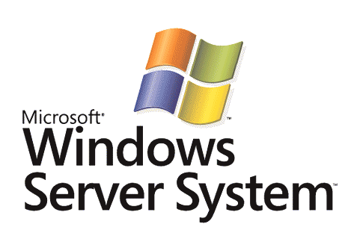

Mobile Messaging with Microsoft Exchange Server 2003 Service Pack 2 and Windows Mobile 5.0 Messaging and Security Feature Pack

Microsoft Corporation
Published: November 2005

Abstract
This white paper examines how Microsoft responds to the evolving mobility needs of your business. Microsoft Exchange Server 2003 communication and collaboration server with Service Pack 2 (SP2), and Windows Mobile® 5.0 with the Messaging and Security Feature Pack (MSFP) deliver an integrated, scalable, security-enhanced and cost-effective enterprise mobile messaging solution.


The information contained in this document represents the current view of Microsoft Corporation on the issues discussed as of the date of publication. Because Microsoft must respond to changing market conditions, it should not be interpreted to be a commitment on the part of Microsoft, and Microsoft cannot guarantee the accuracy of any information presented after the date of publication.
This White Paper is for informational purposes only. MICROSOFT MAKES NO WARRANTIES, EXPRESS, IMPLIED, OR STATUTORY, AS TO THE INFORMATION IN THIS DOCUMENT.
Complying with all applicable copyright laws is the responsibility of the user. Without limiting the rights under copyright, no part of this document may be reproduced, stored in, or introduced into a retrieval system, or transmitted in any form or by any means (electronic, mechanical, photocopying, recording, or otherwise), or for any purpose, without the express written permission of Microsoft Corporation.
Microsoft may have patents, patent applications, trademarks, copyrights, or other intellectual property rights covering subject matter in this document. Except as expressly provided in any written license agreement from Microsoft, the furnishing of this document does not give you any license to these patents, trademarks, copyrights, or other intellectual property.
© 2005 Microsoft Corporation. All rights reserved.
Microsoft, ActiveSync, Excel Mobile, MSN, Outlook, Outlook Mobile, PowerPoint Mobile, Windows, the Windows logo, Windows Mobile, Windows Server System, and Word Mobile are either registered trademarks or trademarks of Microsoft Corporation in the United States and/or other countries.
All other trademarks are property of their respective owners
The example companies, organizations, products, domain names, e-mail addresses, logos, people, places, and events depicted herein are fictitious. No association with any real company, organization, product, domain name, e-mail address, logo, person, places, or events is intended or should be inferred.
Contents
Introduction 1
Evolving mobility needs in the enterprise 1
Microsoft® mobility solutions meet enterprise needs 1
The Microsoft® Mobile Messaging Solution 2
Windows Mobile 5.0 with the Messaging and Security Feature Pack 2
Exchange Server 2003 Service Pack 2 2
End-to-end business value 2
Mobile Devices Overview 4
Exchange Server SP2 and Windows Mobile 5.0 MSFP Advances 5
Direct Push Technology 5
Global Address List (GAL) lookup 6
Enhanced protection of device data 7
Remote device wipe 7
Security-enhanced messaging 8
Meeting Enterprise Needs 9
What your people need 9
What your IT department needs 9
What your business needs 9
Customer Experiences 11
Hewlett-Packard 11
Lifetime Products 11
Conclusion 12
Related Links 13

Introduction
Mobile messaging—the ability to send and receive e-mail anytime, anywhere—is becoming increasingly important in today’s business world. There are four primary reasons for this: businesses like yours have fostered a growing e-mail culture, mobile devices have spread throughout the workplace, the people who work for you increasingly demand more mobility and flexibility, and the business ecosystem is growing more global by the day.
- A growing e-mail culture. Companies increasingly rely on electronic mail to conduct business. A 2003 Meta Group survey found that a majority of business leaders believe e-mail is now more important than the phone as a means of communication.
- Strong mobile device penetration. Mobile phones, PDAs, laptops, and Tablet PCs are becoming commonplace in the enterprise. Some recent reports indicate the size and growth of this market:
- 70 million smartphones are expected to ship worldwide in 2006 (Canalys Report, “Mobile Device Market Forecasts,” April 2005).
- IDC expects there to be over 1.685 billion active wireless subscribers in the world by the end of 2005 (IDC Report, “Worldwide Mobile Phone 2005–2009 Forecast and Analysis,” May 2005).
- Gartner predicts that by 2008 more than 80% of mobile knowledge workers will have access to wireless email (Gartner Report, “Predicts 2005: Mobile and Wireless Technologies,” October 29, 2004).
- Increasing demand for mobility and flexibility by the workforce. Companies must address changing ways of doing business at home and abroad, taking into account such developments as telecommuting, flextime, and growing demand by staff members for a more equitable work/life balance.
- A more global business ecosystem. Your people frequently travel to remote branch offices, to meet with customers and partners. Global business managers face the challenge of coordinating operations across multiple time zones.

Evolving mobility needs in the enterprise
Enterprise needs for mobile solutions are evolving. Your people need greater flexibility, more reliable ways of connecting to the most important resources, and new ways to use their business hours more efficiently. IT organizations need manageable, scalable, and more secure solutions that fit within leaner technology budgets than in previous years. If your business is to meet its expectations, you’ll need a solution that will help reduce costs, achieve a better return on investment (ROI), and increase the productivity of everyone in the office.

Microsoft® mobility solutions meet enterprise needs
This white paper examines how Microsoft responds to the evolving mobility needs that confront your business. Microsoft Exchange Server 2003 communication and collaboration server with Service Pack 2 (SP2), and Windows Mobile® 5.0 with the Messaging and Security Feature Pack (MSFP) deliver an integrated, scalable, security-enhanced and cost-effective enterprise mobile messaging solution that connects the right people with the right information and empowers them to take your business to the next level.

The Microsoft® Mobile Messaging Solution
The Microsoft mobile messaging solution gives users access to Exchange Server data such as e-mail, contacts, tasks, and calendar items from Pocket PCs, Smartphones, and other devices that support cellular/mobile and local-area wireless networks. These technologies help make your people as productive and responsive as possible by connecting them to their team members and to the information they need, when they need it, even when they are away from their desks.
The Microsoft mobile messaging solution consists of:
- The Windows Mobile® 5.0 Messaging and Security Feature Pack (MSFP) running on Windows Mobile–based devices such as Pocket PCs, Smartphones, and Pocket PC phones
- Exchange Server 2003 Service Pack 2 (SP2)

Windows Mobile 5.0 with the Messaging and Security Feature Pack
Windows Mobile 5.0 is an operating system that runs on mobile devices such as Smartphones and Pocket PCs. Mobile devices installed with Windows Mobile 5.0 offer rich features and functionality. Smartphones provide instant messaging, Web browsing, and e-mail. Pocket PCs and Pocket PC Phones add the ability to run compact versions of several Microsoft Office System applications, such as Microsoft Office Word Mobile®.
Windows Mobile 5.0 also provides a platform for devices to run third-party mobile software, including applications that access line-of-business data on enterprise systems.
The Windows Mobile 5.0 Messaging and Security Feature Pack is an extension and update to the Windows Mobile 5.0 operating system. The feature pack requires a Windows Mobile 5.0 device and Exchange Server 2003 SP2. It may already be installed on a newly purchased device, or made available as an upgrade from the user’s mobile operator. Once installed, the feature pack provides users with immediate access to its features without the need to first synchronize with a PC.

Exchange Server 2003 Service Pack 2
Exchange Server 2003 is server software to enable users to send and receive e-mail and other forms of communication through corporate computer networks. Exchange Server data such as e-mail and calendar information is accessible by client software such as the Microsoft Outlook 2003 as well over the Web and on mobile devices.
Exchange Server ActiveSync® is a protocol that facilitates the transfer of information between Exchange Server 2003 and mobile devices such as Pocket PCs and Smartphones. Your people will be able to synchronize their e-mail messages, calendar entries, contacts and tasks with these devices directly over the air from Exchange Server 2003.
Exchange Server 2003 Service Pack 2 builds on the capabilities of Exchange Server 2003 with improved protection against spam and “phishing” e-mail attacks, generous mailbox storage size limits, administrative flexibility, and—the focus of this white paper—mobile e-mail enhancements.

End-to-end business value
Windows Mobile 5.0 MSFP and the mobility features of Exchange Server 2003 SP2 work together to deliver a comprehensive, full-featured mobile messaging solution.
Together, they provide:
- A rich messaging experience. Your representatives in the field can keep their calendars, contacts, task lists, and inboxes up to date using Direct Push Technology. They can browse their company’s global address book over the air and enjoy shorter synchronization times through bandwidth-optimizing GZIP data compression.
- Increased data protection. Features such as local and remote device wipe, and the provisioning and enforcement of password policies for mobile devices help protect sensitive information. The solution also offers certificate-based user authentication and native support for Secure/Multipurpose Internet Mail Extensions (S/MIME).
- A cost-effective, scalable mobility solution. If a company is running Outlook Web Access, the Exchange Server 2003 infrastructure for supporting mobile devices is already largely in place making use of existing investments. The solution’s ease of management helps lower IT costs and reduces the need for dedicated IT resources to support the mobile messaging environment. Many management tasks can be performed remotely from the Exchange Server console or through a Web application.
- Connectivity between Exchange Server 2003 SP2 and devices running the Windows Mobile 5.0 MSFP does not require third-party middleware, service fees or additional server hardware, helping lower licensing and maintenance costs.
- In addition, Exchange Server is a highly scalable messaging environment that can support thousands of users. The cost-effectiveness of the Microsoft solution adds to its scalability as well. Competitive solutions often require additional middleware or services fees, making it prohibitively expensive for companies to deliver mobile access beyond a subset of their staff. The Microsoft mobile messaging solution can bring mobility to all levels of an organization.
The September 2005 IDC Report “The Benefits of Mobile Messaging” (see “Related Links” below) identified many business benefits that companies experienced when they deployed Microsoft mobility solutions. Respondents to the study showed substantial cost savings by reducing the number of laptops issued to salespeople and other mobile users, the number of VPN servers, and the number of remote access services (RAS) calls. The study indicates that, when your people start using Microsoft mobile solutions, on average they will be able to add 36 hours of productive time annually. IT departments reported a more than 33 percent reduction in the time spent supporting mobile devices and mobile applications due to centralized management.

Mobile Devices Overview
Windows Mobile–based devices and data plans are available as a package from 68 mobile operators in 48 countries. Alternatively, users can add a new data plan from one of these mobile operators to their existing mobile device.
In addition to being available through mobile operators, mobile devices can be purchased through thousands of retail outlets and distributors. Many free or subscription-based WiFi services can be accessed from Windows Mobile–based devices.
A variety of mobile devices exists to meet the needs of different types of users:
- Pocket PCs are handheld devices that enable you to store and retrieve e-mail messages, contacts, and appointments, play multimedia files, exchange text messages with MSN® Messenger Services, browse the Web, and more. Users can connect Pocket PCs to personal computers or, in the case of most devices, with WiFi networks to exchange or synchronize information.
- Smartphones integrate text-based messaging into a voice-centric handset comparable in size to today's mobile phones. Windows Mobile–based Smartphones are designed for one-handed operation with keypad access to both voice and data features. They are optimized for voice and text communication and allow wireless access to Outlook information and encrypted browsing to corporate and Internet information and services.
- Pocket PC Phones combine all the standard functionality of a Windows Mobile–based Pocket PC with that of a feature-rich mobile phone. Windows Mobile software for Pocket PC Phones integrates the PDA and phone experience so users can dial phone numbers directly from contacts, send SMS messages, identify incoming callers, and easily take call notes. Using a Windows Mobile–based Pocket PC Phone with wireless service through a mobile operator, your company’s field workers will be able to wirelessly access the Internet and their corporate networks, and send and receive e-mail.
So which device is best for your business? That depends on the needs of the people who work for you. For example, doctors making their rounds may find a Pocket PC to be ideal for wirelessly transmitting their notes on patient care to a server where they’ll be immediately available to hospital employees. Salespeople might need the combined telephony and wireless data access provided by a Pocket PC phone or Smart phone to remain in contact with their many customers. A large multinational business will most likely deploy a variety of devices to different staff members, depending on the type of work they do and how much they travel.

Exchange Server SP2 and Windows Mobile 5.0 MSFP Advances

Direct Push Technology
Direct Push Technology can be enabled on Windows Mobile devices by the Exchange Server 2003 administrator. Direct Push provides a “push e-mail” experience where items received on the Exchange 2003 Server—such as new e-mail messages, calendar changes, contact changes, or task updates—will arrive almost immediately on the Windows Mobile 5.0 device. The service does not rely on Short Message Service (SMS) notifications, third-party subscription services, or special configuration to immediately display new messages.
Direct Push offers other benefits in comparison to scheduled or manual synchronization:
- Less bandwidth consumption. When the device sends a request to the server for change notifications, it spends most of that process waiting for a response, not sending or receiving data.
- Efficient data transfer. Only folders that contain changes are targeted for synchronization.
- Longer battery life and lower data transfer fees. Because it synchronizes only when necessary in the efficient way described above, the device is able to reduce its power consumption and increase its battery life while incurring fewer data transfer charges.
Example
On the day she was due to deliver a major presentation, Jane’s car broke down on the way to work. Stranded at the dealership across town without dial-in or WiFi access to her company network, Jane pulled out her Pocket PC Phone and began sending e-mail messages to the other members of her project group. Through Direct Push, their responses appeared on her Pocket PC Phone almost immediately after they reached her mailbox on the server. Jane was able to collaborate with her group in real time, using the Microsoft Office PowerPoint Mobile® presentation graphics program to review last-minute updates to the presentation based on information that had just come in that morning. When she arrived at the office an hour later, she delivered the finalized presentation armed with the latest information from her project group.

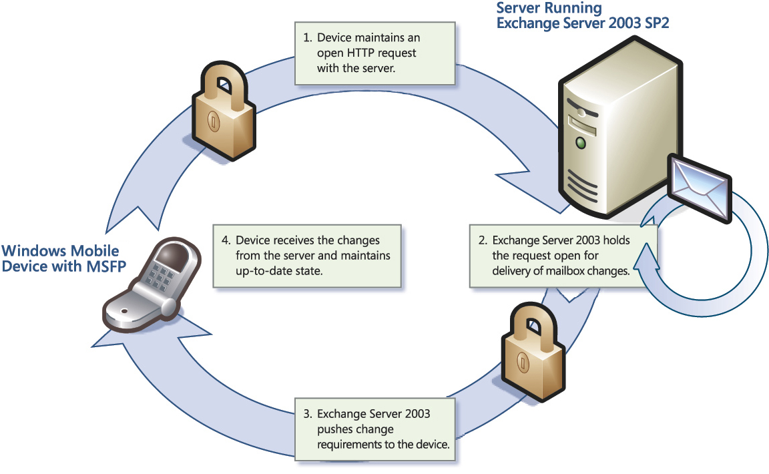
Fig. 1 Direct Push Technology delivers new mailbox items directly after they arrive on the server running Exchange Server 2003 SP2.

Global Address List (GAL) lookup
In addition to their stored contacts, users can now access their corporate Global Address Lists (GAL) over the air from their device. The contact chooser interface that enables access to both types of contacts is embedded within the messaging, phone, calendar, and speed-dial menus. You can search for additional contact details not stored locally on your mobile devices, send e-mail messages or meeting invitations to individuals in your company who may not be stored in your personal contacts list, and browse the global address list for additional contact details such as office location. Once a contact has been located, you can store their information on your mobile device and add him or her to your mobile device contacts list.
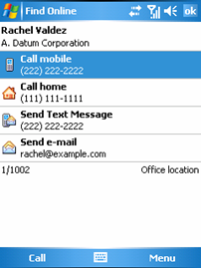
Fig. 2. Global Address List lookup feature lets mobile workers browse corporate address books.

Enhanced protection of device data
IT administrators can use the Exchange Server 2003 console to manage and help enforce corporate security-related policies on mobile devices, such as requiring device users to set up a unique personal identification number (PIN). Administrators can also enable the local device wipe capability, which erases all data and personal settings from devices if the PIN is incorrectly entered more than a preset number of times.
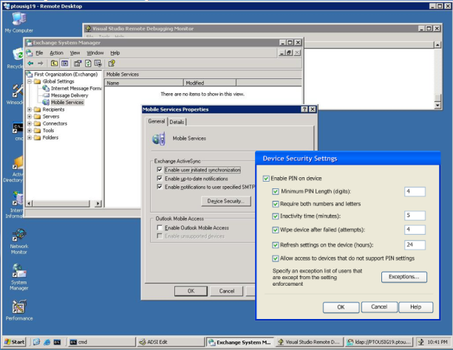
Fig. 3 Enhanced mobile device security-related options, configured through the Exchange management console, help protect critical data outside the office

Remote device wipe
With the remote device wipe feature, administrators can remotely send a command to a lost or stolen mobile device that will reset the device to its original factory settings. This reset erases all data, settings, and applications from the device’s main memory the next time the device attempts to connect to the Exchange Server 2003 information store.
Remote wipe is available through a Web-based tool that is restricted to Exchange Server 2003 administrators by default. However, other individuals such as help desk technicians can be given access to the feature where appropriate. This allows administrators to delegate the remote wipe operation to the first tier of user support. When a lost mobile device is recovered, its owner can simply re-enter his settings and synchronize it to restore the deleted data and applications.
Example
While away on a business trip, Ted realized that he’d accidentally left his Smartphone in the taxi that drove him to the airport. He called the help desk at his office and explained the situation to Maria, the support technician on duty. Maria opened the Web-based administrative tool and located Ted’s phone on the list of managed devices. She immediately configured the device to wipe all of its data. The device’s data and settings were instantly erased, and Maria’s administrative tool sent her an alert confirming that the device had been wiped.
Although he had to get a new Smartphone, Ted was relieved to know there was no chance of the information on the device getting into the wrong hands. Downloading his existing data and device settings into the new device was easy: Ted entered the name of his Exchange server, his user name, and his password into the phone and the new device automatically downloaded all of his existing information over the air from the server.

Security-enhanced messaging
All data transmitted between the Exchange Server and a Windows Mobile device is sent using an encrypted HTTPS connection to help prevent interception by a third party, helping to ensure enhanced security of messages in transport. In addition, the solution provides optional client certificate-based authentication to corporate messaging systems, managed through Internet Information Services version 6.0 and native support for S/MIME (Secure Multipurpose Internet Mail Extension).

Meeting Enterprise Needs

What your people need
To make the decisions that really matter for your business, your people need easy, intuitive access to critical business information, wherever they happen to be. The Microsoft integrated mobile solution meets their needs by going beyond text-only messaging to provide a feature-rich software experience on their mobile devices. In addition, they will have a wide variety of device choices and data plan options to best meet their individual needs.
- The Windows Mobile software extends the familiar Microsoft Windows and Microsoft Office System experience to mobile devices, helping increase productivity and efficiency. Your mobile workers can access e-mail attachments using familiar applications and solutions optimized for use on mobile devices such Microsoft Office Word Mobile, Microsoft Office Outlook Mobile®, Microsoft Office Excel Mobile®, and Microsoft Office PowerPoint Mobile.

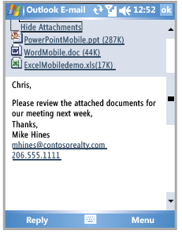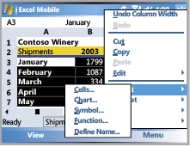
Fig. 3 Windows Mobile 5.0 gives your people access to compact mobile versions of familiar Microsoft software.

What your IT department needs
The professionals in your IT department need an easier way to administer your business’ total messaging environment, including the mobile aspect. The solution helps ensure that confidential data and intellectual property will be protected by providing easy-to use management features that help enforce password and security policies to mobile devices even when their owners are hundreds of miles away. The solution’s scalability, reduced support needs, and use of existing IT investments enable technicians and administrators to do more work with fewer resources, keeping costs down.

What your business needs
Your business needs cost-effective solutions that do not require additional software licensing, subscriptions or hardware purchases. This low-cost and highly scalable solution enables your company to provide mobile access to more than just an elite subset of those who work for you, increasing productivity throughout the whole organization. Your people become more productive because they can access the resources they need anywhere, not just at their desks. The type of information they have available can extend beyond the contents of their mailboxes to line-of-business data. Furthermore, the enterprise benefits from reduced training and support costs for its mobile workforce because the solution provides an extension of the familiar Microsoft Windows and Microsoft Office experience.

Customer Experiences
Many enterprise businesses have already deployed the mobile messaging solution described in this white paper to meet their communication and collaboration challenges. The experience of technology solutions provider Hewlett-Packard and sports equipment manufacturer Lifetime products provide examples of how two global businesses used Exchange Server 2003 SP2 and the MSFP for Windows Mobile 5.0 to enhance personal productivity and data security.

Hewlett-Packard
Hewlett-Packard (HP), a global technology solutions provider to consumers, businesses, and institutions, believes that effective teamwork and knowledge sharing is essential among its staff. After first deploying Microsoft Exchange Server version 4.0 in 1995, HP has since relied on the latest versions of Exchange Server to keep the lines of communication open for its employees. When the prerelease version of Exchange Server 2003 SP2 was announced, the company was eager to try it—together with Windows Mobile 5.0 with the MSFP—to test its rich new mobility features and security enhancements. As a result of the initial SP2 deployment, HP is already benefiting from vast improvements in mobile messaging capabilities and features that help administrators help ensure security on its mobile devices. Read more about how HP uses Exchange Server 2003 Service Pack 2 and Windows Mobile 5.0 to help improve the security of their mobile device infrastructure at https://members.microsoft.com/customerevidence/search/EvidenceDetails.aspx?EvidenceID=13514&LanguageID=1&PFT=Microsoft%20Exchange%20Server&TaxID=19731.

Lifetime Products
With manufacturing operations in China and the United States, Lifetime Products increasingly relies on mobile solutions that allow its representatives to make rapid and informed business decisions. Windows Mobile software, used in conjunction with the mobile communication features of Exchange Server 2003, has played an integral role in the company’s business environment. This combination has lowered mobile access costs and provided mobile workers with an extra hour of productivity a day. Looking to build on these gains, Lifetime implemented Windows Mobile 5.0 software with the MSFP and Exchange Server 2003 SP2. Through this upgrade, the company enhanced the security of its intellectual property stored on mobile devices and garnered further productivity gains through the real-time updating of tasks associated with workflow. Read more about how the Lifetime Exchange Server 2003 Service Pack 2 and Windows Mobile 5.0 deployment is helping the business be more agile and competitive at https://members.microsoft.com/customerevidence/search/EvidenceDetails.aspx?EvidenceID=13518&LanguageID=1&PFT=Microsoft%20Exchange%20Server&TaxID=19731.

Conclusion
In a fast-paced global business environment, where reliance on mobile devices and e-mail communication continuously grows, the businesses that remain competitive will be the ones that employ a strong mobile messaging solution. The evolving needs of your business are best addressed by an integrated, scalable, security-enhanced, and cost-effective mobile messaging solution that meets the needs of your people, IT and the organization as a whole. Deploying a comprehensive messaging and mobility environment using Exchange Server 2003 Service Pack 2 and Windows Mobile 5.0 devices with the Messaging and Security Feature Pack can achieve this goal.
Positive stories such as those of Hewlett-Packard and Lifetime Products illustrate how organizations can use Exchange Server 2003 SP2 and the Windows Mobile 5.0 MSFP to:
- Provide seamless communication and collaboration in a global business environment
- Easily deploy and manage a mobile messaging environment that scales
- Increase IT and the productivity of everyone in your business
- Reduce operational costs while enhancing revenue
Microsoft is committed to a broad mobility vision with a strong continuing investment in mobile messaging based on the Exchange Server and Windows Mobile technologies.

Related Links
See the following resources for further information:
- Mobility in Exchange 2003 at http://www.microsoft.com/exchange/evaluation/features/mobility/default.mspx
- Windows Mobile at
http://www.microsoft.com/windowsmobile/default.mspx
- The Benefits of Microsoft Mobile Messaging at
http://www.microsoft.com/windowsmobile/business/strategy/roi.mspx
- Exchange 2003 Service Pack 2 at http://www.microsoft.com/exchange/downloads/2003/sp2/default.mspx
- Windows Mobile for business at
http://www.microsoft.com/windowsmobile/business
- Buyer’s Guide to Windows Mobile–based devices
http://www.microsoft.com/windowsmobile/devices/shopdevices.mspx
- The road warrior's guide to staying connected at http://www.microsoft.com/atwork/stayconnected/road/connected.mspx
- Search for Windows Mobile solution providers at http://www.microsoft.com/windowsmobile/business/solutions
- IDC Report: “The Benefits of Mobile Messaging” at http://www.microsoft.com/windowsmobile/business/strategy/roi.mspx
- Microsoft customer case study: Hewlett-Packard at https://members.microsoft.com/customerevidence/search/EvidenceDetails.aspx?EvidenceID=13514&LanguageID=1&PFT=Microsoft%20Exchange%20Server&TaxID=19731
- Microsoft customer case study: Lifetime Products at https://members.microsoft.com/customerevidence/search/EvidenceDetails.aspx?EvidenceID=13518&LanguageID=1&PFT=Microsoft%20Exchange%20Server&TaxID=19731
- More information on Messaging and Security Feature Pack devices and upgrades at http://www.microsoft.com/windowsmobile/business/5/learnmore.mspx

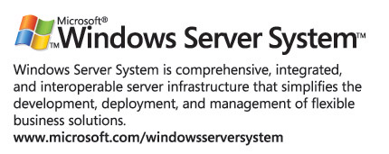
For the latest information about Windows Server System, see the Windows Server System Web site at http://www.microsoft.com/windowsserversystem.

