

How to Use the Greek Polytonic System in Windows XP

Microsoft Corporation
Published: May 2004

Abstract
In Windows, the Polytonic Greek support is a combination of a special Greek keyboard layout (Greek Polytonic) and a few fonts containing all the additional characters (diacritical and punctuation marks). This whitepaper outlines the steps you need to take to use Polytonic Greek from fonts to necessary keyboard layout.

This document is for informational purposes only. MICROSOFT MAKES NO WARRANTIES, EXPRESS OR IMPLIED, AS TO THE INFORMATION IN THIS DOCUMENT.
Complying with all applicable copyright laws is the responsibility of the user. Without limiting the rights under copyright, no part of this document may be reproduced, stored in or introduced into a retrieval system, or transmitted in any form or by any means (electronic, mechanical, photocopying, recording, or otherwise), or for any purpose, without the express written permission of Microsoft Corporation.
Microsoft may have patents, patent applications, trademarks, copyrights, or other intellectual property rights covering subject matter in this document. Except as expressly provided in any written license agreement from Microsoft, the furnishing of this document does not give you any license to these patents, trademarks, copyrights, or other intellectual property.
The example companies, organizations, products, people and events depicted herein are fictitious. No association with any real company, organization, product, person or event is intended or should be inferred.
© 2004 Microsoft Corporation. All rights reserved.
Microsoft, Windows, the .NET logo, Windows NT and the Windows logo are either registered trademarks or trademarks of Microsoft Corporation in the United States and/or other countries.
The names of actual companies and products mentioned herein may be the trademarks of their respective owners.

Contents

Introduction 4

Chapter I - Greek Polytonic System Setup 6

Chapter II - Installing the “Arial Unicode MS” Font in Office Suites 12

Chapter III - Greek Polytonic Keyboard States 15

Chapter IV - Greek Polytonic Key Combinations 17

Introduction

Polytonic Greek is not a language itself but rather a representation form of the Greek Language. It is named Polytonic due to the use of multiple (poly-) diacritic marks, as opposed to Monotonic that uses a single (mono-) diacritic mark.

Polytonic script may be utilised in writing all phases of the Greek language throughout its 3,000+ years of evolution. Very broadly these phases may be divided into 4 categories:
(a) The Homeric script - Can only be written with the Polytonic script,
(b) The Classical Hellenic script - Can only be written with the Polytonic script,
(c) The Neo-Hellenic "Katharevousa" (Puristic) script - Can only be written with the Polytonic script, and
(d) Modern Greek (a.k.a. The Contemporary Neo-Hellenic script/"Demotiki") - Can be written with both Polytonic and Monotonic scripts.

Currently there is a rather limited community of people (mostly academic scholars and clergy) that are still actively using the Polytonic script while writing contemporary Greek language (item d above). The majority is using the Monotonic script (this is the official form).

The Greek Polytonic System is a combination of a special Greek keyboard layout (Greek Polytonic) and few fonts containing all the additional characters (diacritical and punctuation marks). For the system to function it is imperative for the user to have the PC locale set to Greek. Chapter I Greek Polytonic System Setup explains how to verify that the user locale is set to Greek and – if not - how to do so.

Fonts supporting Greek Polytonic

Polytonic Greek is supported by:
- Palatino Linotype
  - The font is installed by default with Windows 2000, WindowsXP and Windows Server 2003 products
- Tahoma
  - The font is installed by default with WindowsXP and Windows Server 2003 products
- Arial Unicode MS
  - The font is installed as an add-on feature in Office 2000, OfficeXP and Office System 2003 products. Chapter II Installing the “Arial Unicode MS” font in Office suites explains how to do so.

Diacritical & Punctuation Marks

- Chapter III Greek Polytonic Keyboard States presents the Greek Polytonic keyboard layout at all of its states, including all the special characters and symbols.
- Any diacritical marks may be reproduced without the accompanying letter simply by hitting the dot key after the dead-key combination. For example in order to reproduce Dasia Varia press Shift+\ & . resulting to ῝. This is true for all diacritical mark combinations except those including an Ypogegrammeni/Prosgegrammeni.
- As more than the usual key combinations are used to cater for the extra diacritical and punctuation marks, in order to reproduce the special characters on the key faces, hit the spacebar after the respective key combination. For example to reproduce } press Shift+] & Spacebar.

Key Combinations

All key combinations of the Greek Polytonic System are depicted in Chapter IV Greek Polytonic Key Combinations. The keyboard needs to be activated (toggled to) before it functions. Please note that all key combinations involving the Alt refer to the right-side Alt designated as AltGr, whereas the ones involving the Shift key may use the Shift key one any keyboard sides. The Left Alt+Left Shift combination is usually reserved for Input Language toggling.

Chapter I | Greek Polytonic System setup

Windows 2000

- Click Start/Control Panel/Regional Options, at the drop-down list select Greek, verify that Language settings for the system are Greek also

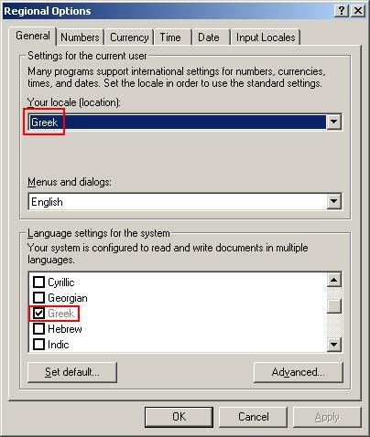

- On the Input Locales tab verify that Greek Polytonic keyboard layout is selected under Greek language. If not click Add…

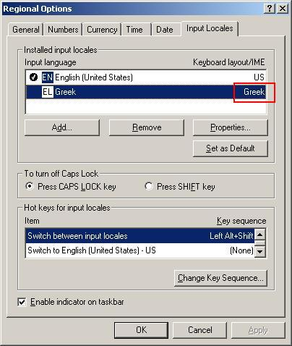

- Select Greek Polytonic from the drop-down list, click OK

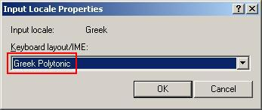

- Click Advanced… on the Regional Options home dialog. Verify that 1253 (ANSI – Greek box is checked. Click OK

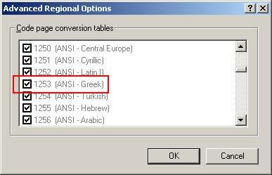

- Click Apply on the Regional Options home dialog

WindowsXP & Windows Server 2003

- Click Start/Control Panel/Regional and Language Options, at the drop-down list select Greek

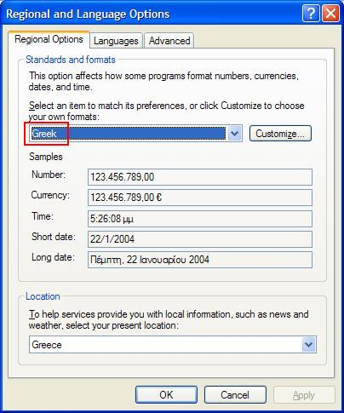

- On the Languages tab click Details

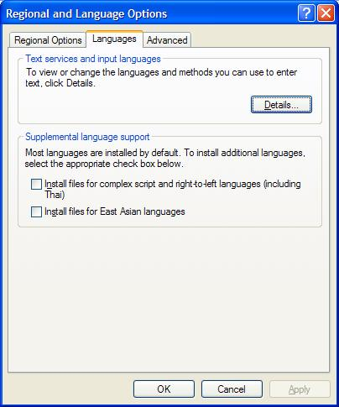

- Verify that Greek Polytonic keyboard layout is selected under Greek language. If not click Add…

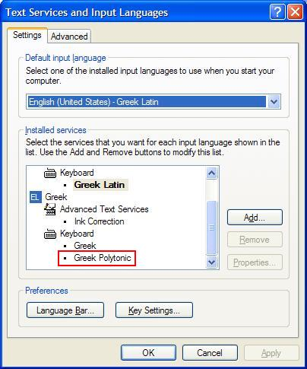

- Check Keyboard layout/IME box and select Greek Polytonic from the drop-down list. Click OK

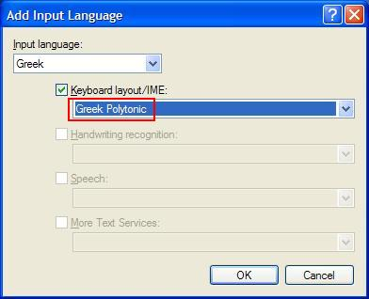

- On the Advanced tab (from the Regional & Language Options home dialog) select Greek as the language for non-Unicode programs and verify that 1253 (ANSI – Greek) box is checked. Click Apply

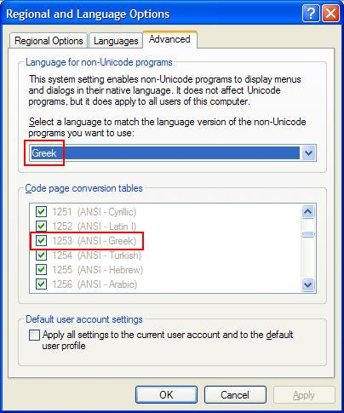

Chapter II | Installing the “Arial Unicode MS” Font in Office Suites

Office System 2003

- Click Start, select Control Panel, double-click Add or Remove Programs
- Chose Microsoft Office Professional Edition 2003, click Change
- Select Add or Remove Features, click Next >
- Check Choose advanced customization of applications, click Next >
- Select Office Shared Features/International Support/Universal font, chose Run from My Computer, click Update

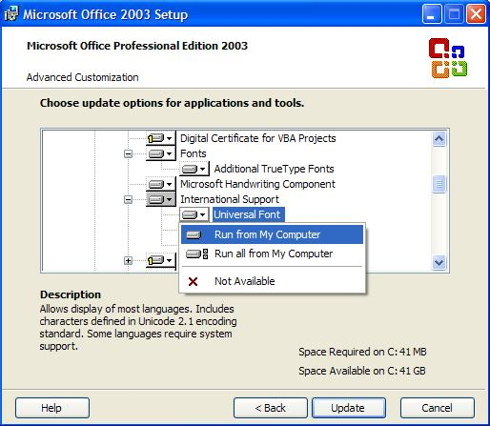

- Click OK

Office XP

- Click Start, select Control Panel, double-click Add or Remove Programs
- Chose Microsoft Office XP, click Change
- Select Add or Remove Features, click Next >
- Select Office Shared Features/International Support/Universal font, chose Run from My Computer, click Update

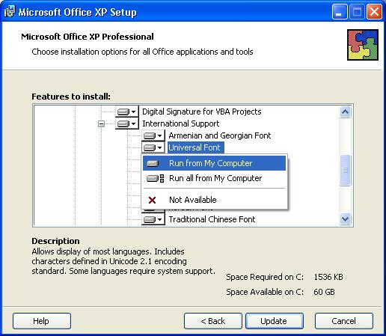

- Click OK
Office 2000

- Click Start, select Control Panel, double-click Add or Remove Programs
- Chose Microsoft Office 2000, click Change
- Select Add or Remove Features, click Next >>
- Select Office Tools/International Support/Universal font, chose Run from My Computer, click Update Now

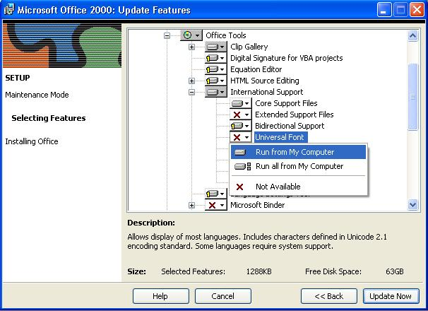

- Click OK

Chapter III | Greek Polytonic Keyboard States

- Normal state

- Shift state

- AltGr state

- AltGr+Shift state

- Normal state & Spacebar

- Shift state & Spacebar

- AltGr state & Spacebar

- AltGr+Shift & Spacebar state

Chapter IV | Greek Polytonic Key Combinations

Diacritic Marks

Dasia
Dasia Oxia
Dasia Oxia Ypogegrammeni/Prosgegrammeni
Dasia Perispomeni
Dasia Perispomeni Ypogegrammeni/Prosgegrammeni
Dasia Varia
Dasia Varia Ypogegrameni/Prosgegrammeni
Dasia Ypogegrameni/Prosgegrammeni
Dialytika Oxia
Dialytika Perispomeni
Dialytika Varia
Makron
Oxia
Oxia Ypogegrameni
Perispomeni
Perispomeni Ypogegrameni
Psili
Psili Oxia
Psili Oxia Ypogegrameni/Prosgegrammeni
Psili Perispomeni
Psili Perispomeni Ypogegrameni/Prosgegrammeni
Psili Varia
Psili Varia Ypogegrameni/Prosgegrammeni
Psili Ypogegrameni/Prosgegrammeni
Varia
Varia Ypogegrameni
Vrachy
Ypogegrameni/Prosgegrammeni

Punctuation Marks

Ano kai kato telia
Ano Telia
Aposiopitika
Aristera Eisagogika
Dexia Eisagogika
Erotimatiko
Diacritic Marks

- Dasia
Shift+’ (dead key) & letter

Valid letters (small form): α, ε, η, ι, ο, ρ, υ, ω –--> Example: 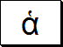
Valid letters (capital form): Α, Ε, Η, Ι, Ο, Ρ, Υ, Ω –--> Example: 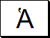

- Dasia Oxia
Shift+/ (dead key) & letter

Valid letters (small form): α, ε, η, ι, ο, υ, ω –--> Example: 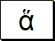
Valid letters (capital form): Α, Ε, Η, Ι, Ο, Υ, Ω –--> Example: 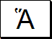

- Dasia Oxia Ypogegrammeni/Prosgegrammeni*
AltGr+Shift+/ (dead key) & letter

Valid letters (small form): α, η, ω –--> Example: 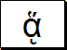
Valid letters (capital form): Α, Η, Ω –--> Example: 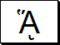 or 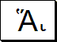

- Dasia Perispomeni
Shift+= (dead key) & letter

Valid letters (small form): α, η, ι, ο, υ, ω –--> Example: 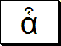
Valid letters (small form): Α, Η, Ι, Ο, Υ, Ω –--> Example: 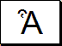

- Dasia Perispomeni Ypogegrammeni/Prosgegrammeni*
AltGr+Shift+= (dead key) & letter

Valid letters (small form): α, η, ω –--> Example: 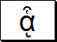
Valid letters (small form): Α, Η, Ω –--> Example: 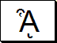 or 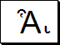

- Dasia Varia
Shift+\ (dead key) & letter

Valid letters (small form): α, ε, η, ι, ο, υ, ω –--> Example:
Valid letters (capital form): Α, Ε, Η, Ι, Ο, Υ, Ω –--> Example:

- Dasia Varia Ypogegrammeni/Prosgegrammeni*
AltGr+Shift+\ (dead key) & letter

Valid letters (small form): α, η, ω –--> Example: 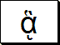
Valid letters (small form): Α, Η, Ω –--> Example: 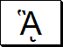 or 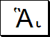

- Dasia Ypogegrammeni/Prosgegrammeni*
AltGr+Shift+’ (dead key) & letter

Valid letters (small form): α, η, ω –--> Example: 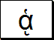
Valid letters (small form): Α, Η, Ω –--> Example: 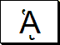 or 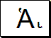

- Dialytika Oxia
` (dead key) & letter

Valid letters (small form only): ι, υ –--> Example: 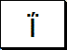

- Dialytika Perispomeni
AltGr+` (dead key) & letter

Valid letters (small form only): ι, υ –--> Example: 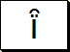

- Dialytika Varia
Shift+` (dead key) & letter

Valid letters (small form only): ι, υ –--> Example: 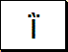

- Makron
- (dead key) & letter

Valid letters (small form): α, ι, υ –--> Example: 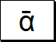
Valid letters (small form): Α, Ι, Υ –--> Example: 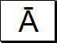

- Oxia
΄ (dead key) & letter

Valid letters (small form): α, ε, η, ι, ο, υ, ω –--> Example: 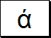
Valid letters (capital form): Α, Ε, Η, Ι, Ο, Υ, Ω –--> Example: 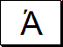

- Oxia Ypogegrammeni
AltGr+; (dead key) & letter

- Valid letters (small form only): α, η, ω –--> Example: 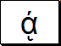

- Perispomeni
[ (dead key) & letter

Valid letters (small form only): α, η, ι, υ, ω –--> Example: 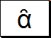

- Perispomeni Ypogegrammeni
AltGr+[ (dead key) & letter

Valid letters (small form only): α, η, ω –--> Example: 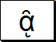

- Psili
‘ (dead key) & letter

Valid letters (small form): α, ε, η, ι, ο, ρ, υ, ω –--> Example: 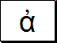
Valid letters (capital form): Α, Ε, Η, Ι, Ο, Υ, Ω –--> Example: 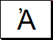

- Psili Oxia
/ (dead key) & letter

Valid letters (small form): α, ε, η, ι, ο, υ, ω –--> Example: 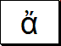
Valid letters (capital form): Α, Ε, Η, Ι, Ο, Ω –--> Example: 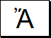

- Psili Oxia Ypogegrammeni/Prosgegrammeni*
AltGr+/ (dead key) & letter

Valid letters (small form): α, η, ω –--> Example: 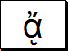
Valid letters (small form): Α, Η, Ω –--> Example: 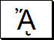 or 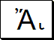

- Psili Perispomeni
= (dead key) & letter

Valid letters (small form): α, η, ι, υ, ω –--> Example: 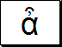
Valid letters (capital form): Α, Η, Ι, Ο, Υ, Ω –--> Example: 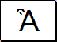

- Psili Perispomeni Ypogegrammeni/Prosgegrammeni*
AltGr+= (dead key) & letter

Valid letters (small form): α, η, ω –--> Example: 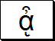
Valid letters (small form): Α, Η, Ω –--> Example: 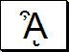 or 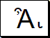

- Psili Varia
\ (dead key) & letter

Valid letters (small form): α, ε, η, ι, ο, υ, ω –--> Example: 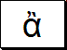
Valid letters (capital form): Α, Ε, Η, Ι, Ο, Ω –--> Example: 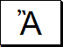

- Psili Varia Ypogegrammeni/Prosgegrammeni*
AltGr+\ (dead key) & letter

Valid letters (small form): α, η, ω –--> Example: 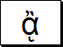
Valid letters (small form): Α, Η, Ω –--> Example: 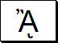 or 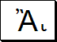

- Psili Ypogegrammeni/Prosgegrammeni*
AltGr+’ (dead key) & letter

Valid letters (small form): α, η, ω –--> Example: 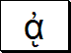
Valid letters (small form): Α, Η, Ω –--> Example: 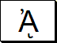 or 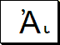

- Varia
] (dead key) & letter

Valid letters (small form): α, ε, η, ι, ο, υ, ω –--> Example: 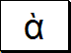
Valid letters (capital form): Α, Ε, Η, Ι, Ο, Υ, Ω –--> Example: 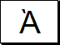

- Varia Ypogegrammeni
AltGr+] (dead key) & letter

Valid letters (small form only): α, η, ω –--> Example: 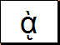

- Vrachy
Shift+- (dead key) & letter

Valid letters (small form): α, ι, υ –--> Example: 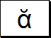
Valid letters (small form): Α, Ι, Υ –--> Example: 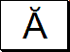

- Ypogegrammeni/Prosgegrammeni*
Shift+[ (dead key) & letter

Vallid letters (small form): α, η, ω –--> Example: 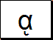
Vallid letters (capital form): Α, Η, Ω –--> Example: 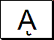 or 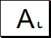

Punctuation Marks

- Ano kai kato telia
Shift+; & spacebar

Example: 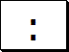

- Ano Telia
AltGr+Shift+]

Example: 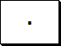

- Aposiopitika
AltGr+.

Example: 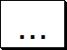

- Aristera Eisagogika
AltGr+[ (dead-key) & spacebar

Example: 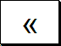

- Dexia Eisagogika
AltGr+] (dead-key) & spacebar

Example: 

- Erotimatiko
; & spacebar

Example: 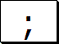

* : Prosgegrammeni is how Ypogegrammeni is called on capital letters.

