
Microsoft Enterprise Project Management Solution 2007

May 2006

Table of Contents

Cover is for
position only

Overview of the Microsoft Enterprise Project Management Solution 2
Gain Visibility and Insights 2
Enterprise Ready 3
Easier to Get Started 3
Extensible and Programmable 4
Gain Visibility and Insights 5
Manage Resources 5
Control Project Finances 5
Budget for Financial Control 5
Assign Costs to Tasks 6
Visibility across the Entire Project Lifecycle 7
Analyze and Create Custom Reports 8
Enterprise Ready 11
Manage the Simple and the Complex 11
Improved Performance 11
Resource Management 12
Utilize Enhanced Timesheet Capabilities 12
Easier to Get Started 15
Access Project Information via the Web 15
Enhance Knowledge Sharing 16
Leverages existing investments and knowledge of desktop applications 16
Save Time with Templates 17
Create Your Own Templates 17
Use Pre-defined Templates 18
Extensible and Programmable 21
Manage the EPM Solution 21
Fully Customizable 21
Architecture 25
Backwards Compatibility, Interoperability and Migration 26
Summary of the Microsoft EPM Solution Benefits 28
System Requirements 29
Project Server 29
Project Professional 30
Project Web Access 31
Project Portfolio Server 32
Additional Resources 34

Overview of the Microsoft Enterprise Project Management Solution
The Microsoft Office Enterprise Project Management (EPM) Solution allows you to effectively manage and prioritize projects and resources across your organization. Microsoft designed the EPM Solution for organizations needing strategic portfolio capabilities, strong team coordination, standardization in managing projects and programs, centralized resource management, as well as high-level analysis and reporting. Project provides a central repository of project and resource information so that organizations can consistently manage and report across the enterprise.
The EPM Solution consists of the following products: Microsoft Office Project Professional 2007, Microsoft Office Project Web Access, Microsoft Office Project Server 2007, Microsoft Office Project Portfolio Server 2007, and Microsoft Office Project Portfolio Web Access. Office Project Professional 2007 incorporates all the features of Office Project Standard 2007. Please refer to the Microsoft Office Project Standard 2007 Solution Guide for more information. To learn more on the specifics of portfolio management, please refer to the Office Project Portfolio Server 2007 Solution Guide.
The new version of the EPM Solution delivers improvements in several areas:
- Visibility and insights
- Enterprise readiness
- Ease in getting started
- Extensibility and programmability

Gain Visibility and Insights
Visibility means you can easily find, analyze, and report on all types of information about your projects. From ad-hoc projects to complex programs and portfolios, organizations can analyze their work and resources investments. In addition to active projects, you can now see the entire project lifecycle from before initiation as Proposals to after project completion as Operations Work.
Key improvements to deliver these capabilities include:
- New! Budget Tracking
- New! Cost Resources
- New! Cube Building Service
- New! Multiple Currencies
- New! Operations Work
- New! Proposals
- New! Reporting Data Service
- New! Resource Plans
- New! Visual Reports

Enterprise Ready
A dependable, scalable offering, the EPM Solution provides a high performance, manageable infrastructure that organizations can use to efficiently manage work from simple projects to large programs of multiple projects. Key features that deliver greater enterprise readiness include:
- New! Active Cache
- New! Assignment Owner
- New! Deliverables
- New! Import Project Task Lists
- New! Programs
- Enhanced! Timesheets
- New! Queuing Service
- New! Team Resource

Easier to Get Started
The new version of Office EMP Solution enhances participation across the entire organization with richer access through familiar applications that integrate with EPM Solution to view, update, and analyze project information. This functionality promotes coordination among project teams, which improves collaboration and yields more data for analysis and reporting. For example, the integration of Office Project Server 2007 with Microsoft Windows SharePoint™ Services 3.0 allows you to centrally store, link, and share project-related issues, risks, and documents for collaborative tracking. Propagate best practices for project work with enterprise templates to improve project management process throughout your organization. A number of improved features contribute to expanding the value and use of the system in your organization.
- Enhanced! Outlook Integration
- Enhanced! Project Guide
- Enhanced! Project Web Access
- Enhanced! Project Workspaces
- Enhanced! Templates

Extensible and Programmable
The EPM Solution provides the flexibility to meet your needs as your business requirements evolve. You can customize and integrate Project Server data with existing systems through the new Project Server Interface (PSI) application programming interface and VBA/object model changes. A redesigned architecture and new features support more users with better performance. The EPM Solution reduces the burden of administration with setup improvements. And the EPM Solution includes many other useful new features, including:
- Enhanced! Administration User Interface
- New! Event Model
- New! Project Server Interface
- New! PWA as Web Services
- New! Server Side Scheduling

Gain Visibility and Insights
The EPM Solution now covers a broader range of work and tracks a wider range of information to provide you better control of your organizations activities, resources, and investments. This information will allow you to analyze your investments, whether they are ad-hoc projects or complex programs and portfolios. You can use Project for reporting of information and analysis, which allows you to set realistic expectations with project teams, management, and customers.

Manage Resources
The EPM Solution helps you accurately assess needs to effectively deploy resources today and create future Resource Plans for your organization. Resource Plans provide information about high-level resource allocation when detailed resource assignments do not exist, for example in proposed and anticipated projects, task-only projects, and for projects where assignments do not accurately reflect resource distribution. These plans help ensure you have the right people on your high-priority projects for optimal delivery, and you hire appropriately skilled resources according to the demands of your projects.

Control Project Finances
By defining budgets for projects or programs, users gain better financial reporting and analysis, allowing alignment of work with corporate objectives. Project further supports financial control by introducing a new “cost” resource type as well as pre-defining a number of new project accounting fields.
Also, with the Multiple Currencies feature, users can now set the rates for resources in different currencies and establish a table of exchange rate data in order to generate reports in a single currency.

Budget for Financial Control
Budget Tracking permits Project to support the method with which many organizations allocate their budgets to specify the amount of resources each project or program should use. A budget may be specified either as monies (for example, dollar amounts for labor, materials, or other cost types), as work (Full Time Equivalents), or as materials. This feature allows display of the variances between the budget with the actual roll-up numbers (Work, Cost, Actual Work and Actual Cost) coming from the detailed plan.

Assign Costs to Tasks
In the previous version, Microsoft Office Project Professional 2003 included two types of resources: Work and Material. In version 2007, you gain a new type of resource: Cost. For each task, you can now assign multiple arbitrary costs (not based on work time) and use custom fields to specify the cost type or financial code. Cost Resources is the resource type for fixed costs assignable to a task. With Cost Resources, you can more accurately monitor project financials and keep your project in sync with data in your accounting systems by tying costs to account codes and rolling up costs against budgets. And, the costs are not tied to the work contours, so changing the percent complete or end date of the task will not affect Cost Resources.
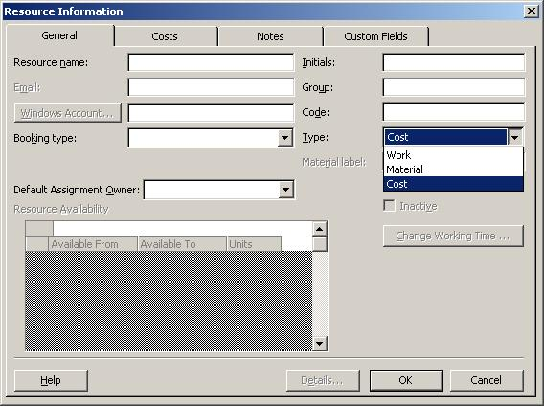
Figure 1: Creating a Cost Resource

Visibility across the Entire Project Lifecycle
Managing work effectively requires covering the whole project lifecycle—from initiation with Proposals to after the project completion—with ongoing maintenance of Operations Work. Proposals now enable project initiation on the Web in Project Web Access (PWA). Creating Proposals enables the use of business processes to track potential projects as well as leverage Project functionality to perform what-if analysis prior to approval. Further, storing proposal data along with project data generates the content for better portfolio decision making.
Using Resource Plans in conjunction with Proposals will provide a more accurate view for forecasting required resources and staff training or hiring. Resource Plans provide information about future high-level resource allocation when detailed resource assignments do not yet exist.
PWA also supports management of Operations Work, which often follows completion of a project. So, now you can track the full project life cycle.
Users can see all types of work in the PWA Project Center, which provides a single view of all proposals, projects, programs, and operations work for basic reporting and analysis.

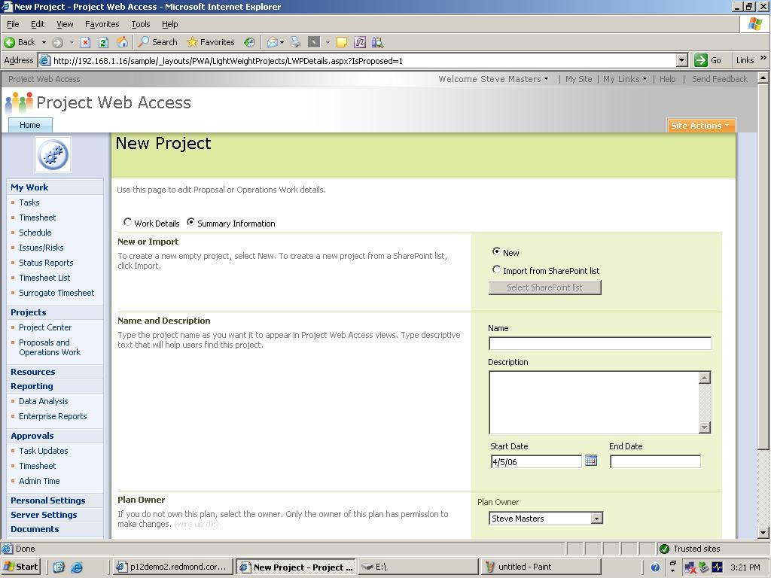
Figure 2: Proposal Entry

Analyze and Create Custom Reports
One of the key uses of the EPM Solution is for communication that necessitates analytical tools and professional reports.
Easily present information in various formats according to the needs of stakeholders. You can format and print one-page schedules or other reports. Smoothly export project-related data into Microsoft Office Word for formal documents, Microsoft Office Excel for custom charts or spreadsheets, Microsoft Office PowerPoint for crisp presentations, or Microsoft Office Visio for diagrams. In addition to static reports, you can generate dynamic reports using Office Excel and Microsoft Office Visio Professional to produce charts, graphs, and diagrams based on Project data by means of the Visual Reports feature. You can easily define custom report templates and share these with other Project users. These reports include a data cube for drill downs and pivots.
To gain insights by performing custom analytics without requiring a system or database administrator, users can access the Cube Building Service (CBS) via a flexible, graphical user interface to build portfolio analyzer cubes with more data options. Users can include custom fields in the cube too. The CBS consumes the RDS-generated data and metadata from the Reporting database in order to build cubes for user reporting.
To deliver these data for reports, extract data from the Project Server “Publish,” “Working,” and “Version” databases with the Reporting Data Service (RDS). The RDS transforms the data into a format suitable for user reporting and Analysis Services cube building and loads it into the “Reporting” database.

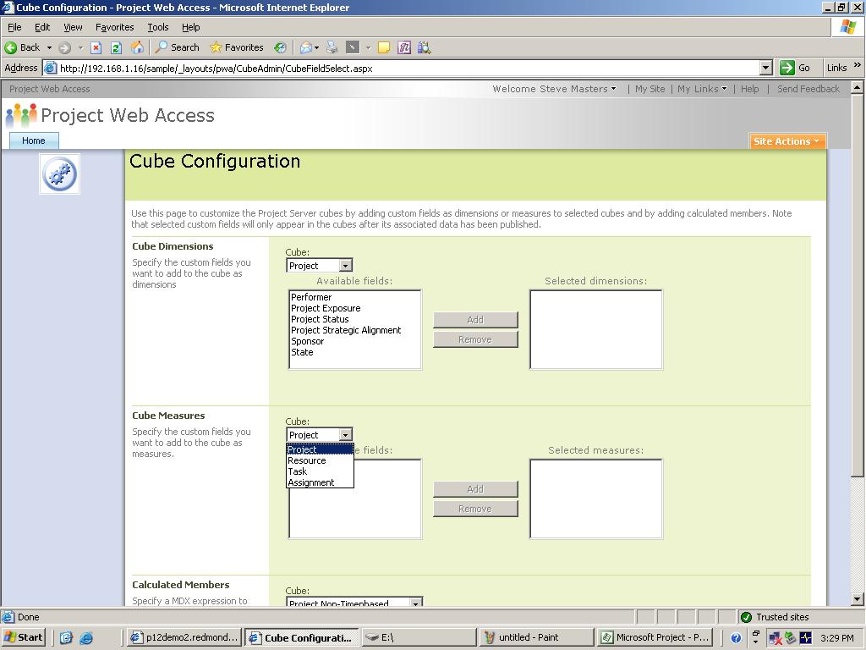
Figure 3: CBS Dialog Box

EPM Scenario: Implementing the EPM Solution to manage growing business
A team of Fabrikam International managers sit in a conference room tossing out ideas for their next year’s operations. To stay competitive, their firm needs to update its existing product lines and develop several new product concepts. These ideas quickly coalesce into a set of proposals, which are entered directly into Project Web Access. To accurately reflect capacity, Resource Plans are added. The management team reviews the proposals promoting proposals to full projects and granting budgets for those proposals that pass through the governance evaluation process in Microsoft Office Project Portfolio Server 2007.
The individual managers can then run their projects. This involves tracking the finances based on the time accrued by resources as well as adding fixed cost resources to tasks. On a monthly basis, each manager can report back to the others by distributing files that leverage a common visual reports Excel template or data pertinent to their specific project as generated through the Cube Building Service. This way everyone stays on the same page with regards to project status.

Enterprise Ready
The EPM Solution scales to support all work in distributed organizations, delivering a dependable solution that adapts in terms of both number of users and content with large programs. This flexible infrastructure provides high performance and manageability.

Manage the Simple and the Complex
When you need an ad hoc project you can use Windows SharePoint Services as part of the EPM Solution. WSS 3.0 includes a new task list for projects. PWA includes the ability to Import Project Task Lists as projects. This process increases participation in the EPM Solution while capturing work investments and time commitments that would otherwise not have been tracked in Project.
At the high end, Programs allow for easy management of complex work that spans multiple sub-projects. This means you can now generate key performance indicators and analysis at the program level rather than just the project level. In order to better display the cross project dependencies within a program, there are Deliverables. Each project manager can publish deliverables as a SharePoint list of committed dates. Other project managers can view this list and create links from their project or tasks.

Improved Performance
As the EPM Solution expands throughout an entire organization, the solution must continue to deliver great performance for the users. In addition to enhancements to the underlying architecture, several new features accelerate response times.
The Active Cache provides more data on demand for faster open, save, publish, and other client-server communications. This feature copies files, enterprise resource pool, enterprise global, and other relevant information to the user’s machine for faster access. This functionality works across WANs and firewalls—and delivers a seamless Online and Offline experience.
Users gain greater resiliency and use of server resources with the Queuing Service. The server side queues work requests pending server availability. This capability enables users to continue working rather than waiting on the server to complete an action. For example, tens of thousands of users can submit their timesheet and shutdown rather than waiting for the server to complete processing their submission.

Resource Management
When scheduling an organization’s work, managing the resources wisely ensures capacity and capabilities align with current and future needs. The EPM Solution adds several new features to expand its resource management capabilities.
The Assignment Owner feature enables individuals other than the assigned resource to provide status updated on an assignment. Assignment Owners permit the tracking of utilization of materials (non-human resources) or staff that does not use the EPM Solution themselves. Assignments can also be changed from the current assignment owner to a new individual as necessary.
Team Resources allow work to be assigned to an entire team rather than an individual resource. Any member of the team can accept the assignment and report time against it. A Team Resource displays availability based on the team’s aggregate capacity.

Utilize Enhanced Timesheet Capabilities
Planning projects relies on knowing what resources are available and which are already scheduled with work. Timesheets provide the basis for this information in Project, but they also extend well beyond the basics to serve as input for financial systems and analyzing progress.
Users can report how they spend their time on project and non-project activities by entering their hours and progress against project tasks, summary tasks, or non-project administrative tasks. For better integration into other timesheet and payment applications, Project includes many predefined project accounting codes such as cost codes. Full auditing will be available and, if enabled, an audit log entry will be created for all changes made when the timesheet is saved or submitted. Timesheets also support billable/non-billable fiscal periods and are 100% HTML Web based. Project Managers can approve or reject a timesheet independently from project status updates. Timesheets will track actual time worked, which can be protected through auditing. Additionally, managers can lock tasks and projects against further time tracking. Now, Timesheets delivers a much broader set of capabilities.

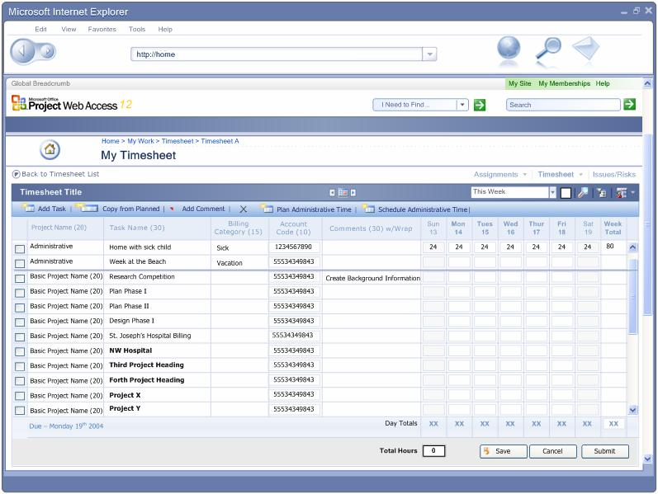
Figure 4: Timesheet

EPM Scenario: Supporting Enterprise Activities
The VP of operations creates a program to retool all of the firms manufacturing plants. The program has separate projects for each existing product line and placeholders for new products. Managers on his team use the firm’s manufacturing line conversion template as the basis for quickly creating each project.
As the managers add specific details beyond the projects’ initial template and resource plan, they assign specific resources to tasks. But in some cases, instead of individuals, they assigned tasks to team resources, which enable the team members to allocate the work themselves.
The managers can start some of their work but are often blocked by dependencies on the product development team’s deliverables. These cross-project dependencies appear in a single SharePoint list of Deliverables, so the VP can easily hold discussions with his counterpart in product development and manage expectations of executives if there are schedule slips.
Project managers often travel between manufacturing plant locations to verify progress and learn local best practices. While on the road, managers can work offline, taking advantage of the Active Cache.
The teams of thousands of workers in the manufacturing plants can all submit their time sheets concurrently and then immediately shutdown as the Server Side Queue holds their submission for processing rather than having the workers wait. The project managers running the various components of the program can then review and approve the time sheets.
The VP of operations can analyze and report across the entire program and its sub-projects to keep other executives informed and manage issues as they arise.

Easier to Get Started
Project enables organization-wide adoption by sharing reports, coordinating on the Web, and integrating with other familiar applications such as Outlook and Excel. This functionality enables you to set expectations and communicate effectively with project teams, management, and customers. Project itself is localized in 23 languages, enabled in 13 other languages and for Unicode, and supports the Multilingual User Interface Pack.

Access Project Information via the Web
Let partners, executives, and team members view and interact with the EPM Solution through Microsoft Office Project Web Access. With just a Web browser, users can gain access to content and functions based on their role and authorization. You can also integrate Project Server data and functions as Web Parts into a dashboard view with other information for a complete view of your business.

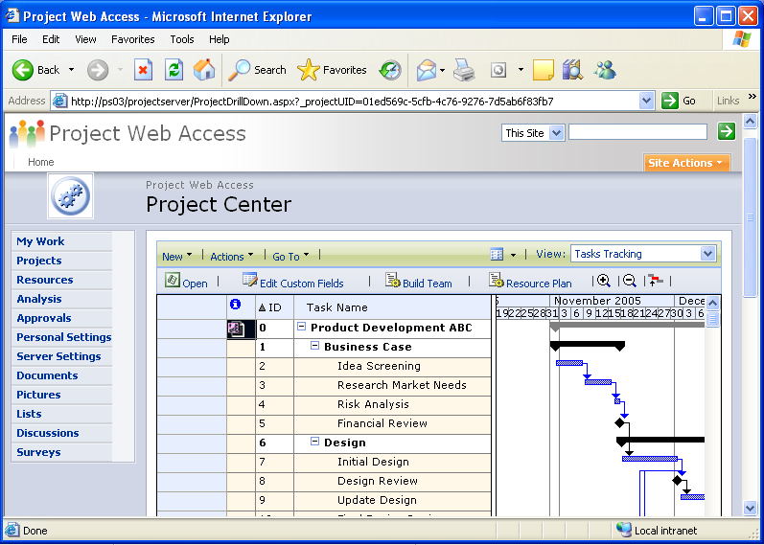
Figure 5: Project Web Access

Enhance Knowledge Sharing
Integration of Project Server and Microsoft Windows SharePoint™ Services provides a rich collaboration platform that enables teams to centrally manage and track project-related documents, issues, and risks.
Centralized document management allows users to improve the quality of project deliverables. With the Microsoft Project Task List Import template, you can build a basic task list in Excel. The Microsoft Project Plan Import Export template enables you to create the task list, add resources, and make assignments. This template can be imported into Project and exported back to Excel for revising.
Quickly master the project management process with the Project Guide, a step-by-step interactive aid that helps you set up projects, manage tasks and resources, track schedules, and report project information. The Project Guide, which can be turned on or off as needed, helps you learn, explore, and discover available features while quickly navigating through the project management process. With the provided instructions and wizards, you can quickly complete activities, such as defining your project, entering tasks, assigning resources, and reporting project information to stakeholders and team members. You can also customize data fields and analytics for information specific to your projects. You can even create custom Project Guides that can be used to maintain consistency or deploy a sepcific project management methodology within your corporation.

Leverages existing investments and knowledge of desktop applications
With Outlook Integration, team members can view and report progress on tasks—right from their Outlook Calendar or To Do List. Team members view project assignments, easily keep track of project tasks alongside other Outlook appointments and tasks. From Outlook, user can provide project managers with timely updates for accurate reporting. In addition, users can automatically send updates or receive notification through any SMTP email system.
More people can thus participate in the EPM Solution without learning a new application.

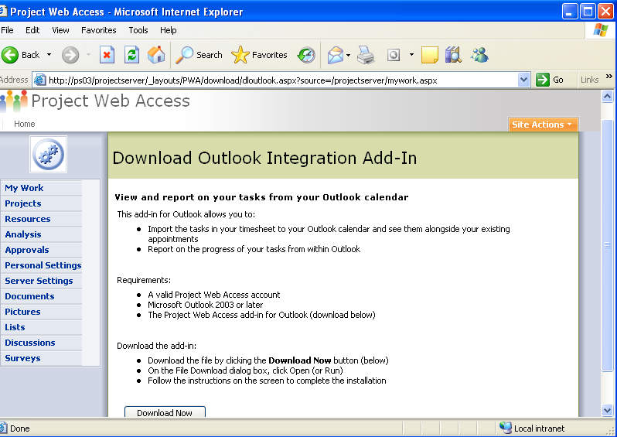
Figure 6: Outlook Integration via Project Web Access

Save Time with Templates
Microsoft Office Project provides a wide range of pre-defined templates to help speed your project management process by establishing repeatable processes and capturing best practices.

Create Your Own Templates
Leverage your time and expertise by creating your own custom templates. This enables you to reuse an existing project as the basis for future projects. A template can capture task and resource information, formatting, macros, and other project-specific settings. Thus, templates give you a quick start by automatically populating a new project with generic information that you can tailor to your specific needs. You can e-mail local templates to others users to share best practices for your specific functional area or industry. You can publish the templates to your whole organization as an Enterprise Template. Enterprise Templates create consistency, which enables roll-up and reporting across projects and programs.

Use Pre-defined Templates
When creating a new project, you can build from a blank slate or choose templates created within your firm, templates provided out-of-the-box from the Project installation, or those templates available on Microsoft Office Online for download. The out-of-the box templates cover a range of industries, functional areas, and business problems. These templates range from Commercial Construction to New Product Development, all of which are designed to fulfill a specific objective that meets your industry and project management needs. (See figure 7, below.) Other templates help with specific project management methodologies such as agile development with SCRUM or quality management with Six Sigma.
Microsoft also provides two templates that you can use in Microsoft Office Excel 2003 to start a new project, create a task list, and include resources. These files can then be imported into Project. These templates automatically map fields and information directly into their Project equivalent.
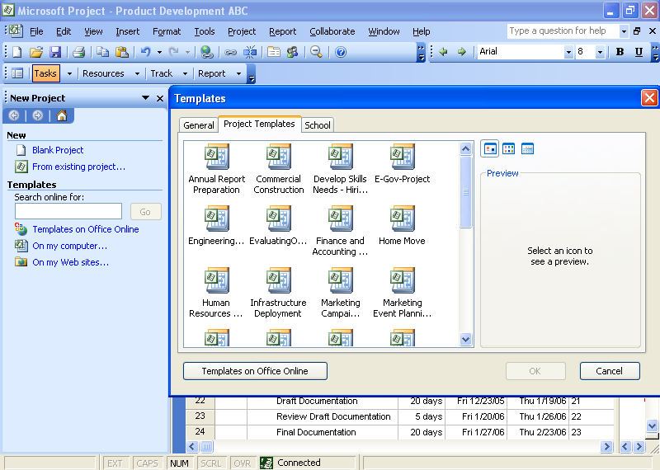
Figure 7: Create a new project based on pre-defined Project Templates.

EPM Scenario: Accelerating the Adoption and Value
Currently, Fabrikam International is working on a large scale project with two project managers to develop a complex new product offering. The project is expected to take two years to complete. Both project managers worked together to create and promote the proposal to a project to which they add all the details required for operational control and reporting of progress.
The project managers did not start from a blank slate. They leveraged the approved enterprise template and Product Guide for new products. The VP of product development had analysts create the best practice template and custom Project Guide. These tools helped the managers to save time and create consistency for reporting and decision making.
The managers need several levels of communication to involve team members and to inform executives.
To provide team collaboration the project mangers create user accounts on Project Server for their team members by synching with Active Directory. They also select the option for email notification which will send messages to indicate the assignment of tasks to team members.
The team working on the project also installs the COM add-in for Outlook integration so they can import Project assignments to their calendar and to do lists. This permits the people working on these projects to report time and progress directly from Outlook.
For an overall time and status reporting, their accounts on Project Server grant them access to the complete timesheet function in Project Web Access (PWA). PWA offers a range of other collaboration functions for status reporting, sharing issues & risks, managing documents and more since PWA is built on Windows SharePoint Services.
As the project proceeds, the managers monitor resource utilization levels, approve timesheets and task progress. They adjust resource allocations and accommodate scope changes while working to keep on the original schedule.
The project managers need to keep the project’s sponsors and the rest of the management team informed of progress and to manage their customer’s expectations on delivery. To communicate their timeline, key deliverables, and finances, the managers create accounts for the project sponsors on Project Server. The sponsors can use the PWA Project Center to analyze the project’s progress. The project managers also use the Visual Reports function in Project Professional to create dynamic report templates in Excel and Visio Professional to communicate monthly status to the broader Fabrikam executive committee.

Extensible and Programmable
The EPM Solution provides enterprise class capabilities for performance and scalability as well as a better foundation for extending & customizing Project as a platform for managing your organization’s work. Project will offer workflow to integrate business processes with project work. Your existing software investments will gain better synergy with Project via an improved API. The new version more readily exposes the administrative functionality through PWA.

Manage the EPM Solution
To save time and reduce the learning curve for EPM Solution Administrators, the new version consolidates security, and other management functions on a single, re-factored web service called Server Settings. Project Server includes a connector which facilitates synchronization from Active Directory to Project Server. This imports AD users to populate the Enterprise Resource Pool and AD security groups, distribution groups, and organization units to Project Server security groups. This means you benefit by not having to implement and manage specific directory services.

Fully Customizable
All Project Server clients and components for integration (PWA, Project Professional, and 3rd party applications) now interact with Project Server 2007 through the Project Server Interface (PSI). The PSI, our application programming interface, is documented in the Software Development Kit, which is posted to MSDN for free download.
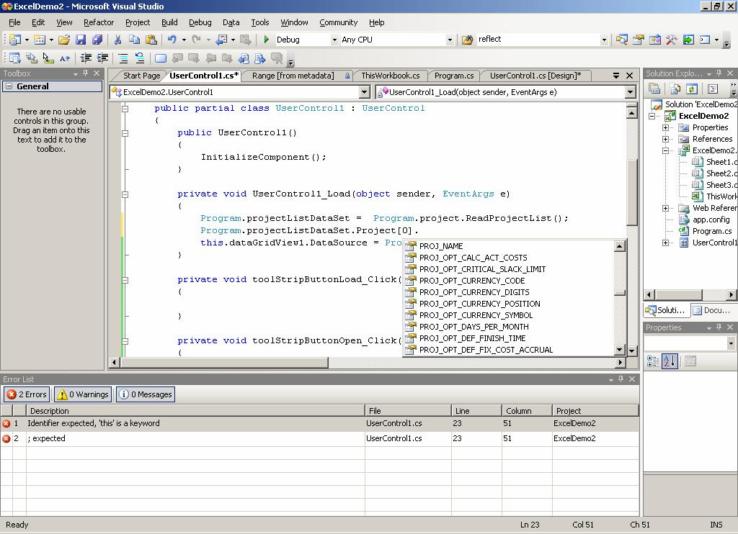
Figure 8: Programming with the PSI.
The PSI, along with the Project Server Event Model, exposes all of the functionality and data that client applications need to integrate fully with Project Server. The server side Event Model can trigger workflow for business processes defined with Windows Workflow Foundation.
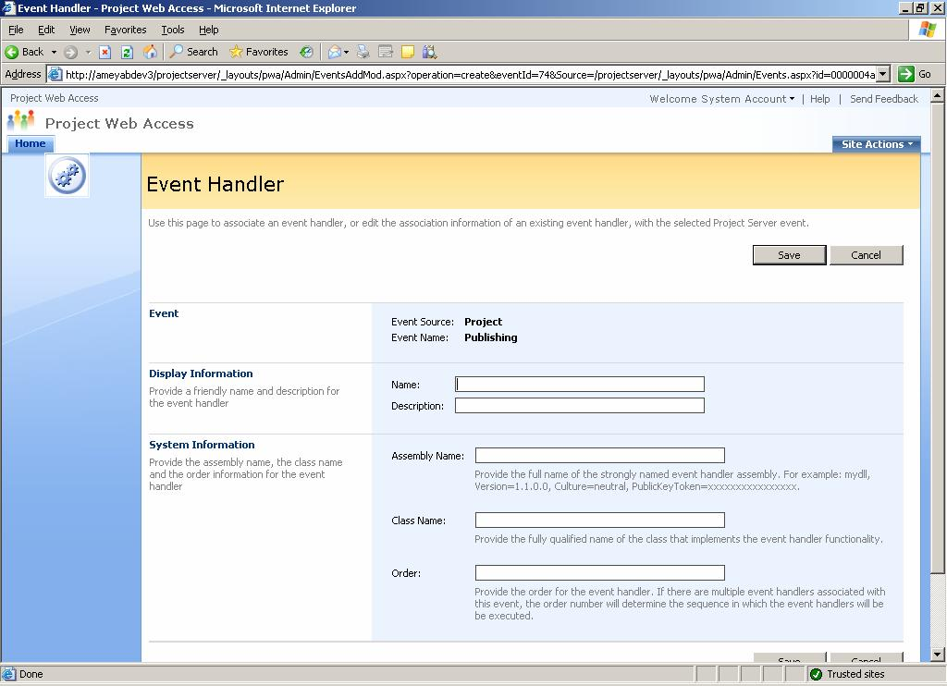
Figure 9: Event Handler to initiate workflow.
The new Server Side Scheduling moves the scheduling engine from Project Professional to the Project Server. This enables you to create a front-end without relying on Project Professional for schedule calculations. Now if a third party builds a front-end, they no longer have to have winproj.exe on each client since the server contains the scheduling engine. This reduces license needs from Professional to a Client Access License.
Additionally, you have greater ability to customize Project Web Access or reuse its capabilities since it is built on WSS 3.0 and exposes all functions as web services. This also means you can flexibly format the PWA interface with all of WSS’ tools.
The administrative interface has been redesigned for better access and to expose new functions.

EPM Scenario: Extending the Platform to Suite Special Needs
Fabrikam International is undertaking a large scale initiative with business partners. This initiative requires integration to backend systems, custom reports and workflow. The internal IT group has been training developers with Project’s new API (the Project Server Interface), the .NET Framework 2.0, and the free tool Windows Workflow Foundation. Thus, they have the skills in-house to customize their EPM Solution.
The extensible platform of Project allows the IT group to create the necessary custom integration to their timesheet system as well as leveraging the free ERP Connector to establish integration between their EPM Solution and their SAP system.
Fabrikam can develop custom applications to include: an extranet portal where suppliers can view what they have committed to deliver; custom workflow to support an approval process changes to requirements; and, a program dashboard in Microsoft’s Business Scorecard Manager that allows the executive committee to track progress and issues within projects and programs.

Architecture

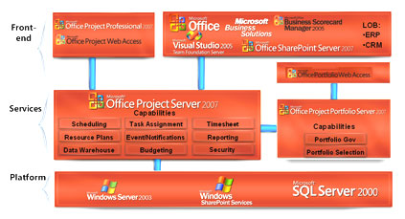
Figure 10

The three-tiered architecture of EPM Solution consists of:
- A front end: Project Web Access, the thin Internet Explorer client or Project Professional, the Win32 client. In addition to the dedicated Project clients, other applications can also serve as front ends due to integration. Visual Studio and Microsoft Business Solutions both offer connectors to Project Server. Microsoft offers an ERP Connector and a Siebel Connector as examples of how to integrate with line of business systems.
- A middle-tier: Project Server and Portfolio Server deliver the business logic and services. Project Server can be accessed programmatically with the Project Server Interface API as described in our Software Development Kit (SDK) that is posted on MSDN.
- A back-end: SQL Server, Windows Server, and Windows SharePoint Services.
For further details, please refer to the system requirements section.

Backwards Compatibility, Interoperability and Migration
Microsoft Office Project Professional 2007 can open files created in previous versions of Project. You can save project plans in prior formats, for example, Project 2000, Project 2002, and Project 2003 file formats. Any features that do not map to prior file formats will be discarded when the project is saved in that file format.
Project Professional 2007 saves to file formats including XML, CSV (Comma Separated Values), Text (Tab delimited), Microsoft Excel Workbook, Microsoft Excel PivotTable, Web Page, and Microsoft Project 2003. It does not support save to ODBC data source or MDB files. Project 2000 and later versions no longer save project plans to the MPX format.
Microsoft Office Project Professional 2007 can not connect to or interoperate with earlier versions of Project Server. Similarly, Project Server 2007 does not interoperate with prior versions of Project Professional. Project Server 2007 does provide a migration tool that allows certain data (including project and other Project Web Access data such as security settings, PWA views, etc.) in Project Server 2003 to be migrated over.
You can continue to use the same infrastructure (Windows Server 2003 and SQL Server 2000) details in system requirements to support Project Server 2007. However, PWA now requires Windows SharePoint Services 3.0 and some functions require the .NET Framework 2.0.
The Microsoft Office Project Portfolio Server 2007 includes with a bi-directional gateway to integrate with Office Project Server 2007. Specific points of interoperability include:
- Create, prioritize, optimize and select project portfolios within Project Portfolio Server and automatically export the selected projects to Microsoft Project Server, dynamically notifying the project manager that the project has been created.
- Export derived valuation attributes from Project Portfolio Server to Project Server (for example, NPV, IRR, ROI, Strategic Value, Risk Assessment scores, and others).
- Manually map fields between Project Portfolio Server and Project Server and create mapping templates for automatic data transfer.
- Set automatic synchronization events between Project Portfolio Server and Project Server to ensure the project data remains current in both environments; or manually refresh the data as required.
- Strengthen existing project management processes with the methodologies and analytics included within Project Portfolio Server (for example, Impact Assessments, Constraint Analysis, Efficient Frontier Analysis, and Sensitivity Analysis).
This integration enables organizations to identify, prioritize, and select the right investments, ensuring alignment with strategic objectives, and to successfully execute the resulting projects to achieve the forecasted benefits.

Summary of the Microsoft EPM Solution Benefits
The Enterprise Management (EPM) Solution, based on Office Project Server 2007, and Office Project Portfolio Server 2007, addresses the needs of key stakeholders to:
- Gain visibility to align work with strategic business objectives and insights to make decisions from the strategic portfolio level to tactical operations.
- Efficiently manage finances and resources for projects and programs from initiation throughout their entire lifecycle.
- Collaborate and communicate the status of work and investments.
- Leverage integration with Microsoft Office System programs and other existing software infrastructure.
- Customize the EPM Solution to meet your organization’s unique needs.
To evaluate the EPM Solution for your organization, please contact your account manager for a hosted trial.

System Requirements
The Enterprise Project Management (EPM) Solution consists of Office Project Server 2007, Office Project Professional 2007, Project Web Access (PWA), and Office Project Portfolio Server 2007, and Project Portfolio Web Access. Each of these products has its own system requirements.

Project Server
Microsoft® Office Project Server 2007 processor, RAM, and hard disk requirements are highly dependent on the number of services installed on the server computer and the load on the server.
Minimum requirements assume one server on which all Project Server components and supporting technologies (i.e., Microsoft SQL Server™, Microsoft Windows® SharePoint™ Services) are installed. Additional system requirement information about advanced Project Server configurations is available in the Microsoft® Office Project Server 2007 Installation Guide.
Microsoft Office Project Server 2007 requires the following for use:
- Operating System: Microsoft Windows® Server 2003 Standard or Enterprise Edition SP2 or higher (32-bit, x 64)
- Processor: Pentium III, 500 MHz or faster
- Memory: 512 MB minimum, 1 GB recommended
- Hard disk: 200 MB of available space
- Display: SVGA (800 x 600) or higher resolution
- Network Connection: 10 Mb/sec or higher connection
- DVD Drive: Required for installation from media
- .Net Framework: Version 2.0
- MDAC: 2.8 or higher
- Database Server: SQL Server™ 2000 SP3 or higher; SQL Server 2005 (32-bit Intel/AMD processor, 64-bit AMD processor)
Additional items or services required to use certain features:
- SQL Server™ Analysis Services for Portfolio Analyzer and SQL Server™ Reporting Services are optional; versions should be matched with SQL Server’s version.

Project Professional
Microsoft Office Project Professional 2007 requires the following for use:
- Operating System: Windows XP SP2 and higher, Windows XP Tablet Edition 2005 (XP SP2), Windows Vista
- Processor: Pentium III, 500 MHz or higher
- Memory: 128 MB of RAM or higher; 500 MB recommended
- Hard disk: 130 MB of available hard-disk space or greater
- Display: SVGA (800 x 600) or higher resolution
- Network Connection: 10 Mb/sec or higher connection
Additional items or services required to use certain features:
- Browser: Internet Explorer 6.0 or higher. Note: Internet access to Project Server requires dial-up or broadband Internet access (provided separately); local or long-distance charges may apply
- Project Server 2003 is required for enterprise resource and project management capabilities; MAPI compliant messaging software such as Exchange 5.5 for inserting new resources; .Net Framework requires Version 2.0 (Whidbey) for use of Resource Substitution wizard and Desktop Reporting; Windows SharePoint Services 2 or higher required for Windows SharePoint Services’ open/save; Export to Excel and Copy Picture to Office Wizard require Office 2000 SP3 and higher; Visual Reports requires Excel 2003 or higher and Visio Professional 2007; Outlook 2003 SP2 and higher, Outlook 2007 (for importing/exporting assignments); Windows Server 2003 SP2 Terminal Services for remote access

Project Web Access
Microsoft Office Project Web Access (PWA) 2007 is a Web portal used to access the information stored in Microsoft® Office Project Server 2007. This also includes the administrative user interface. Using PWA requires a Project Server 2007 Client Access License (CAL).
PWA requires the following for use:
- Operating System: Windows 98 SE, Windows 2000 SP4 and higher, Windows XP SP2 and higher, Windows XP Tablet Edition SP1, Windows Vista
- Processor: Pentium III, 500 MHz or higher
- Memory: 24 MB of additional RAM or more recommended (additional memory may be required depending on operating system requirements)
- Hard disk: 5 MB of available hard disk space
- Display: SVGA (800 x 600) or higher resolution
- Network Connection: 256 Kb/sec or higher connection required to connect to Microsoft Office Project Server 2007
- Browser: Internet Explorer 6.0 or higher. Note: Internet functionality requires dial-up or broadband Internet access (provided separately); local or long-distance charges may apply
- Outlook Web Controls: Portfolio Analyzer views require the Office Web Controls (OWC) version from a valid end user license for an Office 2007 application
Additional items or services required to use certain features:
- Outlook 2003 SP2 and higher, Outlook 2007 (for importing/exporting assignments).
- Windows® SharePoint Services™: Windows SharePoint Services version 3.0 or higher, which requires: Microsoft Internet Information Services 6.0 or higher, NTFS file system (Microsoft Windows includes a conversion utility (Convert.exe) that you can use to convert an existing file allocation table (FAT) volume to NTFS — without losing data), Microsoft Windows Workflow Foundation

Project Portfolio Server
- Computer and processor: Server with an Intel Pentium III 850-MHz or faster processor
- Memory: 521 MB of RAM or greater (1GB recommended)
- Hard disk: 300MB of available hard-disk space
- Database Server: Microsoft SQL Server 2005 (SP4)
- Presentation Server: Microsoft Internet Information Server (IIS) Version 5.0 or 6.0, .NET Framework: Version 2.0
- Reporting Server: Microsoft SQL Server 2005 Reporting Services
- Microsoft SQL 2000 Reporting Services (SP2)
- Drive: DVD drive required for installation from media
- Display: Super VGA (800 × 600) or higher-resolution monitor
- Operating system: Microsoft Windows Server 2003 Standard or Enterprise Edition SP2 or later (32-bit)
Project Portfolio Web Access

- Computer and processor: Personal computer with an Intel Pentium 133-MHz or higher processor, Pentium III recommended

- Memory: 24 MB of RAM or more recommended (additional memory may be required depending on operating system requirements)

- Hard disk: 5 MB of available hard disk space

- Operating system: Windows 2000 or higher; the latest service pack for your operating system is highly recommended

- Display: Super VGA (800 × 600) or a higher-resolution monitor with 256 colors

- Desktop Software: Office Excel 2000 or higher; Adobe Acrobat 5.0 or later

- Browser: Internet Explorer 6 with SP1 or later

Additional items or services required to use certain features:

- Office Project Professional 2007

- Office Project Server 2007

- Microsoft SharePoint Portal Server 2007

- Internet Connection: Internet functionality requires dial-up or broadband Internet access (provided separately); local or long-distance charges may apply.

Additional Resources
To learn more about the Microsoft Enterprise Project Management (EPM) Solution, please refer to the following list of related links for additional resources and information.
- Project Homepage
http://office.microsoft.com/project/
- Business Value from the Microsoft Enterprise Project Management Solution
http://www.microsoft.com/business/epm.aspx
- MPA, the official industry association for Microsoft Office Project
http://www.mympa.org
- Microsoft Office Project Communities
http://www.microsoft.com/technet/community/en-us/project/default.mspx
- Microsoft® Office Project Developer Center
http://msdn.microsoft.com/office/understanding/project/default.aspx
- Microsoft® Office Project TechNet
http://www.microsoft.com/technet/prodtechnol/project/default.mspx
- Microsoft® Office Project Support Information
http://support.microsoft.com/default.aspx

This document is developed prior to the product’s release to manufacturing, and as such, we cannot guarantee that all details included herein will be exactly as what is found in the shipping product. The information contained in this document represents the current view of Microsoft Corporation on the issues discussed as of the date of publication. Because Microsoft must respond to changing market conditions, it should not be interpreted to be a commitment on the part of Microsoft, and Microsoft cannot guarantee the accuracy of any information presented after the date of publication. The information represents the product at the time this document was printed and should be used for planning purposes only. Information is subject to change at any time without prior notice.

This document is for informational purposes only. MICROSOFT MAKES NO WARRANTIES, EXPRESS OR IMPLIED, IN THIS DOCUMENT.

© 2006 Microsoft Corporation. All rights reserved.

Microsoft, Excel, the Office logo, Outlook, SharePoint, Visual Studio, Windows, and Windows Server are either registered trademarks or trademarks of Microsoft Corporation in the United States and/or other countries. All other trademarks are property of their respective owners.

