Animation Antics

How to Make a Movie with your Animation Photos using Windows Movie Maker 2

Importing your photos into Movie Maker 2

- To open Windows Movie Maker 2 click Start > All Programs > Windows Movie Maker 2.
- In the 1. Capture Video section of the Movie Task bar, click Import Pictures.
- Find and open the folder which contains your pictures.
- To select all the pictures, press CTRL and A at the same time. All of the pictures will turn blue.
- Click Import and your pictures will appear in the Movie Maker 2 picture gallery.

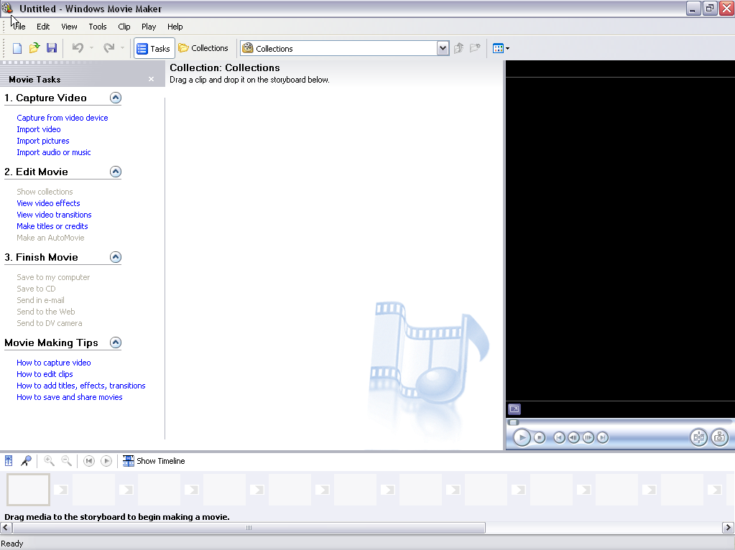

Making your photographs into a movie

- Click one of the photos to select it. A blue boarder will appear around the selected photo. To select all of the photos, click Edit on the top toolbar, and then Select All (or CTRL and A on the keyboard to select all).
- Now click and drag all your photos (they will all be joined together) onto the first square of the movie timeline at the bottom of the window. All your pictures will now appear in order in the movie timeline.

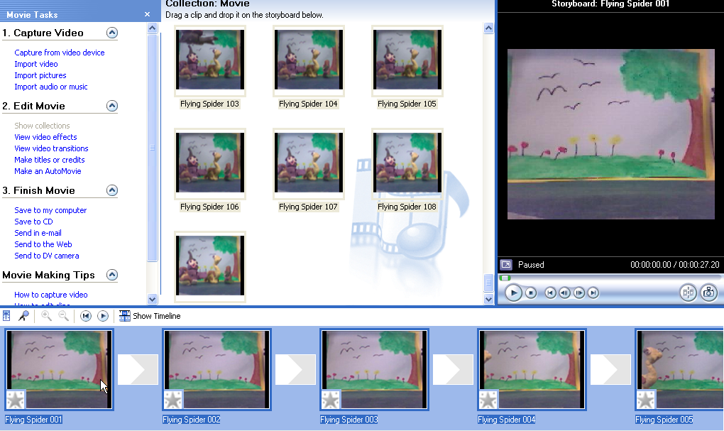

Watching a preview of your animated movie

You can view your movie at any time.
- Select the first picture in the timeline by clicking on it (use the scroll bar to move to it).
- Then click the Play button on the movie screen.

Editing your movie

- To add titles and/or credits to your movie, click Make Titles or Credits on the Movie Task bar under 2. Edit Movie.
- Select where you want to add the text for your title or credits (for example, At the beginning).
- Type the title into the boxes provided and then click Done.
- Repeat this process, selecting Credits at the end if you want to add credits to the end of your movie.

Adding sound to your movie

- To add sound effects or music tracks to your movie go to the Movie Task bar, and under 1. Capture Video click Import Audio or Music.
- Find the sound you want to add (for example, clapping or a music file) and click Import. The sound will appear in the Picture Gallery as a musical note icon. (See the Using Sound Recorder how-to guide accompanying this lesson plan to learn how to insert your own sound files.)
- At the bottom of the screen you will see the Movie Timeline. To see the Music Timeline as well, click Show Timeline (located just above the Movie Timeline).
- Next click and drag the sound you want from the Picture Gallery onto the Audio/Music Timeline.
- To move the sound along the timeline, click and drag it into position. To change the length of the sound click on the sound, move the curser to the end of the sound (red arrow will appear) and drag the end.

Saving and watching your animated movie

You must save your movies twice.

Save as a project (this can be edited)
- Click File > Save Project As.
- Type a name for the movie into the box provided.
- This can be done at any point during production so you don’t lose your work.

Save as a finished movie (this cannot be edited)
- In the Movie Task bar click Save to My Computer > Finish Movie.
- In box 1, give your movie a name.
- In box 2, use the browse tool to navigate to where you want to save the finished movie (for example, into the folder you created for the group on your Desktop).
- Click Next, then Next again, then Finish.

Viewing your finished animated movie

- Open the folder with your saved movie, and double-click it.
- When a small Movie Maker 2 window opens up on the screen, click and drag the icon of your movie into the window and release it. Your movie will start playing.
- For a larger view, click the Maximize button in the top right of the Movie Maker 2 window.

Credits
This project was created by Kate Norman, of St. IIltyd’s Primary School, Wales. It has been made available to us through the Microsoft Innovative Teachers program in the United Kingdom.

