

**Attention SQL Administrators… There Is a Better Way to Back Up!**

If your company relies on Microsoft® SQL Server™ to manage and deliver information, who will you trust to maximize its protection and recovery?

SQL Server administrators are looking for a better way to protect and recover SQL Server databases. Microsoft has heard from our customers and partners and delivered a complete solution with System Center Data Protection Manager (DPM) 2007.

**Microsoft System Center Data Protection Manager 2007 (DPM)**

DPM 2007 is a member of the Microsoft System Center family of management products, which are designed to help IT Professionals manage their Windows Server® infrastructure. DPM 2007 sets a new standard for Windows® backup and recovery—delivering continuous data protection for Microsoft application and file servers to a seamlessly integrated secondary disk and tape solution on the DPM server. DPM enables rapid and reliable recovery through advanced technology for enterprises of all sizes.

**Microsoft protection and recovery for Microsoft applications**

**Microsoft designed DPM 2007 to provide the best backup and most reliable restore for Microsoft SQL Server.**

Focused on the primary Microsoft server workloads, DPM 2007 was specifically built to protect and recover SQL Server,

Microsoft Exchange Server, SharePoint® Portal Server, Microsoft Virtual Server, as well as Windows file services. In addition, DPM 2007 blends the best aspects of continuous data protection (CDP) with traditional tape backup.

DPM 2007 continuously protects the core Microsoft server workloads to a DPM server, which then provides disk-based

recovery and tape-based, long-term archival storage for a complete data protection and recovery solution.

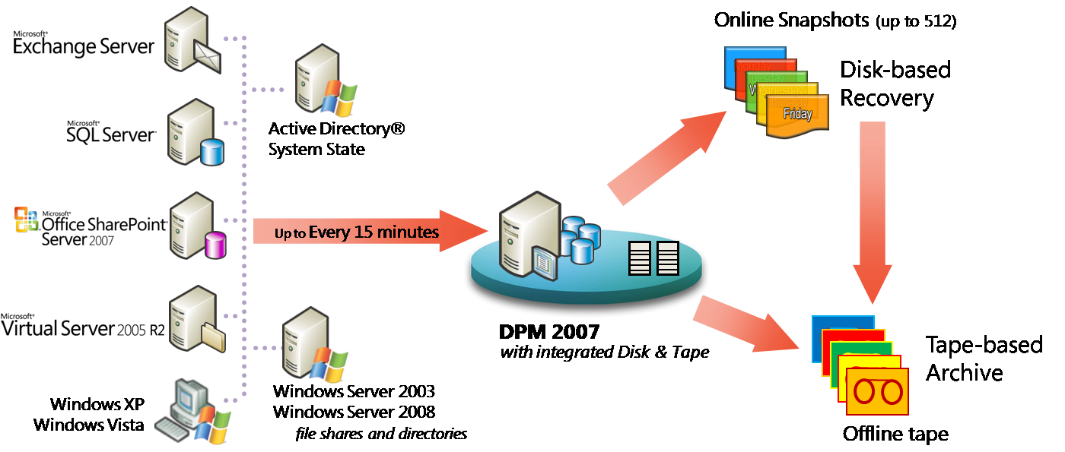

**Now protecting SQL Server 2000, SQL Server 2005 and SQL Server 2008**



**Maximizing Protection of Microsoft SQL Server with Microsoft Data Protection Manager**

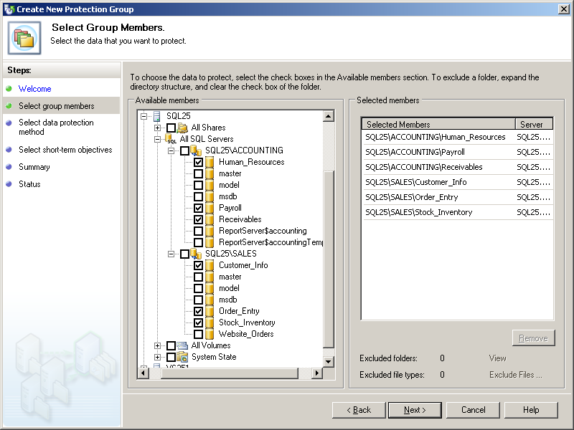

**DPM 2007 is designed for the Database Administrator** or the IT generalist and uses wizards and workflows **to help ensure that you can protect your data** – without requiring an advanced degree, training or certification in storage and backup technologies.

DPM presents the data to be protected in the same context as users access it. In DPM 2006, file servers can be protected by selecting file shares within the Data Protection Wizard. In DPM 2007, SQL Server databases, Exchange Server storage groups, and SharePoint farms are selected and protected the same way.

**Advanced SQL Server Configurations**

Because DPM was designed specifically for SQL Server, DPM understands the advanced configurations of SQL Server that often cause other data protection tools to fail:

* When protecting SQL Server clusters, DPM 2007 is not only “SQL-savvy,” but ”cluster-competent.” During deployment, DPM is aware of the physical nodes, the cluster’s identity, and the virtual servers running within it. DPM will help you ensure that all clustered nodes have the agent, to maximize protection of the SQL data. And when Microsoft Cluster Services moves the SQL Server to a different clustered-node, DPM 2007 will continue to protect the virtual SQL server without intervention.
* When deploying SQL Server mirrored databases, DPM is aware of the mirrored databases and will protect the shared data set correctly through the Active server in the pair.
* When protecting SQL Servers with “Log Shipping” or “Simple Recovery Model” configurations, DPM auto-configures itself to co‑exist for simple-mode protection where needed.

In addition, the rollup update for DPM 2007 released in June 2008, enables SQL Server 2008 protection, as well – including the ability to restore SQL Server 2005 databases into SQL Server 2008, for test migrations and for ensuring that you’ll be able to restore older 2005 data once all of your production servers have been upgraded to SQL Server 2008.

**How does SQL Server protection with DPM 2007 work?**

DPM 2007 uses a combination of transaction log replication and block-level synchronization in conjunction with the SQL VSS Writer to help ensure your ability to recover SQL Server databases. After the initial baseline copy of data, two parallel processes enable continuous data protection with integrity:

* Transaction logs are continuously synchronized to the DPM 2007 server, as often as every 15 minutes.
* An “express full” uses the SQL Server VSS Writer to identify which blocks have changed in the entire production database, and send just the updated blocks or fragments. This provides a complete and consistent image of the data files on the DPM server or appliance. DPM 2007 maintains up to 512 shadow copies of the full SQL Server database(s) by storing only the differences between any two images.

Assuming one “express full” per week, stored as one of 512 shadow copy differentials between one week and the next, times 7 days x 24 hours x 4 (every 15 minutes), **DPM 2007 can provide over 344,000 data consistent SQL recovery points.How to Restore Microsoft SQL Server with Microsoft Data Protection Manager**

**DPM 2007 is focused on “restore” instead of just “backup”**, which is why Microsoft has blended CDP and traditional backup, disk and tape, synchronizations and log shipping – all to enable the best possible recovery experience.

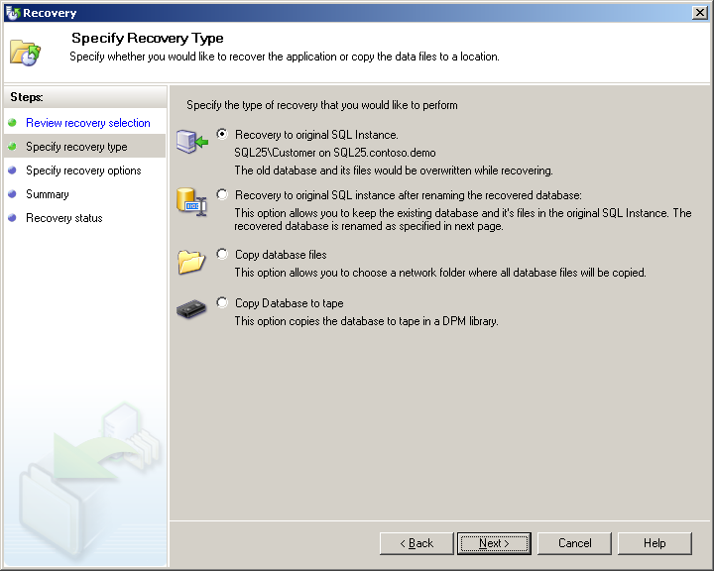With just a few mouse clicks and DPM 2007, you can:

* **Restore a SQL database directly back to the original server**

Databases are recovered back where they came from into the active SQL Server, with no additional work for the database administrator to do afterwards. This improves recovery time and reduces the number of people needed during a crisis recovery.

* **Restore SQL database to an alternate SQL Server**

This provides an alternative where the active SQL database is untouched, but the older data can be restored onto a different SQL server (or same server, alternate database) – allowing both versions of the data to be accessed independently.

* **Copy database files to an alternate server,**

This option enables disaster recovery, compliance auditing, or software testing – without affecting the production environment – including restore of 2005 databases to a SQL Server 2008 server.

* **Copy the database file to tape**,

Use this option to create a long-term archive or portable media of the data at any recovery point, even after the fact. For example, if the accounting department closes the quarterly books at 10:45 AM on a Tuesday, you can “recover” the data from that point, directly to tape – without backing up anything else or impacting the production server that is already serving new data.

**Unique to DPM 2007 is “lossless recovery” of SQL Server data**, meaning that after DPM 2007 restores your database to the latest 15‑minute recovery point, it can automatically reapply the surviving logs from the production server to the very last committed transaction. Thus, the last completed database transaction is recovered and ready for business.

**Designed to Protect and Restore Microsoft SQL Server**

Common customer questions about their existing SQL Server solutions include:

***“Who can help me restore?”***

During a crisis, as part of the data recovery, many customers are frustrated when bringing in multiple support organizations to help restore their data. The third-party backup vendor may say that the data restored successfully. But, Microsoft SQL Server product support may say that the data is un-mountable. And the systems integrator and database administrator can be stuck in the middle. Having a Microsoft backup product protecting a Microsoft SQL Server means customers don’t have to worry about misunderstandings between vendors when restoring their data.

**“*My* *backup product does some things well, but protecting my advanced SQL configuration isn’t one of them*.”**

Because third-party backup products try to back up a wide variety of applications, it is very difficult to protect every application well, particularly with flexible applications like Microsoft SQL Server 2005. Microsoft is dedicated to making sure that our backup solution is one of the very best for protecting our application workloads. Microsoft protects our own enterprise SQL Servers with DPM, beginning early in the beta process. This helps ensure that no DPM build will go to a customer that Microsoft IT hasn’t signed off as tested in our own demanding production environment.



**DPM 2007 is built to protect SQL Server -- in every environment**

Microsoft developed DPM to meet customer needs in SQL Server protection that are not being met by alternative protection technologies, for “enterprises of all sizes”.

**For SQL Administrators within larger enterprises** - Traditional backup products are often managed by an enterprise’s IT storage team, while the applications are maintained elsewhere. Database administrators have asked for the ability to restore data themselves.

DPM 2007 is a best-of-breed solution that combines advanced Continuous Data Protection (CDP) technologies with traditional tape backup for the core Microsoft server workloads. DPM provides SQL Administrators and other Microsoft application stakeholders with a reliable protection and recovery platform from the same vendor that produces their application – with the flexibility to protect as often as the application or the business demands it, but be archived to tape by either DPM or the existing third-party tape solution for long‑term retention.

**For IT Generalists within medium-sized businesses** – In environments that rely primarily on Microsoft applications (SQL Server as their database, Microsoft Exchange for email, SharePoint for collaboration, as well as Windows file services), DPM 2007 provides an opportunity to be assured that all of your core applications are receiving maximum protection by the same company that created them; with the added value of being able to purchase and support for your protection package with all of your other Microsoft licensed products.

Data Protection Manager is part of System Center, the family of management products from Microsoft that have our knowledge built-in. In DPM, this means that workflows and wizards walk the IT Generalist through the straight‑forward browsing of your SQL server(s), instances, and databases, as well as recovery goals and retention requirements. DPM locates the data, manages the disk-based images and logs, and rotates the tapes – so you don’t have to.

**Take a look at how DPM can protect your SQL Server infrastructure**

As you prepare to deploy SQL Server 2008 (or continue to manage your SQL Server 2005 servers), know that DPM 2007 is ready to protect your data. If you depend on Microsoft SQL Server to manage and deliver information within your company, take a look at how DPM 2007 can help you protect your business critical data.

**To learn more about how DPM 2007 can help you protect your Microsoft SQL Server environment**

[www.microsoft.com/DPM](http://www.microsoft.com/DPM) ... and click on “Protect SQL Server”

**Watch the Microsoft TechNet webcast on “Protecting SQL Server with Microsoft DPM 2007”**

<https://msevents.microsoft.com/CUI/WebCastEventDetails.aspx?EventID=1032322230>

**Get Ready … for Data Protection Manager 2007**

This document is for informational purposes only. MICROSOFT MAKES NO WARRANTIES, EXPRESS OR IMPLIED, IN THIS SUMMARY