

BizTalk Server 2006 Runtime Improvements

Microsoft Corporation
Published: November 2005

Abstract
This paper reviews the improvements that have been made to message processing as part of the core engine enhancements for BizTalk Server 2006. These include message interchange, failed message routing, large message transformation, and in-order message delivery.



This is a preliminary document and may be changed substantially prior to final commercial release of the software described herein.
The information contained in this document represents the current view of Microsoft Corporation on the issues discussed as of the date of publication. Because Microsoft must respond to changing market conditions, it should not be interpreted to be a commitment on the part of Microsoft, and Microsoft cannot guarantee the accuracy of any information presented after the date of publication.
This White Paper is for informational purposes only. MICROSOFT MAKES NO WARRANTIES, EXPRESS, IMPLIED, OR STATUTORY, AS TO THE INFORMATION IN THIS DOCUMENT.
Complying with all applicable copyright laws is the responsibility of the user. Without limiting the rights under copyright, no part of this document may be reproduced, stored in or introduced into a retrieval system, or transmitted in any form or by any means (electronic, mechanical, photocopying, recording, or otherwise), or for any purpose, without the express written permission of Microsoft Corporation.
Microsoft may have patents, patent applications, trademarks, copyrights, or other intellectual property rights covering subject matter in this document. Except as expressly provided in any written license agreement from Microsoft, the furnishing of this document does not give you any license to these patents, trademarks, copyrights, or other intellectual property.
Unless otherwise noted, the example companies, organizations, products, domain names, e-mail addresses, logos, people, places, and events depicted herein are fictitious, and no association with any real company, organization, product, domain name, e-mail address, logo, person, place, or event is intended or should be inferred.
© 2005 Microsoft Corporation. All rights reserved.
Microsoft, Microsoft, Active Directory, BizTalk, Outlook, and Windows are either registered trademarks or trademarks of Microsoft Corporation in the United States and/or other countries.
All other trademarks are property of their respective owners.
Contents
Introduction 1
Processing Interchanges in BizTalk Server 2006 2
Standard Interchange Processing 2
Standard Interchange Example 3
Recoverable Interchange Processing 5
Recoverable Interchange Example 5
How to Configure Interchange Processing 8
Failed Message Routing 11
Message Resume 13
In-Order Message Delivery 14
Large Message Transformation 15
Summary 16
For More Information 17

Introduction
BizTalk Server is Microsoft’s premier server for building solutions for business process and integration. BizTalk Server 2006, the fourth major release of the product, builds on the innovation and success introduced by the previous three releases: BizTalk Server editions 2000, 2002, and 2004. The 2006 release includes new capabilities and engine improvements that allow a developer to create more flexible solutions for integrated business processes. A few of these improvements are discussed throughout this document, including interchange processing, failed message routing, message resume, in-order message delivery, and large message transformation.

Processing Interchanges in BizTalk Server 2006
In BizTalk terms, an interchange refers to a message being processed by BizTalk Server. When an interchange contains two or more documents—which is typical when receiving a batch—BizTalk parses the interchange, which results in multiple messages. How these messages are handled depends on the type of interchange processing selected on the pipeline. With BizTalk Server 2006, a developer can select to use standard interchange processing or recoverable interchange processing when developing a custom pipeline. After a pipeline has been compiled and deployed into an application, these settings can be overloaded at run time using the BizTalk Administration Console. The administration console can also be used to modify the setting of the default XML pipeline that comes with BizTalk Server 2006.
Whereas BizTalk Server 2004 supported standard interchange processing, recoverable interchange processing is a new feature introduced in BizTalk Server 2006. To fully explain the enhancements in 2006, a description of both processing options is provided as follows.

Standard Interchange Processing
Standard interchange processing was the only option in BizTalk Server 2004 and is how, by default, the flat-file and XML receive pipelines are configured in BizTalk Server 2006. When an interchange arrives at a receive location the configured pipeline will decompose the interchange into one or more messages. Messages are then individually validated by the pipeline but then collected within the EPM (End-point Manager) inside BizTalk. If at any time any message within the collection fails, the entire interchange will be suspended. The suspended message will appear as the complete interchange, not the separate parts. With BizTalk Server 2004, these messages were not able to be resumed and had to be terminated using HAT (Health & Activity Tracking Tool) or programmatically. With BizTalk Server 2006 inbound, suspended messages may be resumed and the message resumption process will be reviewed in a later section.

Standard Interchange Example
The easiest way to understand is to visualize the process. The following example shows how a flat-file interchange containing five valid messages and one erroneous message is handled by way of the standard interchange processing. Figures 1 through 3 walk you through the stages.

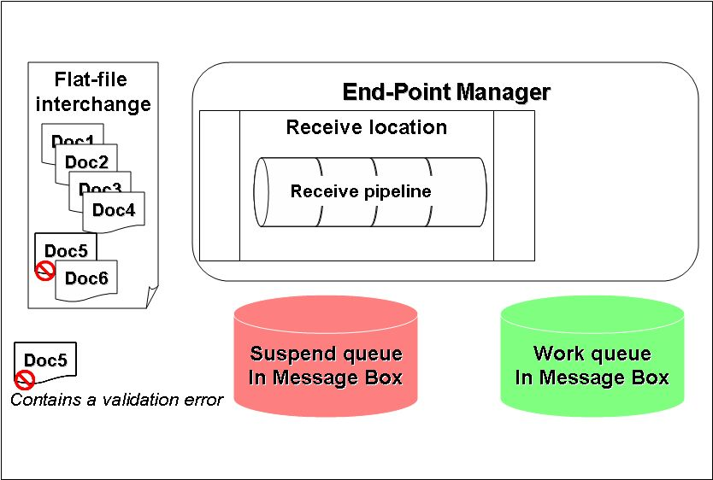
Figure 1. Standard Interchange Processing

In Figure 1, the receive location has a flat-file interchange that contains six individual flat file messages. The receive location has been configured to use a custom flat-file pipeline set for standard interchange processing. When the pipeline receives the interchange, it is broken down into six individual flat files. Each will be disassembled and validated through the pipeline and be collected by the end-point manager.

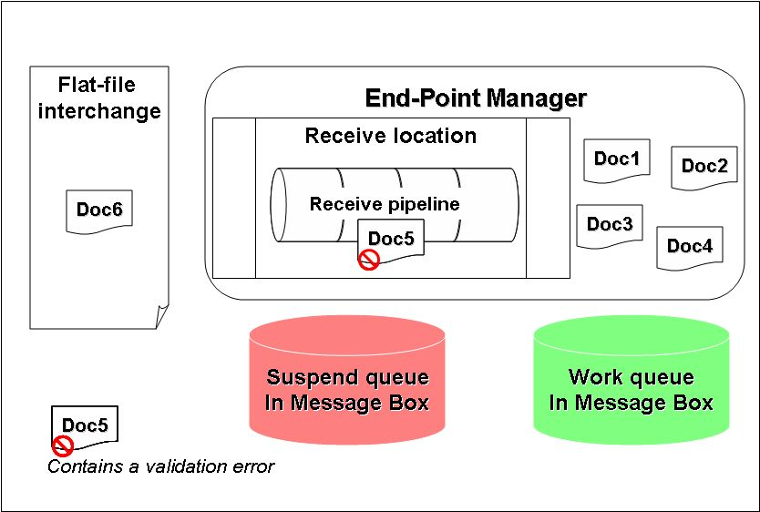
Figure 2. Standard Interchange Processing

In Figure 2 messages #1 through #4 have already have been successfully parsed and validated by the receive pipeline and are being collected by the EPM. Upon validating message #5 a parse error is found. Because message #5 failed validation in the receive pipeline all message bodies, 1 through 6, will be discarded. Instead, the entire flat-file interchange containing all six messages will be suspended in the message box as depicted in Figure 3. If failed message routing, discussed later on, was not selected for the receive port, the entire interchange will remain suspended until manually resumed or terminated by way of the administration console.

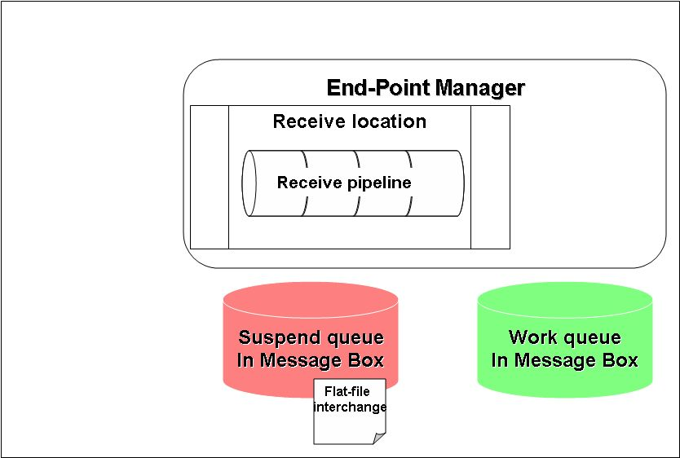
Figure 3. Standard Interchange Processing

Recoverable Interchange Processing
Recoverable interchange processing is a new feature of BizTalk Server 2006 and introduces additional flexibility in multimessage interchanges. When a new interchange arrives, and this option is selected on the active pipeline, it is broken down into individual messages and passed through the pipeline for disassembly and validation. Unlike standard interchange processing, messages are individually validated and individually sent by the EPM to the message box. If any message has an error, it is individually suspended in its original format. This means if a message comes in as a flat-file, it will be suspended as a flat-file, not parsed XML. All messages that passed validation are not affected by the failed messages. Failed messages will show up as individual suspended messages within the BizTalk administration console, not HAT. Just as with standard interchange processing, inbound suspended messages can be resumed if the suspending error is corrected.

Recoverable Interchange Example
Just as we did before, let’s walk through an example of how recoverable interchange processing works. In the following example we’ll look at how a flat-file interchange containing 4 valid messages and 2 erroneous messages is handled by way of recoverable interchange processing. Figures 4 through 8 walk you through these stages.

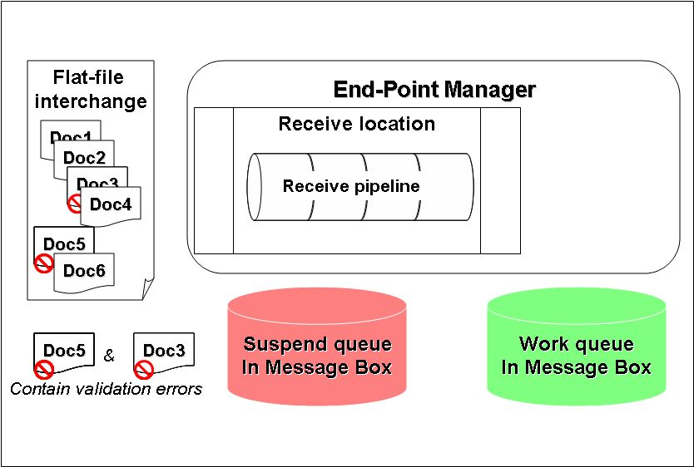
Figure 4. Recoverable Interchange Processing

In Figure 4, the receive location has a flat-file interchange that contains six individual flat file messages. The receive location has been configured to use a custom flat-file pipeline set for recoverable interchange processing. When the pipeline receives the interchange, it is broken down into six individual flat files. Each will be disassembled and validated through the pipeline and eventually routed by the end-point manager.

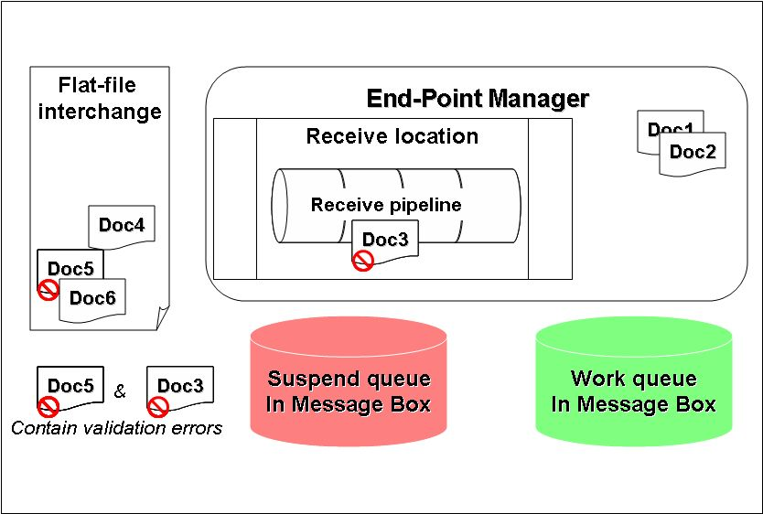
Figure 5. Recoverable Interchange Processing

In Figure 5, messages #1 and #2 have already successfully passed through the receive pipeline and are being collected by the EPM. Messages #1 and #2 are waiting for the rest of the interchange to be processed before being routed to the work queue within the message box. Meanwhile, message #3, which contains a parse error, is being disassembled in the pipeline.

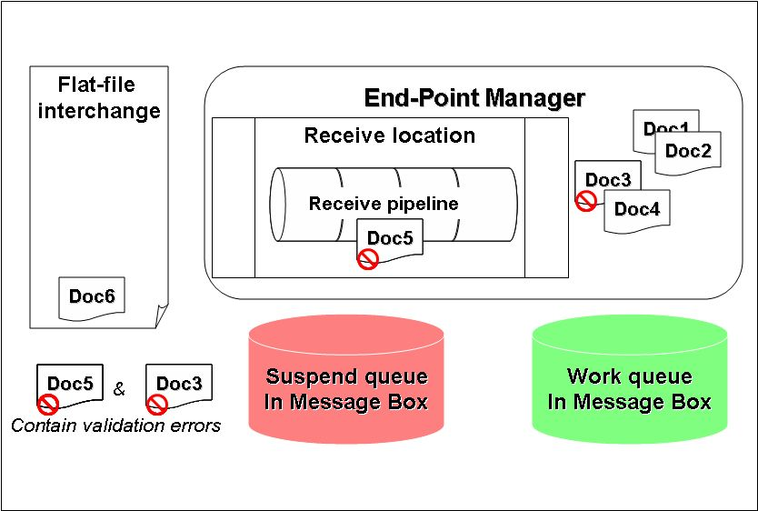
Figure 6. Recoverable Interchange Processing

In Figure 6, messages #1, #2, and #4 have been successfully parsed and validated by the receive pipeline while message #3 failed because it contains a parse error. All four messages are being collected by the EPM and waiting for the rest of the interchange to be processed before being routed to the appropriate queues. Message #5 is currently being processed by the pipeline, but a validation error was found.

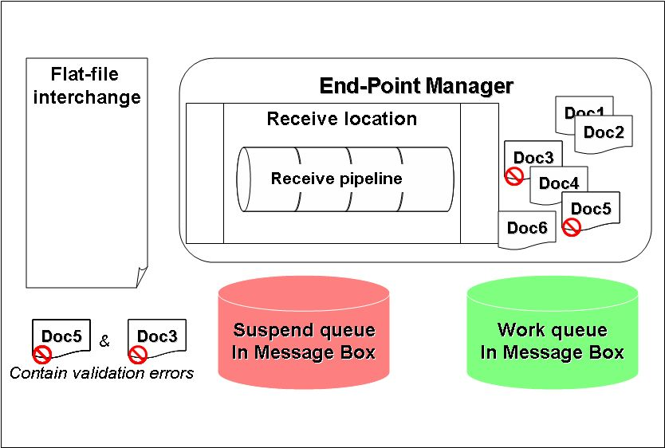
Figure 7. Recoverable Interchange Processing

In Figure 7, all six message parts have been processed. In total, four messages successfully passed and two failed for parsing and validation errors. Now that the complete interchange has been processed the EPM can route all six messages to the appropriate queues within the message box.

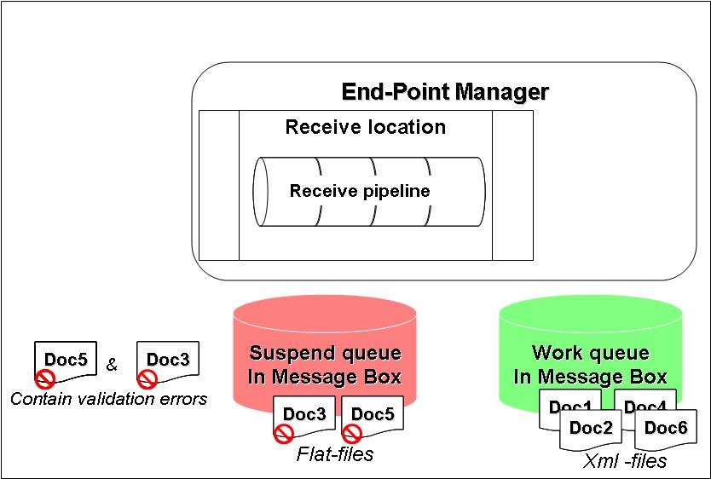
Figure 8. Recoverable Interchange Processing

Because messages #3 and #5 contained errors, they will be sent to the message box in their native flat-file format and placed in the suspended queue. Because messages #1, #2, #4, and #6 were successful, they will be sent to the message box as XML-formatted documents and placed in the work queue as seen in Figure 8.
As you can see from this example, the results from our recoverable interchange processing scenario vary greatly from that of the previous standard interchange example. Instead of just having a single suspended interchange, we have four valid messages waiting to be processed in the message box and two suspended messages.

How to Configure Interchange Processing
You have two ways to select the type of interchange processing for a pipeline. The first option is at design time. When a developer creates a custom pipeline, they have the choice of setting default configuration properties of the disassemble component using the Pipeline Designer within Visual Studio .NET 2005. When compiled and deployed, these settings become the default settings when the pipeline is selected within a receive location. To see the properties that can be set in Visual Studio see Figure 1.

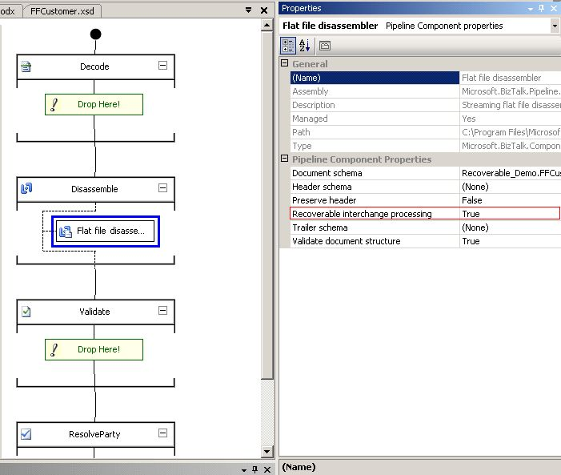
Figure 1. Setting Pipeline Components from Visual Studio

The second option is at run time using the BizTalk Administration Console. The settings for any receive pipeline—except the default PassThruReceive pipeline, which doesn’t require configuration—can be overloaded using the console. By default, the out-of-the-box XML receive pipeline is configured for standard interchange processing. Changing these settings is just a configuration setting and does not require a recompilation of the pipeline. To see the properties that can be set from the administration console, see Figure 2.

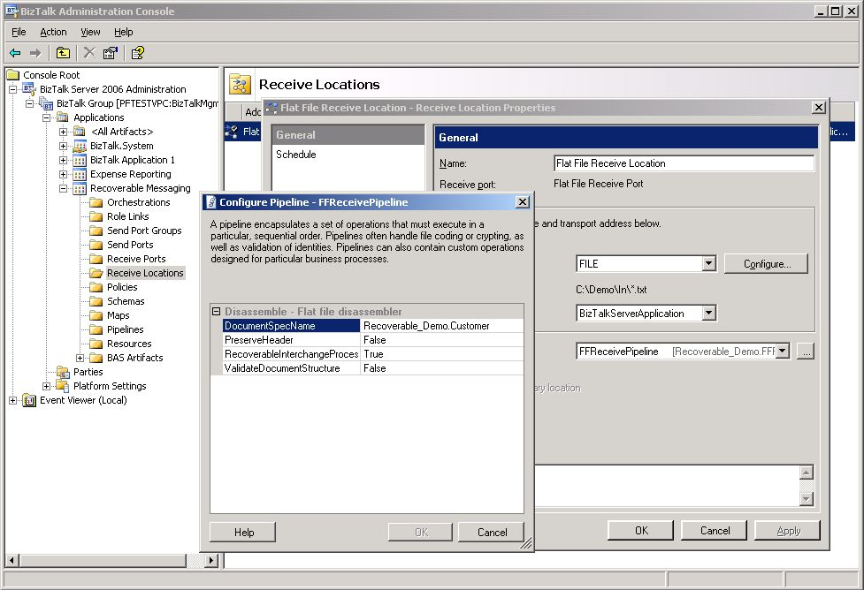
Figure 2. Setting Pipeline Properties from the BizTalk Administration Console

When combined with failed message routing, discussed next, you can create orchestrations that can handle failed—for example, to be routed and manually reviewed by a user.

Failed Message Routing
By default, when a message fails (validation, transformation, routing failure, and so on) within a receive pipeline, the message is automatically placed into the message box as suspended. Suspended messages can be viewed using HAT, and notification of the offending message can be sent by using Microsoft Operations Manager (MOM). By default, failed messages cannot be subscribed to by endpoints such as an orchestration or send port. This was the default operation of failed messages in BizTalk Server 2004.

BizTalk Server 2006 introduces new functionality that provides additional flexibility in dealing with failed messages. When a new receive port is created, a property can be set called “Generate error report for failed message” (see Figure 3).

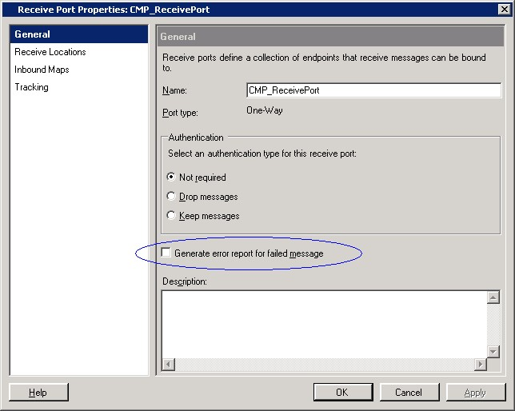
Figure 3. Receive Port Settings

When this property is checked, failed messages will not be suspended. Instead, they will be sent to the message box, and the following additional properties will be set:
- ErrorType
- FailureCode
- Description
- MessageType
- ReceivePortName
- SendPortName
- InboundTransportLocation
- OutboundTransportLocation
- RoutingFailureReportID

All of these will be promoted properties with the exception of Description and RoutingFailureReportID. By taking advantage of these additional context properties you can now create end-point filters, on an orchestration or sent port, that subscribe to these failed messages. When used appropriately, failed message routing can be used for notifying users of failed messages or building rich error handling or message repair capabilities. You can see a sample orchestration filtering messages based on ErrorType, FailureCode, and ReceivePortName in Figure 4.

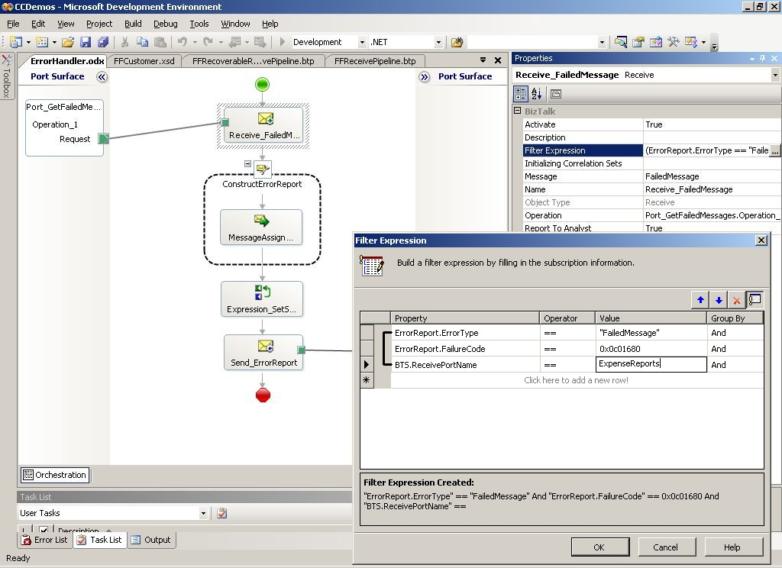
Figure 4. Sample Error Handling Orchestration

Please note that this should not have an effect on existing applications that are only subscribing to the BTS.MessageType property as that property will only be prompted when a message successfully passes a pipeline. When a message fails the ErrorReport.MessageType property will instead be promoted.

Message Resume
In BizTalk Server 2004 resume capabilities were simple. For the send side, you could select individual messages for resume using HAT. On the receive side, messages simply could not be resumed. Things have changed with BizTalk Server 2006. Nearly all receive-side messages can be resumed. In the case of messages that require in-order delivery (that is, MSMQ, MQSeries, and so on) message resume may not be possible, as the order integrity needs to be preserved. In-order message delivery is discussed in the next section.
Additionally the tools for resuming messages have changed. Message monitoring is no longer a function of HAT, though message tracking remains in HAT. Instead, the new BizTalk Administration Console contains new “hub” pages that give an administrator visibility into messaging active within BizTalk.

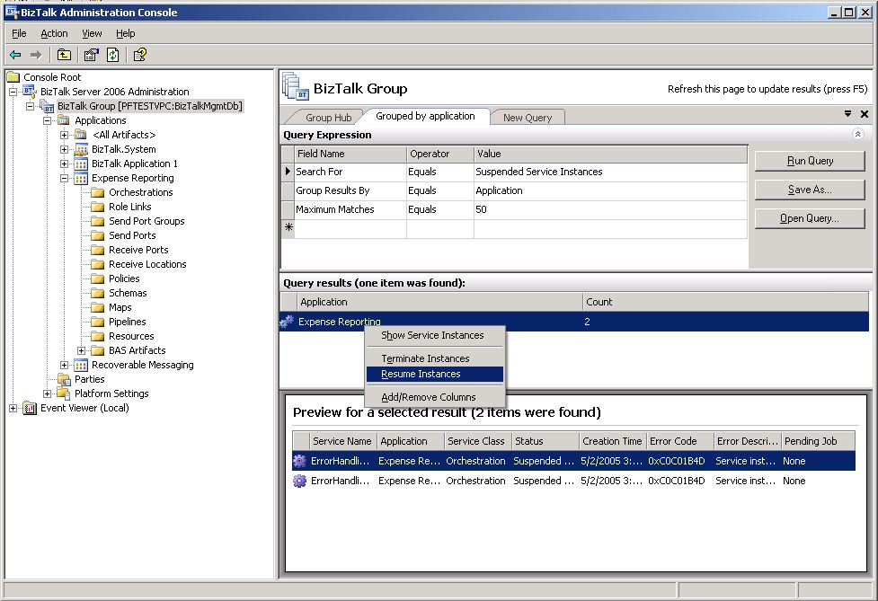
Figure 5. Resuming receive-side messages using the administration console

As you can see from Figure 5, you can either do individual message resume or termination or do bulk resume, or terminate, based on the error code.

In-Order Message Delivery
In BizTalk Server 2004, end-to-end, in-order processing is accomplished by way of the MSMQT as a transport. MSMQ preserves the order of the messages as they come into BizTalk, and the order in which they are added to the outbound work queue. As long as the processing in between those two points preserves this, end-to-end order will be preserved. When using orchestration, DeliveryNotification helps to simulate order delivery by making sure that the message is completely delivered before continuing in the orchestration.
In BizTalk Server 2006, this capability was expanded to support any send port that uses the same ordering semantics that outbound MSMQT does in BizTalk Server 2004 today. On the receive side, you still need an adapter that supports in order processing—MSMQ, and MQSeries adapters will support this option (along with MSMQT). Note that the file adapter can not take advantage of this because of the number of ways that people could interpret order in the files that appear on the system. For example: time stamp order, files that start with Cxxx before all files that start with Oxxx, the digits in the file name determine the order, or any other scheme people may invent.
As you can see BizTalk Server 2006 includes all the capabilities necessary to support end-to-end, in-order delivery, but care should be taken in designing logic and business processes that also take order into account.

Large Message Transformation
In previous releases of BizTalk Server, mapping of documents always occurred in-memory. While in-memory mapping provides the best performance, it can quickly eat up resources when large documents are mapped. For this reason, BizTalk Server 2006 introduced support for large message transformations. A different transformation engine is used when transforming large messages so that memory is utilized in an efficient manner. When dealing with large messages, the message data is buffered to the file system instead of being loaded into memory using the DOM (Document Object Model). This way the memory consumption remains flat as memory is used only to store the cashed data and indexes for the buffer. However, as the file system is used, there is expected performance degradation when comparing with in-memory transformation. Because of the potential performance impact, the two transformation engines will coexist in BizTalk Server 2006.
When message size is smaller than a specified threshold the in-memory transformation will be used. If message size exceeds the threshold then the large message transformation engine is used. The threshold is configurable using the registry

- DWORD ‘TransformThreshold’
- ‘HKLM\\Software\\Microsoft\\BizTalk Server\\3.0\\Administration’.

By default it is set to 1 megabyte (MB). Note that this is the current default and may change in the final release.

Summary
As you can see BizTalk Server 2006 builds upon the innovation introduced by previous version of BizTalk Server and includes a number of run time enhancements. Some of these enhancements include ability to better deal with batch-like messages, failed message routing, message resume, and larger message handling. More than ever, BizTalk server 2006 empowers a developer with the necessary tools for building flexible, integrated, business process solutions.
For More Information
http://www.microsoft.com/biztalk

For the latest information about Windows Server System, see the Windows Server System Web site at http://www.microsoft.com/windowsserversystem.


