

BizTalk Server 2006 Adapter Enhancements

Microsoft Corporation
Published: November 2005

Abstract
This paper discusses both the new built-in adapters that will ship with BizTalk Server 2006 and enhancements to the existing built-in adapters. Specifically we will describe the capabilities of the new POP3 adapter for integrating with common E-mail systems and the Microsoft Office Sharepoint Portal Server adapter, which enables the easy presentation of BizTalk data in the Sharepoint Portal Server. Additionally we will review improvements to the SMTP, File and HTTP adapters, which shipped with previous versions of BizTalk Server.



This is a preliminary document and may be changed substantially prior to final commercial release of the software described herein.
The information contained in this document represents the current view of Microsoft Corporation on the issues discussed as of the date of publication. Because Microsoft must respond to changing market conditions, it should not be interpreted to be a commitment on the part of Microsoft, and Microsoft cannot guarantee the accuracy of any information presented after the date of publication.
This White Paper is for informational purposes only. MICROSOFT MAKES NO WARRANTIES, EXPRESS, IMPLIED, OR STATUTORY, AS TO THE INFORMATION IN THIS DOCUMENT.
Complying with all applicable copyright laws is the responsibility of the user. Without limiting the rights under copyright, no part of this document may be reproduced, stored in or introduced into a retrieval system, or transmitted in any form or by any means (electronic, mechanical, photocopying, recording, or otherwise), or for any purpose, without the express written permission of Microsoft Corporation.
Microsoft may have patents, patent applications, trademarks, copyrights, or other intellectual property rights covering subject matter in this document. Except as expressly provided in any written license agreement from Microsoft, the furnishing of this document does not give you any license to these patents, trademarks, copyrights, or other intellectual property.
Unless otherwise noted, the example companies, organizations, products, domain names, e-mail addresses, logos, people, places, and events depicted herein are fictitious, and no association with any real company, organization, product, domain name, e-mail address, logo, person, place, or event is intended or should be inferred.
© 2005 Microsoft Corporation. All rights reserved.
Microsoft, Microsoft, Active Directory, BizTalk, Outlook, and Windows are either registered trademarks or trademarks of Microsoft Corporation in the United States and/or other countries.
All other trademarks are property of their respective owners.
Contents
Introduction 1
New Adapters 2
POP3 Adapter 2
POP3 Adapter Example 2
How to Configure the POP3 Adapter 3
Windows SharePoint Services 5
Configuring a WSS Receive Location 5
Configuring a WSS Send Port 7
MSMQ Adapter 9
Configuring MSMQ Receive 9
Configuring MSMQ Send 10
MQ Series Adapter 11
Dynamic Receive 12
Updated Adapters 13
SMTP Adapter 13
How to Configure the SMTP Adapter 13
File Adapter 16
File Adapter Property Page UI 16
Alternative Credentials 17
Advance Settings 18
Performance Counters 19
HTTP Adapter 20
Suspend Failed Requests 20
Performance Counters 21
Summary 22
For More Information 23

Introduction
BizTalk Server is Microsoft premier server for building solutions for business process and integration. BizTalk Server 2006, the fourth major release of the product, builds on the innovation and success introduced by the previous three releases: BizTalk Server editions 2000, 2002, and 2004. The 2006 release includes enhancements made to the existing built-in adapters such as SMTP, File, and HTTP as well as the inclusion of some new adapters for POP3 and SharePoint. Through the course of this document we’ll look at these newly introduced adapters as well as highlight the enhancements made to the existing adapters.

New Adapters

POP3 Adapter
E-mail is the primary vehicle for interaction between business processes and humans. While BizTalk Server 2004 provides rich set of transport adapters to exchange documents between business processes, it provides limited support for interaction between business processes and humans. BizTalk Server 2004 has an SMTP send transport adapter which allows the sending of e-mail messages from BizTalk applications; however, it does not provide any out-of-box support for receiving e-mail messages.
BizTalk Server 2006 introduces a new built-in adapter for the Post Office Protocol version 3 “POP3." The POP3 adapter enables BizTalk applications to retrieve e-mails and their attachments from a mailbox using the POP3 protocol. The POP3 adapter paves the way for a number of business process automation scenarios that can now be implemented using this new adapter. The POP3 adapter can be used to retrieve e-mails from Microsoft Exchange, Windows 2003 POP3 Service, or any third-party POP3-compliant system.

POP3 Adapter Example
As seen in Figure 1, BizTalk Server 2006 can be used to automate the expense claims process for the field sales employees at Contoso Ltd. Currently field sales employees at Contoso Ltd scan and e-mail their expenses for reimbursement. The following process can be automated, eliminating any manual data entry for Contoso Ltd back-office employees.
BizTalk Server 2006, along with Microsoft Office InfoPath, can be used to automate the expense claim process. This scenario is one of many examples that can now take advantage of the new built-in POP3 adapter. In the following scenario, the POP3 adapter is used to automatically monitor an expense mailbox. Upon retrieval of expense claims, BizTalk Server can automate the validation and processing of an expense report, notifying a manager of a required approval and then eventually handling the processing of the claim along with reimbursement.

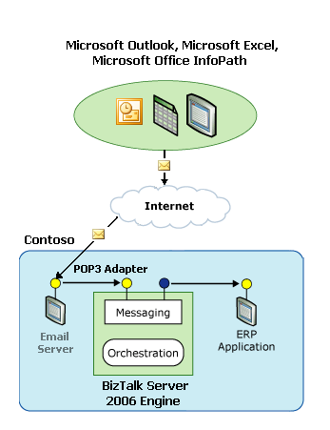
Figure 1. Example POP3 Usage

How to Configure the POP3 Adapter
The process of using the POP3 adapter within a receive location is the same as any of the other built-in transport adapters. The POP3 adapter contains specific configuration settings, as seen in Figure 2, which enable the adapter to communicate with a POP3 server; these settings include mandatory properties such as the name of the mail server, user name and password, and the polling interval. The user name, password, and the other configuration settings for the adapter are all securely stored within the Enterprise Single Sign-on Services (SSO).
Note: The POP3 receive adapter downloads e-mail messages from mailboxes on mail servers and submits them into BizTalk Server as BizTalk Messages. After an e-mail message has been successfully downloaded and persisted into the Message Box (as submitted or suspended) it is deleted from the mail server. If the message cannot be persisted, it is left on the mail server. Please ensure that this behavior is acceptable before testing against a personal mailbox.

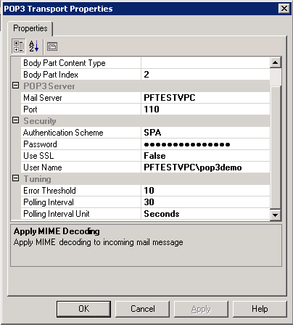
Figure 2. POP3 Adapter Properties Page

Body Part
The POP3 adapter has two configuration properties: BodyPartContentType and BodyPartIndex at the receive location. These properties control which MIME part of the incoming message to use as a BizTalk message body part.
The BodyPartIndex property is used to select the MIME part of the SMTP e-mail to use as the BizTalk message body, for example, Message Context (Index 0), Message Body Part (Index 1) or Message Part (Index 2). A typical e-mail’s message context will contain the SMTP header information, the message body part will contain attachments, and the message part will contain the e-mail body.
The BodyPartContentType property filters for the first part of the message that contains the same content type in its part property as the value specified, for example, text/plain or text/xml.
Note: If the POP3 adapter cannot match a part against either the BodyPartIndex or the BodyPartContentType, then the message submission fails and the message is suspended.

Authentication
The following authentication methods are supported by the POP3 adapter:
- Basic. User name and password are sent to the POP3 server in clear text.
- Digest (APOP). Digest string is used instead of password.
- Secure Password Authentication (SPA). NTLM authentication is used.

Performance Counters
Performance counters are available at the host level. The performance object is called BizTalk:POP receive adapter. The following are the counters available for the POP3 adapter:
- Bytes received. Total number of bytes received. This only includes messages that were persisted into the message box.
- Bytes received/sec. Number of bytes received per second.
- Messages Received. Total number of messages received. This only includes messages that were persisted into the message box.
- Messages Received/sec. Number of messages received per second.
- Active sessions— Number of open connections the adapter is managing at a time.

Windows SharePoint Services
Microsoft Office System 2003 and Microsoft Windows SharePoint Services (WSS) provide powerful features for publishing XML data within an organization. Microsoft BizTalk Server natively supports consuming XML data, connecting to back-end systems, and orchestrating business processes amongst these systems.
By combining multiple systems—the ability of the Microsoft Office System to create XML documents from the desktop, the portal capabilities and document repositories in SharePoint Products and Technologies, and the ability to process XML to communicate with any back-end system with BizTalk—an organization can link the documents and tools familiar to knowledge workers with the enterprise systems that run their businesses.
The goal of the WSS adapter is to make it as easy to access documents stored in SharePoint libraries as it is to access files on a file server. BizTalk Server 2006 introduces the WSS adapter as an in-built transport out-of-the-box.

Configuring a WSS Receive Location
On the receive side, the WSS adapter provides the ability to poll a SharePoint document library, or folder. It calls a Web method on the SharePoint server, which uses the Windows SharePoint Server object model to browse the library, check out the files, and return the file data to the adapter. The adapter then submits the files to the BizTalk Server Message Box and calls another Web method to delete the files from SharePoint. To filter files in a SharePoint library, the adapter can poll the SharePoint library through a SharePoint view. Polling frequency along with other configurations can be set from the property pages in Figure 3.

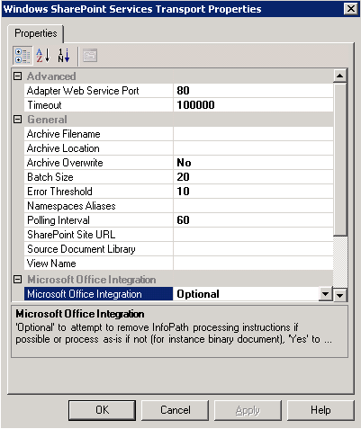
Figure 3. WSS Adapter Transport Property Pages

Interesting properties worth pointing out for the receive adapter are as follows:
- Archive Filename. The file name to be used when archiving the message. This field is similar with the Filename field on send ports, with the exception of the fact that “%SendingOrchestrationID%” and “%SendingOrchestrationType%” placeholders are not supported.
- Archive Location. The path to the folder where the document will be archived after sending into BizTalk. This path is relative to the WSS site. See sample value below. For example, /Archive/PurchaseOrders/.
- Microsoft Office Integration. This property supports the following values:
  - yes — PIs are removed from the XML document.
  - no — Document is processed “as-is.”
  - optional — Any InfoPath PIs that are found are removed, if there are no PIs, or if the message is binary, the message is returned as-is.

Configuring a WSS Send Port
On the send side, the adapter publishes documents to a SharePoint document library by calling a Web method on the WSS server. The adapter specifies the WSS site, document library/list name, file/list item name, and promoted properties to associate with the file (this is not BizTalk property promotion).
By way of the property pages as seen in Figure 4, the adapter can set the file name to a fixed string or to a name derived from the XML data in the document. Deriving the name can be very useful to enforce standard naming conventions. The adapter can also set promoted property values on the file as column values. As with the file names, the promoted property values can be fixed or can be derived from the XML data in the document.
Note: Promoted Properties in WSS Adapter are different entities than Promoted Properties in BizTalk Server, or promoted properties in WSS.
WSS Promoted Properties are used to make XML elements visible when browsing a WSS Forms library. When an InfoPath form is published to a WSS Forms library, InfoPath can configure the Forms library to promote key elements, making this happen automatically. This feature is available in WSS only when using forms document libraries (document libraries that store documents with the same schema).
WSS Adapter property promotion enables the user to promote properties into WSS when documents with different schemas are stored in the same document library.

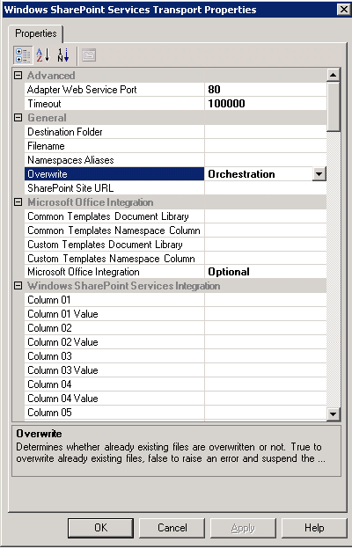
Figure 4. WSS Adapter Transport Property Pages

Properties worth pointing out for the send transport are:
- Override. Whether an already existing WSS file should be overwritten or not. Supported values yes, no, orchestration. The value orchestration means use the value defined by the message context property WSS.ConfigOverwrite. If the property is not defined, then the value defaults to yes.
- Microsoft Office Integration. This property supports three values:
  - yes — PIs are added to the XML document so that the document opens in InfoPath. If no solution is found or the message is binary, the message is suspended.
  - no — the document is saved as-is.
  - orchestration — The orchestration defined value is used. If the orchestration does not define the value, then optional is used.
  - optional — If an appropriate InfoPath solution is found, the document will open in InfoPath, otherwise the document is saved as-is.
- Windows SharePoint Services Integration. Property name: The internal name of the WSS column to be updated with a value from the document. Property Source: The value to be set on the WSS column using expression supported by the property promotion.

Expressions Supported
Expressions allow the end user to easily define the file name value (or custom WSS column value) based on literals as well as values extracted from the message or the BizTalk system.
The expressions can contain literals and placeholders. The literals will show up in the file name as typed. Placeholders must be placed between “%” characters. An example of a placeholder is %MessageID%, which at runtime will be replaced with the GUID of the message.
Placeholder example: %MessageID%
XPath example: %XPATH=//ns0:PurchaseOrder/ns0:ID%

MSMQ Adapter
With BizTalk Server 2006 Adapter for MSMQ, you can now build solutions that integrate Microsoft Message Queuing with BizTalk Server. The MSMQ adapter provides support for sending and receiving messages using MSMQ 2.0 or 3.0, and takes advantage of the new features in MSMQ 3.0.

Configuring MSMQ Receive
The MSMQ Adapter Receive component is capable of accessing different MSMQ Servers and queues, both remote and local.
This can be accomplished by configuring separate Receive Locations where one or more locations are pointing to same or different queues, same or different MSMQ Servers. This flexibility allows the BizTalk Administrator to configure various combinations.

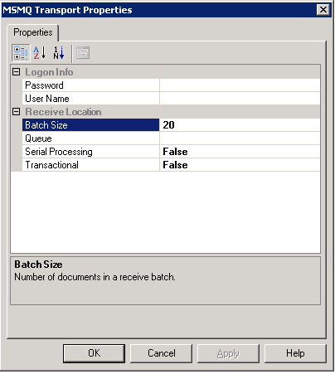
Figure 5. MSMQ Adapter Transport Property Pages

The following properties need to be configured to complete a receive configuration:
- Logon Info. Username/Password, the Windows credentials to use when accessing the queue.
- Queue. The path to the message queue, for example, MachineName\[Private$]\QueueName

Configuring MSMQ Send
The send port of the MSQM adapter can be configured to send messages to an MSMQ queue. This queue could be a local queue, remote definition, or remote queue.
At a minimum, the send port/handler requires the following information to send the message.
- MSMQ Name
- MSMQ Queue Path

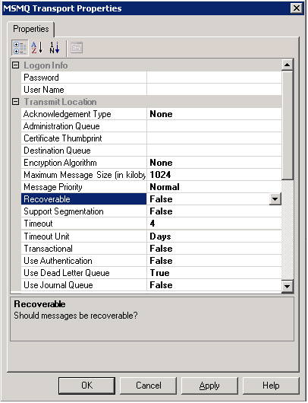
Figure 6. MSMQ Adapter Transport Property Pages

MQ Series Adapter
With The MQSeries adapter, you can quickly build comprehensive messaging solutions for your business. By using the BizTalk Server suite of tools and services, you can enable your existing MQSeries investments with XML, making it possible to more securely and reliably integrate disparate applications.
For BizTalk Server 2004 the MQSeries adapter was available as a download from the Web. In BizTalk Server 2006, the MQSeries support comes built-in. New enhancements have been added to MQSeries adapter; these enhancements include “Dynamic Receive.”

Dynamic Receive
The new MQSeries adapter now includes the ability to perform “dynamic receive” as part of solicit-response. By providing the context properties for MQServer\QM\Queue to get messages from the MQSeries queue as part of a solicit-response, the adapter can receive the response from the specified queue as part of the response. This is used in conjunction with the match option.
The MATCH option is used when receiving messages from MQSeries with solicit-response, for example, wait on the MQGet and look for the match. This can be specified based on MessageID, CorrelationID, GroupID, SequenceNumber, Offset or MsgToken properties.
This feature means that the MQSeries adapter can now determine at run time, the queue it should receive messages from, based on the transport’s match criteria.

Updated Adapters
BizTalk Server 2006 includes enhancement to preexisting adapters such as STMP, File, and HTTP. The following sections explore these enhancements in more detail.

SMTP Adapter
The following section describes the changes and additions to the functionality of SMTP (Simple Mail Transport Protocol) transport adapter. The goal of enhancing the SMTP adapter in BizTalk Server 2006 is to simplify the overall user experience when creating BizTalk applications that require sending e-mail as part of a business process.
The SMTP adapter in BizTalk Server 2004 provided the functionality to transmit e-mails containing the message body as content. Many times this may not be sufficient enough as some business processes need to send human-readable text (HTML) instead of an XML document. In 2004, a developer could use MIME components along with SMTP adapter helps to accomplish this task; however, it involved many configuration steps and custom coding.
In BizTalk Server 2006, this functionality has been enhanced to support sending of plain text or HTML e-mail messages with multiple attachments. BizTalk Server 2006 improves the experience of developing business processes that require e-mail communication and simplifies the configuration steps necessary for enabling those scenarios.

How to Configure the SMTP Adapter
At first glance, the “General” and “Handler override” tabs should look very familiar to those that existed in BizTalk Server 2004. BizTalk Server 2006 introduces two new tabs for the transport properties: “Compose” (Figure 7) and “Attachments” (Figure 8).

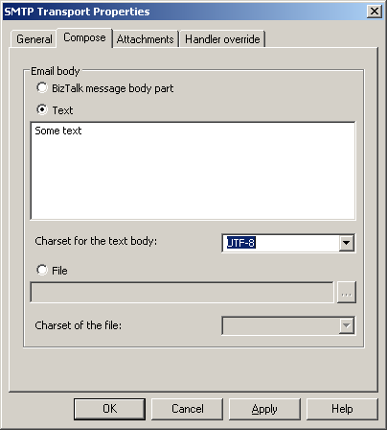
Figure 7. SMTP Adapter Compose Property Pages

The attachments tab, as seen in Figure 8, provides settings that help specify to the adapter how message parts should be handled, these settings include:
- Do not attach part. The default value.
- Attach only body part. The ability to attach the interchange message’s body to the e-mail.
- Attach all parts. The ability to attach all message parts of an interchange to the e-mail.

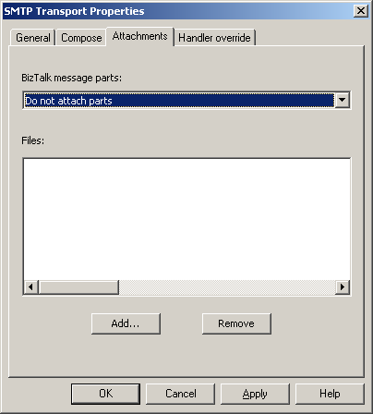
Figure 8. SMTP Adapter Attachments Property Pages

Note: The SMTP adapter does not perform SMIME encryption and digital signing of outgoing messages. To send signed or encrypted messages, the adapter needs to be used in combination with a MIME encoder component in the send pipeline.

Performance Counters
Performance counters are available at the host level. The performance object is called: BizTalk:SMTP send adapter.
- Bytes sent. Total number of bytes sent. This is a number of bytes for all messages that have been sent.
- Bytes sent/sec. Number of bytes sent per second.
- Messages Sent. Number of messages sent. This is a number of messages that have been sent.
- Messages Sent/sec. Number of messages sent per second.

File Adapter
The File adapter is one of the core components of BizTalk Server. BizTalk Server 2006 introduces a number of new enhancements for this adapter. The following enhancements are discussed in this section.

File Adapter Property Page UI
When used within a receive location, the file adapter property page now has three tabs: “General,” “Authentication” and “Batching.” It also has a separate dialog box for configuring advanced options.

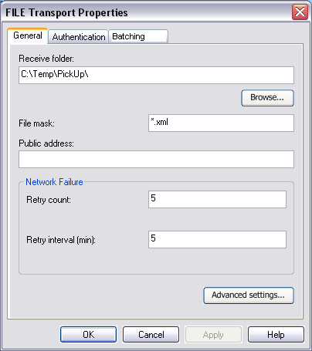
Figure 9. File Adapter General Property Pages

Send location UI
The File send port property page has two tabs: “General” and “Authentication."

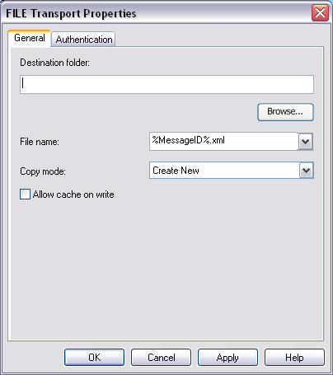
Figure 10. File Transport Properties Dialog Box

Note: A folder browse button is now available on FILE receive/send location property page UI. This button launches the standard Windows folder picker dialog box to select a receive/send folder on a computer where configuration is performed. The dialog box lets user select an existing folder or create a new one.

Alternative Credentials
User credentials necessary to access folders on a remote file share can now be specified using FILE receive location/send port. The File adapter introduces a new property tab called “Authentication”; this tab can be used to specify what credentials to use.
- Host instance. The credentials of the host instance for the File receive adapter are used when accessing folder on a network file share. This is a default setting.
- This user. The specified credentials are used when accessing folder a network file share.

Figure 11. Specifying Alternative Credentials

Note: Because the “This user” credentials can be used only when accessing the folder on a network file share, the FILE adapter property page will issue a validation error when “This user” credentials are specified and the receive or send folder is using the local file system.

Advance Settings
Advance settings for the Receive File Adapter were available in BizTalk Server 2004; however, these settings were only available by way of the registry. BizTalk Server 2006 exposes these setting by way of the File adapter receive location UI Advance dialog box. The following settings are now scoped per receive location as opposed to being scoped for the receive adapter, as a whole, in BizTalk Server 2004.
By clicking Advanced settings button on file receive location property page UI, the user launches a modal dialog box to set additional configuration of file receive location (Figure 12).

Figure 12. File Adapter Advanced Settings Dialog Box

Performance Counters
Receive Adapter
Performance counters are available at the host level. The performance object is called: BizTalk:FILE receive adapter.
- Bytes received. Total number of bytes received. This only includes messages that were persisted into the message box.
- Bytes received/sec. Number of bytes received per second
- Messages Received. Total number of messages received. This only includes messages that were persisted into the message box.
- Messages Received/sec. Number of messages received per second
- Delete retries. Number of retries to delete the read file.

Send Adapter
Performance counters are available at the host level. The performance object is called: BizTalk:FILE send adapter.
- Bytes sent. Total number of bytes sent. This is a number of bytes for all files that have been written to disk.
- Bytes sent/sec. Number of bytes sent per second.
- Messages Sent. Number of messages sent. This is a number of files that have been written to disk.
- Messages Sent/sec. Number of files sent per second.

HTTP Adapter
The HTTP adapter, originally introduced in BizTalk Server 2002, is also one of the most commonly used adapters used in BizTalk Server. BizTalk Server 2006 introduces a number of new enhancements for this adapter. We’ll now look that those improvements.

Suspend Failed Requests
The HTTP receive adapter now has a new configuration setting called Suspend Failed Requests. This setting controls what happens with HTTP requests if inbound processing (receive pipeline failure or routing failure) fail. The new setting has two possible values:
- False (Default). HTTP receive adapter works as in BizTalk Server 2004; if the message fails, it is discarded and error status code (500) is sent to client.
- True. HTTP receive adapter suspends message if it fails routing or pipeline processing. Error status code (202) is sent back to client and the message can be resumed at a later stage.

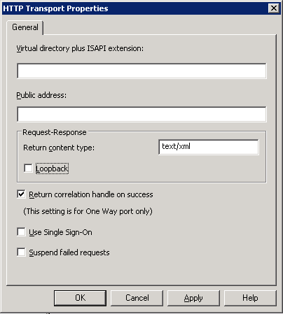
Figure 13. HTTP Adapter Transport Properties

Performance Counters
Receive adapter
Performance counters are available at the host level. The performance object is called: BizTalk:HTTP receive adapter.
- Messages Received. Total number of messages received. This is a number of messages that have been persisted to Message Box (published or suspended).
- Messages Received/sec. Number of message received per second.
- Messages Sent. Number of messages sent. This is a number of response messages that had reached the client.
- Messages Sent/sec. Number of messages sent per second.
- Time to build batch. Average time taken to build an inbound batch.
- Time to add message to batch. Average time between when message is given to adapter by IIS and till message is added to a batch.
- Memory queue size. Number of in-flight inbound messages in queue.

Send adapter
Performance counters are available at the host level. The performance object is called: BizTalk:HTTP send adapter.
- Messages Received. Total number of messages received. This is a number of responses that have been persisted to the Message Box (published or suspended).
- Messages Received/sec. Number of message received per second.
- Messages Sent/sec. Number of messages sent per second.
- Messages Sent. Number of messages sent. This is a number of requests that reached the destination server.
- Memory queue size. Number of in-flight outbound messages in queue.

Summary
BizTalk Server simplifies the integration between two or more line-of-business applications, or trading partners, through common transports and industry standards by providing a common adapter framework. BizTalk Server provides a number of these adapters built on this framework out-of-the-box. BizTalk Server 2006 introduces some new adapters as well as enhancements to existing adapters to further simplify the integration process.
For More Information
http://www.microsoft.com/biztalk

For the latest information about Windows Server System, see the Windows Server System Web site at http://www.microsoft.com/windowsserversystem.


