# Role-Based Template for SharePoint My Sites: Customer Service Manager

***Functional Overview for***

***Business Decision Makers***

### With personalization becoming an increasingly important business need and the key to effective collaboration, Microsoft® Office SharePoint® Server 2007 offers My Site, a personal site that pulls together summary views of personal information and provides full control over information "for me, by me, and about me." Role-Based Templates for SharePoint My Sites are custom templates designed for Office SharePoint Server 2007 and tailored to address the unique needs and requirements of specific roles. They are envisioned as extensions to the standard My Site functionality, providing a personal portal and dashboard data relevant to your role.

### Role-Based Templates for SharePoint My Sites can provide enhanced business insight and help drive company-wide productivity through a common interface to access priority information from varied sources and systems related to job roles, individual responsibilities, and surrounding processes. The templates display information in a way that is familiar and easy, and is built around the way people in the company work, enabling business decision-making with greater confidence.

### Description of Template

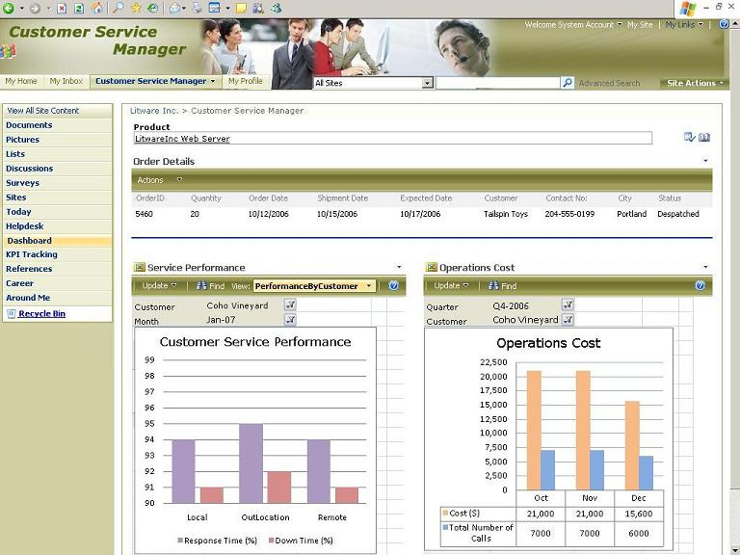The Customer Service Manager monitors the performance and coordinates the activities of the customer services department. To ensure the highest levels of customer satisfaction, a Customer Service Manager is required to constantly monitor various parameters that are indicators of good performance. They include customer satisfaction indicators, vendor performance indicators, help desk parameters, order status, and service representative’s quality indicators.

The Customer Service Manager role-based template for SharePoint My Sites helps managers streamline the process of monitoring performance and enables the quick decision making that is usually required when addressing a customer’s complaints. The template provides a graphical view displaying call distribution, service performance, operation costs and representative quality indicators. It helps review order status and also displays key performance indicators for customer satisfaction and vendor performance. The overall design of this Role-Based My Site template is to help Customer Service Managers attain their goal of 100% customer satisfaction.

**Sample Activities Performed in this Role-Based My Site Template**

Role-based My Site templates provide a consolidated experience by enabling its users to view and access information distributed over various business systems thus accelerating the business processes resulting in increased customer satisfaction. These templates come with sample data. The following example shows how this template might be used in a typical organization.

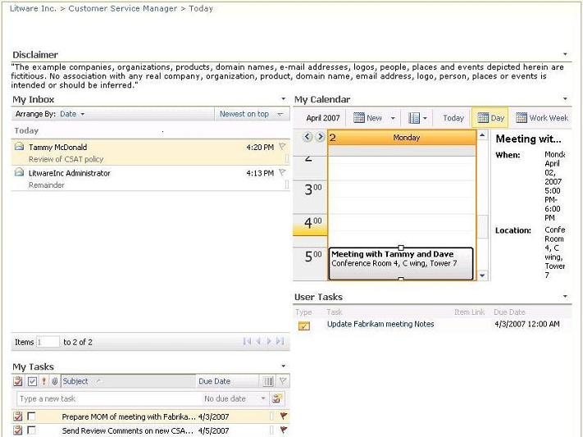

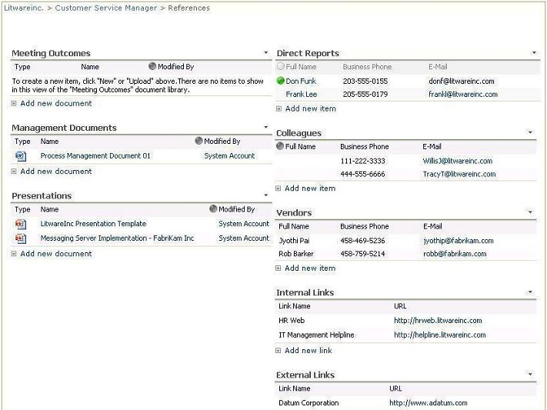Marie is a Customer Service Manager in Litware Inc’s Customer Service department. She starts her day by accessing her personal productivity tool, Microsoft Office Outlook**®** 2007. Since her company has deployed Microsoft Office SharePoint Server 2007 and Role-Based My Site templates, she also logs into her personal My Site page. A quick glance at the Calendar in her My Inbox page reminds her of a meeting with the CEO and the Vice President, Customer Services at 5 PM. She also sees under the User Tasks section that she had assigned a task to herself to update the meeting notes for a teleconference that she attended with Fabrikam Inc yesterday evening for a proposal. She goes to the References page and posts the info to the Meeting Outcomes library using the Microsoft Office InfoPath® 2007 form template. While in the Reference page she sees that the Presence icon indicates one of her direct reports is online. She sends him an instant message asking him to mail her the management document she needs for the meeting scheduled for 5pm.

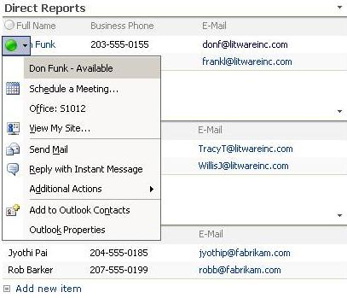

Later in the day, Marie receives a call from a customer, Coho Vineyard, complaining about the repeated delay in service for the Litware Inc Web Server product. Since this is one of her major customers, she immediately reacts and proceeds to analyze the root cause of the problem.

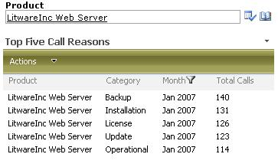Marie visits the Help Desk page to check the top five call reasons for Litware Inc Web Server. In the same page she also checks the Help Desk parameters pertaining to the Web Server product for the current month and gets information about the percentage of calls escalated and the percentage of calls closed over phone. She also checks the Call Distribution by product and finds that this product had the most number of calls in the current month as well as the previous month. Visiting the Dashboard page she checks Service Performance – PerformanceByCustomer. She selects performance for her customer, Coho Vineyard, and sees that the Average Response Time was poor (<98%) and also the Average Down Time was poor (<98%).

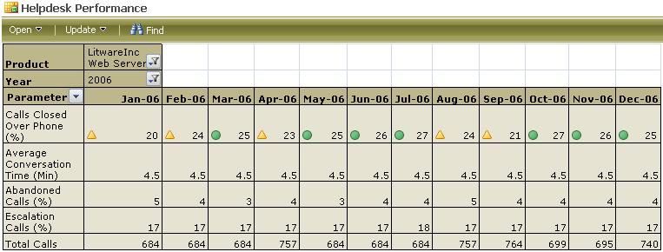

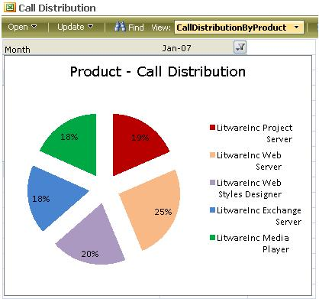The KPI Tracking page shows Marie which vendor is responsible for such poor performance. She first selects January 2007, then selects the customer, Coho Vineyard, and notices that the customer satisfaction rating for the customer is low and that customer expectations have not been met. To figure out the responsible vendor, she selects each vendor in the Customer-Vendor hierarchy under Coho Vineyard. During this process she notices that the vendor Fabrikam Inc had performed poorly in terms of Response and Resolution. She finds that the vendor is not experienced enough to handle this product space. She decides to outsource that contract to another vendor who has been performing well.

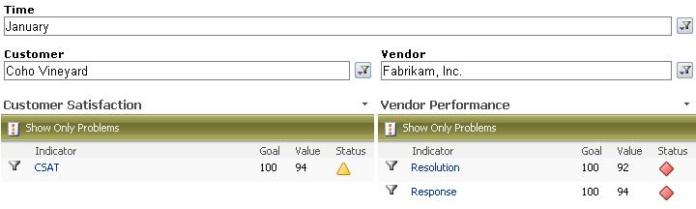

To improve the quality of service provided by her customer service representatives, Marie decides to organize training sessions for them. She looks at the quality indicators and realizes that a couple of the representatives have not completed their required number of sessions for various subjects. She decides to organize training for them to improve their skills.

Marie goes for a coffee break and bumps into another customer service manager who asks her to check out the announcements. Back in the office she checks out her Around Me page. She sees that one of the help desk teams in her department has been awarded the “Feather in the Cap” award. Marie goes to her Career page to update the organization objectives, and adds it to her Awards and Rewards section.

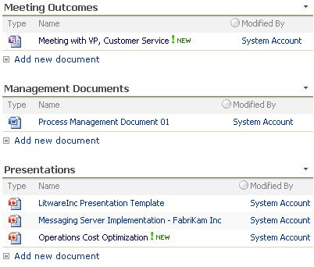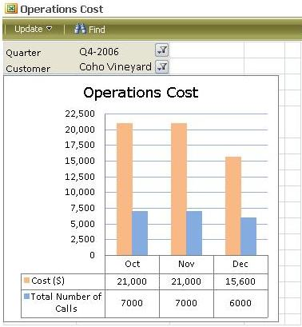Marie gets a reminder email to prepare the presentation on operational cost and her ideas to optimize them. She visits the Dashboard page, looks at the operation cost for the customers, prepares a presentation and uploads it under Presentations in her References page. This triggers an approval workflow, routing the document to her supervisor.

Returning to her My Inbox page, she finds a training remainder. She attends the session and changes the status to “closed” for the training list in her Career page. At the end of the day, Marie updates herself with the latest company info by visiting the Around Me page.

**About Microsoft Office SharePoint Server 2007**

Microsoft Office SharePoint Server 2007 is an integrated suite of server capabilities that can help improve organizational effectiveness by providing comprehensive content management and enterprise search, accelerating shared business processes, and facilitating information-sharing across boundaries for better business insight. Office SharePoint Server 2007 supports all intranet, extranet, and Web applications across an enterprise within one integrated platform, instead of relying on separate fragmented systems. Additionally, this collaboration and content management server provides IT professionals and developers with the platform and tools they need for server administration, application extensibility, and interoperability.

**More Information**

For more information on the technologies described in this article, please visit:

Microsoft Office SharePoint Server 2007:

<http://www.microsoft.com/sharepoint>

Role-Based Templates for SharePoint My Sites:

<http://go.microsoft.com/?linkid=6060804>