Real Estate Agent Discovers New Tools to Help Secure Listing Agreements
Microsoft Office System Customer Solution
Case study

Case Study


With interest rates at historic lows, the U.S. housing market has seen near-record sales over the last few years. For real estate agents it has translated into both an opportunity and a challenge. In a “hot” market, how does an individual agent stand out, secure the property listing or complete a sale? According to Trevor Thirsk, a Northwest real estate agent with John L. Scott Real Estate, it’s all about finding ways to be different.
“My challenge? How to represent myself better than every other agent out there so I win the listing. My goal is to outwork them and out-technology them as well. I’m now getting one to two more listing opportunities per month.”
Trevor Thirsk
Agent
John L. Scott Real Estate

Microsoft Office Small Business Edition 2003 is the technology that is helping Thirsk succeed in his real estate career. It enables a single view of his clients, allows him to communicate effortlessly, and create professional looking marketing materials with ease.
Customer Profile | Business situation | Solution | benefits
Trevor Thirsk is a REALTOR® for John L. Scott Real Estate, a Washington-based regional broker. His office is located in the mostly rural market area of Monroe, Washington. He is one of the top three agents in the office with annual sales of $3.4 million. | Thirsk’s main challenge is to set himself apart from other real estate agents in his market area in order to secure new listings from prospective clients. | Using Microsoft® Office Small Business Edition 2003, Trevor now has critical client data on his laptop while on the road, can create powerful marketing materials quickly, and can communicate and market to clients and prospects more easily. | - Provides a single view of all customer interactions and contacts, saving time while better serving clients  - Reduces the costs of producing professional-looking marketing materials, saving $100–200 per month  - Increases personal selling time by 30–60 minutes each day


John L. Scott Real Estate is one of the largest independent residential real estate companies in the U.S., with more than 3,000 sales associates in more than 115 offices in Washington, Oregon, and Idaho.
“It’s not unusual to have 8 to 12 different people you’re working with for each listing or sale. If you have a half dozen or more properties going at the same time, it’s easy to drop a ball somewhere.”
Trevor Thirsk
Agent
John L. Scott Real Estate

At 27 years old, Trevor Thirsk has two years of experience in an industry that has salespeople who average 52 years old with 13 years of experience. Though young, he is one of the top sales producers in the John L. Scott office in Monroe, Washington. He is on track to earn the President’s Award this year, which represents the top 10 percent of the real estate agents companywide.
However, he does face challenges:
- Overwhelming paper. Even with the use of a computer, much of the paperwork associated with the buying and selling of a home finds its way into manila folders. With most transactions stretching over several weeks, the difficulty in quickly finding the right piece of paper in a two-inch-thick folder grows. In addition, tracking each client interaction using handwritten notes or various documents stored on a computer can create havoc when it’s time to retrieve specific information.
- E-mail management. E-mail sometimes can overwhelm even the most vigilant, and keeping track of action items and follow-up can be a challenge. “It’s not unusual to have 8 to 12 different people you’re working with for each listing or sale. If you have a half dozen or more properties going at the same time, it’s easy to drop a ball somewhere,” says Thirsk.
- Marketing materials expense. According to the National Association of Realtors 2001–2002 Report, the largest expense for an agent is promotion and marketing materials with 51 percent of agents spending more than $1,000 per year. The creation and production of flyers, reports, presentations, and mailers, can be expensive and time consuming. Most of the materials require customized content for each property.
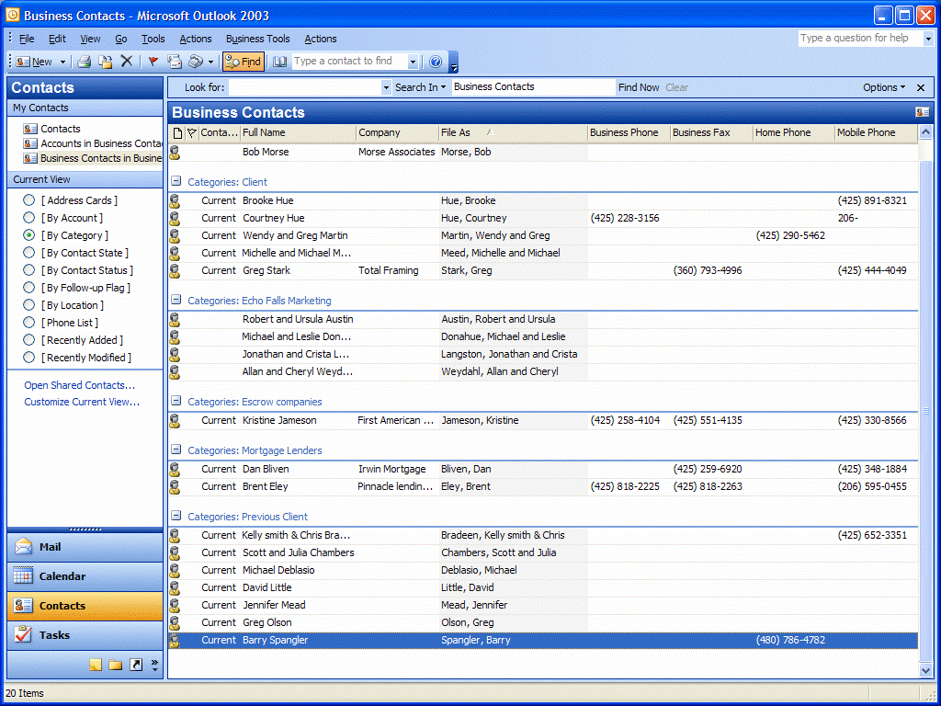
With Business Contact Manager, a real estate agent can create client categories that represent specific housing developments or special locations such as golf course or lakeside properties.

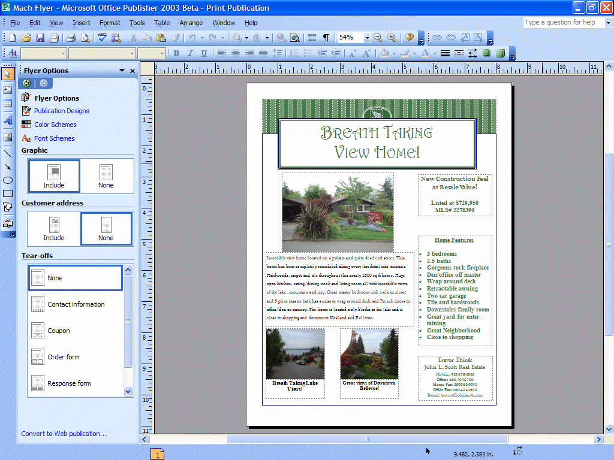

Customized listing flyers are easy to produce using Publisher templates and a color printer. Thirsk often creates a sample listing flyer to pitch and close a prospective client.

Given the fast-pace competitive environment (especially so with the lowest interest rates in 30 years), Thirsk’s challenge was to find ways to operate more efficiently and make his efforts stand out. New technology helped him gain a competitive advantage and increase his own personal “curb appeal” with clients.
Thirsk now uses a new HP 4200 notebook computer running the Microsoft® Windows® XP Professional operating system and Microsoft Office Small Business Edition 2003. Both his office and home use DSL technology and run on a wireless network.



Single View of the Client
Trevor has discovered powerful benefits to using Microsoft Office Outlook® 2003 with Business Contact Manager.
“Most of the paperwork that was once in client folders is now in my contact manager program,” says Thirsk. “All e-mail, faxes, Word documents, and notes are in one place, linked directly to a specific client. I’m saving a lot of time each day by not having to hunt through files.”
For key paper documents like listing agreements, Trevor simply scans them, quickly turning them into electronic files that he can store and retrieve in Microsoft Office Outlook® 2003 with Business Contact Manager.

Control of E-Mail
Trevor immediately noticed and valued the new user interface in the Outlook 2003 messaging and collaboration client. The new three-pane view is very easy to read and navigate. E-mail messages are quick to read without having to open each one individually. And the color-coding capabilities allow for rapid visual recognition for prioritizing correspondence and communication.
The new junk mail control functionality can detect and place likely junk mail messages into a single folder that can be reviewed at will or discarded. This allows the user to concentrate on the most important e-mail messages and actions. Trevor estimates he saves 15 to 20 minutes each day because of the junk e-mail filter.

Fast, Inexpensive Marketing Materials


Microsoft® Windows® XP Professional
Microsoft Office System
- Office Small Business Edition 2003

Hardware
HP 4200 notebook computer with a 2-GHz Pentium processor, 256 MB of RAM, 40-GB hard disk drive, CD/DVD drive, and floppy disk drive
Thirsk uses Microsoft Office Publisher 2003 to quickly create and manage all key marketing materials, including comparative market reports, street-box flyers, pamphlets, postcards, presentations, and announcements.
“I use the pre-designed templates for my marketing materials so there is a consistent, professional look,” says Thirsk. “And I save $100 to $200 per month doing it myself.”
Another powerful feature of Publisher 2003 is the ability to create once and publish multiple times. This has been particularly useful as Thirsk has designed postcards and flyers that can be printed or sent by e-mail to prospects, keeping all the rich formatting and graphics while saving on postage.
“I can now create a street-box flyer with photos, graphics, and text, e-mail it to my new client, and get approval without having to interrupt their dinner or waste time getting linked up,” says Thirsk. “It’s a simple thing, but it’s less hassle for the client and saves me one to two hours.”
Overall, Trevor estimates that he saves 30 to 60 minutes each day because of his use of Office Small Business Edition 2003. E-mail management, creating professional-looking marketing materials, and having a single view of each client give him more time to sell new prospects and keep his existing clients happy.

Microsoft Office is the business world’s chosen environment for information work that provides the software, servers, and services that help you succeed by transforming information into impact.
For more information about the Microsoft Office System, go to:
http://www.microsoft.com/office/


For more information about Microsoft products and services, call the Microsoft Sales Information Center at (800) 426-9400. In Canada, call the Microsoft Canada Information Centre at (877) 568-2495. Customers who are deaf or hard-of-hearing can reach Microsoft text telephone (TTY/TDD) services at (800) 892-5234 in the United States or (905) 568-9641 in Canada. Outside the 50 United States and Canada, please contact your local Microsoft subsidiary. To access information using the World Wide Web, go to: http://www.microsoft.com/ | For more information about John L. Scott products and services, call (800) 872-7268 or visit the Web site at:  http://www.johnlscott.com/ | © 2003 Microsoft Corporation. All rights reserved.  This case study is for informational purposes only. MICROSOFT MAKES NO WARRANTIES, EXPRESS OR IMPLIED, IN THIS SUMMARY.  Microsoft, the Office logo, Outlook and Windows are either registered trademarks or trademarks of Microsoft Corporation in the United States and/or other countries. The names of actual companies and products mentioned herein may be the trademarks of their respective owners.
Published: October 2003

