
COMMUNICATOR

Microsoft Dynamics™ SL

Enhance control of project progress and profitability by increasing awareness of changes in key indicators or documents awaiting action. Automated alerts keep you informed of pending deadlines, required approvals, escalating costs, and eroding margins, making it easy to intervene so projects and profits stay on track.

Benefits
- Speed up review processes
Receive notice of budgets, invoices,
timecards or expense reports awaiting
review so they can be processed
immediately.

- Avoid financial surprises
Set alerts to warn you if project margins, expenses, accounts receivable, or other important indicators cross limits you define so that timely corrective actions can be taken.

- Track business performance
Keep tabs on profitability or other important measures without repeatedly poring over project details by receiving defined messages linked to financial results.

- Ensure documentation compliance
Efficiently maintain important documents related to insurance, liens, permits, or specifications, automatically sending reminders to responsible managers when updates or other actions are required.

- Manage projects proactively
Rely on automated exception notices to
alert you to potential project problem areas while you still have time to take action.

Receive messages
that alert you to take action
or address potential problems.

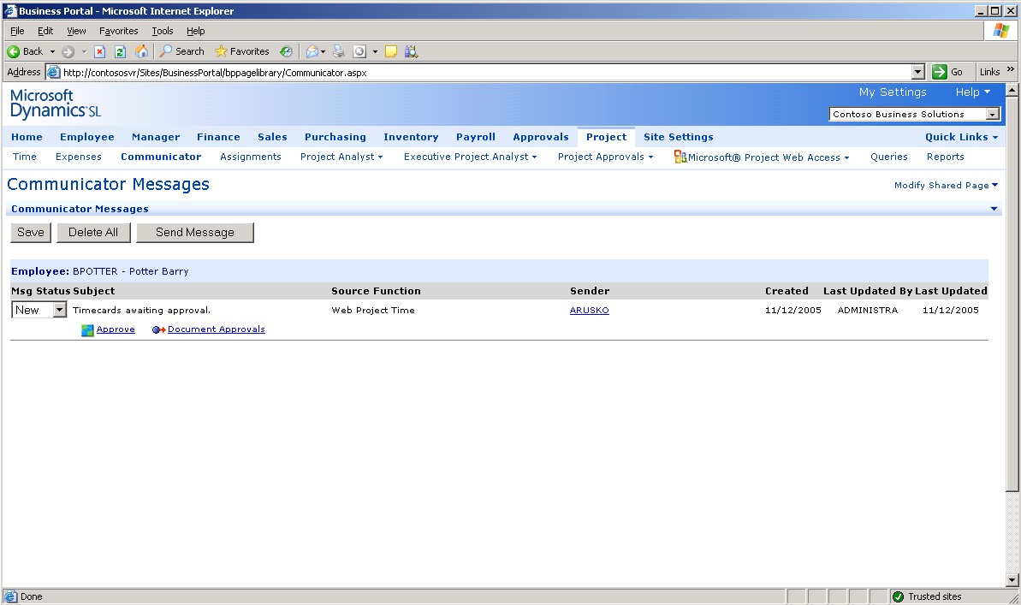

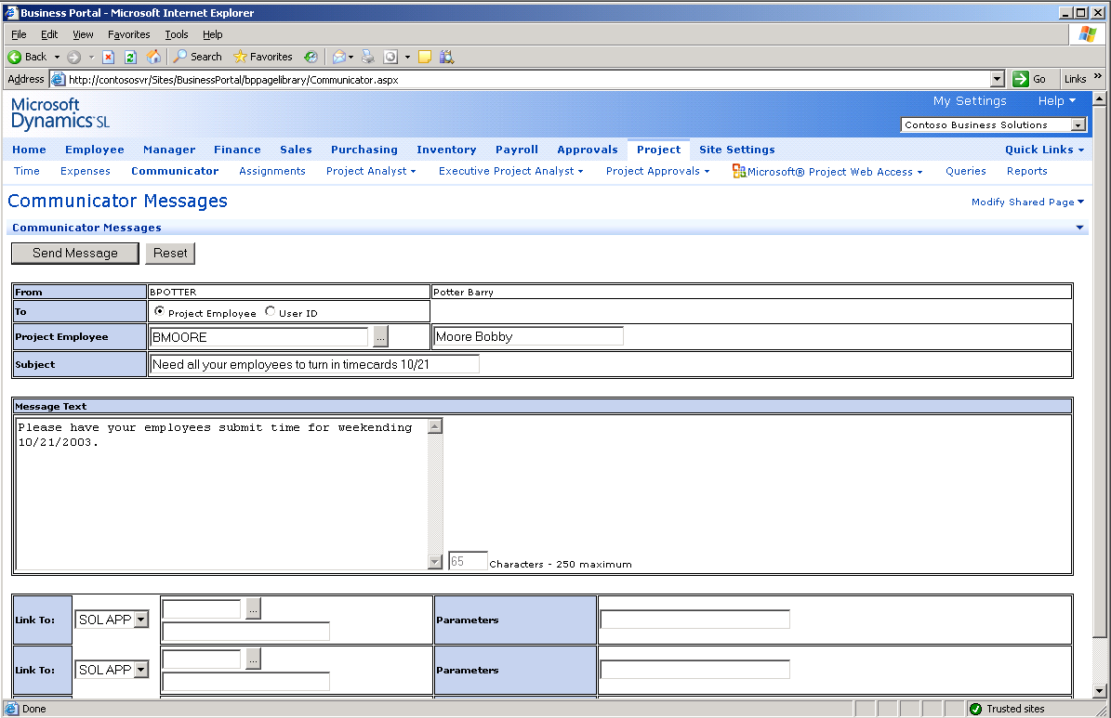

Send messages
to prompt others to take action.



FEATURES

BENEFITS

Improved Project Results | Respond quickly to automated, user-defined exception notices that  point out problem areas while you can still make necessary adjustments.
Streamlined Workflow | Learn about pending timecards, budgets, and other documents the  moment they are ready for review to ensure quick handling and  eliminate delays.
Performance Management | Save time tracking results by requesting notice if key project financials  or schedule milestones stray from targets you define.
Flexible Messaging | Create custom alerts to monitor any important project parameter,  sending the alerts to any user or project employee working in Microsoft  Dynamics SL.
Ad Hoc Messages | Create new project messages as you need them, embedding hot links to  any Microsoft Dynamics SL module or other URL, and send the messages  immediately using the Communicator Send feature.
Distribution Options | Read alerts and messages from within Microsoft Dynamics SL project  accounting modules by using the View Messages screen; receive them  via e-mail; or both.
Remote Access | Keep abreast of project workflow and alerts from the field using Internet  and e-mail messaging options.
Full Integration | Handle pressing project tasks with one-click efficiency thanks to shared  data between Communicator and other Microsoft Dynamics SL modules.

This document is for information purposes only.
MICROSOFT MAKES NO WARRANTIES, EXPRESS, IMPLIED, OR STATUTORY, AS TO THE INFORMATION IN THIS DOCUMENT.

© 2005 Microsoft Corporation. All rights reserved.
Microsoft, The Microsoft Dynamics Logo, are either registered trademarks or trademarks of Microsoft Corporation or Microsoft Business Solutions ApS in the United States and/or other countries. Microsoft Business Solutions ApS is a subsidiary of Microsoft Corporation.

For more information about Microsoft Dynamics™ SL, visit: http/www.microsoft.com/dynamics/sl

