

Running Microsoft SQL Server 2008 on Windows Server 2008

White Paper

Published: February 2008

Updated: July 2008

**Summary:** The combination of SQL Server 2008 and Windows Server 2008 offers enterprise IT administrators and professional developers a superlative platform for mission-critical applications together with enhanced end-to-end security, management, and development capabilities.

For the latest information, see [Microsoft SQL Server 2008](http://www.microsoft.com/sqlserver/2008/en/us/default.aspx).

Contents

Introduction 1

Mission-Critical Data Solutions 1

Compliance 3

Management and Total Cost of Ownership 4

Policy-Based Management 4

Server Administration 6

Performance Management 8

Database Consolidation and Virtualization 10

Consolidating with Virtual Database Servers 10

Application Development 11

Comprehensive Data Application Platform 11

Conclusion 13

# Introduction

This paper describes the advantages of running Microsoft® SQL Server® 2008 on Windows Server® 2008. This paper also explains how your organization can maximize the benefit from combining these two industry-leading products to provide a platform for mission critical applications with enhanced end-to-end security, management, and development capabilities.

## Mission-Critical Data Solutions

The combination of SQL Server 2008 and Windows Server 2008 makes a powerful platform for mission-critical data and business intelligence solutions. Together, SQL Server 2008 and Windows Server 2008 provide a highly compelling solution for security, compliance, and high availability.

### Security

The Microsoft Trustworthy Computing (TWC) initiative helps to ensure that all Microsoft products incorporate security as a prime design and development consideration. The goal of this initiative is to produce products that are secure by design, secure by default, and secure in deployment. Both SQL Server 2008 and Windows Server 2008 follow the TWC requirements and are designed from inception to release with security in mind. This approach adds significant enhancements to the advances that were made in previous releases.

### Authentication

Windows Server 2008 and SQL Server 2008 work together to provide a secure platform through a strong authentication mechanism that integrates Windows authentication with SQL Server. Windows Server 2008 supports numerous authentication mechanisms, including user name and password combinations, smartcard-based certificates, and biometric devices such as fingerprint readers.

Windows Server 2008 has a new authentication architecture and includes enhancements in the area of identity and access management such as Active Directory Certificate Services. These enhancements make it easier to control the enrollment of smart cards, which helps to ensure high levels of security while delegating security administration across a large enterprise.

For enterprise data services, the benefits brought by the security feature enhancements in Windows Server 2008 reduce the total cost of ownership (TCO) of database solutions through integrated authentication. SQL Server database users can use their Windows credentials to connect to database servers, which enables your data services to take advantage of a mature authentication technology that supports password policies and credential encryption.

Integrating SQL Server authentication with Windows Server also reduces security management overhead by centralizing user account management into Active Directory directory services. This centralization ensures that users do not need to remember multiple sets of credentials.

### Data Protection

Data security is a key requirement in any data services solution, and the combination of Windows Server 2008 and SQL Server 2008 provides end-to-end data protection through a powerful set of encryption-based technologies. Windows Server 2008 provides encrypted data transfer across network connections through built-in support for IP Security (IPSec). Windows Server 2008 provides an enhanced implementation of IPSec, which simplifies configuration and reduces management overhead.

SQL Server 2008 extends this ability to protect data as it is transferred across the network by supporting encrypted database connections, and also provides powerful new transparent data encryption (TDE) functionality. TDE encrypts data in the database and in backup files without requiring any changes to client applications that access the data.

TDE protects data in scenarios when the data files or backup files could potentially be accessed and copied. When combined with support for hardware security modules (such as certificates stored on smart cards or Universal Serial Bus keys), TDE provides an effective way to protect data that is stored in databases on laptop computers. This encryption ensures that if the computer is lost or stolen, the database cannot be opened without the corresponding security hardware module.

For even greater data protection in this scenario, Windows Server 2008 provides enhanced Microsoft BitLocker™ drive encryption technology that you can use to encrypt all of the hard disks within the computer.

### Reduced Attack Surface

Both Windows Server 2008 and SQL Server 2008 provide innovations to reduce the attack surface by disabling unnecessary services and include a policy-based approach to enforcing configuration settings across the enterprise. This ability to control services and features proactively makes it easier to minimize the opportunities for malicious attackers to compromise security and results in a more consistently secure environment.

Windows Server 2008 also promotes a secure computing environment through Network Access Protection (NAP), which enforces health requirements by monitoring and assessing the health of computers when they attempt to connect or communicate on a network. With NAP, network administrators can reduce threats to network security that are caused by computers without the latest software patches or adequate antivirus protection.

## Compliance

Compliance is increasingly important to many organizations, especially those that are subject to legislation or industry codes of practice. A central requirement with any compliance solution is the ability to log events comprehensively and securely, and to be able to archive and view these logged events in a central repository.

SQL Server 2008 extends the auditing capabilities of previous releases by including the capability to audit all actions. By creating an **Audit** object and an **Audit Specification** object, SQL Server database administrators can log data access events to a file, the Windows Application log, or the Windows Security log. You can audit events with as much detail as required at both the server and database level and force specific actions, such as stopping the server if the log destination becomes inaccessible.

Enhancements to Directory Service auditing, event logging improvements in Windows Server 2008, and the new event forwarding capability on computers that run the Windows Vista® operating system enable you to centralize database server auditing across the enterprise, which simplifies compliance and reduces TCO.

### Availability

High availability is an essential feature for mission-critical applications. High availability technologies ensure that server downtime is kept to an absolute minimum, thus maximizing productivity and preventing revenue losses.

### Dynamic Hardware Partitioning

One significant cause of server downtime is planned maintenance, which typically results from actions such as adding or replacing memory, processors, or input/output devices (network cards and host bus adapters). 64-bit and Itanium versions of Windows Server 2008 support dynamic hardware partitioning, which ensures service continuity during hardware upgrades to computers that are running mission-critical SQL Server 2008 databases.

SQL Server 2008 builds on the support for hot-add memory in previous releases by providing a new hot-add CPU capability when running on Windows Server 2008. This capability enables mission-critical applications to scale without requiring any planned database server downtime.

### Clustering

On other occasions, unplanned database server downtime can occur because of hardware failures or natural disasters. Typically, organizations protect mission-critical servers from these kinds of failures by deploying server clusters. Window Server 2008 considerably simplifies the process of setting up and managing failover clustering. The new wizard-based cluster validation tool helps to ensure that you have adequate hardware resources for a clustered solution.

Windows Server 2008 Enterprise and Datacenter editions extend the clustering abilities of previous versions of Windows by reducing hardware and infrastructure requirements for clustering and by supporting up to 16 nodes in a cluster. Windows Server 2008 clustering also supports globally unique identifier partition table (GPT) disks. GPT disks are particularly suitable for SQL Server 2008, because these disks support single partitions in excess of 2 terabytes and provide redundancy for storing partition information.

By taking advantage of the clustering enhancements in Windows Server 2008, SQL Server 2008 provides a robust high-availability solution for an entire SQL Server instance.

### Database Mirroring

To provide greater protection for mission-critical data, SQL Server 2008 implements database mirroring. This provides complete or nearly complete database redundancy in the event of a disaster or planned upgrade. Database mirroring provides a high availability solution that does not require proprietary hardware, is easy to set up and manage, and provides automatic client redirection. SQL Server 2008 Enterprise protects against page corruption by fetching the mirror version of a corrupt page from a partner server automatically.

# Management and Total Cost of Ownership

Manageability is a significant factor in the total cost of ownership (TCO) of any IT solution. The combination of Windows and SQL Server has created a long history of innovative administrative capabilities that simplify management of complex deployments. Together, Windows Server 2008 and SQL Server 2008 develop and extend that manageability.

## Policy-Based Management

Windows Server 2008 continues to support the proactive configuration management capabilities of previous releases of Group Policy. This latest release has been enhanced to extend the configuration settings that can be enforced though Group Policy and to make it easier for administrators to configure Group Policy across the enterprise.

The new policy-based management feature in SQL Server 2008 uses the proactive configuration management capabilities in Windows Server 2008 to define policies that apply to servers, databases, and other objects in your data environment. Well-defined policies can help you to control and manage change proactively within the data services environment.

Policy-based management delivers the following benefits:

* **Management by Intent**. Policies provide a logical view of the system configuration, which enables you to define the desired configuration of data services proactively, instead of making changes in response to issues when they arise.
* **Intelligent Monitoring**. Policies can monitor and prevent changes to the system that deviate from the desired configuration.
* **Virtualized Management**. With policy-based management, you can scale management across multiple servers, which simplifies enforcement of consistent configuration policies across the enterprise.

SQL Server 2008 includes a number of pre-defined *facets*, with each facet describing a set of configurable settings that relate to a specific aspect of a SQL Server policy-based management target (such as a server or a database). You can define *conditions* that specify the desired state of the settings in a facet, and then create *policies* that determine how those conditions are enforced. SQL Server then checks policy compliance on demand or automatically on a scheduled basis. These policies can also reject or log non-compliant changes to targets.

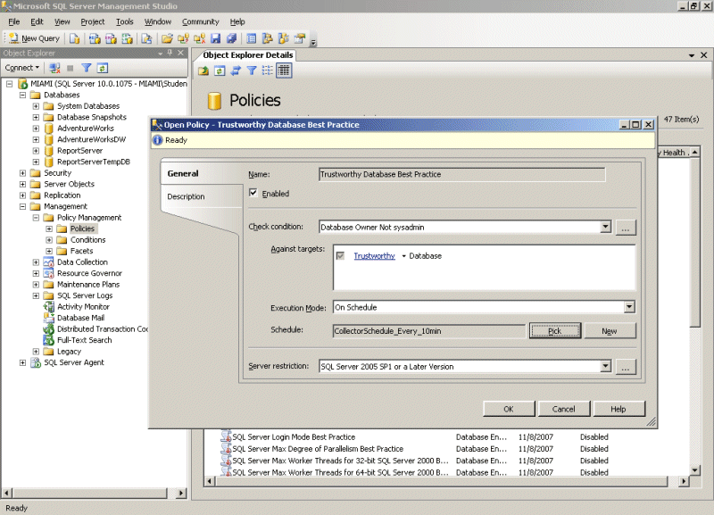

Figure 1: SQL Server 2008 Policy-Based Management

The combination of Group Policy for Windows computers and users with Policy-Based Management for database servers enables organizations to manage configuration settings proactively. This combination ensures compliance with IT policies across the enterprise and significantly reduces the administrative overhead of large, complex, multi-computer environments.

## Server Administration

The installation, configuration, and ongoing management of servers can be a considerable administrative burden in a large organization with multiple servers. To reduce this overhead, both Windows Server 2008 and SQL Server 2008 provide comprehensive management tools that you can use to manage multiple server instances across the enterprise.

Windows Server 2008 includes Server Manager (shown in Figure 2), a single management interface that guides administrators through the end-to-end process of installing, configuring, and managing Windows server roles and features. Windows Server 2008 also simplifies the management of remote servers, such as servers in branch offices, and enhances Active Directory, by introducing read-only domain controllers and administrative role separation.

For data services, SQL Server Management Studio provides a single, consistent environment for managing database servers, SQL Server Analysis Services instances, SQL Server Reporting Services instances, and SQL Server Integration Services. SQL Server 2008 also introduces Central Management Servers (CMS), which you can use to manage a group of SQL Server database servers as a single unit, for example by using SQL Server Management Studio to run a Transact-SQL script on all of the servers in a group. The CMS stores server registrations which can be shared among a DBA team. Actions on groups of servers can also be done against servers that have been registered locally in SSMS by a DBA.

Windows Server 2008 includes Windows PowerShell, which provides a powerful command-line scripting environment that enables administrators to automate administrative task across multiple servers easily. By writing PowerShell scripts that use the Microsoft .NET Framework, administrators can create sophisticated management utilities that simplify multi-server administration and automate complex tasks for database servers and other computers throughout the enterprise.

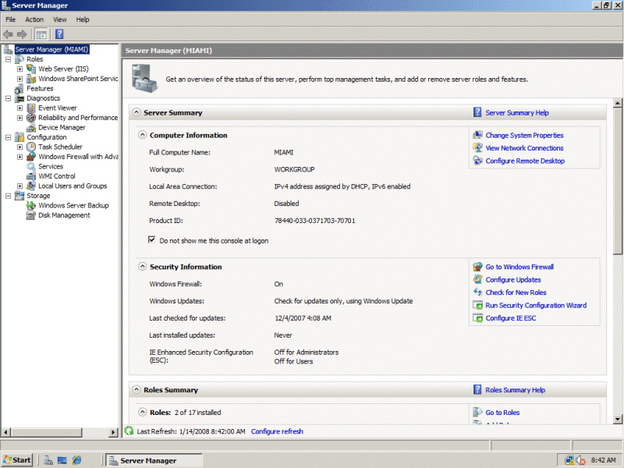

Figure 2: Windows Server 2008 Server Manager

## Performance Management

Performance management is an important aspect of overall system management. SQL Server 2008 and Windows Server 2008 both provide new and enhanced features that simplify performance management across the enterprise.

Windows Server 2008 includes new performance monitoring and diagnostic tools, such as Windows Reliability and Performance Monitor (shown in Figure 3). This tool provides enhanced monitoring that enables you to track reliability issues and identify performance bottlenecks over extended periods. The information provided by this tool can be extremely useful when troubleshooting performance or reliability issues in mission-critical database servers.

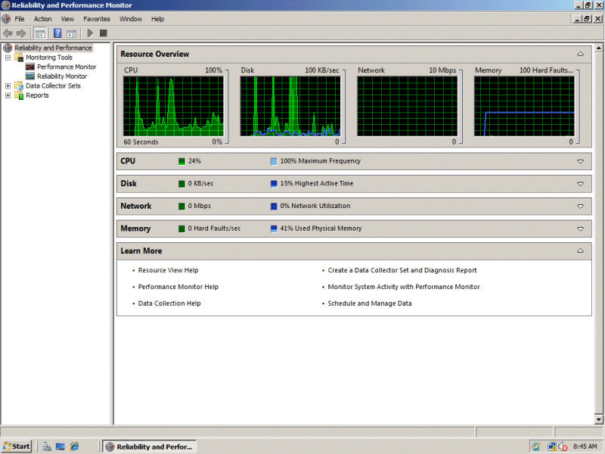

Figure 3: Windows Server 2008 Reliability and Performance Monitor

SQL Server 2008 supplements the monitoring capabilities of Windows Server 2008 by introducing Performance Data Collector, an integrated framework that you can use to collect, analyze, troubleshoot, and store SQL Server diagnostics information. Performance Data Collector provides an end-to-end solution for performance monitoring that includes low overhead collection, centralized storage of performance data in a management data warehouse, and analytical reporting of performance data.

You can use SQL Server Management Studio to manage collection tasks, such as enabling the data collector, starting a collection set, and viewing system collection set reports. You can also use system-stored procedures and the Performance Data Collector application programming interface to build your own performance management utilities based on Performance Data Collector.

While Performance and Reliability Monitor and Performance Data Collector can provide insights about the performance of database servers throughout the organization, you may often find it challenging to provide predictable performance for a given workload on a server because other workloads on the same server compete for system resources. With multiple workloads on a single server, you must avoid resource conflict problems, such as a runaway query that starves another workload of system resources, or low priority workloads that adversely affect high priority workloads.

SQL Server 2008 includes Resource Governor, which enables you to define limits and assign priorities to individual workloads on a SQL Server instance. Workloads include factors such as users, applications, and databases. By defining limits on resources, you can minimize the possibility of runaway queries and limit the resources on workloads that can monopolize these resources. You can also set priorities to optimize the performance of a mission-critical process while maintaining predictability for the other workloads on the server.

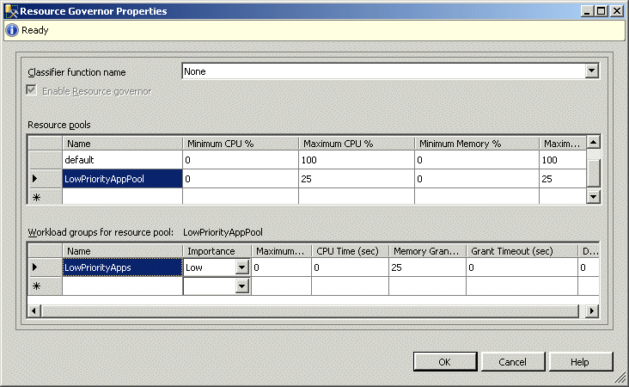

Figure 4: SQL Server 2008 Resource Governor

# Database Consolidation and Virtualization

As organizations deploy increasing numbers of applications to manage business processes, provide new services, and gain an insight into business performance, the number of application servers and data storage servers that are required to support those applications has grown significantly. In many organizations, the hardware costs and the overhead of deploying and maintaining multiple servers throughout the enterprise is a major financial and logistical burden.

However, recent advances in hardware and software technologies mean that modern IT systems can handle significantly greater workloads than previously possible. This increase in capacity and capability has enabled organizations to consolidate network services onto fewer physical servers, which results in higher utilization and better return on investment. Consolidation reduces the costs that are associated with buying, operating, and maintaining servers and enables more efficient and effective IT infrastructure management.

## Consolidating with Virtual Database Servers

Windows Server 2008 introduces Hyper-V, a new hypervisor-based virtualization technology that enables organizations to consolidate multiple server roles within separate virtual machines that are running on a single physical host computer. The use of virtualization to consolidate multiple servers onto fewer host computers helps to lower TCO. These TCO reductions result from:

* Lower power requirements.
* Reduced cooling costs.
* Reduced management costs.

Server consolidation also improves operational flexibility by:

* Enabling automated provisioning of virtual computers.
* Running both 32-bit and 64-bit workloads on the same platform.
* Hosting third-party operating systems within Windows Server 2008.

You can further combine the ability to consolidate multiple servers through virtualization in Windows Server 2008 with the multi-database and multi-instance capabilities of SQL Server 2008 to create a flexible and dynamic data center. This data center can meet the security, configuration, and operational needs of your organization on a significantly reduced number of physical servers.

Finally, SQL Server 2008 Enterprise enables you to reduce licensing costs when hosted on Windows Server 2008. With the Enterprise edition, a single SQL Server license is valid for unlimited instances of SQL Server in multiple virtual machines on the same physical computer.

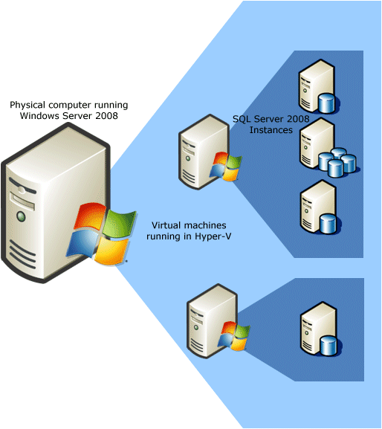

Figure 5: Consolidation Through Virtualization

# Application Development

As a platform for custom applications, Windows Server 2008 and SQL Server 2008 offer a compelling set of development technologies that makes it possible to build cutting-edge solutions that give your business a real competitive advantage.

## Comprehensive Data Application Platform

Windows has always provided a solid platform for application development. Windows Server 2008 includes Internet Information Services 7.0 (IIS7). IIS7 is more than a Web server; it includes a componentized architecture for greater flexibility and control and provides a security-enhanced, easy-to-manage platform for developing and reliably hosting Web applications and services.

IIS7 also provides command-line and graphical management interfaces, powerful timesaving diagnostic and troubleshooting capabilities, and comprehensive extensibility. IIS7 is closely integrated with the .NET Framework 3.0 to provide a powerful platform for building applications that connect users and data, so enables them to visualize, share, and act on information.

IIS7 plays a central role in unifying the Microsoft Web platform technologies—Microsoft ASP.NET, Windows Communication Foundation Web services, and Windows SharePoint Services—and enables you to create powerful, reliable, and feature-rich multi-tier applications that generate a real business advantage.

The powerful application platform of Windows provides a solid foundation for new and innovative applications that access and deliver data across organizations, devices, and the Internet. New .NET technologies such as the ADO.NET Entity Framework and Language Integrated Query make it easier for developers to build applications that access data. Innovations such as the Microsoft Sync Framework and ADO.NET Data Services make it possible to deliver data to multiple kinds of device and to build mash-up solutions that combine data from multiple sources across the Web.

These data application platform additions integrate fully with the database engine enhancements in SQL Server 2008, which include:

* Support for table-valued parameters.
* New data types for date and time data.
* Native spatial data types.
* Support for XML formats.
* Integration of file stream data into a database.

This class-leading combination enables organizations to use SQL Server 2008 to develop a new generation of data services that go beyond traditional relational data solutions.

# Conclusion

Separately, Windows Server 2008 and SQL Server 2008 provide compelling benefits that can deliver real improvements to your IT environment and justify the decision to upgrade. Together, Windows Server 2008 and SQL Server 2008 can maximize your returns by integrating improvements in security, availability, and developer technologies to create a world-class data solutions platform.

**For more information:**

Microsoft SQL Server 2008  
<http://www.microsoft.com/sqlserver/2008/en/us/default.aspx>

SQL Server Developer Center  
<http://msdn2.microsoft.com/sqlserver>

SQL Server TechCenter  
<http://technet.microsoft.com/sqlserver>

Windows Server 2008  
<http://www.microsoft.com/windowsserver2008>

Comparison of Server Platforms  
<http://www.microsoft.com/compare>

**Please give us your feedback:**

Did this paper help you? Tell us on a scale of 1 (poor) to 5 (excellent), how would you rate this paper and why have you given it this rating? For example:

* Are you giving it a high rating because it has good examples, excellent screenshots, clear writing, or another reason?
* Are you giving it a low rating because it has poor examples, fuzzy screenshots, unclear writing?

This feedback will help us improve the quality of white papers we release. [Send feedback](mailto:sqlfback@microsoft.com?subject=White%20Paper%20Feedback:%20%5bTitle%20of%20white%20paper%5d).