Demo Script
FINANCIAL MANAGEMENT IN Microsoft DYNAMICS NAV
the fixed assets application Area

Introduction
The aim of this demo script is to assist the channel in demonstrating the main functionality of the Fixed Assets application area within Microsoft Dynamics_{TM} NAV* for Financial Management to customers.
The demo script provides instructions on how to demonstrate the benefits of the main functionality (acquisition, depreciation, insurance policies, maintenance and disposal) in the Fixed Assets application area within Microsoft Financial Management.

the fixed assets application area
The Fixed Assets application area in Microsoft Financial Management is a comprehensive resource for businesses to use in managing, organizing and accounting for their fixed assets. It enables companies to keep track of depreciation expenses, maintenance costs and helps them manage the insurance policies related to the fixed assets.
The Fixed Assets application area in Microsoft Financial Management saves companies’ time and frees them to focus on their business because it:
- gives an immediate real-time overview of the company’s value.
- makes it easy to report in different ways according to business needs and legal requirements
- allows a complete track of fixed assets.
- is easy to use and is customized to meet business needs.
- can be fully integrated with other application areas in Microsoft Financial Management.

Content
The demo script should be presented using Microsoft Dynamics NAV. The employee names referred to in the demo script story can be changed and do not appear directly in any screen shots. Any similarity to real people, places, or things is coincidental.
The demo script is based on the assumption that the customer has some prior knowledge of fixed assets and accounting in general. It is, however, advisable to give the audience a brief introduction to the Fixed Assets application area in Microsoft Financial Management.
Please note that the screen shots used and the demo script story examples only correspond 100% if the demo script is shown in its full length in a new database (i.e. where no transactions have been made before). You should therefore be aware of minor changes in the screen shots and demo script story examples.

Preparation for the demonstration of the scenarios
Before the demonstration of the scenarios, some preparation needs to be done:
- In the Fixed Asset G/L Journal window, make the Insurance No. field and the Maintenance Code field viewable (View, Show Column…).
- In the Fixed Asset G/L Journal window, hide the Gen. Posting Type field, the Gen. Bus. Posting Group field and the Gen. Prod. Posting Group field (View, Show Column…).
- In the Purchase Invoice window, make the Insurance No. field viewable (View, Show Column…).

Demo script scenarios
The demo script is built up using the scenario of normal cycle for a fixed asset. The normal cycle comprises of the following steps:
Acquisition
Insurance

Depreciation

Maintenance
Disposal

The demo script consists of step-by-step instructions on how to handle fixed assets going through the steps of a normal cycle for fixed assets. The following fixed assets scenarios are addressed:
- How do I create a fixed asset card?
- How do I define how the fixed asset should be depreciated?
- How do I post acquisition costs?
- How do I calculate periodic depreciation?
- How do I post maintenance expenses?
- How do I get an overview of a fixed asset?
- How do I dispose a fixed asset?

Demo script story

The demo script story revolves around a business scenario where the demo company, CRONUS International Ltd., goes through the normal cycle for a fixed asset (see description above). The demo script story includes Debra L. Core, an accountant, as well as other personas, to exemplify the scenarios.

First, Debra L. Core, accountant in CRONUS International Ltd., enters a new fixed asset in the system and links the fixed asset to the company’s depreciation book. Second, Debra L. Core posts the acquisition cost for the fixed asset and links the fixed asset to one of the company’s insurance policies. Third, Debra L. Core calculates and posts a periodic depriciation for the fixed asset.

Next, Debra L. Core posts maintenance expenses for the fixed asset and gets an overview of the fixed asset entries.

Finally, Debra L. Core disposes of the fixed asset and gets a final overview of all the fixed asset entries.

DEMO scenario

#1 How do I create a fixed asset card?
CRONUS International Ltd. has purchased a new welder from vendor CoolWood Technologies (No. 30000). The welder is a machine used in production and belongs to the Production department.
Debra L. Core, accountant in CRONUS International Ltd., wants to enter the welder as a new fixed asset in the system. The demo shows how to create a fixed asset card.
What to do | What to say | Screen shots
- On the Financial Management menu, click Fixed Assets, Fixed Assets. The Fixed Assets Card window appears. | Debra L. Core wants to create a new fixed asset card in the Fixed Assets application area. The fixed asset is a welder that the company has purchased from vendor CoolWood Technologies (No. 30000). | 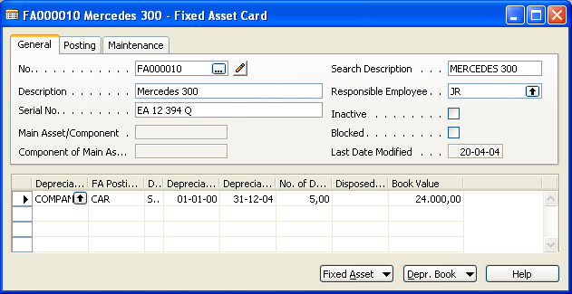
- In the No. field, press F3, Enter to create a new fixed asset card, and then type Welder in the Description field and TS in the Responsible Employee field. | Debra fills in Welder in the Description field and the initials of Timothy Sneath, TS, the responsible production assistant, in the Responsible Employee field. | 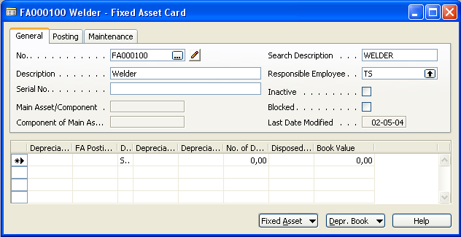
- On the Postings tab, fill out the window as shown in the screen shot. | Next, Debra specifies the class codes for the welder. | 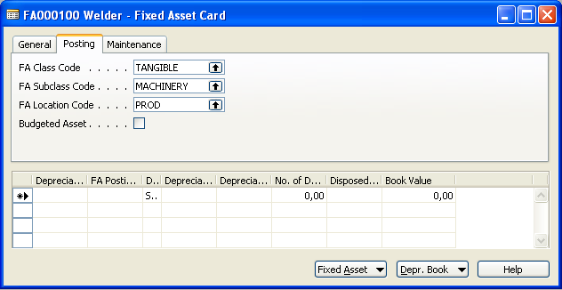

What to do | What to say |  |  | Screen shots
- Click Fixed Asset, Dimensions. The Default Dimensions window appears. | The welder belongs to the Production department so Debra sets up a default dimension, DEPARTMENT, to be proposed whenever an entry is created for the welder. |  |  | 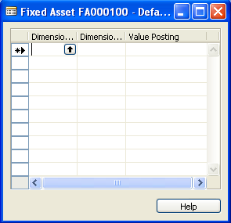
- Fill out the Default Dimensions window as shown in the screen shot and close the window. |  |  | 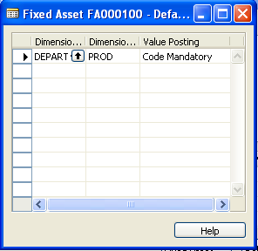
- On the Maintenance tab, fill in 30000 in both the Vendor No. field and the Maintenance Vendor No. field. |  | Finally, Debra fills out the vendor and maintenance information. | 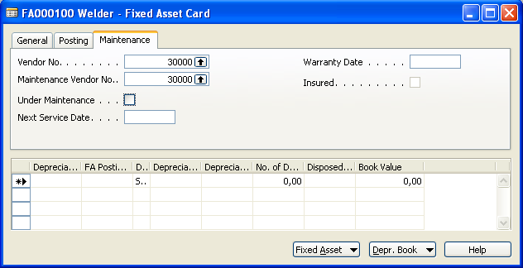
Notes:
Explain that when you purchase a fixed asset, you use the Fixed Asset Card feature to fill out information about the fixed asset, such as serial no., responsible employee, posting codes, maintenance information and depreciation.
(3) Note that class codes are important for running batch jobs and reports and locations codes allow you to keep track of the placement of fixed assets.
(4-5) Note that the Dimensions functionality is fully integrated in the Fixed Assets application area.
(7) Explain that the maintenance information is used when you want to contact the vendor in case of, for example, repairs or returns.
Benefits:
When using the Fixed Asset Card feature in Microsoft Financial Management to fill out information about the fixed asset, transactions become easy to track so that even complex business transactions become transparent.
The fully integrated Dimensions functionality enables you to create statements, statistics and analyses that are extracts of the complete financial statements. These extracts can be created using individual dimensions or combinations of dimensions.

#2 How do I define how the fixed asset should be depreciated?
Debra L. Core, accountant in CRONUS International Ltd., wants to specify a depreciation method for the welder by linking the fixed asset to the company’s depreciation book. The demo shows how to define a depreciation method for a fixed asset.
What to do | What to say | Screen shots
- On the Fixed Asset Card (from the previous demo) fill out the first line as shown in the screen shot. | Debra L. Core wants to specify a depreciation method for the welder. | 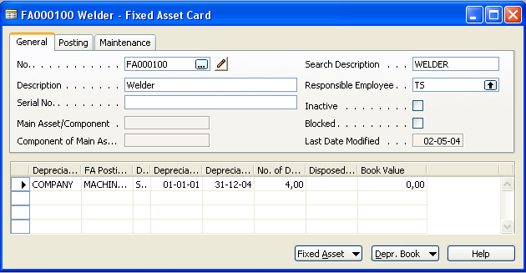
- Point out the various depreciation methods (for explanation, see Notes) and select the Straight-Line depreciation method. | Debra links the welder to the company’s depreciation book and depreciate using the straight-line method over a period of four years.  The depreciation start date is specified as January 1, 2001. | 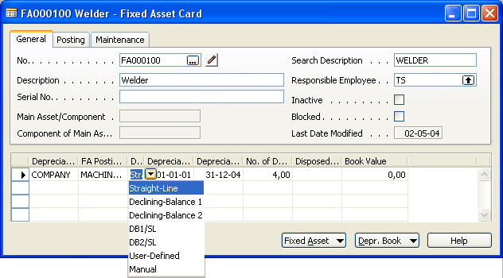
- Close all windows to return to the Navigation Pane menu.
Notes:
Explain you use the FA Depreciation Book feature to define how the fixed asset should be depreciated. The FA Depreciation Book is integrated on the Fixed Asset Card, but can also be filled out by clicking Fixed Asset, Depreciation Books.
(2) Mention some of the various depreciation methods with focus on the following:
Depreciation Methods:
- Straight-Line: this method is used when you want a fixed asset to be depreciated by the same amount each year.
- Declining-Balance 1: this accelerated depreciation method allocates the largest portion of the cost of an asset to the early years of its useful lifetime.

Notes continued:
- Declining-Balance 2: this other accelerated depreciation method is used when you run the Calculate Depreciation batch job more than once a year and want the batch job to result in depreciation amounts that decline for each period.
- DB1/SL: this method is an abbreviated combination of Declining-Balance 1 and Straight-Line and is used when you want only the greater of the two amounts (straight-line amount and declining balance amount) to be transferred to the journal.
- DB2/SL: this method uses the same principle as DB1/SL, but the declining-balance depreciation amounts are calculated according to the Declining-Balance 2 method.
- User-Defined Method: this method is used to set up user-defined depreciation methods.
- Manual Method: this method can be used for fixed assets that are not subject to depreciation, for example land.
Note that you can attach a depreciation book to several fixed assets using the Create FA Depreciation Books feature in the Fixed Assets Setup.
Benefits:
The FA Depreciation Book feature in Microsoft Financial Management enables you to link as many fixed assets to depreciation books as you need.
When the Fixed Assets application area is integrated with the General Ledger application area, everything you post in the Fixed Assets application area is automatically posted to the General Ledger application area. You do not need to reenter the same information a number of times, and you get a real-time picture of you company’s book value.

#3 How do I post acquisition costs?
Debra L. Core, accountant in CRONUS International Ltd., wants to post the first entry - the acquisition cost - of the welder and at the same time she will attach the welder to one of the company’s insurance policies. The demo shows how to post a fixed asset entry, and also how to link a fixed asset to an insurance policy.
What to do | What to say | Screen shots
- On the Financial Management menu, click Payables, Invoices. The Purchase Invoice window opens. | Debra L. Core wants to post the acquisition cost of the welder in the Payables application area. | 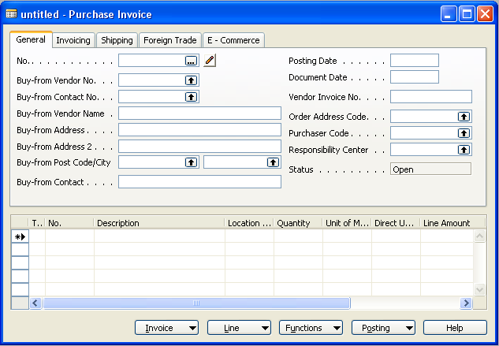
- In the No. field, press F3, Enter to create a new invoice and fill out the window as shown in the screen shot. | The acquisition cost is 48.000 and the vendor Buy-from Vendor No. is 30.000. | 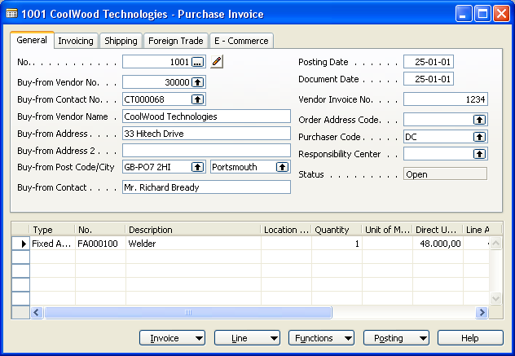
- Scroll to the right to type INS000040 in the Insurance No. field. | Debra attaches the welder to insurance policy No. INS00040. | 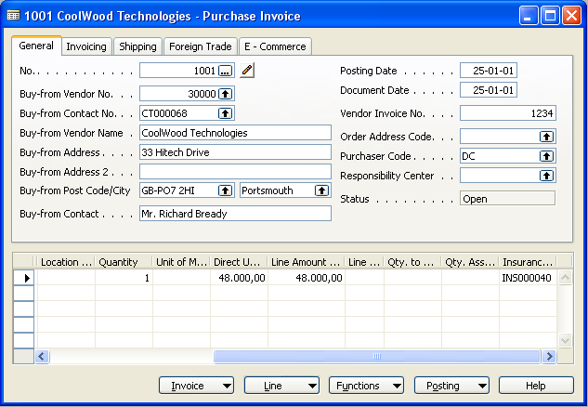

What to do | What to say | Screen shots
- Press F11 to post the acquisition and accept the message that follows. | Debra posts the acquisition cost. | 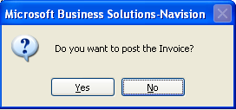
- On the Financial Management menu, click Fixed Assets, Fixed Assets to open the Fixed Asset Card window. | Next, Debra opens the fixed asset card for the welder. | 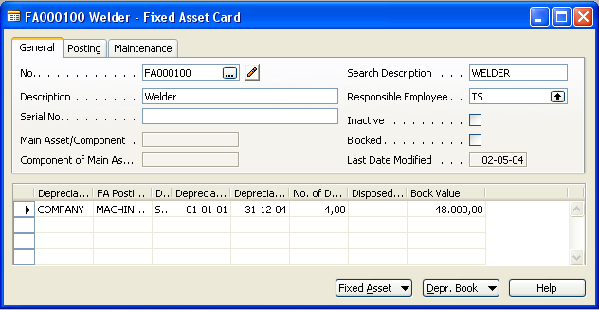
- Press Ctrl+F5 to open the FA Ledger Entries window and then click Navigate. | In the Navigate window, Debra can see all entries for the welder. | 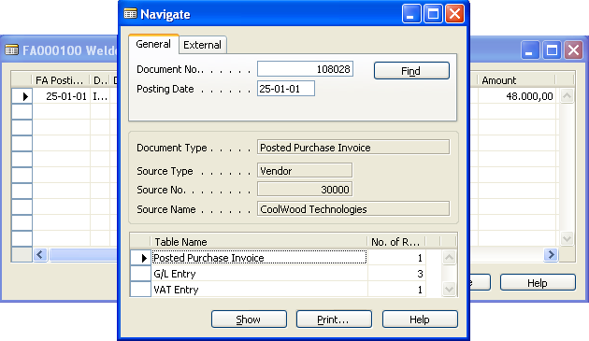
- Select the G/L Entry line and click Show to open the General Ledger Entries window. |  | 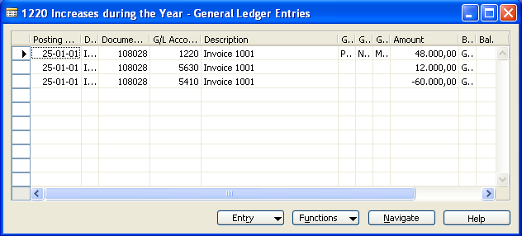
- On the Financial Management menu, click Fixed Assets, Insurance to open the Insurance Card window. | Debra opens the Insurance Card window to view the insurance policy (No. INS00040). | 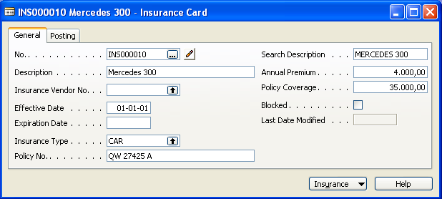

What to do | What to say | Screen shots
- Press F5 to open the Insurance List window, and then select insurance No. INS000040 and click OK. | On the Insurance Card, Debra can see all entries for the insurance policy including the welder entry. | 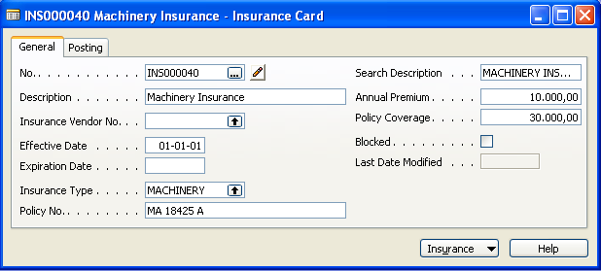
- Press Ctrl+F5 to open the Ins. Coverage Ledger Entries window. |  | 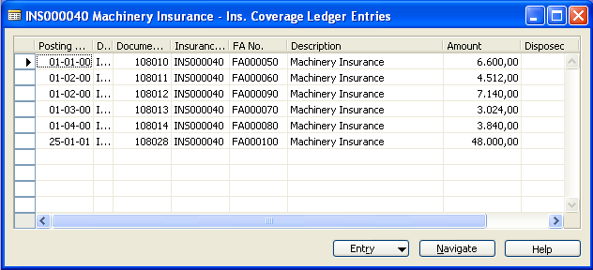
- Close the Ins. Coverage Ledger Entries window and press F9 to open the Insurance Statistics window. | In the Insurance Statistics window, Debra can see that the insurance policy does not cover the total value of all insured fixed assets. | 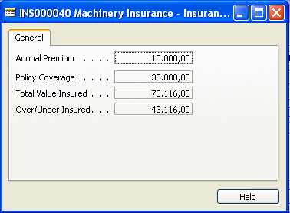
- Close all windows to return to the Navigation Pane menu.
Notes:
Explain that the first entry for a fixed asset is an acquisition cost. You can either post an acquisition cost from a purchase invoice in the Payables application area or in a FA journal in the Fixed Assets application area.
(3) Explain that you can attach a fixed asset to different insurance policies. You attach the first insurance policy in the Insurance No. field, and then to other insurance policies by posting insurance journals.
(5-6-7) Note that you can use the Navigate feature to demonstrate that the invoice has also been posted to the general ledger and the vendor ledger.
(8) Explain that on the Insurance Card you can see and manage insurance policies related to fixed assets.
(9) Note that in the Ins. Coverage Ledger Entries window you can see all the insurance ledger entries that have been linked to the specific insurance policy when posting to an insurance account. The total value insured has been increased by 48.000.
(10) Note that in the Insurance Statistics window you can see that the policy does not cover the total value of insured assets.

Benefits:
When posting acquisition costs in Microsoft Financial Management, the acquisition cost is automatically posted to the vendor ledger, the general ledger (when posting from the Payables application area) and the fixed asset ledger. The posting process is fully integrated, thus, saving you time.
Each fixed asset can be linked to any number of insurance policies, which makes is easy for you to ensure that the amount of coverage in an insurance policy corresponds the value of the fixed assets covered by the policy.
The insurance amount can be indexed, which is important to reflect the cost of replacing your assets, for example, in case of fire of theft. When the fixed asset is sold, the insurance is automatically disconnected from the fixed asset, thus, giving you an updated overview of whether you are under-insured or over-insured.

#4 How do I calculate periodic depreciation?
Debra L. Core, accountant in CRONUS International Ltd., wants to calculate and post a depreciation of the welder for a period of one month starting on January 1, 2001. The demo shows how to calculate and post periodic depreciation on a fixed asset.
What to do | What to say | Screen shots
- On the Financial Management menu, click Fixed Assets, Periodic Activities, Calculate Depreciation. The Calculate Depreciation window appears. | Debra L. Core want to calculate and post a depreciation on the welder.  The depreciation period is one month starting on January 1,2001. | 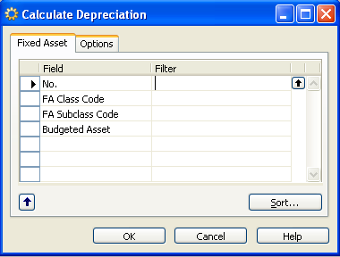
- On the Fixed Asset tab, fill in FA000100 in the Filter Column as shown in the screen shot. | In the Calculate Depreciation window, Debra specifies the fixed asset number, the depreciation book and the fixed asset posting date (31-01-01). | 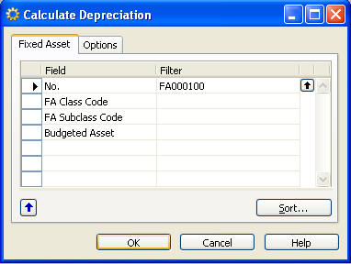
- On the Options tab, fill out the window as shown in the screen shot. |  | 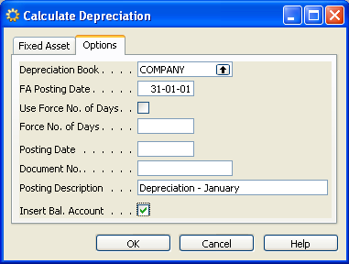
- Click OK to run the Calculate Depreciation batch job. | Once the calculate depreciation batch job has been run, the system automatically fills in the depreciation amounts in a fixed asset G/L journal.

What to do | What to say | Screen shots
- On the Financial Management menu, click Fixed Assets, G/L Journals. The Fixed Asset G/L Journal window appears. | Next, Debra opens the G/L Journals window to post the depreciation. | 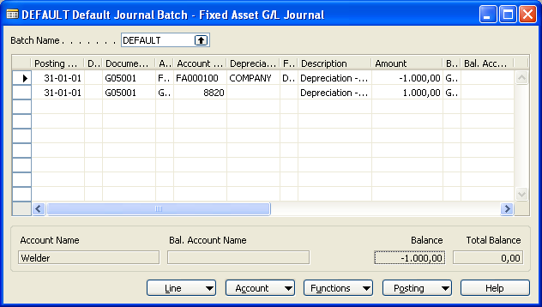
- Press F11 to post the two journal lines and accept the messages that follow. |  | 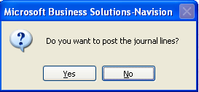  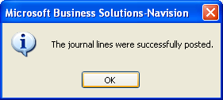
- Close all windows to return to the Navigation Pane menu.
Notes:
Explain that to calculate periodic depreciation, you run the Calculate Depreciation batch job. The Calculate Depreciation batch job is the most import batch job in the Fixed Assets application area. The batch job calculates depreciation for each FA Depreciation Book and inserts the depreciation amounts in the Fixed Asset G/L Journal window if integrated.
(2) Note that if you do not specify a filter, the batch job depreciates all fixed assets.
(3) Note that if the Posting Date field is left blank, the batch job will automatically assign the same posting data as the data in the FA Posting Date field.
(5) Explain that the batch job automatically inserts two lines in the FA G/L Journal window on completion.
(5) Note that in the Amount field, the depreciation amount for the specified time period is 1.000,00 (one month out of 4 years specified in the FA Depreciation Book).
Benefits:
The Calculate Depreciation batch job in Microsoft Financial Management automatically calculates depreciation for each FA Depreciation Book and inserts the depreciation amounts in the Fixed Asset G/L Journal window if integrated.
The Frequency of depreciation is completely user-defined, enabling the user to calculate and post the depreciation, for example, every month, quarter or year.

#5 How do I post maintenance expenses?
CRONUS International Ltd. has had vendor CoolWood Technologies (No. 30000) do some maintenance work on the welder and now Debra L. Core, accountant in CRONUS International Ltd., wants to post the maintenance expense for the welder. The demo shows how to post maintenance expenses for a fixed asset.
What to do | What to say | Screen shots
- On the Financial Management menu, click Fixed Assets, G/L Journals. The Fixed Asset G/L Journal window appears. | Debra L. Core wants to post some maintenance expenses for the welder. | 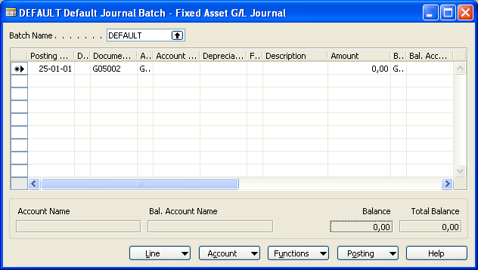
- Fill out the window as shown in the screen shot and press F11 to post the journal line. (Accept the messages that follow.) | The maintenance expense amount is 639,00.  Debra also specifies the depreciation book and the balancing account for the welder before posting the journal. | 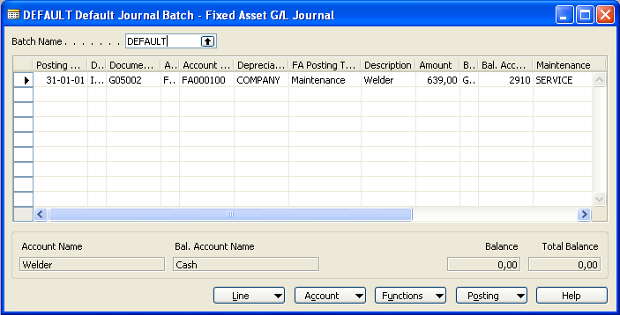
- On the Financial Management menu, click Fixed Assets, Fixed Assets. The Fixed Assets Card window opens. | Next, Debra opens the Fixed Asset Card window to see the posted maintenance ledger entry. | 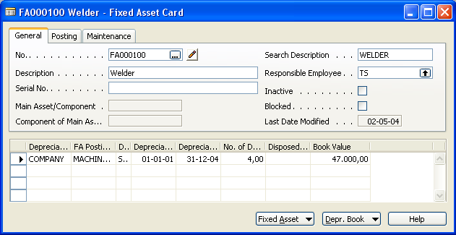
- Click Fixed Asset, Maintenance Ledger Entries and point out the posted maintenance cost. |  | 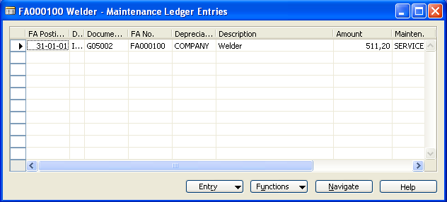

What to do | What to say | Screen shots
- Close all windows to return to the Navigation Pane menu.
Notes:
Explain that for each fixed asset, you can post maintenance expenses, record the next service date and estimate replacement of a fixed asset. Maintenance costs can be posted in the Payables application area as a purchase invoice or in the Fixed Assets application area as a FA G/L Journal.
(2) Note that the value filled in in the Maintenance Code field can be used for filtering purposes in the Maintenance-Analysis report.
(4) Note that the maintenance value is 511,20 and not 639,00. This is because the program treats the maintenance amount filled in in the Fixed Asset G/L Journal as an amount that includes VAT. When the amount is posted to the maintenance ledger, the program removes the calculated VAT amount.
Benefits:
The Maintenance functionality in Microsoft Financial Management enables you to easily post maintenance expenses, record the next service date and estimate replacement of a fixed asset, which is useful for budgeting purposes. The maintenance entries can be integrated with the general ledger so you only have to post them once.

#6 How do I get an overview of a fixed asset?
Debra L. Core, accountant in CRONUS International Ltd., wants to answer a query regarding the welder and therefore wants to get an overview of the fixed asset entries. The demo shows how to use the Statistics feature on a fixed asset.
What to do | What to say | Screen shots
- On the Financial Management menu, click Fixed Assets, Fixed Assets. The Fixed Asset Card window appears. | Debra L. Core has been asked an inquery regarding the welder. | 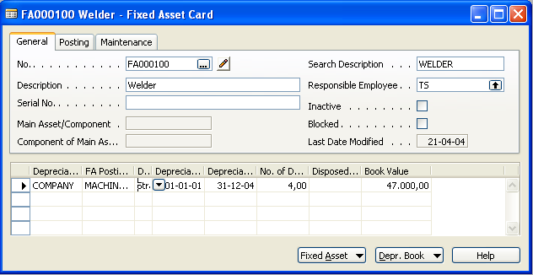
- Click Fixed Asset, Statistics. The Fixed Asset Statistics window appears. | Debra opens the Fixed Asset Statistics window for the welder to get an overview of all fixed asset entries. | 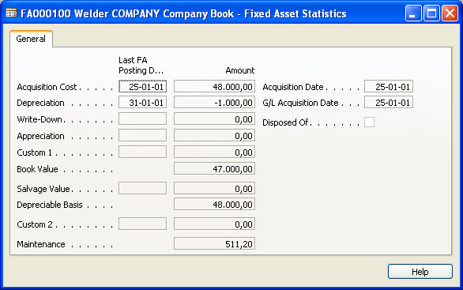
- Click AssistButton in the Book Value field. |  | 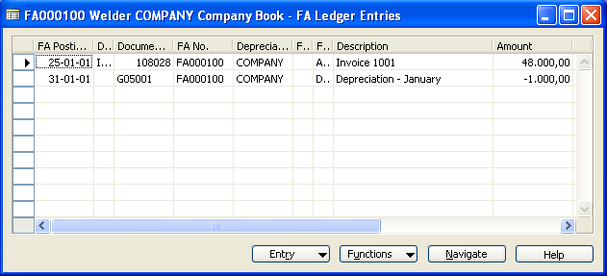
- Close all windows to return to the Navigation Pane menu.
Notes:
Explain that in the Fixed Asset Statistics window, you can see, for example, the acquisition cost, depreciation, book value and maintenance expenses.
(3) Note that you can see how the book value is calculated by clicking AssistButton in the Book Value Field.

Benefits:
The Fixed Asset Statistics window in Microsoft Financial Management gives you a real-time overview of a fixed asset. You can for example see the acquisition cost, depreciation, book value and maintenance expenses. A statistics window exists for each FA Depreciation Book.

#7 How do I dispose of a fixed asset?
CRONUS International Ltd. has sold the welder to a subsidiary and Debra L. Core, accountant in CRONUS International Ltd., wants to dispose of the welder by posting the disposal value of the welder. The demo shows how to post the disposal value of a fixed asset.
What to do | What to say | Screen shots
- On the Financial Management menu, click Fixed Assets, G/L Journals. The Fixed Asset G/L Journal window appears. | CRONUS International Ltd. has sold the welder and Debra L. Core wants to post the disposal value for the welder in a fixed asset G/L journal. | 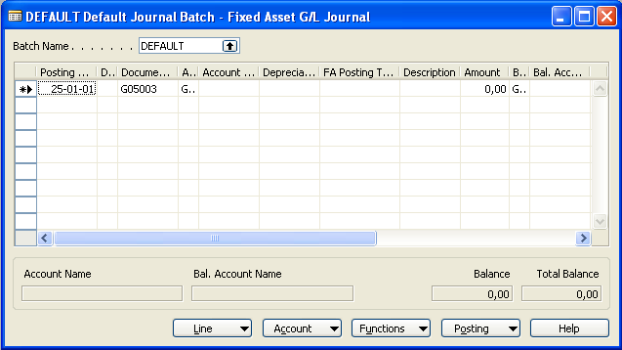
- Fill out the journal line as shown in the screen shot. | The disposal value is 40.000.  Debra also specifies the depreciation book and balancing account before posting the journal. | 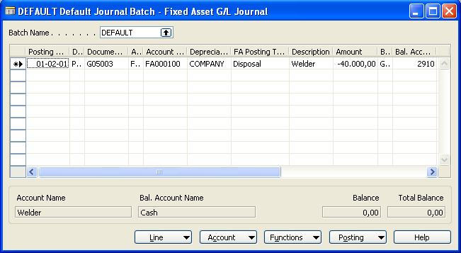
- Press F11 to post the journal and accept the messages that follow. |  | 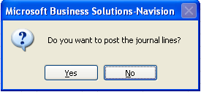  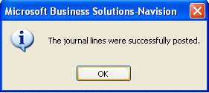
- On the Financial Management menu, click Fixed Assets, Fixed Assets to open the Fixed Asset Card window. | Finally, Debra opens the fixed asset card for the welder to get a final overview of all fixed asset entries. | 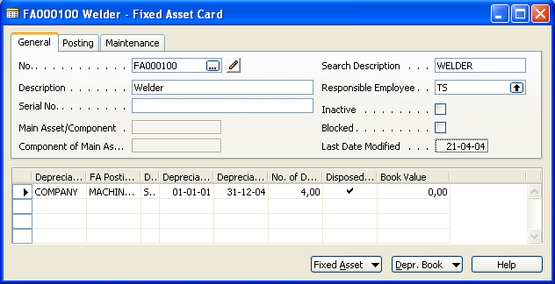

What to do | What to say | Screen shots
- Press Ctrl+F5 to open the FA Ledger Entries window and point out the entries created when you posted the disposal line (for explanation, see Notes). | In the FA Ledger Entries window, Debra can see all entries including the ones created when disposing of the welder. | 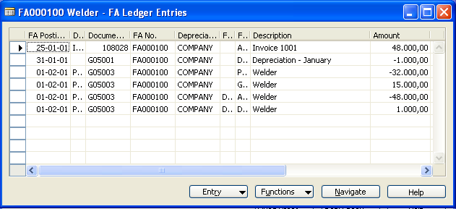
- Close the FA Ledger Entries window.
- Press F9 to open the Fixed Asset Statistics window to show the updated disposal information. | In the Fixed Asset Statistics window, Debra can see the latest data changes for the welder. | 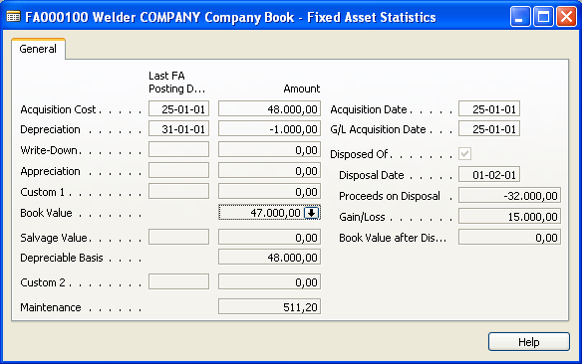
- Close all windows to return to the Navigation Pane menu.
Notes:
Explain that when you sell or otherwise dispose of a fixed asset, the disposal value must be posted. Disposals can be done in the Fixed Assets application area as an FA G/L Journal or in the Receivables application area as a sales document. You can dispose of a fixed asset in two ways, net or gross – this example will be an FA G/L Journal where the net method is used.
Note that for partially disposed fixed assets, you can post more than one disposal entry.
(2) Note that the posting date (01-02-01) must be after the end of depreciation date (here 31-01-01).
(5) Point out the different entries with emphasis on the following:
FA Posting Type:
- Proceeds on Disposal: the proceeds are –32.000 since the program treats the –40.000 filled in in the FA G/L Journal as an amount that includes VAT.
- Gain/Loss: the amount is the total of the Proceeds on Disposal amount (-32.000) and the Book Value amount (47.000).
In this example, a loss of 15,00 was made on FA000100.

Notes continued:
- Acquisition Cost: the acquisition cost.
- Depreciation: the depreciation cost at time of disposal.
Benefits:
When you dispose of a fixed asset in Microsoft Financial Management, many entries in the general ledger are created. If you have set up the Fixed Assets application area to be integrated with your General Ledger application area, then all these entries are automatically created when filling out a journal line.

* Microsoft Dynamics NAV, formerly Microsoft® Business Solutions–Navision®

