Capacity Requirements Planning effectively addresses your capacity monitoring and planning needs, displaying capacity used and available, and load percentage information for all work centers in a single, concise, easy-to-read view.
Capacity Requirements Planning provides the summary information you need to spot situations where capacity is short or long, making it easier for you to shift production and manage your resources efficiently, and detailed information is a single click away. You can view capacity information by day, week or month, as far into the future as necessary.
Using Capacity Requirements Planning, you can view both released and open requirements, allowing side-by-side “what-if” analysis of actual and projected capacity demands.
Capacity Requirements Planning also requires the Bill of Materials and Manufacturing Order Processing modules to operate.
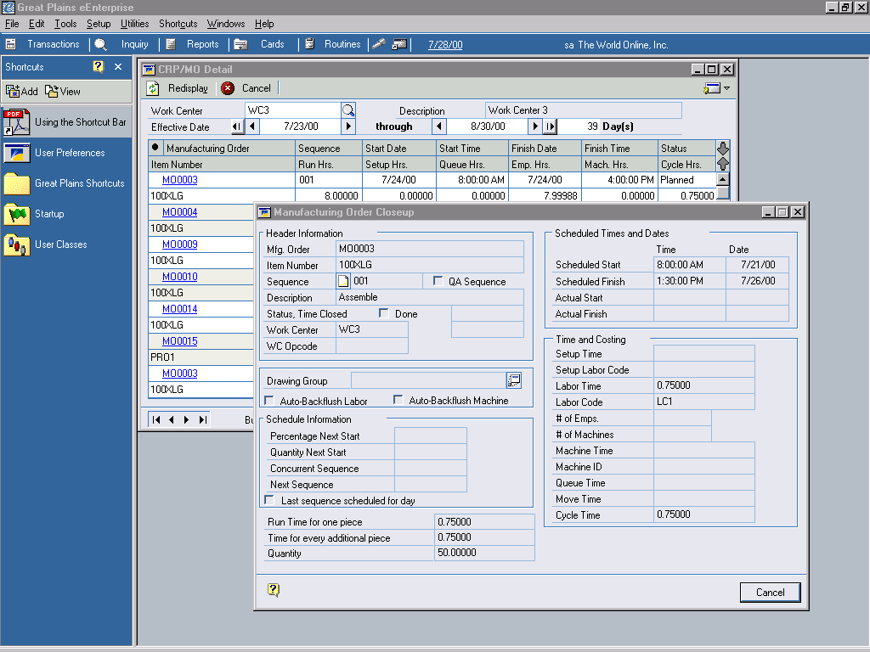

Capacity Requirements Planning allows you to easily see what has been scheduled for each of your work centers as well as drill down for more information on the manufacturing order.

© 2002 Microsoft Corporation and Great Plains Software, Inc. All rights reserved. Microsoft, Microsoft Business Solutions and Great Plains are either registered trademarks or trademarks of Microsoft Corporation, Great Plains Software, Inc. or Microsoft Business Solutions Corporation in the United States and/or other countries. Both, Great Plains Software Inc. and Microsoft Business Solutions Corporation are wholly-owned subsidiaries of Microsoft Corporation. Functionality described herein may not be available on all versions of Microsoft Business Solutions–Great Plains products. The names of actual companies and products mentioned herein may be the trademarks of their respective owners.

