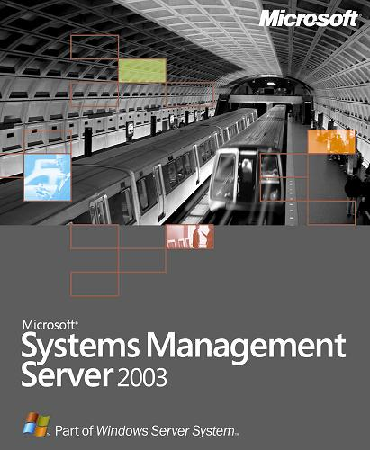
Microsoft® Systems Management Server (SMS) 2003 provides a comprehensive solution for addressing and resolving your change and configuration needs, enabling you to reduce software costs and stay compliant by understanding the installed application base and its usage.

- As hardware and software assets comprise an increasing portion of the IT budget, corporations are becoming more focused on finding ways to reduce these costs while continuing to stay compliant with their vendors’ licensing policies.

- Systems Management Server 2003 delivers the necessary tools to reduce hardware and software costs while enabling IT organizations to make informed and cost effective business decisions related to the infrastructure.

http://www.microsoft.com/smsserver
Understanding Software Assets
As corporations are becoming more focused on reducing costs, the ability to accurately track corporate software throughout the lifecycle and stay compliant with vendors’ licensing policies has become a necessity. Systems Management Server 2003 enables corporations to effectively track which applications are installed and how they are actually used, resulting in using what is paid for and paying only for what is used.

Standards-Based Hardware Inventory
By utilizing Windows® Management Instrumentation (WMI), Systems Management Server 2003 provides improved client-side performance during inventory scans and a richer set of inventory data, including BIOS and chassis enclosure data.

Flexible Granular Inventory Discovery
Although Systems Management Server 2003 allows enterprises to track almost all the software assets on their systems, typically there are a core set of applications and files that are of particular importance and interest. Systems Management Server 2003 enables enterprises to focus on the information they need by providing the capability to implement intelligent inventory searches through the use of functionality such as wildcards, environment variables and file properties. Systems resource overhead can also be reduced by enabling the skipping of compressed and encrypted files.

Usage Tracking
Inventory is only the first step in understanding the software assets within an enterprise. To fully comprehend and support business requirements, Systems Management Server 2003 integrates inventory with rich and robust software metering, enabling enterprises to not only know what is installed, but more importantly, what is used. By understanding application usage, enterprises can save money on potential new application purchases, stay compliant, and effectively phase out unused applications. The following list details these benefits:

- Reduce Purchasing Needs
The rich inventory and usage tracking capabilities of Systems Management Server 2003 provide an excellent planning tool in the application deployment process. Equipped with information such as the number of Office XP installations and usage metrics in the sales and marketing department, enterprises can make informed decisions on issues such as “how many copies of Office 2003 are needed in sales and marketing” potentially decreasing purchasing costs.

- Stay Compliant
With the wide range of applications in the enterprise, staying compliant with licensing requirements is a complicated task. Systems Management Server 2003 enables simplified license compliance tracking by monitoring concurrent application usage, arming enterprises with the information they need to make licensing decisions.

- Reduce Support Costs
As new applications are deployed, legacy applications are often left installed but unused. Usage tracking allows enterprises to reduce cost by identifying and discontinuing support for these unused applications.

Integrated Customizable Web Reporting
To ensure that the rich inventory and usage tracking information is easily accessible and relevant to the business, Systems Management Server 2003 includes a robust, highly flexible and fully extensible Web reporting engine, with more than 120 pre-built reports available out of the box. Reports can be customized or created, and an import and export capability is available for transferring these to other Systems Management Server 2003 environments.

Specifications

To use Microsoft Systems Management Server 2003, you need:

For server components
- PC with 550 MHz or faster processor (Intel Pentium/Celeron family or compatible processor recommended)
- Microsoft Windows 2000 Server, Windows 2000 Advanced Server, or Windows 2000 Datacenter Server with Service Pack 2 or later; or Windows Server™ 2003 Standard Edition, Windows Server 2003 Enterprise Edition, or Windows Server 2003 Datacenter Edition
- 256 MB of RAM (4 GB of RAM maximum)
- 2 GB of available hard-disk space
- Microsoft SQL Server™ 7.0 with Service Pack 3 or later, or SQL Server 2000 with Service Pack 3a or later
- CD-ROM or DVD-ROM drive
- Network interface card
- Windows 2000-compatible video graphics adapter
- Keyboard and Microsoft Mouse or compatible pointing device, or hardware that supports console redirection
- Internet Information Services (IIS) must be installed as part of the Windows Server installation for certain Systems Management Server site system roles; for specific details, see the “Getting Started” chapter in the Microsoft Systems Management Server 2003 Concepts, Planning, and Deployment Guide

Microsoft Systems Management Server 2003 supports up to eight processors per server machine.

For the client installation
- PC with 300 MHz or faster processor recommended; 133 MHz minimum required (Intel Pentium/Celeron family or compatible processor recommended)
- Microsoft Windows 98; or Windows NT® Workstation 4.0, Windows NT Server 4.0, or Windows NT Server 4.0 Enterprise Edition with Service Pack 6 or later; or Windows 2000 Professional, Windows 2000 Server, Windows 2000 Advanced Server, or Windows 2000 Datacenter Server; or Windows XP Professional; or Windows XP Embedded with Service Pack 1 or later; or Windows Server 2003 Standard Edition, Windows Server 2003 Enterprise Edition, or Windows Server 2003 Datacenter Edition
- 128 MB of RAM or higher recommended (64 MB supported; may limit performance and some features)
- 80 MB of available hard-disk space
- Network interface card
- Microsoft Internet Explorer 5.0 or later
- Super VGA (800 × 600) or higher-resolution video adapter and monitor
- Keyboard and Microsoft Mouse or compatible pointing device

Actual requirements will vary based on your system configuration and the applications and features you choose to install.
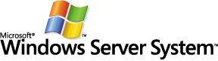
Windows Server System is the comprehensive, integrated
server software that simplifies the development, deployment, and operation of agile business solutions.
www.microsoft.com/windowsserversystem

For more information about Microsoft Systems Management Server 2003 visit http://www.microsoft.com/smsserver/. For the latest management news and more information on Microsoft’s broad range of resources for managing your environment, including support programs, events, training, and the Microsoft Management Update Service, visit Microsoft Management Online at http://www.microsoft.com/management/.
TO ORDER:
To order Microsoft Systems Management Server 2003 or other Microsoft management tools, or to receive a reseller referral in the United States or Canada, call (800) 621-7930, Dept. A334DS. Outside the United States and Canada, please contact your local Microsoft subsidiary. Customers who are deaf or hard-of-hearing can reach Microsoft text telephone (TTY/TDD) services by calling (800) 892-5234 in the United States or (905) 568-9641 in Canada.

© 2001-2003 Microsoft Corporation. All rights reserved. This data sheet is for informational purposes only. MICROSOFT MAKES NO WARRANTIES, EXPRESS OR IMPLIED, IN THIS SUMMARY
Microsoft, Windows, the Windows logo, Windows NT, Windows Server, and Windows Server System are either registered trademarks or trademark of Microsoft Corporation in the United States and/or other countries. The names of actual companies and products mentioned herein may be the trademarks of their respective owners.
0601 Part No. 098-00000 (color)
Part No. 098-00000 (black and white)


