

Microsoft Windows Server 2003 Network Access Quarantine Control

Microsoft Corporation
Published: March 2003
Updated: October 2004

Abstract
The Network Access Quarantine Control feature of Microsoft® Windows Server™ 2003 delays normal remote access to a private network until the configuration of the remote access computer has been examined and validated by an administrator-provided script. This paper describes the components of Network Access Quarantine Control, how it works, and how to deploy it using Windows Server 2003 remote access servers, the Connection Manager Administration Kit, and, optionally, Internet Authentication Service.
Note Network Access Quarantine Control is not the same as Network Access Protection, which is a new policy enforcement platform that is being considered for inclusion in Windows Server "Longhorn," the next version of the Windows Server operating system. Network Access Quarantine Control only provides added protection for remote access connections. Network Access Protection provides added protection for virtual private network (VPN) connections, Dynamic Host Configuration Protocol (DHCP) configuration, and Internet Protocol security (IPsec)-based communication. For more information about Network Access Protection, see the Network Access Protection Web site.
This is a preliminary document and may be changed substantially prior to final commercial release of the software described herein.
The information contained in this document represents the current view of Microsoft Corporation on the issues discussed as of the date of publication. Because Microsoft must respond to changing market conditions, it should not be interpreted to be a commitment on the part of Microsoft, and Microsoft cannot guarantee the accuracy of any information presented after the date of publication.
This White Paper is for informational purposes only. MICROSOFT MAKES NO WARRANTIES, EXPRESS, IMPLIED OR STATUTORY, AS TO THE INFORMATION IN THIS DOCUMENT.
Complying with all applicable copyright laws is the responsibility of the user. Without limiting the rights under copyright, no part of this document may be reproduced, stored in or introduced into a retrieval system, or transmitted in any form or by any means (electronic, mechanical, photocopying, recording, or otherwise), or for any purpose, without the express written permission of Microsoft Corporation.
Microsoft may have patents, patent applications, trademarks, copyrights, or other intellectual property rights covering subject matter in this document. Except as expressly provided in any written license agreement from Microsoft, the furnishing of this document does not give you any license to these patents, trademarks, copyrights, or other intellectual property.
© 2004 Microsoft Corporation. All rights reserved.
Microsoft, Active Directory, Windows, and Windows Server are either registered trademarks or trademarks of Microsoft Corporation in the United States and/or other countries.
The names of actual companies and products mentioned herein may be the trademarks of their respective owners.
Contents
Introduction 1
Components of Windows Remote Access 2
Components of Network Access Quarantine Control 3
Quarantine-compatible Remote Access Clients 3
Quarantine-compatible Remote Access Server 4
Quarantine-compatible RADIUS Server (Optional) 5
Quarantine Resources 6
Accounts Database 6
Quarantine Remote Access Policy 6
How Network Access Quarantine Control Works 8
How to Deploy Network Access Quarantine Control 10
Creating Quarantine Resources 10
Creating a Script or Program that Validates Client Configuration 11
Installing Rqs.exe on Remote Access Servers 12
Installing Rqs.exe on Remote Access Servers Running Windows Server 2003 with no Service Packs Installed 12
Installing Rqs.exe on Remote Access Servers Running Windows Server 2003 with SP1 13
Creating a New Quarantine CM Profile with Windows Server 2003 CMAK 14
Distributing the CM Profile for Installation on Remote Access Client Computers 17
Configuring a Quarantine Remote Access Policy 18
Alternate Configurations 27
Using an Exception Remote Access Policy 27
Mitigating Application Delay in Quarantine Mode 27
Using Only a Quarantine Session Timeout 28
Immediate Notification 28
Global Dispersion of Quarantine Resources 28
Appendix A. Sample Quarantine Script 30
Appendix B. Network Access Quarantine Control Requirements 32
Summary 33
Related Links 34

Introduction
Typical remote access connections only validate the credentials of the remote access user. Therefore, the computer used to connect to a private network can often access network resources even when its configuration does not comply with organization network policy. For example, a remote access user with valid credentials could connect to a network with a computer that does not have the following:
- The correct service pack or the latest security patches installed.
- The correct antivirus software and signature files installed.
- Routing disabled. A remote access client computer with routing enabled might pose a security risk, providing an opportunity for a malicious user to access corporate network resources through the client computer, which has an authenticated connection to the private network.
- Firewall software installed and active on the Internet interface.
- A password-protected screensaver with an adequate wait time.
Despite the efforts made within organizations to ensure that computers used internally comply with network policy, those used from employee’s homes for remote access can still present significant risk to the network.
Network Access Quarantine Control, a new feature in the Windows Server 2003 family, delays normal remote access to a private network until the configuration of the remote access computer has been examined and validated by an administrator-provided script. When a remote access computer initiates a connection to a remote access server, the user is authenticated and the remote access computer is assigned an IP address. However, the connection is placed in quarantine mode, with which network access is limited. The administrator-provided script is run on the remote access computer. When the script notifies the remote access server that it has successfully run and the remote access computer complies with current network policies, quarantine mode is removed and the remote access computer is granted normal remote access.
The quarantine restrictions placed on individual remote access connections consists of the following:
- A set of quarantine packet filters that restrict the traffic that can be sent to and from a quarantined remote access client.
- A quarantine session timer that restricts the amount of time the client can remain connected in quarantine mode before being disconnected.
You can use either restriction, or both, as needed.
Network Access Quarantine Control is not a security solution. It is designed to help prevent computers with unsafe configurations from connecting to a private network; not to protect a private network from malicious users who have obtained a valid set of credentials.
To understand the components of Network Access Quarantine Control and how it works, we will first review a normal Windows-based remote access configuration and then examine a quarantine configuration.

Note Network Access Quarantine Control is not the same as Network Access Protection, which is a new policy enforcement platform that is being considered for inclusion in Windows Server "Longhorn," the next version of the Windows Server operating system. Network Access Quarantine Control only provides added protection for remote access connections. Network Access Protection provides added protection for virtual private network (VPN) connections, Dynamic Host Configuration Protocol (DHCP) configuration, and Internet Protocol security (IPsec)-based communication. For more information about Network Access Protection, see the Network Access Protection Web site.

Components of Windows Remote Access
Figure 1 shows the components of Windows remote access when Remote Authentication Dial-In User Service (RADIUS) authentication is being used.
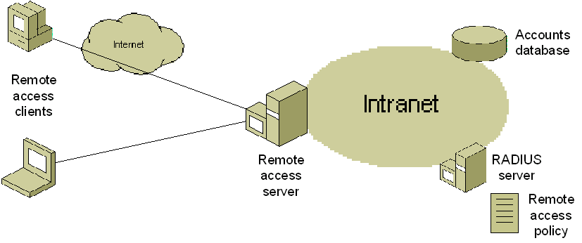
Figure 1 Components of Windows remote access
This configuration consists of the following components:
- Remote access clients
Computers running a Windows operating system that create either a dial-up or virtual private network connection to the remote access server. The remote access client can use either a manually configured connection or a Connection Manager (CM) profile.
- Remote access server
A computer running a member of the Windows 2000 Server or Windows Server 2003 families and the Routing and Remote Access service configured for the Windows or RADIUS authentication provider.
- RADIUS server (optional)
A computer running a member of the Windows 2000 or Windows Server 2003 families and the Internet Authentication Service (IAS). The use of a RADIUS server is optional and is only required when the remote access server is configured to use RADIUS as the authentication provider.
- Accounts database
For Windows 2000 or Windows Server 2003-based networks, the Active Directory® directory service is used as the accounts database, which stores user accounts and their dial-in properties.
- Remote access policy
On the remote access server running Routing and Remote Access or the IAS server, a remote access policy that provides authorization and connection constraints is configured for remote access connections.

Components of Network Access Quarantine Control
Figure 2 shows the components of Windows remote access for Network Access Quarantine Control when RADIUS is being used as the authentication provider.
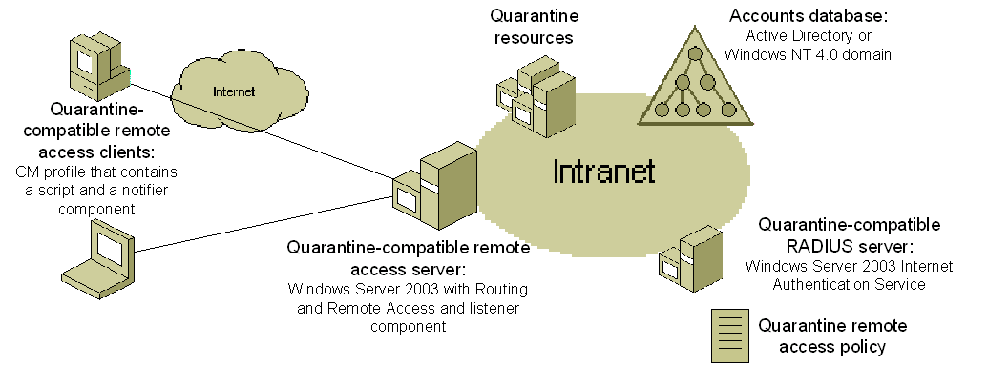
Figure 2 Components of Windows remote access for Network Access Quarantine Control
This configuration consists of the following components:
- Quarantine-compatible remote access clients
- Quarantine-compatible remote access server
- Quarantine-compatible RADIUS server (optional)
- Quarantine resources
- Accounts database
- Quarantine remote access policy

Quarantine-compatible Remote Access Clients
The remote access client must be a computer running one of the following operating systems:
- Windows Server 2003
- Windows XP Professional
- Windows XP Home Edition
- Windows 2000
- Windows Millennium Edition
- Windows 98 Second Edition
These versions of Windows support CM profiles that are created with the Connection Manager Administration Kit (CMAK) provided in Windows Server 2003. The CM profile contains the following:
- A post-connect action that runs a network policy requirements script.
This is configured when the CM profile is created with CMAK.
- A network policy requirements script.
This script performs validation checks on the remote access client computer to verify that it conforms to network policies. It can be a custom executable file or as simple as a command file (also known as a batch file). When the script has run successfully and the connecting computer has satisfied all of the network policy requirements (as verified by the script), the script runs a notifier component (an executable) with the appropriate parameters.
If the script does not run successfully, it should direct the remote access user to a quarantine resource such as an internal Web page, which describes how to install the components that are required for network policy compliance.
- A notifier component
The notifier component sends a message that indicates a successful execution of the script to the quarantine-compatible remote access server. You can use your own notifier component or you can use Rqc.exe, which is provided with the Windows Server 2003 Resource Kit Tools for computers running Windows Server 2003 with no service packs installed or installed with the Connection Manager Administration Kit component in the Program Files\CMAK\Support folder for computers running Windows Server 2003 Service Pack 1 (SP1) (Control Panel-Add or Remove Programs-Add/Remove Windows Components-Management and Monitoring Tools).
With these components installed, the remote access client computer uses the CM profile to perform network policy requirements tests and indicate its success to the remote access server as part of the connection setup.
Notes Because quarantine network access control introduces a delay in obtaining normal remote access, applications that run immediately after the connection is complete might encounter problems. For ways to reduce this delay or otherwise mitigate the impact to applications, see "Alternate configurations" in this paper.
The previous discussion describes using a separate script and notifier component. For a custom script and notifier component, it is possible to combine them into a single component.
It is possible to use a third-party dialer program instead of a CM profile, as long as there is a way to configure a post-connect action to run the quarantine script and to embed the script and notifier component with the dialer or otherwise install the script and notifier component on the remote access client.

Quarantine-compatible Remote Access Server
A quarantine-compatible remote access server requires the following:
- A computer running a member of the Windows Server 2003 family and Routing and Remote Access, which supports the use of a listener component and the MS-Quarantine-IPFilter and MS-Quarantine-Session-Timeout RADIUS vendor-specific attributes (VSAs) to enforce quarantine settings.
- A listener component
This component listens for messages from quarantine-compatible remote access clients, which indicate that their scripts have been run successfully. You can create your own custom listener component (matched with your own custom notifier component), or you can install the Remote Access Quarantine Agent service (Rqs.exe) from the Windows Server 2003 Resource Kit Tools for computers running Windows Server 2003 with no service packs installed or install the Remote Access Quarantine Service component for computers running Windows Server 2003 SP1 (Control Panel-Add or Remove Programs-Add/Remove Windows Components-Networking Services).
If you create your own listener component, it must be designed to listen for a message from the notifier component and use the MprAdminConnectionRemoveQuarantine() application programming interface (API) to remove the quarantine restrictions from the remote access connection. For more information, see the Microsoft Developer Network at http://msdn.microsoft.com/.
With these components installed, the remote access server computer can use quarantine mode for connecting remote access clients and listen for notifier messages, indicating that they have satisfied network policy requirements and can be taken out of quarantine mode.
If you are using Rqc.exe and Rqs.exe, the notification message sent by Rqc.exe contains a text string that indicates the version of the quarantine script being run. This string is configured for Rqc.exe as part of its command-line parameters, as run from the quarantine script. Rqs.exe compares this text string to a set of text strings stored in the registry of the remote access server. If there is a match, the quarantine conditions are removed from the connection. For an example of how to configure the quarantine script and Rqs.exe for a matching script version string, see "How to deploy Network Access Quarantine Control" in this paper.
Note The notification sent by Rqc.exe is not encrypted or authenticated and can be spoofed by a malicious client.
Routing and Remote Access can be configured with either the Windows or RADIUS authentication provider. If Routing and Remote Access is configured with the Windows authentication provider, then quarantine-compatible RADIUS servers are not required and you configure the quarantine attributes for a remote access policy that is stored on the remote access server. The configuration shown in Figure 2 assumes that Routing and Remote Access is configured with the RADIUS authentication provider.

Quarantine-compatible RADIUS Server (Optional)
If Routing and Remote Access on the remote access server is configured with the RADIUS authentication provider, a quarantine-compatible RADIUS server requires a computer running Windows Server 2003 and IAS, which supports the configuration of the MS-Quarantine-IPFilter and MS-Quarantine-Session-Timeout RADIUS vendor-specific attributes (VSAs). The MS-Quarantine-IPFilter attribute is for the quarantine filters. The MS-Quarantine-Session-Timeout attribute is for the quarantine session timer.

Quarantine Resources
Quarantine resources consists of servers that a remote access client in quarantine mode can access to perform name resolution (such as Domain Name System [DNS] servers), obtain the latest version of the CM profile (file servers with anonymous access allowed), or access instructions and components needed to make the remote access client comply with network policies (Web servers with anonymous access allowed). Anonymous access to file and Web resources is needed because, although the remote access user had correct credentials to create the remote access connection, they might not be using correct domain credentials to access protected file and Web resources.

Accounts Database
For Windows Server 2003 or Windows 2000-based networks, Active Directory is used as the accounts database to store user accounts and their dial-in properties. You can also use Windows NT 4,0 domains.

Quarantine Remote Access Policy
You need to configure a quarantine remote access policy with the required conditions for remote access connections, but with profile settings that can specify the MS-Quarantine-IPFilter or MS-Quarantine-Session-Timeout attributes (configured on the Advanced tab of the profile).
You can use the MS-Quarantine-IPFilter attribute to configure input and output packet filters to allow only the following:
- The traffic generated by the notifier component. If you are using Rqc.exe and Rqs.exe with its default port, then configure a single input packet filter to allow only traffic to TCP port 7250.
- The traffic needed for Dynamic Host Configuration Protocol (DHCP) messages between the remote access client and the remote access server.
- The traffic needed to access the quarantine resources. This includes filters that allow the remote access client to access name resolution servers (such as DNS servers), file shares, or Web sites.
The packet filters configured for the MS-Quarantine-IPFilter attribute provide the quarantine of the remote access client until the notifier component on the remote access client indicates that the computer is in compliance with network policies.
You can use the MS-Quarantine-Session-Timeout attribute to specify how long the remote access server must wait to receive the notification that the script has run successfully before terminating the connection.
If the quarantine remote access policy is the only policy for remote access connections, then all of your remote access clients must be using the quarantine CM profile in order to validate the remote access computer configuration and send the notification to the remote access server. Remote access clients that do not install and use the quarantine CM profile are unable to obtain a normal remote access connection. They are placed in quarantine mode, and because they do not run the script or send the notification, are either left in quarantine mode (if no quarantine timer has been configured) or are left in quarantine mode until the quarantine timer expires (if a quarantine timer has been configured), at which time they are automatically disconnected.
If you want to support a mixture of quarantine clients and non-quarantine clients, you can create a group to contain the user accounts of the non-quarantine clients and create a new group-based remote access policy that does not use the quarantine restrictions. For more information, see "Using an exception remote access policy" in this paper.
Note Network Access Quarantine Control cannot be used for wireless or authenticated switch clients because it requires the use of the Routing and Remote Access service and the ability to run a post-connect script on the wireless or switch client. However, wireless and switch clients must have a domain account for computer authentication and network policy compliance scripts can be run as part of the computer's startup and domain logon sequence.

How Network Access Quarantine Control Works
The following process describes how Network Access Quarantine Control works when the set of components in Figure 2 and Rqc.exe and Rqs.exe and RADIUS authentication are used:
- The user on the quarantine-compatible remote access client uses the installed quarantine CM profile to connect with the quarantine-compatible remote access server.
- The remote access client passes its authentication credentials to the remote access server.
- The Routing and Remote Access service sends a RADIUS Access-Request message to the IAS server.
- The IAS server validates the authentication credentials of the remote access client and, assuming that the credentials are valid, checks its remote access policies. The connection attempt matches the quarantine policy.
- The connection is accepted with quarantine restrictions. The IAS server sends a RADIUS Access-Accept message that contains the MS-Quarantine-IPFilter and MS-Quarantine-Session-Timeout attributes, among others. This example assumes that both attributes are configured in the matching remote access policy.
- The remote access client and remote access server complete the remote access connection, which includes obtaining an IP address and other configuration settings.
- The Routing and Remote Access service configures the MS-Quarantine-IPFilter and MS-Quarantine-Session-Timeout settings on the connection. At this point, the remote access client can only successfully send traffic that matches the quarantine filters and has up to the number of seconds specified in MS-Quarantine-Session-Timeout to notify the remote access server that the script has run successfully.
- The CM profile runs the quarantine script as the post-connect action.
- The quarantine script runs and verifies that the remote access client computer's configuration complies with network policy requirements. If all the tests for network policy compliance pass, the script runs Rqc.exe with its command-line parameters, one of which is a text string for the version of the quarantine script included within the CM profile.
- Rqc.exe sends a notification to the remote access server, indicating that the script was successfully run. The notification includes the quarantine script version string.
- The notification is received by the listener component (Rqs.exe). The notification traffic was allowed because it matched the permitted traffic specified by the quarantine filters configured via the MS-Quarantine-IPFilter attribute in the matching remote access policy.
- The listener component verifies the script version string in the notification message with those configured in the registry and sends back either a message indicating that the script version was valid or a message indicating that the script version was invalid.
- If the script version was valid, the listener component calls the MprAdminConnectionRemoveQuarantine() API, which causes the Routing and Remote Access service to remove the MS-Quarantine-IPFilter and MS-Quarantine-Session-Timeout settings from the connection and configure the normal connection constraints. At this point, the remote access client has normal access to the intranet.
- The listener component creates an event detailing the quarantined connection in the System event log.

How to Deploy Network Access Quarantine Control
In the set of instructions that follow, the following assumptions are made:
- The notifier component is Rqc.exe
- The listener component is Rqs.exe
- The client dialer program is a CM profile created with the Windows Server 2003 CMAK
If you use a custom notifier component, listener component, or client dialer program, substitute their configuration and deployment procedures as needed.
To deploy Network Access Quarantine Control, the basic steps (in order) are as follows:
- Create quarantine resources
- Create a script or program that validates client configuration
- Install Rqs.exe on remote access servers
- Create a new quarantine CM profile with Windows Server 2003 CMAK
- Distribute the CM profile for installation on remote access client computers
- Configure a quarantine remote access policy

Creating Quarantine Resources
To allow your remote access clients to access name server, Web server, or file server resources while they are in quarantine mode, you must designate the servers and their resources that are available to remote access clients. Quarantine resources consist of the following types of resources:
- Name resolution servers (such as DNS and Windows Internet Name Service [WINS] servers)
Allows resolution of DNS or NetBIOS names while the client is in quarantine mode. This is important when you are referencing file servers, Web sites, or other types of resources by name. For example, if the remote access client is directed to the Web page at http://www.corpnet.example.com/remote_access_tshoot.asp to install components and the name www.corpnet.example.com cannot be resolved, the client will be unable to access the Web site.
- File servers
Allows access to shares and files for components to install on remote access clients such as updated virus signatures or CM profiles. The file share should allow anonymous access. The Universal Naming Convention (UNC) addresses of file shares or files for designated quarantine resources can be used in the quarantine script.
- Web servers
Allows access to Web pages containing instructions and links to components to install on remote access clients. The Web pages should allow anonymous access. The Uniform Resource Locators (URLs) to the quarantine Web pages can be used in the quarantine script.
When designating your quarantine resources, you can do one of the following:
- Designate different servers on your intranet as quarantine resources, regardless of their location.
The advantage to this approach is that you can use existing servers to host quarantine resources, taking advantage of underutilized servers. The disadvantage to this approach is that for each quarantine resource, you might have to specify a different packet filter for the MS-Quarantine-IPFilter attribute in the quarantine remote access policy. Microsoft recommends that you try to minimize the number of filters configured in the MS-Quarantine-IPFilter attribute.
In this configuration, the following are recommended input packet filters:
- For Rqc.exe notifier traffic, destination TCP port 7250 (this is the default TCP port used by Rqs.exe).
- For DHCP traffic, source UDP port 68 and destination UDP port 67 (this allows DHCPInform messages to be received by the remote access server).
- For DNS traffic, destination UDP port 53. Alternately, you can also specify the IP address of a specific DNS server.
- For WINS traffic, destination UDP port 137. Alternately, you can also specify the IP address of a specific WINS server.
- For HyperText Transfer Protocol (HTTP) traffic, destination TCP port 80. Alternately, you can also specify the IP address of a specific Web server.
- For file sharing traffic using NetBIOS over TCP/IP, destination TCP port 139. Alternately, you can also specify the IP address of a specific file server.
- For file sharing traffic using direct hosting over TCP/IP, destination TCP port 445. Alternately, you can also specify the IP address of a specific file server.
- Designate or place all your quarantine resources on a separate subnet.
The advantage to this approach is that, at a minimum, you only need to configure a single input or output packet filter for your quarantine resources; a packet filter that specifies all traffic to the range of IP addresses corresponding to the subnet ID of the quarantine resource subnet. The disadvantage to this approach is that it requires you to configure a separate subnet and separate servers just for quarantine access.
In this configuration, the following are recommended input packet filters:
- For Rqc.exe notifier traffic, destination TCP port 7250 (this is the default TCP port used by Rqs.exe).
- For DHCP traffic, source UDP port 68 and destination UDP port 67 (this allows DHCPInform messages to be received by the remote access server).
- For quarantine resource traffic (name resolution, file sharing, and Web), the IP address range (destination IP address and subnet mask) of the quarantine subnet.

Creating a Script or Program that Validates Client Configuration
The quarantine script or program that you create can be an executable file (*.exe) or as simple as a command file (*.cmd or *.bat). In the script, perform the set of tests to ensure that the remote access client complies with network policy. If all of the tests are successful, the script must run Rqc.exe with the following parameters:
rqc ConnName TunnelConnName TCPPort Domain Username ScriptVersion
The command-line parameters of Rqc.exe are as follows:
- ConnName The name of the remote access connection on this host. The value of this parameter can be inherited from the Connection Manager profile %DialRasEntry% variable (also known as a macro).
- TunnelConnName The name of the tunnel connection on this host. The value of this parameter can be inherited from the Connection Manager profile %TunnelRasEntry% variable.
- TCPPort The TCP port used to send the notification message. The default TCP port used by Rqs.exe is 7250. If you configure Rqs.exe to use a different TCP port than 7250, you must specify that TCP port number here.
- Domain The domain of the connecting user. The value of this parameter can be inherited from the Connection Manager profile %Domain% variable.
- Username The username of the connecting user. The value of this parameter can be inherited from the Connection Manager profile %UserName% variable.
- ScriptVersion A text string that contains the script version. You can specify a text string using keyboard characters, except that cannot use the "/0" character sequence.
For an example use of Rqc.exe in a quarantine script, see Appendix A. For additional example scripts, see the free Sample Scripts for verifying client configuration for VPN Quarantine download.
If the remote access computer fails to pass the network policy compliance tests, the script can direct the remote access user to a Web page that contains instructions about how to obtain the current set of components (such as the latest virus signature file or the latest security patch). If the notification response message indicates an invalid script version, the script can direct the remote access user to install the latest CM profile from a file share or Web page.

Installing Rqs.exe on Remote Access Servers
The Remote Access Quarantine Agent service (Rqs.exe) must be installed on all Windows Server 2003-based remote access servers.

Installing Rqs.exe on Remote Access Servers Running Windows Server 2003 with no Service Packs Installed
Run the Rqs_setup.bat file from the Program Files\Windows Server 2003 Resource Kit folder. Rqs_setup.bat copies the appropriate files and modifies registry settings to install Rqs.exe as an auto-starting service.
Part of setting up Rqs.exe is configuring the script version strings, which must match the script version string configured on the Rqc.exe command line as run from the quarantine script. Rqs.exe can be configured to accept multiple script version strings, which are written to the registry of the remote access server. For initial configuration, you can either modify the registry manually or you can modify the Rqs_setup.bat file before running it, and have Rqs_setup.bat create the correct registry settings during installation of Rqs.exe. For subsequent configuration of script version strings, you must manually modify the registry.
The following procedure assumes that you are modifying Rqs_setup.bat before running it to configure Rqs.exe for script version strings. To install and configure Rqs.exe on a Windows Server 2003 remote access server, do the following:
- Install the Windows Server 2003 Resource Kit tools on the remote access server.
- Use Notepad from the Accessories folder to open the file named Rqs_setup.bat from the Program Files\Windows Server 2003 Resource Kit folder from the drive on which the Windows Server 2003 Resource Kit tools were installed.
- Click Edit, then click Find. In Find what, type Version1\0, and then click OK.
- The text cursor should be on a line that reads:
REM REG ADD %ServicePath% /v AllowedSet /t REG_MULTI_SZ /d Version1\0Version1a\0Test
- To add a single script version string, remove "REM" from the beginning of the line and replace the text "Version1\0Version1a\0Test" with the script version string specified in the Rqc.exe command line of the quarantine script. For example, for the single script version string "QScript1.0a", the modified line is:
REG ADD %ServicePath% /v AllowedSet /t REG_MULTI_SZ /d QScript1.0a
- To add multiple script version strings, remove "REM" from the beginning of the line and replace the text "Version1\0Version1a\0Test" with the series of script version strings, separated by "\0". For example, to use the script version strings Script1, Script1a, and Script2, the modified line is:
REG ADD %ServicePath% /v AllowedSet /t REG_MULTI_SZ /d Script1\0Script1a\0Script2
In both cases, the script version strings are added to HKEY_LOCAL_MACHINE\SYSTEM\CurrentControlSet\Services\rqs\AllowedSet.
- Click File, and then click Save. Click File, then click Exit.
- Run Rqs_setup /install in the Program Files\Windows Server 2003 Resource Kit folder from a Command Prompt .
The Rqs_setup.bat file installs all needed files to the SystemRoot\System32\Ras folder.
Running the Rqs_setup.bat file does not automatically start the Remote Access Quarantine Agent service. As the network administrator, you must decide the best time to start the service in relation to the configuration of the Routing and Remote Access service. The Remote Access Quarantine Agent service depends on the Routing and Remote Access service. However, when the Routing and Remote Access service is restarted, the Remote Access Quarantine Agent service is not automatically restarted. You must manually restart the Remote Access Quarantine Agent service.
To remove Rqs.exe, type Rqs_setup /remove at a Command Prompt.
To modify script version strings manually, use the Windows Registry Editor (Regedit.exe) to modify the value of HKEY_LOCAL_MACHINE\SYSTEM\CurrentControlSet\Services\rqs\AllowedSet.
By default, Rqs.exe listens for notifications from Rqc.exe on TCP port 7250. To change the default TCP port, create the HKEY_LOCAL_MACHINE\SYSTEM\CurrentControlSet\Services\rqs\Port registry value (REG_DWORD) and set it to the desired port. Make sure that the port you configure for Rqs.exe is the same TCP port that Rqc.exe uses to send the notification.

Installing Rqs.exe on Remote Access Servers Running Windows Server 2003 with SP1
To install and configure Rqs.exe on a remote access server running Windows Server 2003 with SP1, do the following:
- Click Start, point to Settings, click Control Panel, double-click Add or Remove Programs, and then click Add/Remove Windows Components.
- Under Components, scroll to and click Networking Services.
- Click Details.
- Under Subcomponents of Networking Services, click Remote Access Quarantine Service, and then click OK.
Installing the Remote Access Quarantine Service does not automatically start the Remote Access Quarantine Agent service. As the network administrator, you must decide the best time to start the service in relation to the configuration of the Routing and Remote Access service. The Remote Access Quarantine Agent service depends on the Routing and Remote Access service. However, when the Routing and Remote Access service is restarted, the Remote Access Quarantine Agent service is not automatically restarted. You must manually restart the Remote Access Quarantine Agent service.
Part of setting up the Remote Access Quarantine Agent is configuring the script version strings, which must match the script version string configured on the Rqc.exe command line as run from the quarantine script. Rqs.exe can be configured to accept multiple script version strings, which are written to the registry of the remote access server. You must manually modify the registry to specify the allowed script version strings.
To modify the script version strings, use the Windows Registry Editor (Regedit.exe) to modify the HKEY_LOCAL_MACHINE\SYSTEM\CurrentControlSet\Services\rqs\AllowedSet (type REG_MULTI_SZ) registry value. By default, the AllowedSet value is set to "RASQuarantineConfigPassed". For multiple allowed script version strings, type the strings on separate lines in the Edit Multi-String dialog box when modifying the AllowedSet value.
By default, Rqs.exe listens for notifications from Rqc.exe on TCP port 7250. To change the default TCP port, create the HKEY_LOCAL_MACHINE\SYSTEM\CurrentControlSet\Services\rqs\Port registry value (type REG_DWORD) and set it to the desired port. Restart the Remote Access Quarantine Agent service so that the changed port number takes effect. Make sure that the port you configure for Rqs.exe is the same TCP port that Rqc.exe uses to send the notification.

Creating a New Quarantine CM Profile with Windows Server 2003 CMAK
A quarantine CM profile is just a normal remote access CM profile for dial-up or VPN access with the following additions:
- You must add a post-connect action to run the script or program you have created to check network policy compliance and include the script or program within the profile. This is done on the Custom Actions page of the CMAK Wizard.
- You must add the notification component to the profile. This is done on the Additional Files page of the CMAK Wizard.
For more information about using custom actions in CMAK, see the topic titled "Incorporating custom actions" in Windows Server 2003 Help and Support.
The following instructions provide an example of how to configure the post-connect action and add the notification component to the profile. These instructions do not guide you step by step through the creation of the entire profile. For more information about creating CM profiles, see Windows Server 2003 Help and Support.
To configure the quarantine portions of the CM profile with the CMAK Wizard, do the following:
- Proceed through the CMAK Wizard pages and configure as appropriate for your remote access connections until the Custom Actions page is displayed, as shown in the following figure.
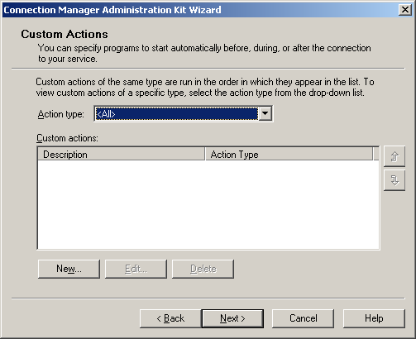
- In Action type, click Post-connect, and then click New.
- The New Custom Action dialog box is displayed, as shown in the following figure.
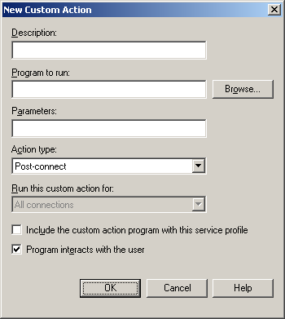
- In Description, type a descriptive title for the post-connection action.
- In Program to run, type the name of the program or script file for network policy compliance testing or click Browse to specify it.
- In Parameters, type the set of command-line parameters that are passed to the program specified in Program to run.
- Select the Include the custom action program with this service profile check box. The following figure shows an example for the Script.bat script file using the parameters "%DialRasEntry% %TunnelRasEntry% %Domain% %UserName%". These parameters are CM profile variables that are passed to the script file for use in making decisions within the script.
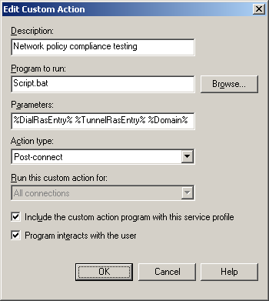
- Click OK. An example is shown in the following figure.
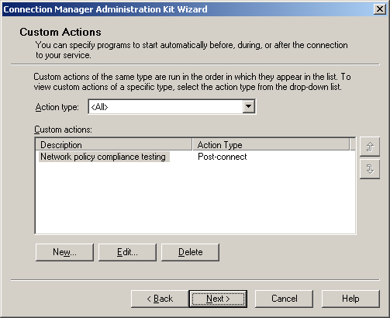
- Add additional post-connect actions as needed.
- Click Next.
- Configure the CM profile as needed, until the Additional Files page is displayed. This is shown in the following figure.
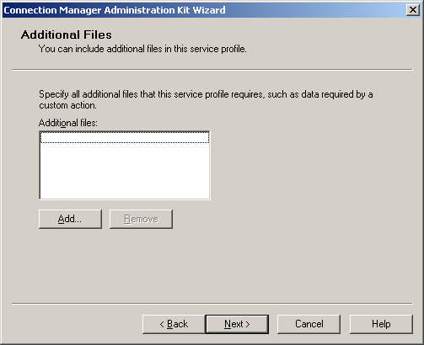
- Click Add. In the Browse dialog box, specify the location of the Rqc.exe file.
- Click OK. The addition of the Rqc.exe file to the CM profile is shown in the following figure.
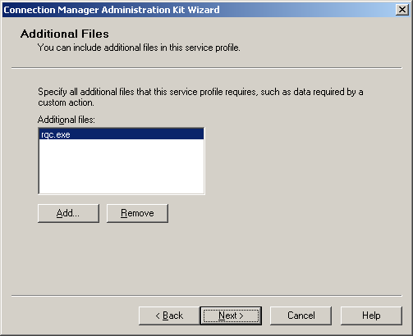
- Add additional files as needed.
- Complete the remainder of the CMAK Wizard to create the quarantine CM profile.

Distributing the CM Profile for Installation on Remote Access Client Computers
After the quarantine CM profile has been created, it must be distributed and installed on all your remote access client computers. The profile itself is an executable file that must be run on the remote access client to install the profile and configure the quarantine network connection. There are many methods to distribute and run the profile on remote access client computers:
- Send out the profile executable file or a link to the profile in an email message to your remote access users with instructions to run the profile that installs the quarantine connection.
- Place the profile executable on a Web page and instruct your users to run the profile that installs the quarantine connection.
- Have the profile run as part of a startup script or the domain login script.
In addition to distributing the profile to your remote access users, you should place the profile on a file share or Web site corresponding to your quarantine resources. Once placed there, remote access clients who do not have the current profile installed and are in quarantine mode can be instructed to install the latest profile and then reconnect.

Configuring a Quarantine Remote Access Policy
If Routing and Remote Access is configured with the Windows authentication provider, configure the quarantine remote access policy on the remote access server using the Routing and Remote Access snap-in. If Routing and Remote Access is configured with the RADIUS authentication provider, configure the quarantine remote access policy on the IAS server using the Internet Authentication Service snap-in.
To configure a quarantine remote access policy, first create the remote access policy for normal remote access connections using a common remote access policy configuration. Modify the newly created remote access policy for your custom settings. Then, add the MS-Quarantine-Session-Timeout and MS-Quarantine-IPFilter attributes as needed on the Advanced tab of the remote access policy profile properties.
The following is an example of creating a quarantine remote access policy for VPN remote access connections that does not use any custom settings or additional vendor-specific attributes and all files for installation on the client are available through Web pages:
- In the console tree, right-click Remote Access Policies, and then click New Remote Access Policy.
- On the Welcome to the New Remote Access Policy Wizard page, click Next.
- On the Policy Configuration Method page, type Quarantined VPN remote access connections in Policy name. This is shown in the following figure.
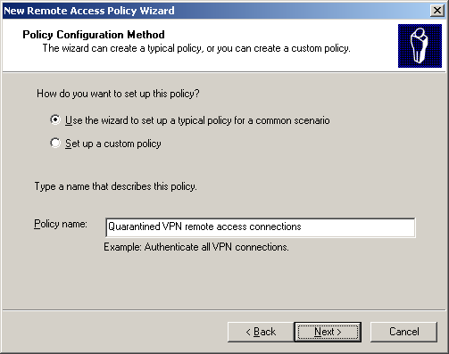
- Click Next. On the Access Method page, select VPN. This is shown in the following figure.
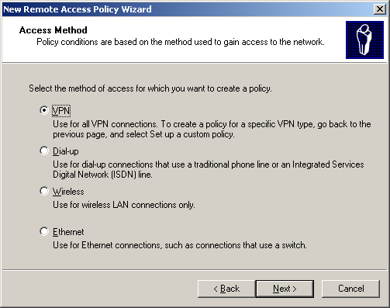
- Click Next. On the User or Group Access page, select Group. This is shown in the following figure.
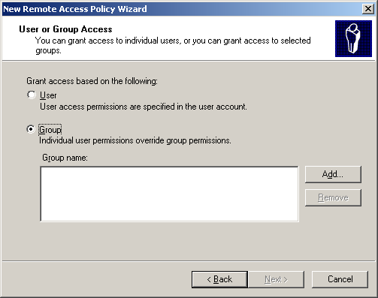
- Click Add. In the Select Groups dialog box, type the group names Enter the object names to select. An example using the VPNUsers group is shown in the following figure.
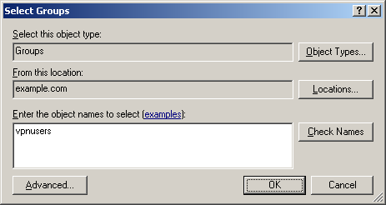
- Click OK. The VPNUsers group in the example.com domain is added to the list of groups on the Users or Groups page. This is shown in the following figure.
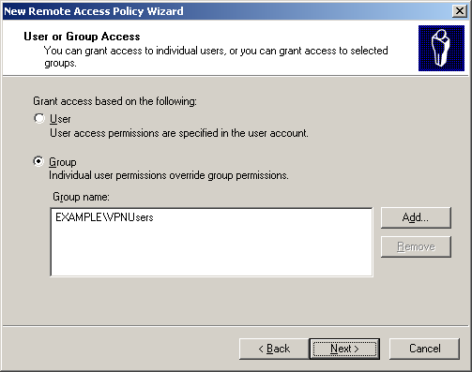
- Click Next. On the Authentication Methods page, the MS-CHAP v2 authentication protocol is selected by default. This is shown in the following figure.
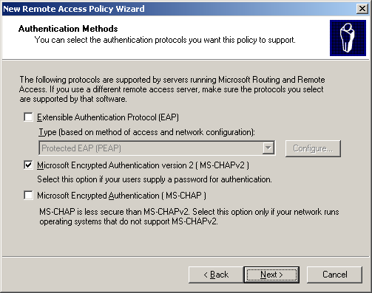
- Click Next. On the Policy Encryption Level page, clear the Basic encryption and Strong encryption check boxes. This is shown in the following figure.
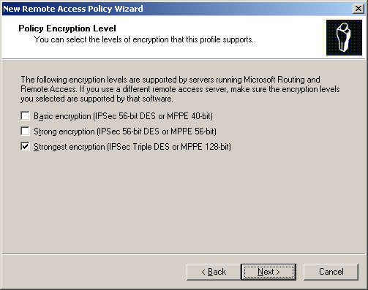
- Click Next. On the Completing the New Remote Access Policy page, click Finish.
- In the contents pane, right-click the new Quarantined VPN remote access connections remote access policy and click Properties.
- Click the Advanced tab. This is shown in the following figure.
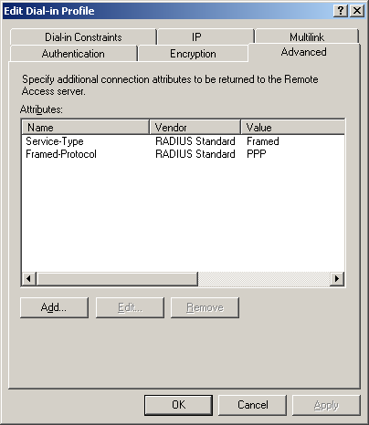
- Click Add. The Add Attribute dialog box is displayed. This is shown in the following figure.
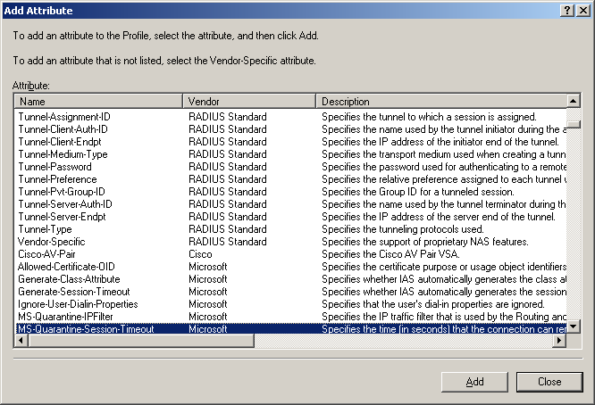
- In the Attribute list, click MS-Quarantine-Session-Timeout, and then click Add.
- In the Attribute Information dialog box, type the quarantine session time in Attribute value. This is shown in the following figure for a 60 second quarantine session timer.
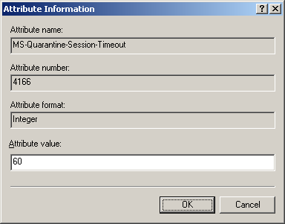
- Click OK
- Click Add. In the Attribute list, click MS-Quarantine-IPFilter, and then click Add. This is shown in the following figure.
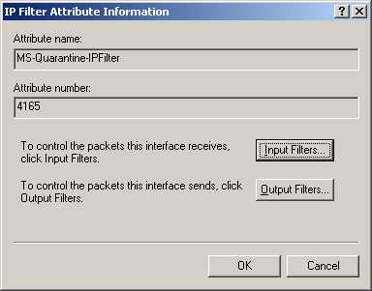
- In the IP Filter Attribute Information dialog box, click Input Filters. The Inbound Filters dialog box is displayed. This is shown in the following figure.
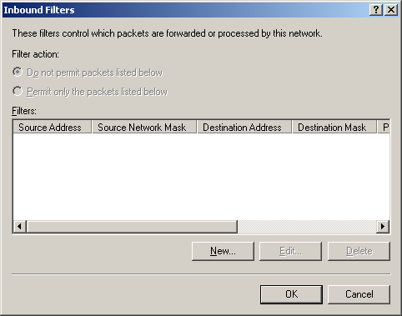
- Click New to add the first filter. The Add IP Filter dialog box is displayed. In Protocol, click TCP. In Destination port, type 7250. This is the input filter that allows the notification message from quarantined remote access clients and is shown in the following figure.
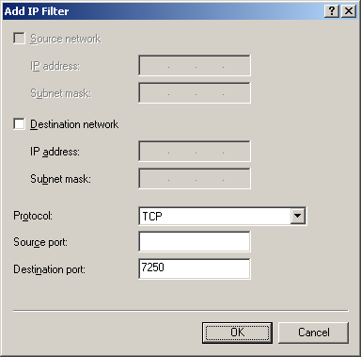
- Click OK. On the Inbound Filters dialog box, click Permit only the packets listed below. This is shown in the following figure.
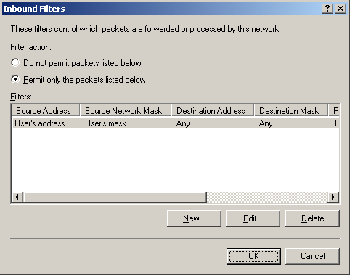
- Click New and add the input filter for DHCP traffic. This is shown in the following figure.
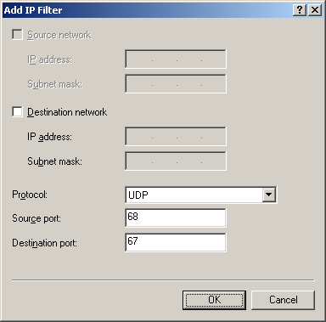
- Click OK. Click New and add the input filter for DNS traffic. This is shown in the following figure.
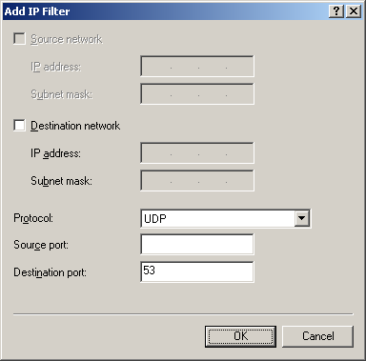
- Click OK. Click New and add the input filter for WINS traffic. This is shown in the following figure.
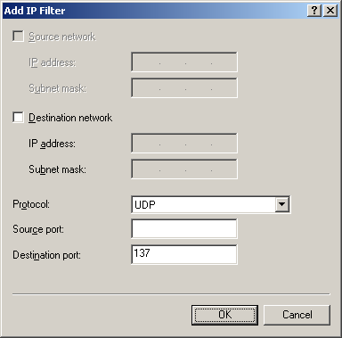
- Click OK. Click New and add an input filter for a quarantine resource (a Web server). The example shown in the following figure is for HTTP traffic to the Web server with the address 131.107.47.91.
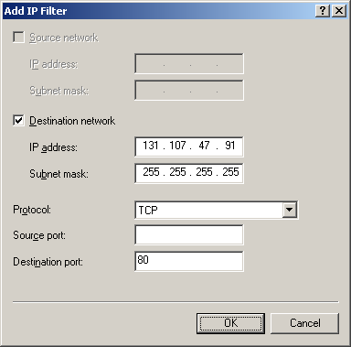
- Repeat step 23 for additional filters needed for quarantine resources.
- When you are done adding filters, click OK on the Inbound Filters dialog box to save the filter list.
- On the Edit Dial-in Profile dialog box, click OK to save the changes to the profile settings. Then, click OK to save the changes to the quarantine remote access policy.
If you are using RADIUS, after the quarantine remote access policy is created on the first IAS server, either create the quarantine remote access policy on your other IAS servers or copy the configuration of the first IAS server to your other IAS servers. For more information, see the topic titled "Copy the IAS configuration to another server" in Windows Server 2003 Help and Support.

Alternate Configurations
This section discusses the following alternate Network Access Quarantine Control configurations:
- Using an exception remote access policy
- Mitigating application delay in quarantine mode
- Global dispersion of quarantine resources

Using an Exception Remote Access Policy
As described previously, the creation of quarantine remote access policy means that all of your remote access clients must be running a quarantine CM profile and successfully run the quarantine script. If a remote access client is not using the quarantine CM profile or cannot run the quarantine script, their connection will be stuck in quarantine mode either indefinitely (if no quarantine session timeout is configured) or until automatically disconnected (if a quarantine session timeout is configured).
Although it is ideal to have all users using a quarantine script and completing the quarantine script successfully, if that is not possible, then you can create a separate remote access policy for those users who are not or cannot use the quarantine profile or run the quarantine script. Before you create the exception remote access policy, you must create an exception group and place all the users who are exempted from quarantine within the exception group or within a group that is a member of the exception group.
After the group is created and populated with the correct user accounts, create a new remote access policy that uses the exceptions group and is configured with the same settings as the quarantine remote access policy, but do not add and configure the MS-Quarantine-IPFilter and MS-Quarantine-Session-Timeout attributes. Move the exceptions remote access policy so that it is evaluated before the quarantine remote access policy.
When an exception user connects, the connection attempt will match the exceptions remote access policy and be accepted for normal remote access. When the user's situation changes such that they can use the quarantine CM profile and quarantine script, then remove their account from the exceptions group.

Mitigating Application Delay in Quarantine Mode
As previously discussed, running a quarantine script creates a delay between the time that the connection is successfully made and the time in which normal remote access is granted. This delay is a function of how long it takes to run the quarantine script, send the notification, and have the quarantine restrictions removed by the remote access server. Immediately after the connection is successfully made, applications may begin to operate over it. If quarantine filters do not include the application's traffic, then the application's startup traffic is dropped by the remote access server, which might cause the application to fail.
One workaround is to create input packet filters to allow the application's traffic while the remote access client is in quarantine mode. The drawback to this approach is the tasks of identifying the application's traffic and creating additional packet filters. However, Microsoft recommends that you keep the number of quarantine packet filters to a minimum.
The following alternate configurations are designed to lower the delay time or otherwise mitigate the delay experienced by applications when connecting to a quarantine remote access server, without having to add packet filters for application traffic:
- Using only a quarantine session timeout
- Immediate notification

Using Only a Quarantine Session Timeout
In this configuration, the MS-Quarantine-Session-Timeout attribute is configured but the MS-Quarantine-IPFilter attribute is not. The remote access client is given immediate normal remote access unrestricted by quarantine packet filters, however the remote access client must still send a notification message that it complies with network policies, otherwise it is disconnected when the quarantine session timeout expires.
The advantages to this configuration are that there is no need to configure quarantine packet filters and there are no application delay issues. Remote access occurs in the same way as if there were no quarantine. The disadvantage to this configuration is that remote access clients are given normal access to the network for the quarantine session timeout period, even if they do not comply with network policies.

Immediate Notification
In this configuration, the quarantine script runs Rqc.exe to send the notification before any of the tests are completed. The quarantine restrictions are removed from the connection and the remote access client has immediate normal access. Within the quarantine script, the network policy compliance tests are performed. If any of them fail, the quarantine script notifies the user of the corrective actions required and automatically disconnects the user after a specific amount of time, emulating quarantine mode and the use of a quarantine session timer.
Note that in this configuration, the MS-Quarantine-Session-Timeout or MS-Quarantine-IPFilter attributes are still configured to provide the desired quarantine restrictions. Even though they are immediately removed from a connection that was initiated from a remote access client using the quarantine CM profile, they are still needed to provide quarantine for a remote access client that is either not using the quarantine CM profile or is using the wrong quarantine CM profile (with the wrong version of the quarantine script).
The advantage of this configuration is that there are no application delay issues. Remote access occurs in the same way as if there were no quarantine. The disadvantage to this configuration is that remote access clients are given normal access to the network for the delay associated with the running of the quarantine script, even if they do not comply with network policies.

Global Dispersion of Quarantine Resources
In a large enterprise, it might be desirable to create multiple sets of quarantine resources, depending on regional, topological, and bandwidth considerations. For example, having a single set of quarantine resources for a large enterprise located in the New York headquarters means that VPN clients connecting to VPN servers in the Australia regional office must access quarantine resources across the corporate wide area network to New York. If you create regional quarantine resources, you must modify your quarantine script or program so that the quarantine resources that are accessed are based on the remote access server to which it is connecting.
For example, if the user connects to the New York VPN server, then the URL to the quarantine resource Web server is set to http://qserver.newyork.corpnet.example.com/remote_access_quar.asp. If the user connects to the Sydney VPN server, then the URL to the quarantine resource Web server is set to http://qserver.sydney.corpnet.example.com/remote_access_quar.asp.
You can use Connection Manager variables within your quarantine script or program such as %ConnectionType%, %PopName%, or %TunnelServerAddress% to determine which set of quarantine resources to use. For information about additional Connection Manager variables you can use, see the topic titled "Incorporating custom actions" in Windows Server 2003 Help and Support.

Appendix A. Sample Quarantine Script
The following is an example quarantine script written as a batch file named Script.bat that provides a framework for testing network policy compliance. From the CM profile, Script.bat is run as a post-connect action using the following command line (as configured from the New Connect Action dialog box of the CMAK Wizard):
script.bat %DialRasEntry% %TunnelRasEntry% %Domain% %UserName%
The value of the %DialRasEntry% CM variable becomes the %1 variable in the batch file. The value of the %TunnelRasEntry% CM variable becomes the %2 variable in the batch file. The value of the %Domain% CM variable becomes the %3 variable in the batch file. The value of the %UserName% CM variable becomes the %4 variable in the batch file.

@echo off

echo RAS Connection = %1
echo Tunnel Connection = %2
echo Domain = %3
echo User Name = %4

set MYSTATUS=

REM
REM Network policy compliance tests
REM

REM
REM Check if Internet Connection Firewall is enabled.
REM Set ICFCHECK to 1 if it is (pass).
REM Set ICFCHECK to 2 if it is not (fail).
REM

REM
REM Check if Virus checker is running and has correct signature file installed.
REM Set VIRCHECK to 1 if it is (pass).
REM Set VIRCHECK to 2 if it is not (fail).
REM

REM
REM Based on the test results, run Rqc.exe.
REM

if "%ICFCHECK%" == "2" goto :TESTFAIL
if "%VIRCHECK%" == "2" goto :TESTFAIL

rqc.exe %1 %2 7250 %3 %4 Version1

REM %1 = %DialRasEntry%
REM %2 = %TunnelRasEntry%
REM 7250 is the TCP port on which Rqs.exe is listening
REM %3 = %Domain%
REM %4 = %UserName%
REM Version1 is the script version string

REM
REM Print out the status
REM

if "%ERRORLEVEL%" == "0" (
set MYERRMSG=Success!
) else if "%ERRORLEVEL%" == "1" (
set MYERRMSG=Unable to contact remote access gateway. Quarantine support may be disabled.
) else if "%ERRORLEVEL%" == "2" (
set MYERRMSG=Access denied. Please install the Connection Manager profile from http://www.corpnet.example.com/remote_access_tshoot.asp and reconnect.
) else (
set MYERRMSG=Unknown failure. The client will remain in quarantine mode.
)
echo %MYERRMSG%
goto :EOF

:TESTFAIL
echo
echo Your computer has failed network compliance tests. Either
echo Internet Connection Firewall is not enabled or you do not
echo have the correct virus-checking program with the current
echo signature file loaded. For information about how to configure
echo or install these components, see
echo http://www.corpnet.example.com/remote_access_tshoot.asp.
echo

:EOF
For additional script examples, see the free Sample Scripts for verifying client configuration for VPN Quarantine download.

Appendix B. Network Access Quarantine Control Requirements
Network Access Quarantine Control requires the following:
- For the remote access server, a computer running Windows Server 2003 and Routing and Remote Access.
Only Routing and Remote Access in Windows Server 2003 supports the processing of the MS-Quarantine-Session-Timeout and MS-Quarantine-IPFilter attributes and the MprAdminConnectionRemoveQuarantine() API to remove the quarantine restrictions from the remote access connection.
If the remote access server is configured to use the Windows authentication provider, then the quarantine remote access policy is created on the remote access server.
- On the remote access server, a listener component that listens for network policy compliance messages from connecting remote access clients and uses the MprAdminConnectionRemoveQuarantine() API to inform Routing and Remote Access to remove the quarantine restrictions from the remote access connection.
An example of the listener component is the Remote Access Quarantine Agent service (Rqs.exe).
- For the remote access client, the capability to execute network policy compliance tests after the connection has been made and, if the client computer passes the tests, send a network policy compliance message to the listener component on the remote access server.
An example of a remote access client with this capability is a computer running Windows Server 2003, Windows XP Professional, Windows XP Home Edition, Windows 2000, Windows Millennium Edition, or Windows 98 Second Edition with a CM profile containing a post-connect action network policy requirements script and Rqc.exe.
- For the accounts database, Active Directory or a Windows NT 4.0 domain
If the remote access server is configured to use the Windows authentication provider, then the remote access server uses Active Directory or a Windows NT 4.0 domain to validate credentials and obtain user account properties. If the remote access server is configured to use the RADIUS authentication provider, then the RADIUS server must be a Windows Server 2003 IAS server, which also uses Active Directory or a Windows NT 4.0 domain to validate credentials and obtain user account properties.
Network Access Quarantine Control can optionally use the following:
- For RADIUS servers, computers running Windows Server 2003 and IAS.
IAS servers are only needed when the remote access server is configured to use the RADIUS authentication provider. Only IAS in Windows Server 2003 supports the configuration of the MS-Quarantine-Session-Timeout and MS-Quarantine-IPFilter attributes in the advanced properties of the remote access policy profile.

Summary
Network Access Quarantine Control is an advanced security feature of Windows Server 2003 that provides a managed way to prevent full access to your intranet until the configuration of the remote access client computer has been verified as complying with network policies. Network Access Quarantine Control uses a CM profile containing an embedded quarantine script and a notifier component, a listener component running on a Windows Server 2003 remote access server, and a quarantine remote access policy. To deploy Network Access Quarantine Control you must designate and configure quarantine resources, create a quarantine script, install the listener component on the remote access servers, create and distribute the quarantine CM profile, and configure a quarantine remote access policy.

Related Links
See the following resources for further information:
- Windows Server 2003 Resource Kit Tools at http://www.microsoft.com/downloads/details.aspx?familyid=9d467a69-57ff-4ae7-96ee-b18c4790cffd&displaylang=en
- Sample Scripts for verifying client configuration for VPN Quarantine at http://www.microsoft.com/downloads/details.aspx?FamilyID=a290f2ee-0b55-491e-bc4c-8161671b2462&displaylang=en
- Windows VPN Web site at http://www.microsoft.com/vpn
- Managed Remote Access with the Connection Manager Components of Windows 2000 at http://www.microsoft.com/technet/columns/cableguy/cg0901.asp?frame=true
- Step-by-Step Guide for Setting Up Network Quarantine and Remote Access Certificate Provisioning in a Test Lab at http://download.microsoft.com/download/a/e/2/ae25c0a2-f11f-4bb2-bf83-52ace5b46a26/StepByStep_QuarTestlab.doc
- Internet Authentication Service Web site at http://www.microsoft.com/ias

For the latest information about Windows Server 2003, see the Windows Server 2003 Web site at http://www.microsoft.com/windowsserver2003.
