Overview  Country: India  Industry: International customs  Customer Profile  NG Pillai, established in 1983, is a Custom House Agent. Working for many blue chip companies such as LG Electronics, JK Technosoft, and American Express. The company works closely with the Customs Department to make timely clearance of all imports for its customers.  Business Situation  Custom House Agents need to utilize specific software created by the National Informatics Center. This can be done at notified Service Centers. NG Pillai decided to set up a Service Center in addition to its CHA business.  Solution  To start the service center operations, NG Pillai set up a network with 20 PCs on a LAN. A client-server network based on Microsoft® Windows® Small Business Server 2003 was created.  Benefits  - Easy implementation  - Improved network security  - Ability to reach more customer |  |  | “Microsoft Windows Small Business Server 2003 has clearly been a business enabler for us, without which we would not have been able to create an effective service center.”  N.G. Pillai, CEO, NG Pillai
 |  |  | NG Pillai, a New Delhi–based Custom House Agent (CHA) (internationally known as a custom broker), was started in 1983 and today has over 35 employees. As it was starting a new business as an Authorized Service Center of Customs for CHAs and Trade (import and export), the company decided to set up a high-technology infrastructure to file relevant documents electronically with the government. NG Pillai bought 20 computers networked on a LAN with high-speed Internet access. To upload documents from its office to the government server, the company deployed Microsoft® Windows® Small Business Server (SBS) 2003. The Service Center uses Microsoft Exchange Server for communications and runs a database on Microsoft SQL Server™. Because CHA representatives visit the Service Center for 16 hours each day, it is
 |  |  | 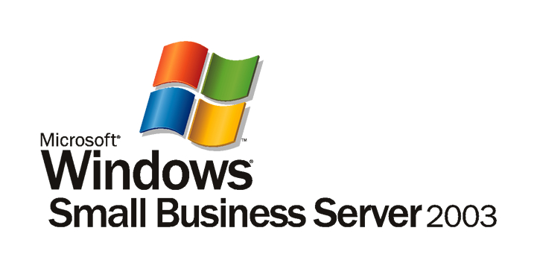

Situation
“With SBS, we know that the data entrusted to us by our customers is safe. The security features of SBS allow us to focus on our core business and not worry about network security etc.”
N. G Pillai, CEO, NG Pillai

NG Pillai is a firm of Custom House Agents (CHAs), approved by the Ministry of Finance to handle customs clearance of a variety of products for companies based in and around New Delhi. Established in New Delhi in 1982, the company today employs over 35 people and its customers include LG Electronics, JK Technosoft, and others.

Of the approximately 600 CHAs in New Delhi, 60–70 companies have been allowed to use the Electronic Data Interchange infrastructure created by the National Informatics Center (NIC) to securely upload documents such as Import/Export Declaration and Manifests over the Internet. This is called the Indian Customs Excise Gateway, which acts as a single point of interface between the Customs Computer Network and the partners in the Customs community system. The smaller clearing houses need to visit one of the Service Centers created by the customs authority to file their documents.

NG Pillai was also a sub contractor for the Public Sector Undertaking, Electronics Trade and Technology Corporation Ltd. (ET & T Ltd.), which used to run these Service Centers. The company’s employees used to staff one such center until June 2003, when the government shut down ET & T Ltd. At this point, NG Pillai decided to become a Service Center for the customs depot in New Delhi.
With this in mind, the organization decided to create an IT infrastructure that would support the smaller CHAs in the National Capital Region.

To become a Service Center, the organization needed to set up an IT infrastructure comprising hardware, software, and networking components on its premises where other CHAs could visit to file documents using the NIC’s Remote Electronic Data Interchange System. The Customs Department responds with the Bill of Entry and Shipping Bills, which is used by the CHA for clearance of cargo.

Solution
NG Pillai turned to IT Solutions India, a Microsoft Partner, for help in designing and deploying a new solution. Using Microsoft® Windows® Small Business Server (SBS) 2003, IT Solutions India created an end-to-end solution for the Service Center.
A LAN has been set up with high-speed access to the Internet. This is important as all documents need to be filed online. In the next phase, NG Pillai implemented the server-side infrastructure, which includes the Microsoft Windows Server™ 2003 operating system and Microsoft Exchange Server 2003.

Windows Server is also used for file and print server needs, in addition to managing the Web access and e-mail infrastructure for the Service Center. A common hard disk drive on the server is used to store and access all documents. This removes the need for paper copies.

The Microsoft Shared Fax Service has also been deployed. As many of the CHAs don’t have e-mail infrastructure, confirmations often have to be faxed to their offices or hard copies provided.

Currently, NG Pillai is working with the NIC to port the excise application to Microsoft SQL Server™ from an Oracle database. This will enable the organization to use the existing infrastructure provided in SBS more effectively.

Twenty Service Center personnel assist the CHA representatives to complete the forms as required by Customs. The infrastructure uses SQL Server to store the information for each transaction. Exchange Server has been deployed as the messaging infrastructure.

Benefits
SBS forms the cornerstone of NG Pillai’s foray into the Service Center business. Explaining the benefits of the Microsoft software implementation, N.G. Pillai, CEO, NG Pillai says, “Microsoft Windows Small Business Server 2003 has clearly been a business enabler for us, without which we would not have been able to create an effective service center.”
“It has been very easy to start our business, as SBS offers an integrated solution that met all our requirements.”
N.G. Pillai, CEO, NG Pillai.

Is Up and Running Quickly
NG Pillai was able to create the entire IT infrastructure in a matter of days with SBS. Online license activation means that the organization did not have to physically set up the clients using a floppy disk or CD drive. “It has been very easy to start our business, as SBS offers an integrated solution that met all our requirements,” says N.G. Pillai, CEO of NG Pillai.

Ensures Network Security
As a Service Center, the company manages a large amount of confidential information for various importers across the region. Therefore, it is imperative that the information is secure. Wizards simplify security settings and help ensure all the necessary security steps are taken while setting up the network. Additionally, the solution has an internal firewall and supports third-party external firewalls for greater security.

Creates a Central Location to Store Business-Critical Information
NG Pillai has been able to centralize access to data and applications. This has improved employee productivity by ensuring employees can locate relevant information from their desktops.

Reaches More Customers
“We believe we are better equipped and can manage a larger number of customers on any given day. This is because SBS provides us with a stable and secure infrastructure that supports our business needs and helps us grow,” explains Mr. Prakashan, General Manager, NG Pillai.

Windows Small Business Server 2003
For More Information
For more information about Microsoft products and services, call the Microsoft Sales Information Center at 1600-111-100. To access information using the World Wide Web, go to:
www.microsoft.com/india

For more information about N. G. Pillai products and services, call +91-11-26784646

© 2006 Microsoft Corporation. All rights reserved. This case study is for informational purposes only. MICROSOFT MAKES NO WARRANTIES, EXPRESS OR IMPLIED, IN THIS SUMMARY. Microsoft, Microsoft, Outlook, Windows, the Windows logo, and Windows Server are either registered trademarks or trademarks of Microsoft Corporation in the United States and/or other countries. The names of actual companies and products mentioned herein may be the trademarks of their respective owners.

Document published January, 2006

Software and Services  - Products  - Microsoft Small Business Server 2000 | Hardware  - HP Server TC 2120, Pentium IV  - Pentium IV desktops  Partners  - I.T. Solutions India (P) Limited

Microsoft Windows Small Business Server 2003 is a powerful advantage for your business success. Improve the security of your data and help your network run dependably. Release new productivity from your desktops while empowering your employees to do more. And connect to your customers like never before.

For more information about Windows Small Business Server 2003, please visit:
www.microsoft.com/sbs

