


Mobile Messaging with Exchange ActiveSync
White Paper
Published: November 2006
For the latest information, please see http://www.microsoft.com/exchange/

Abstract
Companies of all sizes are turning toward mobile devices as a way to help their employees work more effectively and productively. Mobile device manufacturers and mobile network operators have released a wide array of devices with different form factors and capabilities. The Microsoft Exchange Server product family includes integrated support for a wide range of mobile devices, giving companies the ability to choose the right devices for their needs. This paper describes the mobility features of Exchange Server 2003 and Exchange 2007, including technical details of how the Exchange ActiveSync protocol works and how various mobile messaging features are implemented in Exchange.
Contents
Introduction 1
Benefits of Mobile Messaging 2
Exchange Mobility Explained 3
Advantages of Exchange Mobility 3
The Exchange ActiveSync Protocol 3
Exchange 2003 Mobility Features 5
Exchange 2007 Mobility Features 7
Exchange Mobility Clients 10
Conclusion 13

Introduction
Companies of all sizes are turning toward mobile devices as a way to help their employees work more effectively and productively. Mobile device manufacturers and mobile network operators have released a wide array of devices with different form factors and capabilities. Many mobile messaging solutions require the purchase of specific devices and accompanying server-based middleware; these requirements add to the cost, complexity, and administrative overhead of mobility-enabled messaging deployments.
Microsoft’s approach is different from the traditional industry pattern in several ways. First, the mobility software is embedded as part of Microsoft Exchange Server, the industry-leading messaging platform. There’s no requirement to purchase additional server software or client licenses for users already licensed through an Exchange Client Access License (for example, because they use Outlook or Outlook Web Access). Second, Microsoft has aggressively licensed the Windows Mobile operating system and the Exchange ActiveSync protocol to a wide range of mobile device manufacturers, allowing customers to choose the type of device and operating system that works best for them. Third, because all of the necessary components are included with Exchange and the mobile device, there’s no requirement for an outside network operations center or a special data network.
The Exchange Server mobile messaging features are implemented using the Exchange ActiveSync (EAS) protocol, which consists of two separate components. The EAS server component is included as part of the Exchange installation process. The EAS client component may be included with the operating system on a mobile device (as it is with Windows Mobile), or it may be made available as a separate download from the device manufacturer, the mobile network operator, or a third-party independent software vendor.

Benefits of Mobile Messaging
Traditional business processes have mostly assumed that most workers sit in the same place each day, and that they are relatively immobile. Until recently, for many workers it wasn’t efficient or practical to work any other way. However, over the last several years, the rapid deployment of broad cellular and mobile data networks and the increasing prevalence of laptops and wireless personal digital assistants (PDAs) have moved the technology required for mobile messaging squarely within reach of companies of all sizes. At the same time, the pace of business operations has increased, placing a high premium on the ability to be productive from a wider range of locations. Individual users are increasingly demanding mobile access to e-mail, calendar, task, and contact data because it gives them more options to balance work, travel, and personal time. Companies are searching for mobile messaging solutions that provide the capabilities users want at an acceptable cost and with good security.
Mobile messaging offers some key benefits for both companies and their workers:
- Workers can turn downtime into productive time by using mobile messaging devices to stay in touch with co-workers, customers, and business partners. This enables faster response times and greater customer satisfaction.
- Organizations can increase their agility and flexibility by using mobile devices to keep their mobile or field staffs up to date when they’re away from traditional desktop or laptop work environments.
- Executives and other key decision makers can stay better informed and better connected by using mobile messaging devices to keep abreast of changes or events in their businesses.
- Users can quickly find and act on needed information no matter where they are.
- Unified messaging systems like Exchange 2007 can deliver multiple information types (including e-mail, contact, calendar, task, voice mail, and fax data) to a single inbox on a mobile device, cutting down wasted time and eliminating phone tag.
Mobile devices can also serve as an application deployment platform so that line-of-business applications can be deployed and used by mobile users. Examples include customer relationship management and sales management applications designed to be used by field customer support and sales staff. In this role, mobile devices extend the reach of both off-the-shelf and custom line-of-business applications.

Exchange Mobility Explained
Microsoft first introduced integrated mobile messaging support in Exchange Server 2003. This provided Exchange customers with a low-cost, easy-to-manage mobile messaging solution as part of their Exchange deployments. Microsoft has continued this pattern with the subsequent releases of Exchange Server 2003 Service Pack 2 and Exchange 2007.

Advantages of Exchange Mobility
There are four key advantages to the implementation of mobile messaging in the Exchange Server product family:
- Exchange mobility reduces costs. Support for mobile messaging is included as part of the server. There is no additional cost for this functionality. No additional server software is required, and users who are already licensed to use Exchange don’t need additional client licenses (a sharp contrast to third-party mobility solutions for Exchange and competing messaging products). Mobility management is integrated with the same familiar user, server, and system management tools that administrators already know how to use, so training and management costs are minimized.
- Exchange mobility is highly scalable. Microsoft has carefully tuned Exchange Server 2003 and Exchange 2007 to provide industry-leading scalability. This tuning extends to the Exchange ActiveSync implementation, which provides efficient communications between client and server. Unlike other mobile messaging servers which rapidly require the addition of more servers (both third-party mobile servers and core messaging servers) as the mobile user base expands, Exchange uses the same servers for mobility as well as OWA and Outlook Anywhere. Each mobile user is simply equivalent to users of other access methods from a server sizing perspective. This allows the benefits of mobile messaging to be enjoyed by an ever-expanding portion of the organization. Additionally, Exchange ActiveSync works with all types of mobile communication networks, including GSM, GPRS, UMTS, HSDPA, and CDMA.
- Exchange mobility supports many different devices. Microsoft provides client support for Exchange ActiveSync in its own Windows Mobile operating system, which is currently used by more than 45 worldwide device manufacturers. There is a wide range of Windows Mobile devices, including clamshell/”flip” phones, thin and lightweight phones like the Motorola Q, the Palm 700w/wx, and the T-Mobile Dash, devices with full QWERTY keyboards, and devices with full VGA-resolution screens. In addition, Microsoft has also licensed the Exchange ActiveSync protocol to other device and software manufacturers, including DataViz (RoadSync), SonyEricsson (P990 and M600), Nokia (E-series), Palm (Treo 650 and 700p), Motorola (A780),, and Symbian (OS); these manufacturers have implemented EAS features in a wide range of their devices, including both-Windows Mobile and other operating systems. This provides companies an even broader choice of device styles, types, sizes, and capabilities.
- Exchange mobility provides policy and security enforcement. The Exchange ActiveSync protocol includes tools for policy and security management, including remote device wipe, password strength and age restrictions, and password-based device locking and lockout. The EAS protocol delivers policies to the device, where device-based software can enforce and control them.

Exchange ActiveSync Protocol
The Exchange ActiveSync protocol allows mobile devices to receive timely updates when new data items arrive in a user’s mailbox. EAS works with e-mail messages, calendar items, contacts, and tasks, although the exact set of data items supported may vary between device manufacturers.

Scheduled Synchronization
The original version of EAS supported in the release version of Exchange Server 2003 included the ability to perform manual and scheduled synchronizations. When synchronization was triggered either manually or by a schedule, the device would initiate a connection to the Exchange server and retrieve any new items in subscribed folders. These synchronization modes were, and remain, popular because they give users total control over their bandwidth usage and the amount of time that the device radio is in use.

Always-Up-To-Date (AUTD)
The Always-Up-To-Date (AUTD) feature of EAS notifies the device of updates by sending a specially formatted Short Message Service (SMS) message to the device; upon receipt, the device initiates a synchronization to pull new data items to the device. This approach has some limitations: it depends on the timeliness and reliability of SMS messages, it requires that the mobile operator network support the Simple Mail Transfer Protocol (SMTP), and it doesn’t provide a secure way of sending policy commands to the device. While still supported in Exchange Server 2003, the AUTD feature was dropped from Exchange 2007 due to these limitations.

Direct Push
The versions of EAS supported in Exchange Server 2003 Service Pack 2 and Exchange 2007 use a significantly different technology called Direct Push (Figure 1). Direct Push, which is supported by Windows Mobile 5 with MSFP (or later) and a number of EAS licensees, uses a client-created HTTPS connection to the server. The mobile device creates a connection and keeps it open for a duration known as the heartbeat interval, sending an initial synchronization request when the connection is opened. The server will then take several actions:
- When the device makes an initial connection, it may send the heartbeat interval and a list of subscribed folders to the server. If the server receives these items, it stores them in an XML file in the user’s mailbox; if it doesn’t receive them, it retrieves them from the mailbox.
- The server will ask the mailbox server for notification of changes to items in the list of subscribed folders from the device.
- If there are unsynchronized changes on the server, the server immediately returns a status code that tells the client that changes are available; the client will then initiate synchronization and pull the new changes.
- If there are no changes since the last synchronization, the server does nothing.
- When the heartbeat interval expires, the server sends a notification to the client, which can then re-establish the connection.
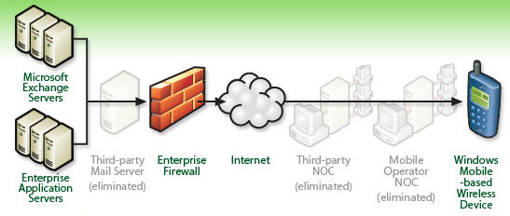
Figure 1: Direct Push directly links a mobile device with your Exchange servers

Most packet-based mobile networks allow an unused data connection to go dormant, at which point the client radio can stop transmitting over its data channel to save power; when activity occurs, the device is signaled to re-establish the connection. Because the server doesn’t return a response until either the heartbeat interval has expired or a new item has arrived, the device is free to let the persistent HTTP connection go dormant while waiting for new items to arrive. This reduces battery usage and bandwidth consumption because the device radio only needs to be fully active during synchronizations, while still maintaining the HTTPS connection. The mobile device can dynamically adjust the heartbeat interval used with the server, taking into account, how long the mobile operator will allow a dormant connection to remain active, and how long the enterprise firewall allows the connection to stay active. Administrators can adjust the timeouts used on their firewalls if needed; Microsoft recommends a standard setting of 30 minutes for most applications.
While the connection is dormant, if items in a subscribed folder arrive (or are changed), the server returns a response code to the client. The request to deliver data to the device causes the mobile network to signal that the connection should be re-established, and the device does so. Once the client receives the response code, it initiates a synchronization to get the new or changed items.

Exchange ActiveSync Client Software
The server components of Exchange ActiveSync are complemented by software that runs on the mobile device and implements the client-side support for the features of EAS. The EAS protocol itself is capable of transferring data (including e-mail messages, calendar items, contacts, and tasks) and sending policies and commands (including remote device wipe commands) to the client. The client EAS implementation is responsible for requesting the kinds of data it can handle, and it is responsible for implementing policy settings in a way that cannot be easily circumvented by the user.
All Windows Mobile 5.0 or later devices include native support for EAS; Windows Mobile 5.0 devices that have the Messaging and Security Feature Pack (MSFP) installed support EAS with Direct Push. Other licensees of the EAS protocol may support either version.

Exchange 2003 Mobility Features
Exchange Server 2003 Service Pack 2 provides support for several important mobility features. As previously mentioned, Direct Push was introduced in SP2, along with the ability to wirelessly synchronize tasks between a mobile device and a user’s Exchange mailbox, and the ability to search the global address list (GAL) from a mobile device.

Device Security Policy
Exchange Server 2003 has the capability to create security policies that are delivered to the client device through Exchange ActiveSync. The device implements the policy and takes action when it receives the policy information from the server. Different devices have differing levels of support for EAS policies, which can specify several aspects of device security:
- Whether or not a device must be locked with a personal identification number (PIN).
- The minimum length of the PIN.
- Whether the PIN can be numeric-only or alphanumeric.
- Whether failed PIN entry attempts should trigger a local device wipe.
- How often policy settings are reapplied to the device.
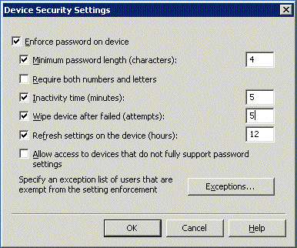
Figure 2: Device security policy settings for Exchange Server 2003 SP2

Policy Enforcement and Control
Exchange Server 2003 SP2 provides robust remote policy management for mobile devices. When a mobile device security policy is defined, it is automatically sent to each device the next time that device starts synchronization. The device user can choose to accept or decline the policy. However, the administrator can specify whether devices that reject the policy (or that don’t implement it) may still connect. This provides administrators a short-term way to allow connections from older devices until those devices can be replaced while still providing policy controls for devices that fully implement Exchange ActiveSync.
The Exchange administrator may also define a list of users who are exempt from security policy controls. This is useful for exempting users with special requirements, or whose devices don’t completely implement the client-side Exchange ActiveSync capabilities.

Local and Remote Device Wipe
When a mobile device is lost or stolen, the potential risk can be significant. Mobile devices often contain sensitive business data, including personally identifiable information of employees and customers, sensitive e-mail messages, and other items whose compromise can have a negative impact. Exchange ActiveSync addresses this risk by providing two levels of device wipe capability.
Local device wipes are triggered when a user incorrectly enters a PIN more than a specified number of times (the policy default is 8 times, but the administrator can adjust this value). After each two missed attempts, the device displays a confirmation prompt that requires the user to type a confirmation string (usually “A1B2C3”). This prevents the device from being wiped by accidental key presses. Once the PIN retry limit is reached, the device immediately wipes itself, erasing all local data.
Remote wipes occur when the administrator issues an explicit wipe command through the Exchange Mobile Admin tool (Figure 3); in Exchange 2007, users can also issue wipe commands for their own devices from within Outlook Web Access. . Remote wipe operations are separate from local wipes, and a device can be wiped remotely even if EAS policies are in use. The wipe command is sent as an out-of-band EAS command, so that the device receives it on its next synchronization. The device sends an acknowledgement message when it receives the wipe command, so the administrator can confirm that the device was actually erased. The device user doesn’t have the ability to opt out of the remote wipe. Wiping the device remotely has the effect of performing a factory or “hard” reset; all programs, data, and user-specific settings are removed from the device.
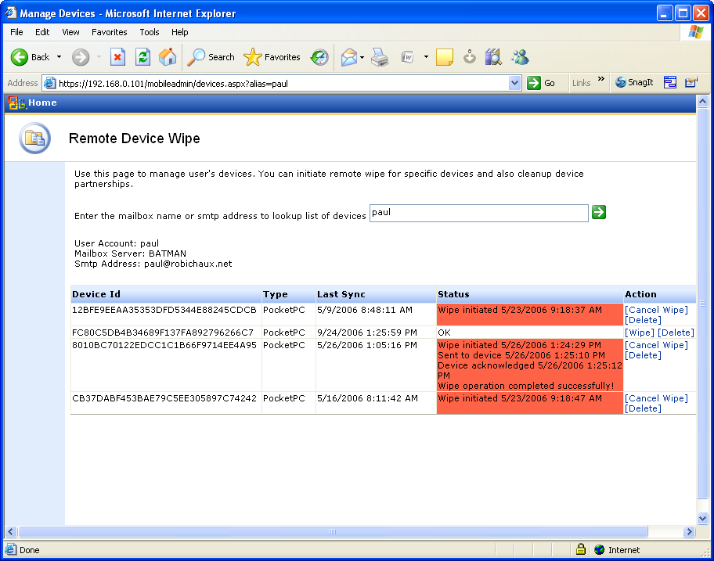
Figure 3: The Exchange Mobile Admin tool gives administrators control over remote device wipes

Certificate-Based Authentication
In addition to conventional password-based authentication, Windows Mobile 5.0 supports the use of X.509 digital certificates for user authentication. Certificate-based authentication has some major security advantages over conventional authentication. Because authentication is tied to the certificate and its associated private key, there are no credentials that an attacker can feasibly steal or intercept. Exchange Server 2003 SP2 allows administrators to require the use of digital certificates on mobile devices that synchronize using EAS. Enabling certificate-based authentication allows mobile users to establish secured connections without exposing their domain user name and password. For high-security environments, Windows Mobile devices support the use of a peripheral smart card or Common Access Card (CAC) reader. In addition, the device-based certificates can be used to send and receive S/MIME-protected e-mail messages.

Exchange 2007 Mobility Features
Exchange 2007 builds on the successful mobility features that Microsoft delivered in Exchange Server 2003. The Exchange ActiveSync protocol has been extended to provide a number of compelling new mobility features.
Note: Many device manufacturers and EAS licensees will be updating their clients to take full advantage of these features, but no specific roadmap has been released as of this writing.

Enhanced Outlook Experience
One key improvement area in Exchange 2007 is making the mobile device experience more like the desktop Outlook experience. The Exchange 2007 implementation of EAS provides full support for several desktop features, including:
- Mail flags to enable more efficient triage of important messages on mobile devices.
- Exchange Unified Messaging so that voice mail and fax messages processed by an Exchange Unified Messaging server are synchronized with, and available on, compatible mobile devices.
- Viewing HTML messages on devices that support HTML rendering, delivering more faithful rendering of message contents.
- Viewing protected messages sent with Windows Rights Management Services.

Enhanced Over-the-Air Search
One of the difficulties in using mobile devices is that their storage capacities are much smaller than even low-end desktop and laptop computers. In most environments, it is not practical to keep all your mail and documents copied onto a mobile device. Many information workers use their e-mail inbox as a primary means of storing and accessing information, so losing access to that information—even temporarily—makes it more difficult for people to get their jobs done.
Exchange 2007 helps solve this problem by including a powerful new content indexing service that enables full-text access to e-mail messages, contacts, tasks, and other item types at speeds up to 35 times faster than the Exchange Server 2003 full-text content indexer. Compatible devices can search this index directly; the server returns the list of search results, and the user can select individual messages to view. These messages are synchronized to the device without synchronizing other unwanted content.
Exchange ActiveSync supports limiting the search scope to a folder or tree of folders, and setting limits on the number of items returned in a single search. The combination of these features provides fast access to the entire contents of your mailbox from a mobile device, even though mobile devices typically don’t have the resources to keep the entire mailbox on the device.

Improved Calendaring Support
In Exchange 2007, Microsoft focused on improving key aspects of the calendaring experience, and many of these improvements are accessible to mobile device users through Exchange ActiveSync. These improvements include:
- The Calendar Attendant, which automatically processes meeting requests and updates so that your calendar remains up to date even when you’re not online.
- The ability to forward and reply to appointments and meeting requests directly from your mobile device.
- The ability to see attendee status for meetings you’ve organized.
- Tools for setting your Out of Office status and message directly from the mobile device.

LinkAccess
One persistent difficulty that information workers face when working with mobile devices is that much of the information they need remains inside the corporate network, where it’s difficult to access. Exchange 2007 solves this problem by providing LinkAccess technology, which provides administrator-controlled, read-only access to the contents of file shares and SharePoint sites. The Exchange 2007 Client Access Server proxies requests for this content using the mobile device’s user credentials, so users have exactly the same access to SharePoint sites and file shares that they would have when directly connected to the network.

Better Device Management and Logging
Exchange 2007 improves device management by allowing administrators to let users take care of simple requests that formerly required an administrator’s assistance. For example, users can wipe their own devices through Outlook Web Access (Figure 4) so they can immediately react when a device is lost or stolen. With older devices, users would have to call a cellular carrier to deactivate a lost device; with Exchange Server 2003 SP2, the company help desk could erase the device. With Exchange 2007, users can erase the device themselves and gain immediate peace of mind without the wasted time of involving a third party.
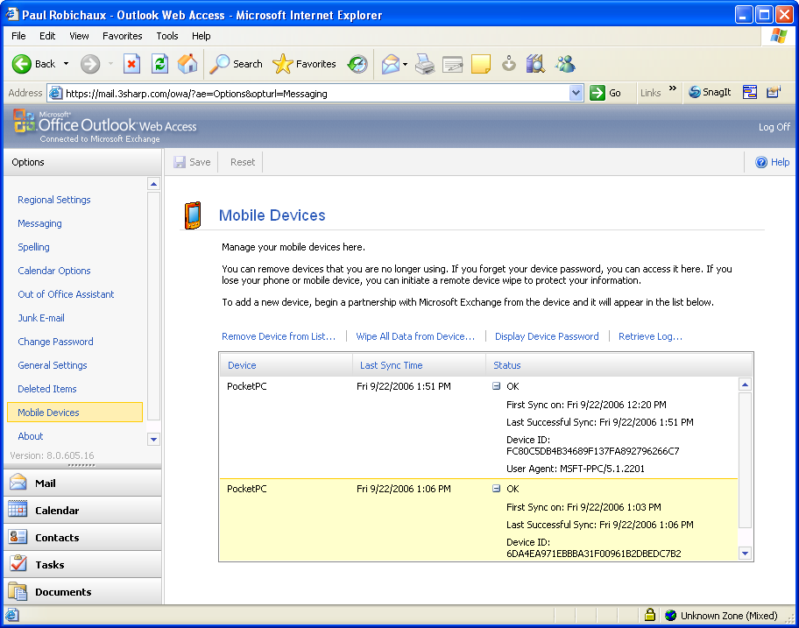
Figure 4: Exchange 2007 users can remotely wipe their own devices
In addition, devices that support the full feature set of Exchange 2007 allow users to provision their own devices by entering their e-mail address and password. This makes device provisioning and setup much easier because users can set up their own devices completely over-the-air, with no need for a desktop synchronization or assistance from the help desk.
Exchange 2007 also provides significantly more detailed server-side logging and reporting tools. These tools, which include the ability to track and update device partnerships and see which devices are connected at a given time, ease troubleshooting and provide more in-depth information on device and data plan usage. This helps companies optimize their data plan purchases by seeing how users are actually using their devices. Exchange 2007 also provides full support for monitoring Exchange ActiveSync traffic using the Microsoft Operations Manager (MOM) toolset.

Improved Device Security Policy and Enforcement
Exchange 2007 extends the Exchange ActiveSync security policy model by defining new security policy extensions that can be applied to compatible devices. These extensions include:
- The ability to specify that removable storage cards on the device must be encrypted.
- The ability to allow or block access to e-mail attachments on the mobile device.
- The ability to set PIN expiration times.
- Support for defining multiple EAS security policies and applying them to different groups.
In addition, Exchange 2007 can restrict or allow synchronization access based on individual device IDs or classes of devices. This allows administrators to specify exactly which devices can synchronize: enterprise-provisioned devices (by device ID), enterprise-approved devices, any device, or no devices.

Exchange Mobility Clients
Exchange Server 2003 and Exchange 2007 both provide support for a wide range of client devices. Rather than tying mobility functionality to a single operating system or device manufacturer, Microsoft has broadly licensed Exchange ActiveSync functionality to a number of third parties. Companies that adopt Exchange as a mobile messaging platform can choose from dozens of devices in different form factors (including devices with full QWERTY keyboards, small “stick”-style phones, and clamshell/flip phones) and with different capabilities (including full VGA screens, built-in Wi-Fi and Bluetooth, and support for various 2G, 2.5G, and 3G data networks).
It is important to remember that each manufacturer can choose which Exchange ActiveSync features to support. If there are particular features that are important to your deployment plans, verify that the devices or software you’re planning on using support the needed features.

Windows Mobile
Microsoft Windows Mobile powered devices help you access the business information you need even when you are away from your desk. With over 100 device models shipping from over 45 device-maker partners, and more than 120 mobile operators that support Windows Mobile devices, the Windows Mobile platform offers a range of devices across many regions that is uniquely suited for your organization, your team, and your role. In addition to Microsoft Outlook Mobile and familiar Microsoft Office Mobile software, innovations in Windows Mobile 5.0 include applications such as Voice over IP, persistent storage, on-device password enforcement, and remote wipe.
The Windows Mobile platform is an open platform that supports needs beyond mobile messaging. It’s based on Microsoft .NET, giving developers freedom to build applications and extend the operating system using familiar, mature tools. Over 18,000 Windows Mobile applications are available from third-party developers.
The Messaging and Security Feature Pack for Windows Mobile 5.0 works with Exchange Server 2003 SP2 and Exchange 2007 to deliver a direct, scalable and cost-effective mobile messaging solution. It enables business users to easily stay connected to their critical information while on the go, and helps businesses to better protect device data.
- Keep your Calendar, Contacts, Tasks, and Inbox up-to-date using Direct Push technology. You can also browse your corporate address book over-the-air with Exchange Server 2003 SP2 and Exchange 2007.
- Protect device data and manage devices using the Feature Pack and Exchange Server 2003 SP2. With this combination, IT administrators can remotely manage and enforce select corporate IT policies over-the-air using the Exchange Server 2003 SP2 console. Businesses can mandate policies like requiring PIN passwords for every device.
- Deploy scalable, cost-effective mobile messaging solutions and reduce the need to pay for an additional third party server product and client access license fees by using existing Exchange 2003 SP2 investments.
Microsoft is committed to making Windows Mobile the best mobile handheld solution for Microsoft Exchange customers. In addition to the platform benefits noted above, Microsoft endeavors to deliver the most complete and comprehensive implementation of Exchange Active Sync capabilities possible..
For more information please visit http://www.microsoft.com/windowsmobile.

DataViz
As a Microsoft Certified Partner with over 22 years of Office compatibility experience and as the first and only independent software vendor to license the Exchange ActiveSync protocol, DataViz is committed to extending Exchange ActiveSync technology to reach the world's most popular smart phones and wireless handsets.
The DataViz RoadSync client supports Symbian S60, S80, UIQ, Palm, Java and Windows Mobile devices, delivering a standardized cross-platform Exchange ActiveSync client that provides secure wireless and Direct Push synchronization of e-mail, calendar, contacts and attachments. RoadSync helps maximize existing device and server investments by enabling improved management and mobility features such as Direct Push, remote wipe, gzip data compression, Global Address List lookup and security policy enforcement on both new and existing devices. Support for Exchange 2007 mobility enhancements are also available for Nokia S60 smart phones and will soon be incorporated into upcoming versions of RoadSync for Windows Mobile 5.0 and Symbian UIQ based handsets. RoadSync is available as a traditional after-market software product, as well as preloaded on several OEM and VAR device variants. For free trials and information to help enable your top-down and bottom-up mobility projects, please visit http://www.dataviz.com/MSWP or contact EnterpriseSales@dataviz.com.

Nokia
Nokia’s Eseries are business-optimized devices with a range of advanced voice features. The Eseries family currently includes the Nokia E50, Nokia E60, Nokia E61, Nokia E62 and Nokia E70. These devices use Nokia’s Mail for Exchange, a mobile e-mail application included with Eseries devices that works with Microsoft Exchange ActiveSync to provide wireless e-mail, calendar, and contact synchronization. Eseries devices that are WiFi-capable can synchronize over mobile networks and WiFi connections. Attachments can be downloaded to the device; some Eseries models support attachment editing.

SonyEricsson
SonyEricsson includes Exchange ActiveSync support in the P990, M600 and W950 devices, providing secure wireless and Direct Push synchronization of corporate e-mail, calendar, contacts and attachments from Exchange Server 2003 and Exchange 2007. The Exchange ActiveSync software implementation is based on DataViz’s RoadSync solution.
- P990, the flagship 3G smartphone, is Wi-Fi enabled, has a 2 megapixel camera with autofocus, and features a hardware keyboard beneath the flip-down keypad.
- M600 is a fully-specified e-mail tool and mobile phone rolled into an extremely stylish, slim device featuring a touch screen and handwriting recognition. At just 15mm thick, it is one of the slimmest business 3G devices of its kind available. The large dual function keyboard gives easy messaging input and is also the keypad for number buttons.
- W950 is SonyEricsson’s top of the line Walkman phone.
The P990, M600 and W950 devices support GSM 900, GSM 1800, GSM 1900 and UMTS bands, except for the Chinese-variant M608 which only supports the three GSM bands. They are Symbian 9.1 and UIQ 3 enabled phones, offering great customization opportunities and the ability to buy personal productivity and other applications from the SonyEricsson Application shop.
The P990/M600/W950 software platform and user interface make multitasking—for example browsing the Internet while making a voice call—a reality. The 3G capabilities ensure fast and easy e-mail handling (even with large attachments) and high bandwidth multimedia downloads. Document handling in the M600/P990 device line includes PowerPoint, Word and Excel editors and an Adobe PDF viewer. Reading e-mail and viewing high quality video and graphics content is made easy with the three-way Jog Dial and a 2.6” QVGA screen, capable of handling 262K colors.
Sony Ericsson has taken great care to ensure mobile security. McAfee, the powerful anti-virus and firewall software for mobile devices, is offered as a “Try & Buy” package and the Certicom VPN client for secure access to corporate networks is offered free of charge.

Palm
A leader in mobile computing, Palm, Inc. strives to put the power of computing in your hands so you can gain access to and share your most important information. On selected devices, you can synchronize your Exchange Server e-mail and calendar by using integrated Exchange ActiveSync.
- Treo 700 series Smartphones bring the award winning Treo design to Windows Mobile 5.0. Treos are available from many of the major 3G carriers worldwide and they all come with Direct Push technology for the immediate delivery of Exchange 2003 and Exchange 2007 e-mail.
- The affordable Treo 680 Smartphone is the ideal device for growing businesses, giving your company or department a productivity boost and a quick return on investment.
- Treo 650 Smartphones combine a compact mobile phone with e-mail capabilities, an organizer, Web access, a digital camera, and MPEG Audio Layer-3 (MP3) player—all in a device that’s small enough to fit in your pocket.
- The LifeDrive mobile manager integrates a 4-gigabyte (GB) hard drive and Wi-Fi and Bluetooth wireless technologies so you can easily carry all the essentials of your busy life with you.
For more information, please visit http://www.palm.com.

Motorola
Motorola’s MOTOSYNC™ is an e-mail and synchronization messaging framework that interoperates with leading corporate e-mail and messaging solutions through key strategic alliances to provide always-up-to-date over-the-air synchronization of corporate e-mail, calendar, and contact information to Motorola’s line of user-friendly, phone-first devices.
The MOTOSYNC™ product has been optimized for phone-first Motorola devices to provide an office-on-the-go experience without the need for a separate e-mail device. In its first phase, starting with the new JAVA™-based Linux A780 device, MOTOSYNC™ enabled devices will interoperate with Microsoft Exchange Server 2003 and Exchange 2007 using the Exchange ActiveSync protocol. This allows A780 users to take their office data with them without having to cradle or be close to the office. Additional MOTOSYNC™ enabled devices are expected be available in the market in 2006 and 2007. For more information, please visit http://direct.motorola.com/hellomoto/uk/motosync/.

Conclusion
Mobile devices offer a powerful way for people to be more productive and flexible in how they work. Microsoft Exchange Server provides powerful, built-in mobile messaging capability that includes security policy management, device lockout and wipe, and full synchronization for calendar, contact, task, and e-mail data. With a broad array of licensees who support the Exchange ActiveSync protocol, organizations of all sizes can find the right form factor and capability of mobile device for their needs, all supported by the mature, reliable Exchange Server product line.

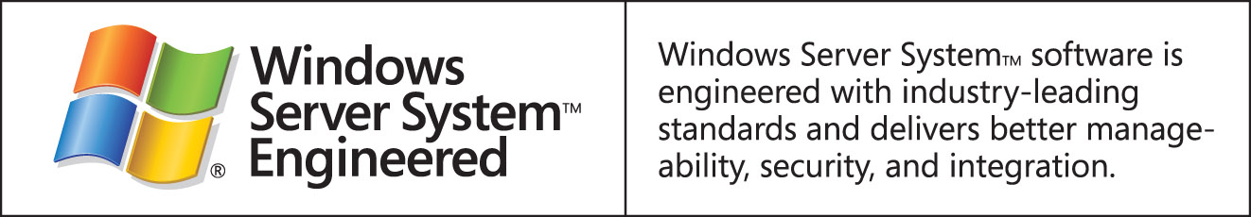

Disclaimer

This is a preliminary document and may be changed substantially prior to final commercial release of the software described herein.

The information contained in this document represents the current view of Microsoft Corporation on the issues discussed as of the date of publication. Because Microsoft must respond to changing market conditions, it should not be interpreted to be a commitment on the part of Microsoft, and Microsoft cannot guarantee the accuracy of any information presented after the date of publication.

This White Paper is for informational purposes only. MICROSOFT MAKES NO WARRANTIES, EXPRESS, IMPLIED OR STATUTORY, AS TO THE INFORMATION IN THIS DOCUMENT.

Complying with all applicable copyright laws is the responsibility of the user. Without limiting the rights under copyright, no part of this document may be reproduced, stored in or introduced into a retrieval system, or transmitted in any form or by any means (electronic, mechanical, photocopying, recording, or otherwise), or for any purpose, without the express written permission of Microsoft Corporation.

Microsoft may have patents, patent applications, trademarks, copyrights, or other intellectual property rights covering subject matter in this document. Except as expressly provided in any written license agreement from Microsoft, the furnishing of this document does not give you any license to these patents, trademarks, copyrights, or other intellectual property.
©2006 Microsoft Corporation. All rights reserved.

Microsoft, Active Directory, ActiveSync, Entourage, and Outlook, are either registered trademarks or trademarks of Microsoft Corporation in the United States and/or other countries.

The names of actual companies and products mentioned herein may be the trademarks of their respective owners.

