This document describes how to install, start, use, and uninstall the Outlook Configuration Analyzer Tool (OCAT). Tips are also provided for how to read and understand the reports that OCAT generates.

Note: This document has been updated to include information about new features and functionality in OCAT version 2.

OCAT Overview 2

New Features included in OCAT version 2 3

Support for OCAT 4

How to install OCAT 4

System requirements 4

OCAT version 2 download 7

OCAT version 2 setup 7

How to start OCAT 10

How to generate an OCAT report 11

How to specify Active Directory Domain Services credentials 14

How to generate an offline report 16

Generating a Scan using the Command-line version of OCAT 16

Running OCATcmd.exe 17

Switches for OCATcmd.exe 17

How to understand an OCAT report 20

How to open a previously generated OCAT report 29

How to view a report that was originally created on your computer 29

How to view a report that was created on another computer 30

How to use the Exchange Remote Connectivity Analyzer 33

Automatically update OCAT with new detection rules or application files 34

Rule Updates 35

Updated location of the Ocat.config.xml file 35

Application Updates 36

Configuring OCAT Automatic Update Settings 37

How to uninstall OCAT 38

How to submit feedback about OCAT 38

# OCAT Overview

The Outlook Configuration Analyzer Tool (OCAT) was developed by a pair of support engineers at Microsoft. These support engineers have over 30 years of combined experience in supporting Microsoft Office, Microsoft Outlook, and Microsoft Exchange Server. Based on their support experience, they compiled a set of detection rules that look for Outlook configurations that have historically been possible sources of problems. To wrap these rules into a useful framework, the same infrastructure first used by the [Microsoft Exchange Best Practices Analyzer](http://www.microsoft.com/download/en/details.aspx?displaylang=en&id=22485) was chosen for the development and final implementation of OCAT.

The end-result of this work is shown in the following figure, the **Welcome** page for OCAT version 2.

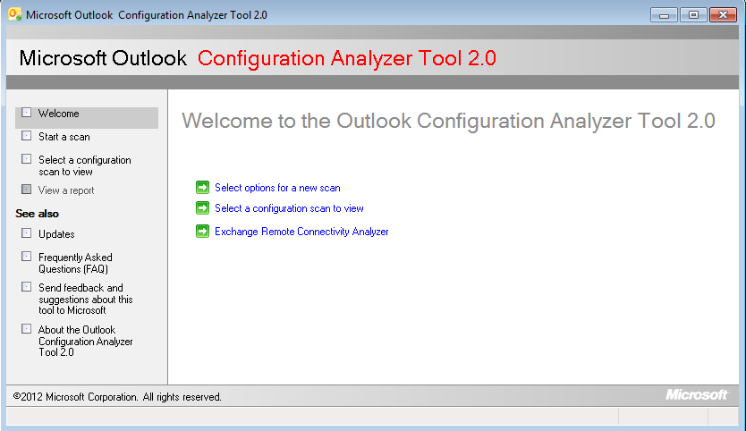

With OCAT version 2, you can take the following actions to help you detect possible problems with your Outlook profile:

* Scan your Outlook configuration
* Open a previously run scan on your computer
* Import a scan from another computer
* Use several reporting formats to view the scan results
* Start the Exchange Remote Connectivity Analyzer tool
* Send feedback to the OCAT team
* Update your OCAT installation with new detection rules
* Update your OCAT installation with new features or application fixes

These features are discussed in detail in this document.

## New Features included in OCAT version 2

The original version of OCAT included the core functionality provided by OCAT -- Outlook profile scanning, detection of known issues, and reporting of problems or Outlook configuration settings. After OCAT version 1 shipped, we immediately started work on OCAT version 2 to fix bugs and to add several core features that greatly enhance OCAT detection scope and OCAT maintenance.

Here are the key features added in OCAT version 2:

* **Automatic downloading of new detection rules**

As we create new rules to detect issues or to collect additional information about your Outlook profile, we will post a new updated rule file to the Internet. With the default OCAT version 2 configuration, OCAT will automatically check for a new rule file and provide a mechanism to update OCAT if a new file is found.

Please see the **Automatically update OCAT with new detection rules or application files** section of this document for additional details.

* **Automatic downloading of OCAT installation files**

As we update and fix the core OCAT application, we will post a new Windows Installer package file (.Msi) to the Internet. With the default OCAT version 2 configuration, OCAT will automatically check for a new installer file and provide a mechanism to update OCAT if a new file is found.

Please see the **Automatically update OCAT with new detection rules or application files** section of this document for additional details.

* **Addition of the CalCheck tool**

The Calendar Checking Tool (**CalCheck**) for Outlook is a command-line program that checks Outlook Calendars for problems. This tool is now included in OCAT to scan for and report on any known problems with items on your primary Calendar.

Please see the following article in the Microsoft Knowledge Base for additional information about the CalCheck tool.

2678030 Information about the Calendar Checking Tool for Outlook (CalCheck)  
<http://support.microsoft.com/kb/2678030/EN-US>

* **Addition of new detection rules**

To greatly enhance the list of known issues detected by OCAT, approximately 75 new rules were added to OCAT version 2.

* **Command-line version of OCATcmd.exe**

OCAT version 2 includes a command-line version of OCAT (**OCATcmd.exe**) that administrators can use to scan computers in their organization. Please see the **Generating a Scan using the Command-line version of OCAT** section of this article for details.

## Support for OCAT

There is no available support for OCAT. This tool is provided as-is.

If you encounter any problems when you use OCAT, you can send a detailed email message to [OCATsupp@microsoft.com](mailto:OCATsupp@microsoft.com). We appreciate your feedback. However, we cannot reply to your email message. We will review your feedback and determine whether any changes or issues can be incorporated or fixed in a later version of OCAT.

However, before sending email to the OCAT team, please review the [Current Issues/FAQ](http://support.microsoft.com/default.aspx?scid=kb;EN-US;2659007#3) section of the following article in the Microsoft Knowledge Base:

2659007 Outlook Configuration Analyzer Tool information  
<http://support.microsoft.com/default.aspx?scid=kb;EN-US;2659007>

This article is updated frequently with new issues as they are discovered, and workarounds are provided when available.

Periodically, OCAT will be updated to include new detections rules and new features. You can follow the OCAT team on Twitter [](http://www.twitter.com/ms_ocat) to receive news of any publicly available OCAT updates.

# How to install OCAT

## System requirements

Before you install OCAT, make sure that your computer meets the following OCAT system requirements.

* Supported operating systems:
  + Windows 7
  + Windows Vista Service Pack 2
  + Windows XP Service Pack 3
* This download works with the following Microsoft Office programs:
  + Microsoft Outlook 2010 (32-bit or 64-bit)
  + Microsoft Office Outlook 2007
  + Microsoft Office Outlook 2003 (Offline Scans only)
* The following minimum version of the **Microsoft .NET Framework** is required:
  + Microsoft .NET Framework Version 2.0

**Note :** The Setup program for the Outlook Configuration Analyzer Tool prompts you to install the Microsoft .NET Framework version 2.0 if it is not already installed. In this scenario, the link that is provided to install the .NET Framework opens the download page for the Microsoft .NET Framework 3.5 Service Pack 1. This version supersedes the .NET Framework 2.0. After the system requirements for the .NET Framework are met, you can install the Outlook Configuration Analyzer Tool.

* The .**NET Programmability Support** feature of Office is required to be installed.

**Note** : If you do not have the **.NET Programmability Support** feature installed as part of your Office installation, you will receive the following error when you start a scan:

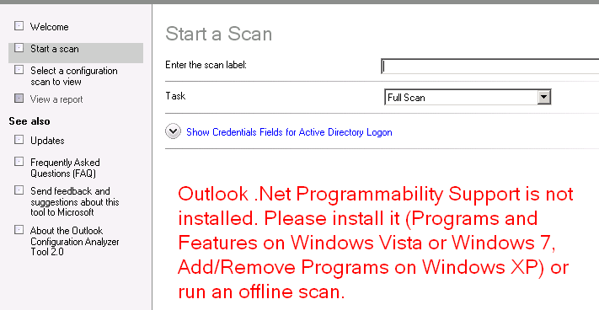

Please use the following steps to add the .**NET Programmability Support** feature to your Office installation.

**Windows 7 and Windows Vista**

1. Exit Outlook.
2. Click **Start**, and then click **Control Panel**.
3. In **Control Panel**, click **Programs**.
4. Then, click **Programs and Features**.
5. In the list of installed products, select your Microsoft Office product and then click **Change**.
6. When prompted, select **Add or Remove Features** and then click **Continue**.
7. In the **Installation Options** feature tree, expand the node for **Microsoft Outlook**.
8. Click the icon next to **.NET Programmability Support** and then select **Run from My Computer**.

This setting is shown in the following figure.

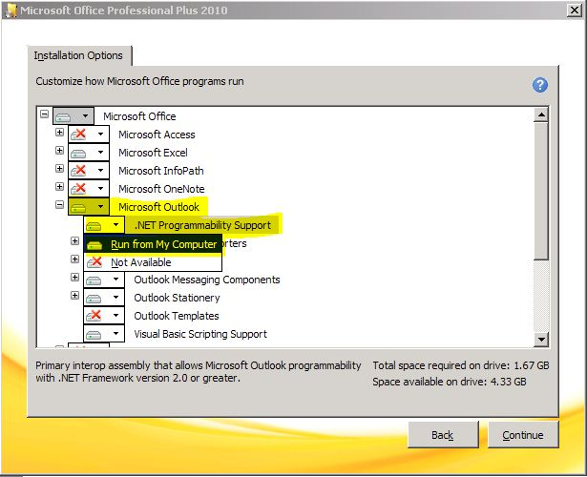

1. Click **Continue**.
2. Click **Close** when the installation update is finished.

**Windows XP**

1. On the **Start** menu, point to **Settings**, and then click **Control Panel**.
2. Double-click **Add/Remove Programs**.
3. In the list of currently installed programs, select your Microsoft Office product and then click **Change**.
4. When prompted, select **Add or Remove Features** and then click **Continue**.
5. In the **Installation Options** feature tree, expand the node for **Microsoft Outlook**.
6. Click the icon next to **.NET Programmability Support** (shown in the above figure) and then select **Run from My Computer**.
7. Click **Continue**.
8. Click **Close** when the installation update is finished.

## OCAT version 2 download

The Outlook Configuration Analyzer tool is available for download from the following location on the Microsoft Download site.

[OCAT.zip](http://download.microsoft.com/download/D/C/1/DC138478-52B7-4A4E-B5BC-CA21650CACC9/OCAT.zip)

## OCAT version 2 setup

**NOTE**: The same steps are used whether you are installing OCAT for the first time or you are upgrading from OCAT version 1.

1. To start the Setup program, extract the following file from the **OCAT.zip** file that you downloaded to your hard disk.

**OCAT.msi**

1. Double-click **OCAT.msi**.
2. On the **Welcome** page for the Setup wizard, click **Next**.

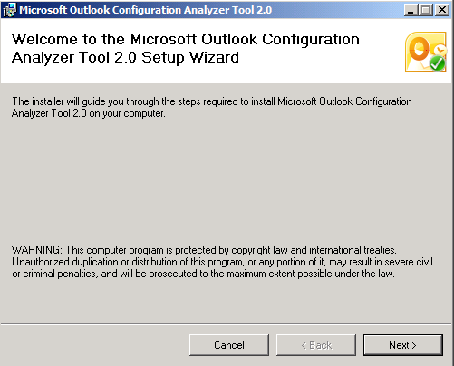

1. If you agree with the license terms for OCAT, click to select **I Agree**, and then click **Next**.

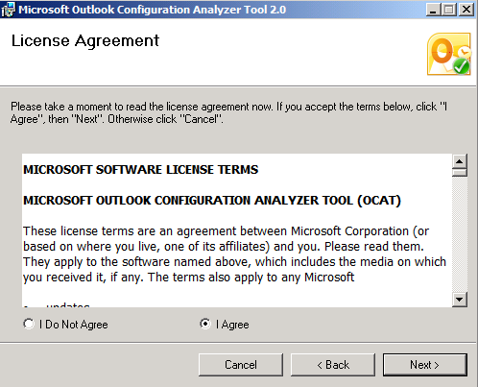

1. Select the installation folder for OCAT, and then click **Next**.

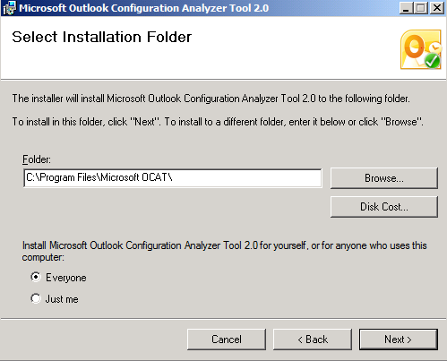

1. Click **Next** to start the OCAT installation.

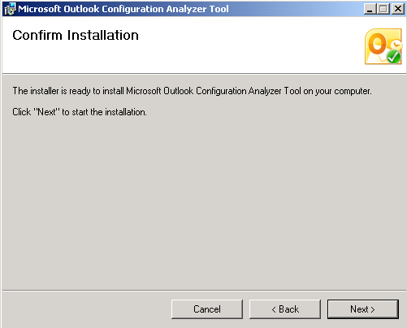

1. Click **Close** when the installation is finished.

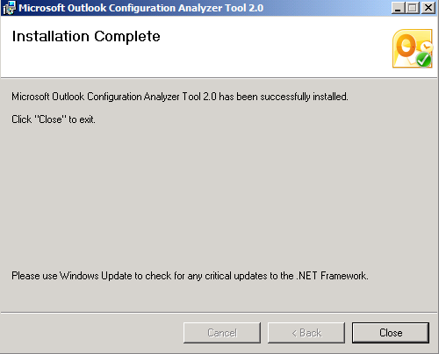

# How to start OCAT

To start the Outlook Configuration Analyzer Tool, on the **Start** menu, click the **Microsoft OCAT** icon. If you do not see the **Microsoft OCAT** icon on the **Start** menu, look for the icon on your **All Programs** menu under **Microsoft Outlook Configuration Analyzer Tool**.

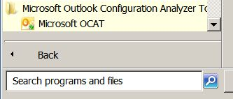

If you cannot locate the shortcut for OCAT, you can also start OCAT by using the OCAT executable file (**OCAT.exe**). The following figure shows this file in the default installation location on a 64-bit version of Windows 7:

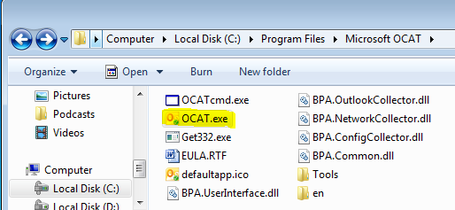

# How to generate an OCAT report

To generate an OCAT report for your Outlook profile, follow these steps:

1. In the left panel, click **Start a scan** to generate a report of your Outlook profile.

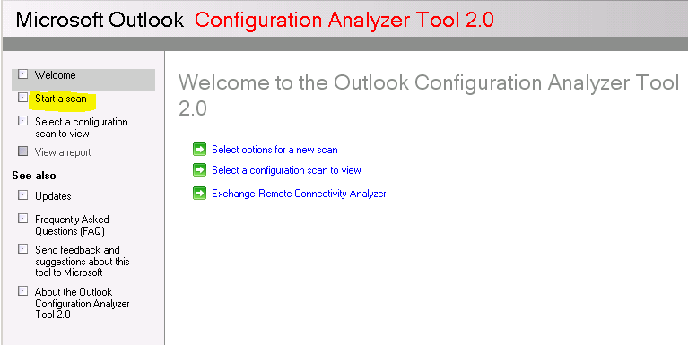

Be aware that you must make sure that Outlook is running before you start an OCAT scan. If Outlook is not running when you start a scan, OCAT displays the following notification.

*Outlook is not running.*

*Please start Outlook and click here when done, or choose Offline Scan in the Task drop-down list.*

This notification is shown in the following figure.

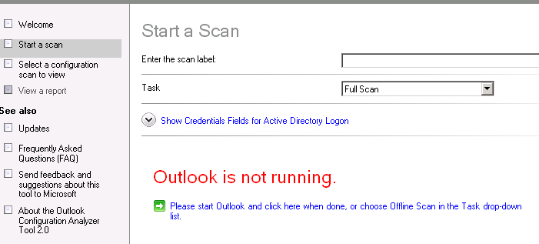

**Note** If you are using Outlook **2003**, the following warning is displayed when you start a scan:

*Full scan is not supported with versions earlier than Outlook 2007. You can run an offline scan.*

This warning is shown in the following figure.

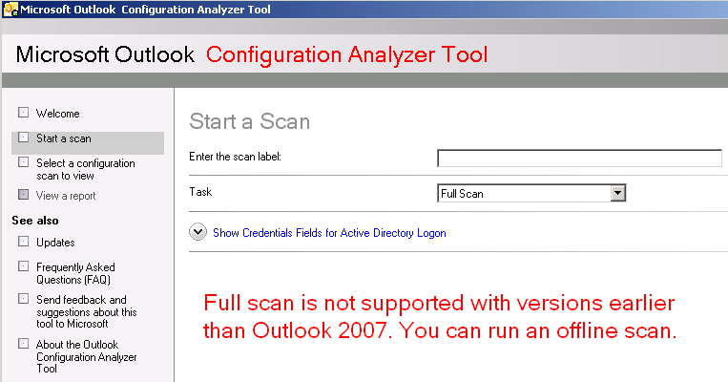

Please see the **How to generate an offline report** section of this document for details on performing an *offline* scan.

1. In the **Enter the scan** **label** box, enter a name for your scan, and then click **Start scanning**.

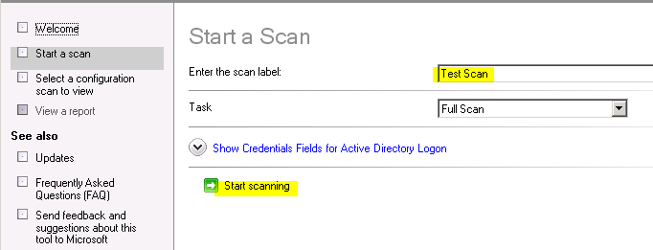

1. For an online scan, you may receive the following prompt to enable OCAT to access information that is stored in Outlook. To allow this access, click to select **Allow access for**, specify **1 minute**, and then click **Allow**.

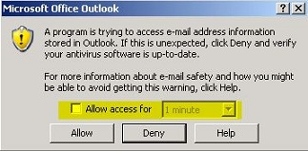

**Note** This warning may not automatically take focus. To display this warning, click the Outlook icon on the Task bar.

1. After the scan is complete, click **View a report of this configuration scan** to display the report that is generated by OCAT.

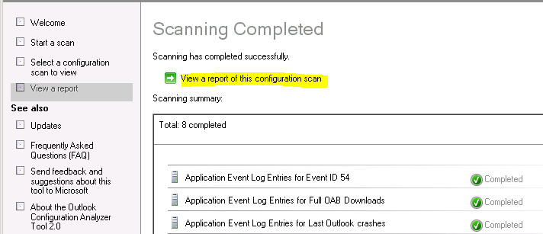

## How to specify Active Directory Domain Services credentials

Some information that OCAT collects is maintained in the Active Directory Domain Services (AD DS) environment. If your computer is not joined to the same AD DS domain as your Exchange mailbox, OCAT cannot use the default scan configuration to retrieve this information. In this case, your report will contain information that resembles the following.

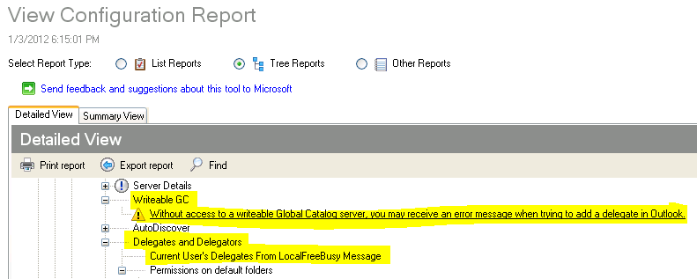

In this scenario, you can add your mailbox credentials in OCAT so all available information can be retrieved from the AD DS environment. To provide your mailbox domain credentials in OCAT, follow these steps:

1. On the **Start a Scan** page, click **Show Credentials for Active Directory Logon**.

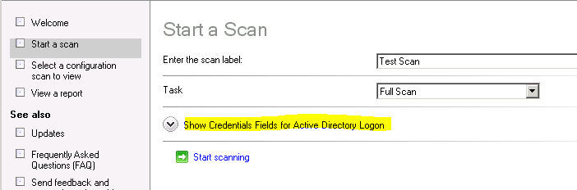

1. Click to select the **Enable credentials when mailbox account does not match Windows account** check box, and then enter your mailbox domain credentials.

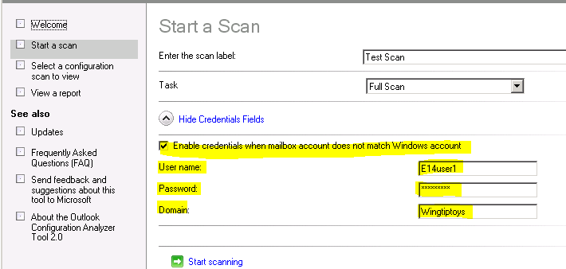

1. Click **Start scanning**.

Be aware that, even when you specify your domain credentials by using these steps, you will probably still see an error that indicates that you do not have access to a writeable global catalog server. This is expected in this configuration.

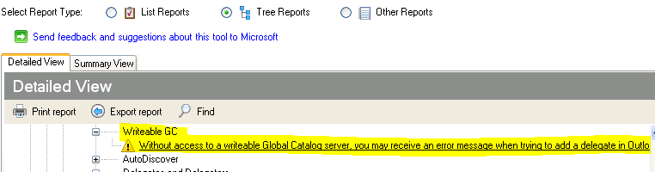

## How to generate an offline report

If you cannot keep Outlook running long enough to start a scan, you can still perform a basic scan. To do this, in the **Task** drop-down list, select **Offline Scan**,and then click **Start scanning**.

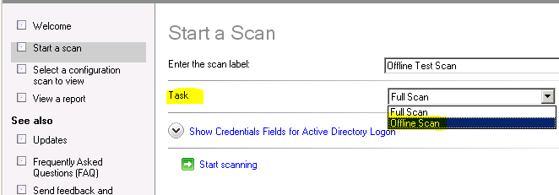

The report that an offline scan generates contains only information that is available on your computer, such as registry data, Application log details, a list of installed updates, and local file details.

Although an offline scan does not contain as many profile details as an online scan, an offline scan may still provide enough information to help you resolve any problems that you are experiencing with Outlook.

## Generating a Scan using the Command-line version of OCAT

When you install OCAT version 2, a command-line version of OCAT (**OCATcmd.exe**) is added to folder in which you installed OCAT (by default, the **\Program Files\Microsoft OCAT** folder).

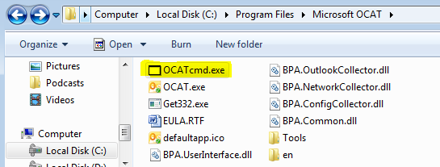

The command-line version of OCAT is useful in situations where administrators need to remotely run OCAT on several machines in their organization. This can be done, for example, by incorporating OCATcmd.exe in a logon script that launches OCAT, performs a scan, and then saves the scan report file to a network share.

### Running OCATcmd.exe

The following steps can be used to use OCATcmd.exe to run an OCAT scan without any user interface.

1. Install OCAT version 2 on *any* computer.
2. Copy all of the files in the \**Microsoft OCAT** folder to the computer on which you will be running **OCATcmd.exe**.
3. Open a command-prompt.
4. In the command-prompt window, navigate to the folder in which you copied the OCAT files.
5. Run **OCATcmd.exe** using one or more of the switches discussed in the **Switches for OCATcmd.exe** section below.

**Note** If you are in an organization where this needs to be performed on multiple computers, you can write a script that automates the above steps.

### Switches for OCATcmd.exe

The following list includes the currently available switches you can use to control OCATcmd.exe.

**-dat <file>**

Use the -dat switch to specify the path and filename for the output (.xml) file generated by OCAT. If the -dat switch is not used, the output file is created in the same folder location as the UI version of OCAT (%userprofile%\AppData\Roaming\Microsoft\OCAT).

**-l <label>**

The -**l** switch is used to specify a label for the OCAT report. The label is independent of the file name for the output file and is used in the OCAT user interface to help you better identify a scan among several scans.

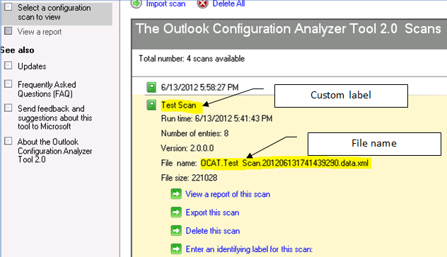

**-u <context>**

The -u switch is used when you need to specify domain credentials. This is equivalent to specifying credentials in the OCAT interface when the mailbox account does not match the currently logged on Windows account.

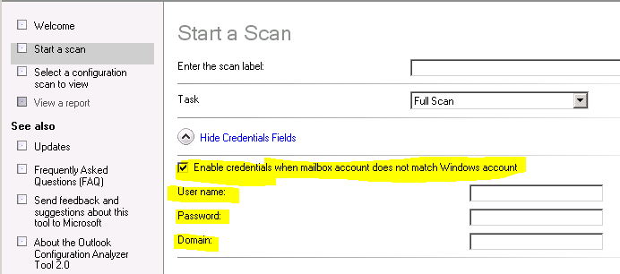

**-r <option>**

Use the -r switch to specify either a *Full* scan or an *Offline* scan. If you do not use the -r switch a *Full* scan is performed.

**-?**

The -? switch is used to output the list of all switches available with OCATcmd.exe

#### Examples:

Here are some examples of switches you might find useful when using OCATcmd.exe.

* **Run a *Full* scan**, **using a custom label and custom output location**.

The report will have a custom label of "*example 1*" and the output file will be created as *Example1-Test.xml* in the *C:\ocatfiles* folder.

Ocatcmd.exe -dat "C:\ocatfiles\Example1-Test.xml" -l "example 1"

Result:

18:35:32.118: Starting Collecting Data phase

18:39:22.119: Scan type: Full Scan.

18:35:33.948: Completed Collecting Data phase.

18:35:36.778: Starting Postprocessing Rules phase.

18:35:40.639: Completed Postprocessing Rules phase.

18:35:43.325: Saving data to file c:\ocatfiles\Example1-Test.xml

* **Run an *Offline* scan**.

The report will have a custom label of "*example 2*" and the output file will be created in the *default folder* location (%userprofile%\AppData\Roaming\Microsoft\OCAT).

Ocatcmd.exe -l "example 2" -r "offline scan"

Result:

18:39:24.676: Starting Collecting Data phase.

18:39:24.692: Scan type: Offline Scan.

18:39:34.400: Completed Collecting Data phase.

18:39:34.510: Starting Postprocessing Rules phase.

18:39:34.540: Completed Postprocessing Rules phase.

18:39:34.660: Saving data to file C:\Users\administrator\AppData\Roaming\Microsoft\OCAT\

OCAT.example 2.201206011839212912.data.xml

* **Run a *Full* scan**, **using credentials for someone other than the logged on user.**

The report will use the *default label* and *default file location*. The credentials for *Contoso\User1* will be used instead of the currently logged on user's credentials.

Ocatcmd.exe -u ADLOGON Contoso\User1 P@ssw0rd

Result:

18:49:38.070: Starting Collecting Data phase

18:49:38.080: Scan type: Full Scan.

18:52:08.932: Completed Collecting Data phase.

18:52:11.741: Starting Postprocessing Rules phase.

18:52:15.471: Completed Postprocessing Rules phase.

18:52:18.025: Saving data to file C:\Users\Administrator\AppData\Roaming\Microsoft\OCAT\

OCAT.201206011849348824.data.xml

# How to understand an OCAT report

The report that OCAT generates can, in most cases, provide lots of information about your Outlook profile. To help you better understand and use this information, this document provides a high-level description of the different views that are available in your scan report.

* **List Reports**

The **List Reports** view is the default presentation of your scan data.

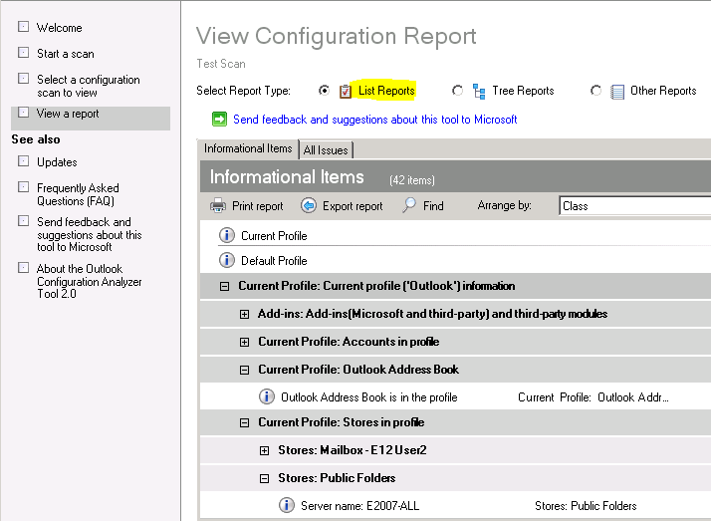

In this report view, there are up to three tabs that are available to view different snapshots of this data.

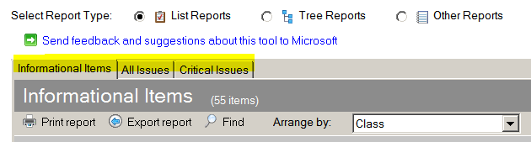

* + **Informational Items**

All scans have an **Informational Items** tab for the **List Reports** view.

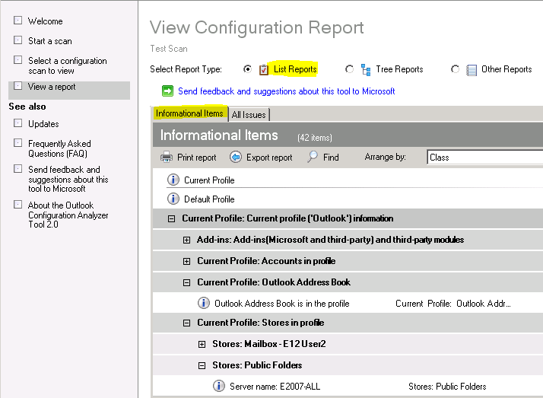

This view of the scan data shows you items that are considered "Informational" (according to OCAT rules) because these items are useful to most people. However, these items do not necessarily indicate any problems. They are displayed just to provide general information about your profile.

The entries in this view are not static. If you want to see more details about the item, click the row for that item to expand the row.

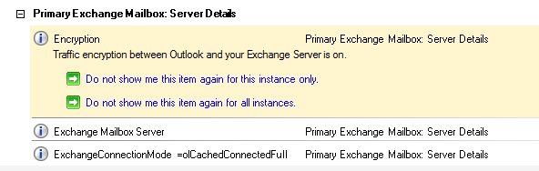

You can also use the **Find** feature to search for particular items. To perform a search, click , and then enter your search string in the **Look for** box.

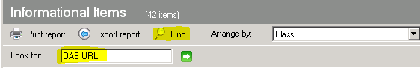

The items that match the search string are displayed in the view.

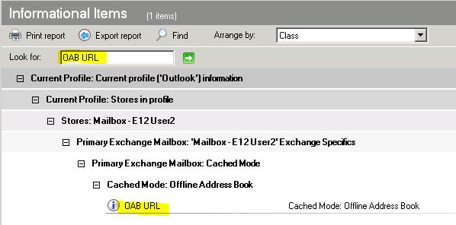

All other items are hidden while the results are displayed. To redisplay the hidden items, click the  on the right side of your search criteria.



* + **All Issues**

OCAT has built-in rules that look for issues in your Outlook configuration together with any issues that are classified as either a warning ( ) or a critical () issue. The **All Issues** tab displays all the warning and critical issues that are detected in your Outlook profile.

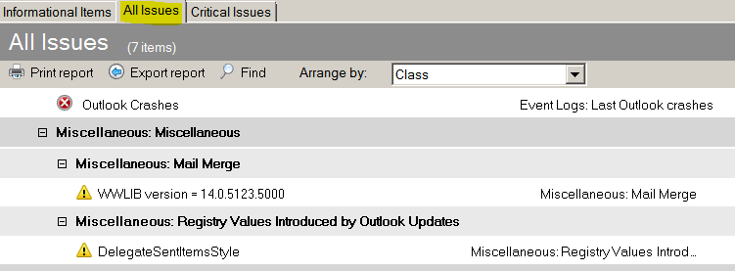

As with the data on the **Informational Items** tab (and on any other tab in your scan report), you can click the row to show additional details about that item.

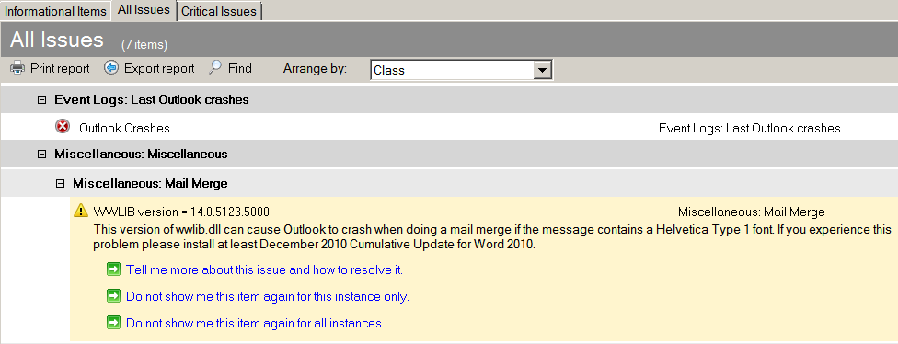

For even more information about the issue, click the **Tell me more about this issue and how to resolve it** link. In the previous example, the following article in the Microsoft Knowledge Base is opened in your browser.

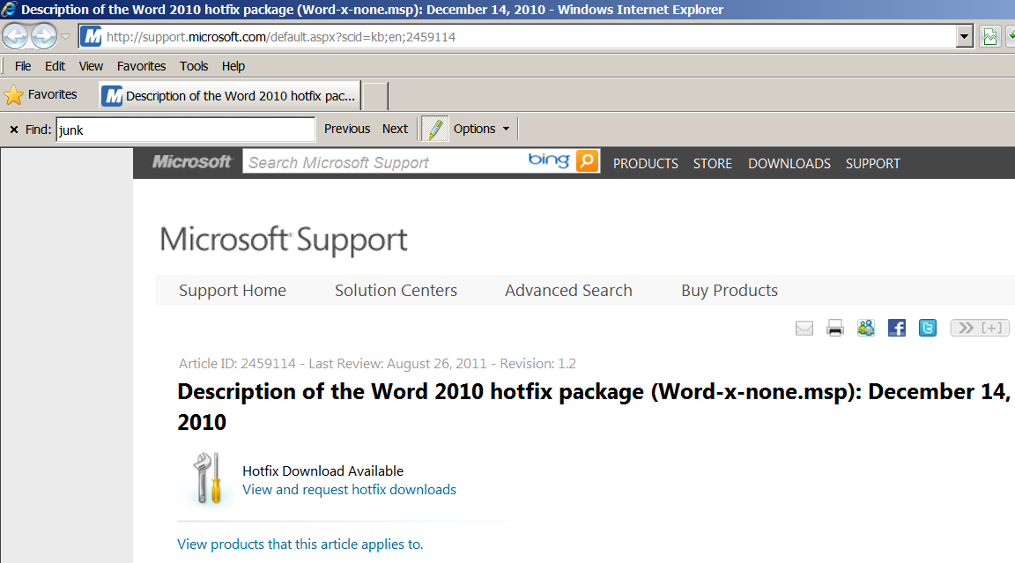

If you use the information that is provided in this article, this issue should not appear in your next scan report.

* + **Critical Issues**

The **Critical Issues** tab displays only those issues that are considered critical by the detection rules that are built into OCAT.

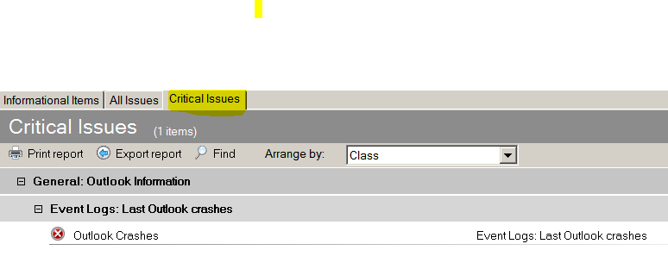

These are the same critical issues that are displayed on the **All Issues** tab. They are broken out on the **Critical Issues** tab for convenience.

Be aware that, if OCAT finds no critical issues, you do not see a **Critical Issues** tab.

* **Tree Reports**

The **Tree Reports** view of your scan report provides tree-control functionality to view your scan results.

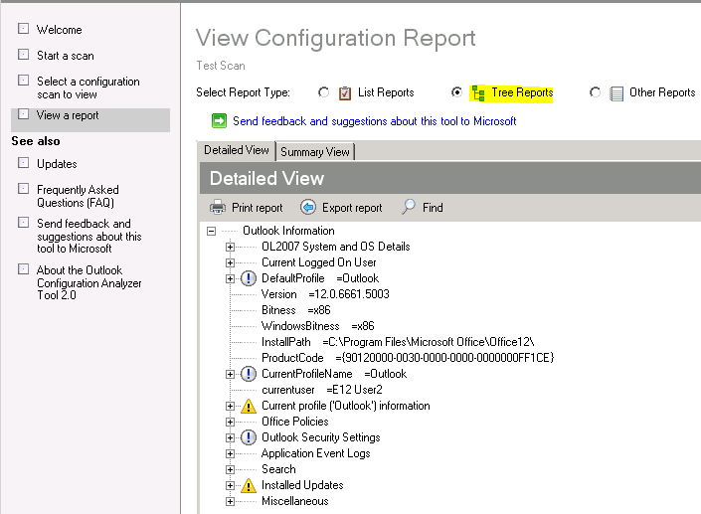

In this report view, two tabs are available to view different snapshots of this data.

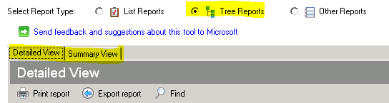

* + **Detailed View**

The **Detailed View** tab exposes all the available data that OCAT collects.

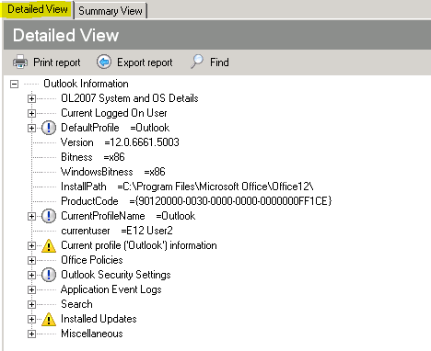

Therefore, if you want to see informational and critical issues plus all relevant settings in your Outlook profile, use the **Detailed View** tab to review your scan results.

The **Detailed View** also provides additional data if you rest the pointer over some items that contain more information than can be displayed in the tree window. For example, the following figure shows the *AutoDiscoverXM*L data that OCAT retrieved.

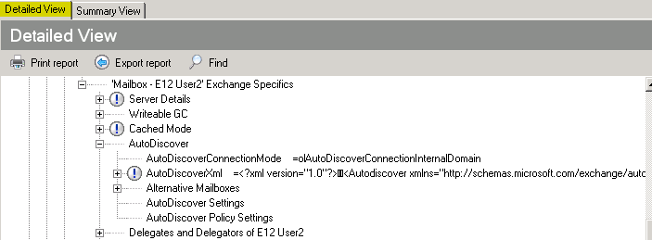

Resting the pointer over *AutoDiscoverXml* in the report displays all the results in a pop-up window.

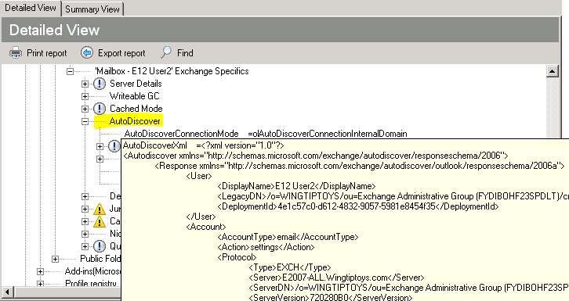

You can also copy the Autodiscover XML results by selecting the **AutoDiscoverXml** entry in the Tree Report, pressing **CTRL+C** (to copy), and then pasting the information into a text file.

Because OCAT collects lots of data that is displayed on the **Detailed View** tab, you can use the **Find** feature to quickly locate the data that is important to you.

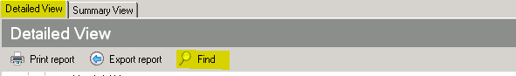

Click **Find**, enter your search criteria in the **Look for** box, and then click  or to locate the items that match your search criteria.

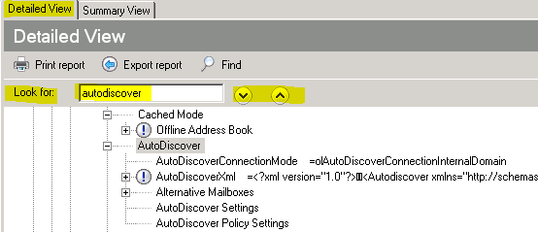

* + **Summary View**

The **Summary View** tab uses the same tree structure as the **Detailed View** tab. However, the **Summary View** tab only shows you a subset of the data that is found on the **Detailed View** tab.

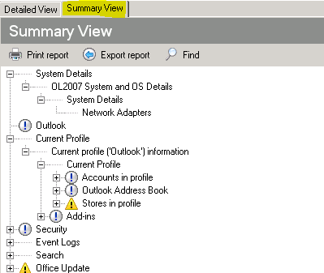

This information is useful because it might not be as overwhelming as the information that is found on the **Detailed View** tab. If you locate information on the **Summary View** tab that is important to you, switch over to the **Detailed View** tab if you want more details about that particular item.

* **Other Reports**

The information under **Other Reports** is mostly a running log of the actions that OCAT took. Generally, you will not use this information to analyze the information that is collected about your Outlook profile and that is found in the other reports.

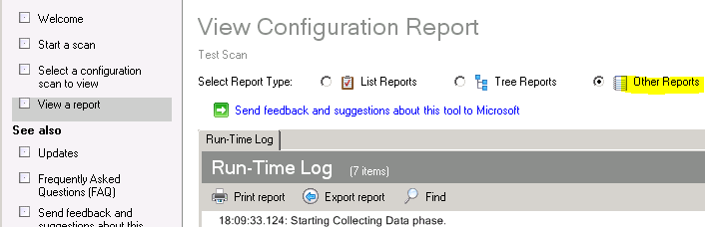

# How to open a previously generated OCAT report

By default, OCAT saves its scan report as an xml file in the following folder.

**In Windows 7 and in Windows Vista**

C:\Users\<username>\AppData\Roaming\Microsoft\OCAT

**In Windows XP**

C:\Documents and Settings\<username>\Application Data\Microsoft\OCAT

You do not have to manually locate the scan files in these folders because the folder location is only provided here for reference.

## How to view a report that was originally created on your computer

If you are running OCAT on the same computer where you generated the scan, follow these steps to view the scan report at any time:

1. Start OCAT.
2. In the left panel, click **Select a Configuration scan to view**.

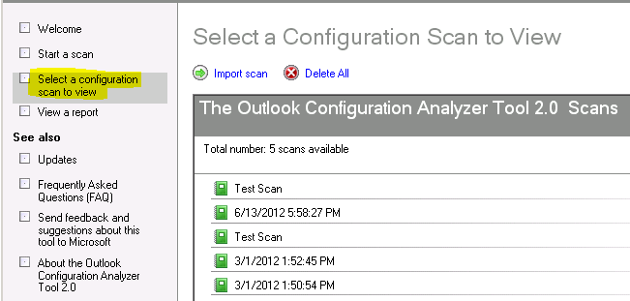

1. Then, select the scan to be viewed from the list of available scans.
2. Finally, click **View a report of this scan**.

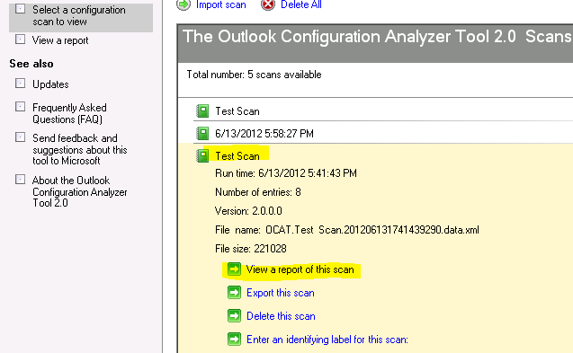

## How to view a report that was created on another computer

If someone else created an OCAT scan report on his or her computer, you can view this report using the follow these steps.

**Note**: You can skip steps 1-5 if you used the command-line version of OCAT to generate the report file.

1. Start OCAT on the computer where the scan was performed.
2. In the left panel, click **Select a** **Configuration scan to view**.

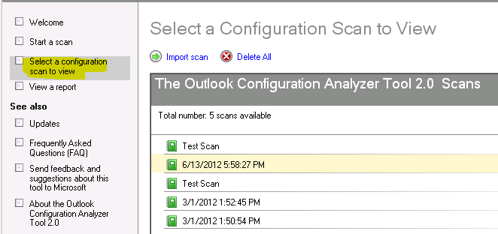

1. Then, select the scan to be viewed from the list of available scans.
2. Click **Export this scan**.

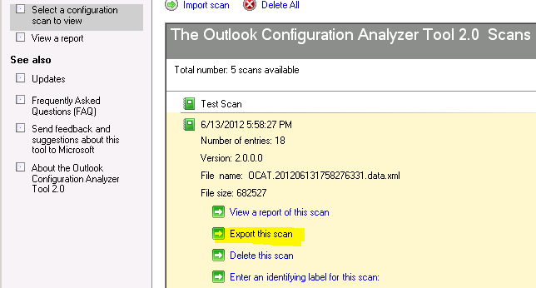

Be aware that you can also export an OCAT report from a report that you are currently viewing. To do this, use the **Export report** link on the **View Configuration Report** page.

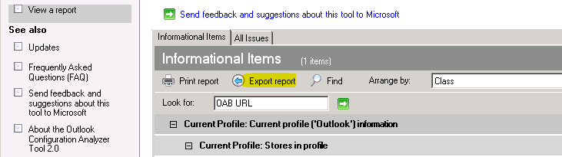

1. In the **Export this scan** dialog box, specify a file name and a folder location.
2. Copy the .xml file that you saved in step 5 to the computer from which you will be viewing the report.
3. On the computer to which you copied the file in step 6, start OCAT.
4. On the **Welcome** page, click **Select a** **Configuration scan to view**.

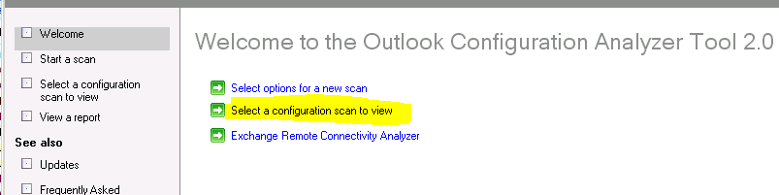

1. On the **Select a Configuration Scan to View** page, click **Import scan**.

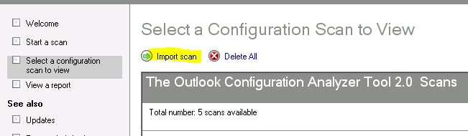

1. Browse to the folder that contains the .xml file that you copied in step 6, and then click **Open**.

The scan is opened automatically for viewing.

# How to use the Exchange Remote Connectivity Analyzer

For convenience, OCAT provides a link to the Exchange Remote Connectivity Analyzer tool on the OCAT **Welcome** page.

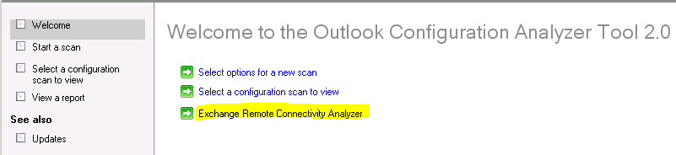

Click this link to browse to the Internet site for the Remote Connectivity Analyzer.

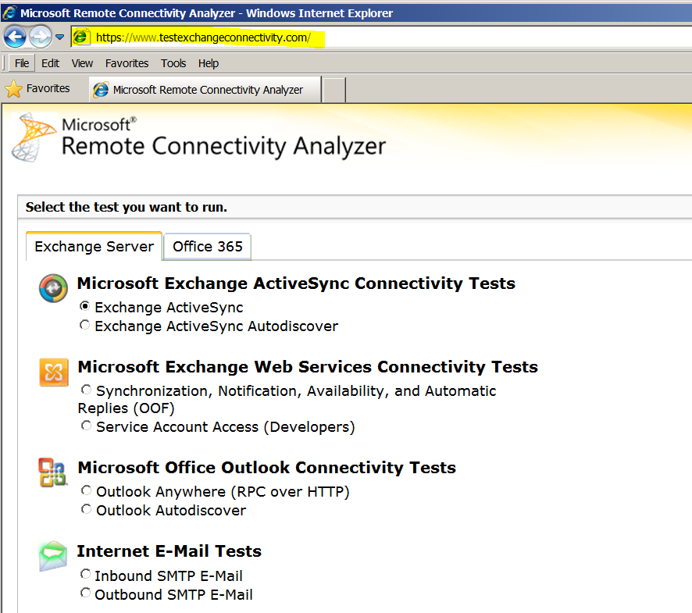

There is no technical connection between OCAT and the Remote Connectivity Analyzer tool. The link is provided as a convenience for you to troubleshoot issues that cannot be resolved by using the information that is generated in an OCAT scan report.

# Automatically update OCAT with new detection rules or application files

When you launch OCAT version 2, the default configuration will check to see if new detection rules or application files are available.

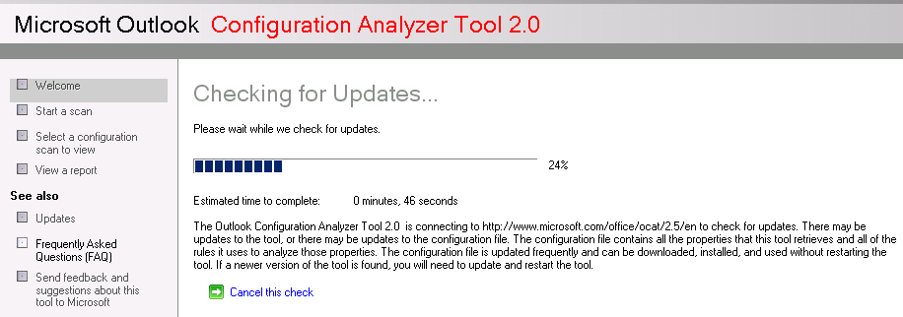

This check can be cancelled by clicking **Cancel this check** while OCAT is checking for updates. If no updates are available, you will see the default screen where you can start a new scan or open an existing scan. If an update is available, you will receive a prompt to update OCAT.

If you do not have access to the Internet or OCAT is unable to access the Internet location where the updated files reside, OCAT will display the following error after the update check finishes.

*An error occurred trying to access the web.*

This error is shown in the following figure.

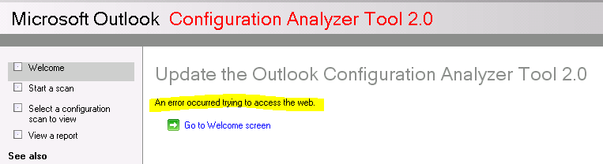

## Rule Updates

If a rule file update is available, then you will see the following prompt when you start OCAT (with automatic updating enabled) or when you manually check for updates.

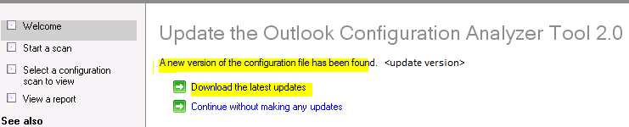

Click **Download the latest updates** to download the latest *rules* file.

### Updated location of the Ocat.config.xml file

When you download an updated version of the *rules* file, OCAT will copy the updated **Ocat.config.xml** file to the **\%userprofile%\AppData\Roaming\Microsoft\OCAT\En** folder if both of the following conditions are true:

* You are using Windows 7
* You installed OCAT into the default folder (**\Program Files\Microsoft OCAT**)

This occurs because of the security considerations given to the **\Program Files** folder on Windows 7.

If you are using Windows XP, or you installed OCAT on Window 7 to a folder that is not a subfolder of **\Program Files**, the updated rules file is copied into the **\En** subfolder of your OCAT installation folder.

#### OCAT rules file versioning

You can determine the version of the rules file by opening **Ocat.config.xml** in a text editor such as Notepad. The version information can be seen in the value for **ConfigVersion** in the .xml file.

<?xml version="1.0" encoding="utf-8"?><ObjectCollector>

<Configuration ConfigName="OCAT Master Configuration File" ChangeDescription="Test" **ConfigVersion="1.9.0.4**"

#### Automatic rules file update for the command-line version of OCAT

The command-line version of OCAT will also check to see if an updated *rules* file is available, and if so, automatically download and use the updated *rules* file.

If OCATcmd.exe is unable to retrieve the updated *rules* file, errors similar to those shown in the following figure will be displayed in the command-prompt window.

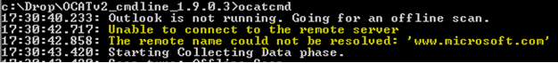

This does not prevent OCATcmd.exe from performing as scan as the local version of the Ocat.config.xml file is used.

## Application Updates

If an application update is available, then you will see the following prompt when you start OCAT (with automatic updating enabled) or when you manually check for updates.

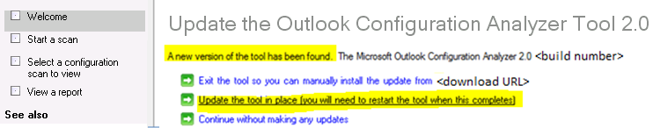

To update OCAT, click **Update the tool in place (you will need to restart the tool when this completes)**

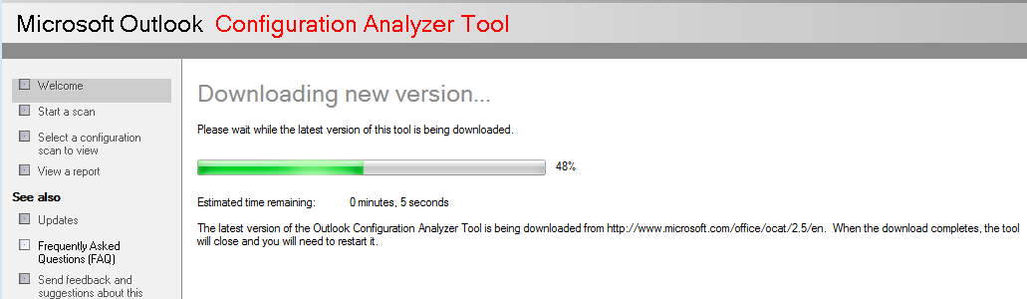

and then follow the instructions as they are provided during the OCAT installation.

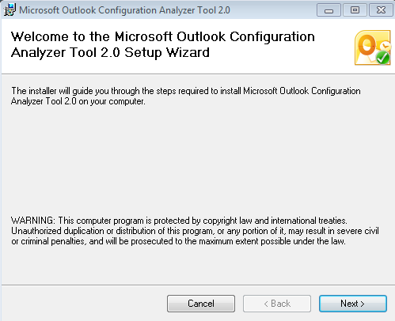

After the update is finished, start OCAT.

**Note**: The automatic application update does not occur if you are using the command-line version of OCAT (OCATcmd.exe).

## Configuring OCAT Automatic Update Settings

OCAT update settings can be viewed and modified by clicking **Updates** under **See also** in the left panel of the OCAT window.

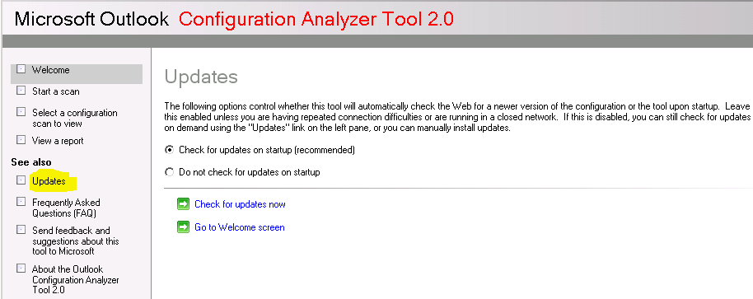

The following options are available on the **Updates** page.

* **Check for updates on startup (recommended)**

This is the default OCAT configuration as we feel the latest files and rules will give you the most updated report on your Outlook configuration.

* **Do not check for updates on startup**

If you do not want OCAT to automatically check for updates when you start OCAT, select the **Do not check for updates on startup** option. If you have this option enabled, you can manually check for updates by clicking **Check for updates** **now** on the **Updates** page.

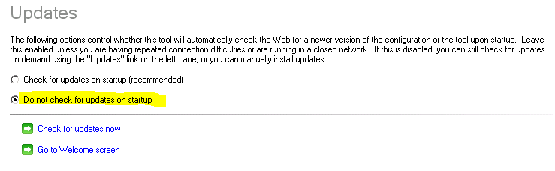

# How to uninstall OCAT

To uninstall OCAT from a computer, follow these steps.

**For Windows 7 and for Windows Vista**

1. Click **Start**, and then click **Control Panel**.
2. In **Control Panel** under **Programs**, select **Uninstall a program**.
3. In the list of currently installed programs, select **Microsoft Outlook Configuration Analyzer Tool**, and then click **Remove**.
4. Click **Yes** to confirm that you want to remove the program.

**For Windows XP**

1. Click **Start**, point to **Settings**, and then click **Control Panel**.
2. Double-click **Add or Remove Programs**.
3. In the list of currently installed programs, select **Microsoft Outlook Configuration Analyzer Tool**, and then click **Remove**.
4. Click **Yes** to confirm that you want to remove the program.

# How to submit feedback about OCAT

If you want to submit feedback or improvement suggestions for OCAT, under **See also** in the left panel of OCAT, click the *feedback* link.

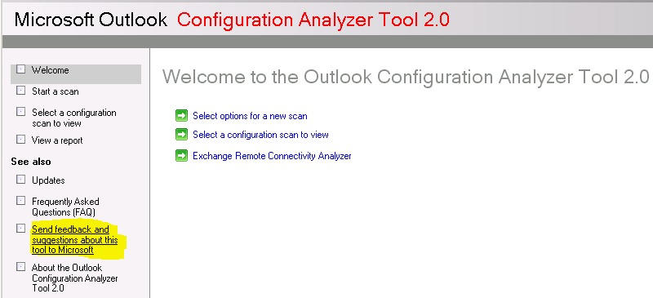

When you click this link, a new email message is opened that is addressed to [OCATsupp@microsoft.com](mailto:OCATsupp@microsoft.com).

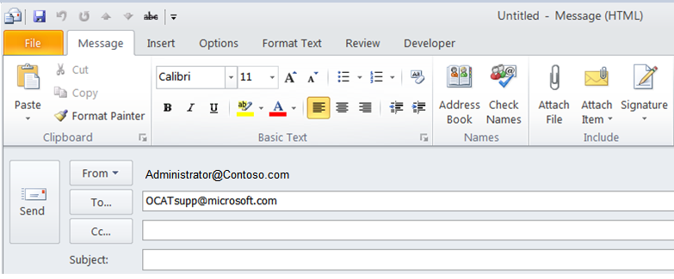

Please provide as many details as possible so we can give your request a thorough review.

**Note** Please be aware that you will not be contacted after you submit feedback.