Using the Planet Software Outlook Form Installer

This product was developed and tested with Outlook 2000, but will work fine with Outlook 97/98.

The Planet Software Outlook form installer makes it a simple task to install an Outlook form into a series of folders. Some Outlook form applications require a form to be installed in a large number of folders. Installing and updating these forms must be done every time a change is made to the form’s design.

Normally, installing these forms is a labour-intensive task involving a repetitive process that is subject to “human error”.

Creating an Installer Form
Open the Installer OFT file (double click) that you obtained from Planet Software. You will be asked to navigate to the location:
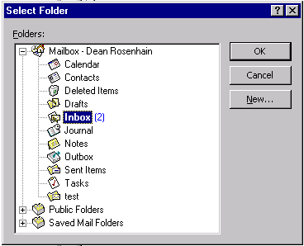

Choose a folder (Inbox is OK). The Installer form will open

The installer form has the “include form with item” flag set so that you can mail the form (with its enclosed attachment) to another user. Because of this, you will get the standard macro warning when you open the Installer form:

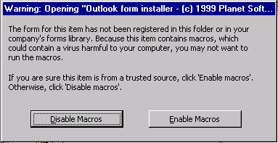

Click “Enable” to see the form:
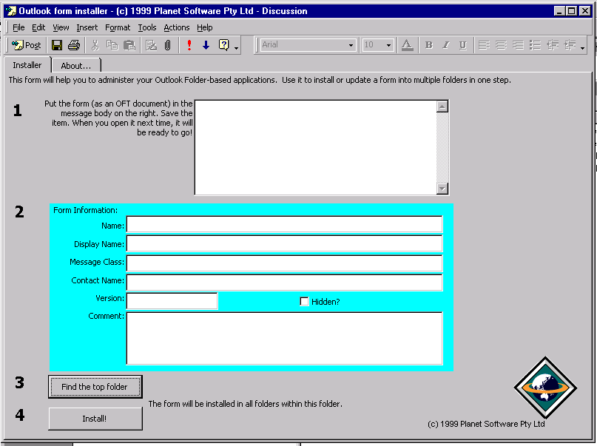

At this stage, you should attach YOUR form (as an OFT file) to the Installer – by dragging the form onto the message area or using the Insert/File menu.

That’s it! Now click the POST button to save the Installer form (with your attached form).

To install your form, all you need to do is to open the Installer form with attachment. It will open, displaying details of your form’s design:

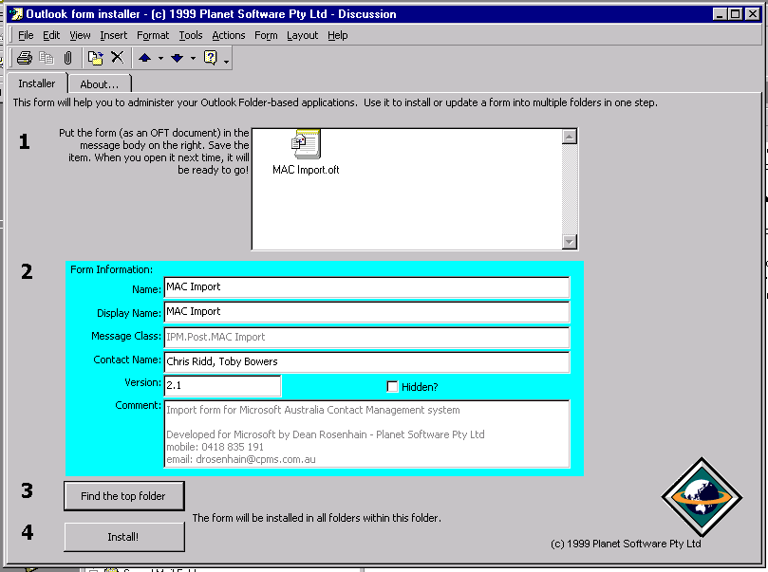

If your form (the attachment) has code, it too will produce a warning message like the one before. You should click “Enable” for the Installer form warning and “Disable” on the second warning (your form).

At this stage, you can change some of the form’s installation information (such as the version).

The next step is to choose the top of the folder heirarchy that will contain the form. (Click the “Find the top folder” button).

Finally, click the “Install!” button to install the form! Installation is not instant – it takes a few seconds to do each folder… but it beats installing it manually!

The demonstration version of the form will only install your form in the first four folders it encounters.

Price and availability
The Planet Software Outlook form Installer is priced at a very reasonable $A50. See our web page (www.planetsoftware.com.au) for details of ordering. The form will be delivered to you via email on placement of your order.

