

ADAM Step-by-Step Guide
Microsoft Corporation
Published: April 11, 2005
Author: Andrea Weiss
Editor: Jim Becker

Abstract
This document is a step-by-step guide for Active Directory Application Mode (ADAM).
The Active Directory® directory service in Microsoft® Windows® 2000 and in Microsoft® Windows® Server 2003 is the fastest growing directory service for intranets and extranets, as a result of its rich integration of directory support and security, scalability, and native Lightweight Directory Access Protocol (LDAP) support. Active Directory in Windows Server 2003 builds on that success by supporting a number of new LDAP capabilities that are targeted for information technology (IT) professionals and applications developers. Active Directory Application Mode is one of these new capabilities. Organizations, independent software vendors (ISVs), and developers who want to integrate their applications with a directory service now have an additional capability in Active Directory that provides numerous benefits.
With this document, you will be able to set up Active Directory Application Mode and get it running quickly, so that you can explore some of its new and important features.

This document supports a preliminary release of a software product that may be changed substantially prior to final commercial release, and is the confidential and proprietary information of Microsoft Corporation. It is disclosed pursuant to a non-disclosure agreement between the recipient and Microsoft. This document is provided for informational purposes only and Microsoft makes no warranties, either express or implied, in this document. Information in this document, including URL and other Internet Web site references, is subject to change without notice. The entire risk of the use or the results from the use of this document remains with the user. Unless otherwise noted, the example companies, organizations, products, domain names, e-mail addresses, logos, people, places, and events depicted herein are fictitious, and no association with any real company, organization, product, domain name, e-mail address, logo, person, place, or event is intended or should be inferred. Complying with all applicable copyright laws is the responsibility of the user. Without limiting the rights under copyright, no part of this document may be reproduced, stored in or introduced into a retrieval system, or transmitted in any form or by any means (electronic, mechanical, photocopying, recording, or otherwise), or for any purpose, without the express written permission of Microsoft Corporation.

Microsoft may have patents, patent applications, trademarks, copyrights, or other intellectual property rights covering subject matter in this document. Except as expressly provided in any written license agreement from Microsoft, the furnishing of this document does not give you any license to these patents, trademarks, copyrights, or other intellectual property.

© 2005 Microsoft Corporation. All rights reserved.

Active Directory, Microsoft, MS-DOS, Visual Basic, Visual Studio, Windows, Windows NT, and Windows Server are either registered trademarks or trademarks of Microsoft Corporation in the United States and/or other countries.

All other trademarks are property of their respective owners.

Contents
Step-by-Step Guide to Deploying ADAM 7
Requirements for ADAM 7
Installing ADAM Using the Active Directory Application Mode Setup Wizard 8
If the Active Directory Application Mode Setup Wizard Fails 18
Viewing the ADAM Program Group 19
Using the ADAM Administration Tools 19
Stopping and Restarting an ADAM Instance 19
Using the ADAM ADSI Edit Administration Tool 20
Configuring the ADAM Schema Snap-in Administration Tool 25
Setting Up Application Data 28
Adding Optional User Classes to the ADAM Schema 29
Extending the ADAM Schema 30
Importing Application Data 31
Using an Application with ADAM 33
Querying Data with Windows Address Book 33
Managing OUs, Groups, and Users in ADAM 38
Creating OUs and Groups 38
Creating an ADAM User 41
Adding Users to Groups 43
Disabling and Enabling ADAM User Accounts 46
Managing Directory Partitions in ADAM 46
Connecting and Binding to an ADAM Instance Using Ldp.exe 47
Adding an Application Directory Partition 48
Deleting an Application Directory Partition 50
Managing Authorization in ADAM 53
Viewing Effective Permissions 53
Granting Permissions 54
Denying Permissions 55
Managing Authentication in ADAM 57
Binding as a Windows Principal 58
Setting the Password of an ADAM User 58
Binding as an ADAM Principal 60
Binding Through an ADAM Proxy Object 60
Binding Security and ADAM Proxy Objects 61
Creating and Binding with an ADAM Proxy Object 62
Demonstrating ADAM Proxy Object Functionality 63
Backing Up and Restoring Active Directory Application Mode (ADAM) 64
Backing Up an ADAM Instance 65
Removing an ADAM Instance 66
Restoring an ADAM Instance 66
Managing Configuration Sets 68
Installing a Replica Using the Active Directory Application Mode Setup Wizard 68
Installing a Replica from Media Using Unattended Install 70
Scheduling Replication 72
Forcing Immediate Replication of a Directory Partition 74
Administering ADAM Programmatically 75
Administering ADAM Programmatically Through Visual Basic Scripts 75
Administering ADAM Programmatically Through System.DirectoryServices.dll 77
Administering ADAM Proxy Objects Programmatically 79
Integrating ADAM with DSML Services for Windows 80

Step-by-Step Guide to Deploying ADAM
This document is a step-by-step guide for Active Directory Application Mode (ADAM).
The Active Directory® directory service in Microsoft® Windows® 2000 and in Microsoft® Windows® Server 2003 is the fastest growing directory service for intranets and extranets, as a result of its rich integration of directory support and security, scalability, and native Lightweight Directory Access Protocol (LDAP) support. Active Directory in Windows Server 2003 builds on that success by supporting a number of new LDAP capabilities that are targeted for information technology (IT) professionals and applications developers. Active Directory Application Mode is one of these new capabilities. Organizations, independent software vendors (ISVs), and developers who want to integrate their applications with a directory service now have an additional capability in Active Directory that provides numerous benefits.
With this document, you will be able to set up Active Directory Application Mode and get it running quickly, so that you can explore some of its new and important features.

Requirements for ADAM
Before you start using the procedures in this guide, do the following regarding system requirements:
• Have available at least one test computer on which you can install Active Directory Application Mode (ADAM). You can install ADAM on computers running any of the following operating systems:
• Windows Server 2003, Standard Edition
• Windows Server 2003, Enterprise Edition
• Windows Server 2003, Datacenter Edition
• Windows XP Professional with Service Pack 1 (SP1)
Note:
There are some functional considerations for running ADAM on Windows XP Professional. For more information, see Running ADAM on Windows XP Professional. In addition, you must also install the latest service packs and hotfixes to run ADAM on Windows XP Professional. For information about installing the latest service packs or hotfixes, see Windows Update (http://go.microsoft.com/fwlink/?LinkId=284) and Using Windows Update (http://go.microsoft.com/fwlink/?LinkId=36828) at the Microsoft Web site.
• Obtain a copy of the ADAM download, which includes lab files for use with this guide. For this exercise, use only the lab files in the download. Install the ADAM application itself from the Windows Server 2003 R2 CD. The ADAM download is available at the Microsoft Download Center (http://go.microsoft.com/fwlink?linkid=29359).
• For the purposes of this guide, you can install replica ADAM instances on your first test computer, or you can install them on a second computer, if you have one available.
• If you previously installed an earlier version of ADAM, you must uninstall the earlier version from the computer before installing the new version of ADAM.

Installing ADAM Using the Active Directory Application Mode Setup Wizard
You can install an Active Directory Application Mode instance either by using the Active Directory Application Mode Setup Wizard or by using the ADAM unattended install process. In the first exercise, you use the Active Directory Application Mode Setup Wizard to install Active Directory Application Mode. In a later exercise, you use an unattended install to install an ADAM replica.
Note:
To install Active Directory Application Mode, you must log on to your computer using an account that belongs to the local Administrators group.
In this exercise, you first install ADAM, and then install an ADAM instance with the Active Directory Application Mode Setup Wizard.
To install ADAM
1. To install ADAM, click Start, point to Control Panel, and then click Add or Remove Programs.
2. Click Add/Remove Windows Components.
3. Select the check box next to Active Directory Services, and then click Details.
4. Select the check box next to Active Directory Application Mode (ADAM), click OK, and then click Next.
5. Review the message that appears. Based on the contents of message, do one of the following:
• If the message "You have successfully completed the Windows Component Wizard" appears, click Finish.
• If an error message appears, make a note of the error, click Finish, and then review the Active Directory Application Mode (ADAM) event messages in Event Viewer.
To install an ADAM instance using the Active Directory Application Mode Setup Wizard
1. To start the Active Directory Application Mode Setup Wizard, click Start, point to All Programs, point to ADAM, and then click Create an ADAM instance. The first page of the Active Directory Application Mode Setup Wizard looks like the following:
Active Directory Application Mode Setup Wizard Welcome page
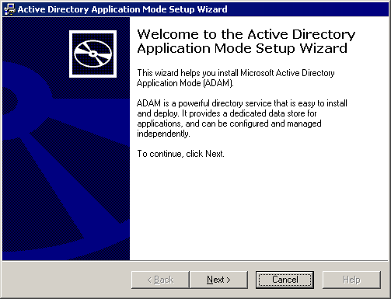

2. On the Welcome to the Active Directory Application Mode Setup Wizard page, click Next.
3. On the Setup Options page, you can choose whether to install a unique ADAM instance or join an existing configuration set. Because you are installing the first ADAM instance, click A unique instance (as shown below), and then click Next. Later, you will create additional ADAM instances and join them in a configuration set.
Active Directory Application Mode Setup Wizard Setup Options page
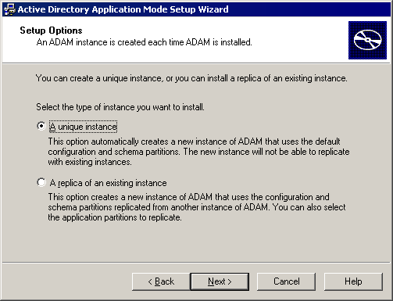

4. On the Instance Name page, provide a name for the ADAM instance that you are installing. This name is used on the local computer to uniquely identify the ADAM instance. For this exercise, simply accept the default name of instance1, and then click Next.
Active Directory Application Mode Setup Wizard Instance Name page
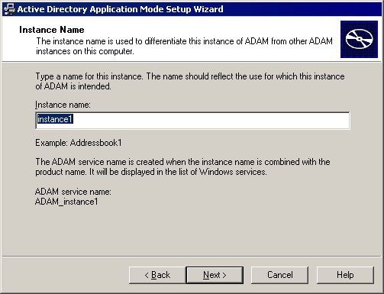

5. On the Ports page, specify the communications ports that the ADAM instance uses to communicate. Active Directory Application Mode can communicate using both LDAP and Secure Sockets Layer (SSL), so you must provide a value for each. For this exercise, accept the default values of 389 and 636, and then click Next.
Active Directory Application Mode Setup Wizard Ports page
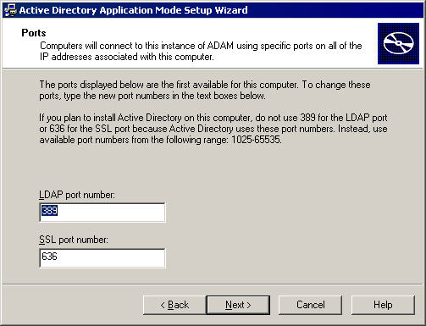

Note:
If you install ADAM on a computer where either of the default ports is in use, the Active Directory Application Mode Setup Wizard automatically locates the first available port, starting at 50000. For example, Active Directory uses ports 389 and 636, as well as ports 3268 and 3269 on global catalog servers. Therefore, if you install ADAM on a domain controller, the Active Directory Application Mode Setup Wizard provides a default value of 50000 for the LDAP port and 50001 for the SSL port.
6. On the Application Directory Partition page, you can create an application directory partition (or naming context) by clicking Yes, create an application directory partition. Or, you can click No, do not create an application directory partition, in which case you must create an application directory partition manually after installation. For this exercise, click Yes, create an application directory partition. When you create an application directory partition, you must provide a distinguished name for the new partition. For this exercise, type o=Microsoft,c=US as the distinguished name (as shown below), and then click Next.
Active Directory Application Mode Setup Wizard Application Directory Partition page
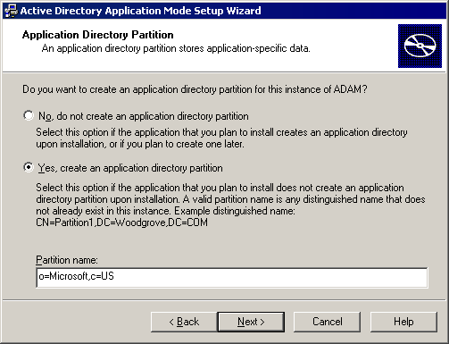

Note:
ADAM supports both X.500-style and Domain Name System (DNS)-style distinguished names for top-level directory partitions.
7. On the File Locations page, you can view and change the installation directories for ADAM data and recovery (log) files. By default, ADAM data and recovery files are installed in \%ProgramFiles%\Microsoft ADAM\instancename\data, where instancename represents the ADAM instance name that you specify on the Instance Name page. For this exercise, click Next to accept the default file locations.
Active Directory Application Mode Setup Wizard File Locations page
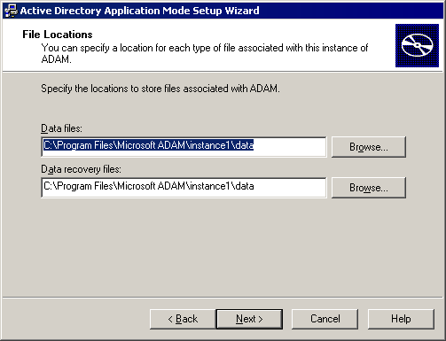

Note:
ADAM setup installs program files and administration tools in \%windir%\ADAM.
8. On the Service Account Selection page, you select an account to be used as the service account for Active Directory Application Mode. The account that you select determines the security context in which the ADAM instance runs. Unless you are installing ADAM on a domain controller, the Active Directory Application Mode Setup Wizard defaults to the Network Service account. For this exercise, accept the Network service account default by clicking Next. Or, if you are installing Active Directory Application Mode on a domain controller, click This account, and then select a domain user account to use as the ADAM service account.
Active Directory Application Mode Setup Wizard Service Account Selection page
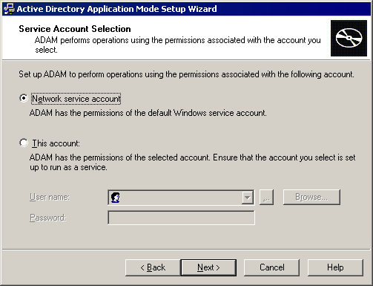

Note:
You can change the ADAM service account after ADAM is installed by using dsmgmt. When you install ADAM on a domain controller, you must select a domain user account as the ADAM service account.
9. On the ADAM Administrators page, you select a user or group to become the default administrator for the ADAM instance. The user or group that you select will have full administrative control of the ADAM instance. By default, the Active Directory Application Mode Setup Wizard specifies the currently logged on user. You can change this selection to any local or domain account or group on your network. For this exercise, click the default value of Currently logged on user, and then click Next.
Active Directory Application Mode Setup Wizard ADAM Administrators page
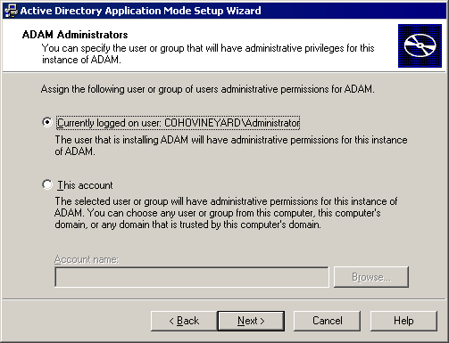

10. On the Importing LDIF Files page, you can import into the ADAM schema two .ldf files containing user class object definitions. Importing these user class object definitions is optional. However, these object definitions are required later in this guide, so you should import these definitions now:
a. Click Import the selected LDIF files for this instance of ADAM.
b. Click MS-InetOrgPerson.LDF, and then click Add.
c. Click MS-User.LDF, click Add, and then click Next.
Active Directory Application Mode Setup Wizard Importing LDIF Files page
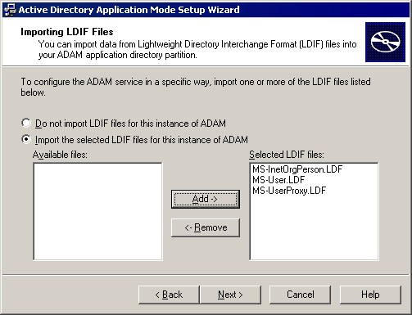

11. The Ready to Install page gives you an opportunity to review your installation selections. After you click Next, the Active Directory Application Mode Setup Wizard begins copying files and setting up Active Directory Application Mode on your computer.
Active Directory Application Mode Setup Wizard Ready to Install page
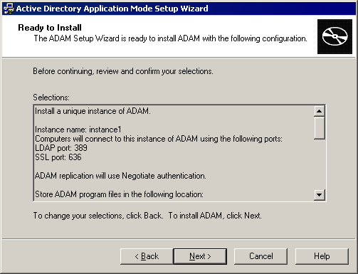

12. When the Active Directory Application Mode Setup Wizard finishes installing ADAM, it displays this message: “You have successfully completed the Active Directory Application Mode Setup Wizard.” When the Completing the Active Directory Application Mode Setup Wizard page appears, click Finish to close the wizard.

If the Active Directory Application Mode Setup Wizard Fails
If the Active Directory Application Mode Setup Wizard does not complete successfully, an error message describing the reason for the failure appears on the Summary page.
If an error occurs in the Active Directory Application Mode Setup Wizard before the Summary page, you can review the error message that appears. In addition, you can click Start, click Run, and type either of the following:
%windir%\Debug\adamsetup.log
%windir%\Debug\adamuninstall.log
The Adamsetup.log and Adamuninstall.log files contain information that can help you troubleshoot the cause of an ADAM setup failure.

Viewing the ADAM Program Group
The Active Directory Application Mode Setup Wizard creates a new program group at installation, which you can view in the Start menu.
To view the ADAM program group
• Click Start, point to All Programs, and then point to ADAM.

Using the ADAM Administration Tools
An ADAM instance runs as a standard user service, rather than as a system service, and it can be stopped and started through the Services snap-in in Microsoft Management Console (MMC). In addition, Active Directory Application Mode includes several administration tools for general administration tasks. In the following exercises, you use the Services snap-in to stop and start your ADAM instance, you use ADAM ADSI Edit to browse your directory, and you also configure the ADAM Schema snap-in.

Stopping and Restarting an ADAM Instance
To stop and restart an ADAM instance using the Services snap-in
1. Click Start, point to Administrative Tools, and then click Services.
2. The ADAM instance that you just installed is listed in the details pane of the Services snap-in, along with other services on the computer. ADAM instances are listed in Services by their name, which in this case is instance1. Click the ADAM instance that you installed, as shown below.
Stopping and Starting Active Directory Application Mode
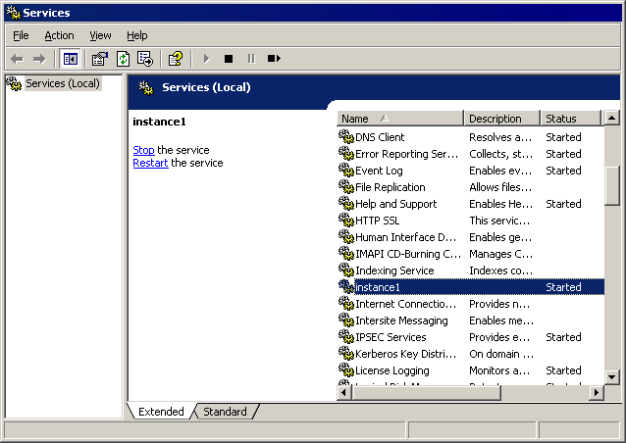

3. To stop the ADAM instance, on the Action menu, click Stop.
4. After the ADAM instance is stopped, on the Action menu, click Restart to restart the ADAM instance.

Using the ADAM ADSI Edit Administration Tool
The main administration tool for Active Directory Application Mode is ADAM ADSI Edit. In this exercise, you use ADAM ADSI Edit to bind to, view, and browse your ADAM instance.
To bind to, view, and browse an ADAM instance using ADAM ADSI Edit
1. Click Start, point to All Programs, point to ADAM, and then click ADAM ADSI Edit.
2. In the console tree, click ADAM ADSI Edit. The ADAM ADSI Edit snap-in looks like the following:
ADAM ADSI Edit
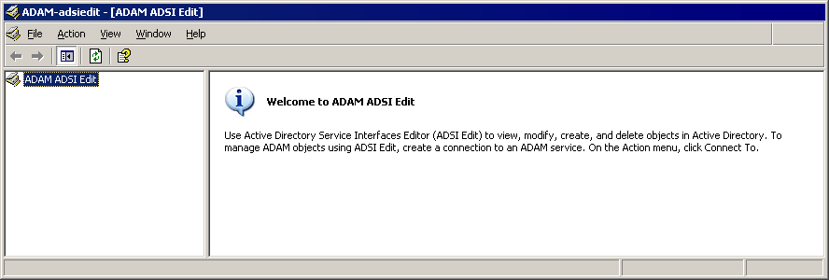

3. On the Action menu, click Connect to. The Connection Settings dialog box appears.
4. In Connection name, you can type a label under which this connection will appear in the console tree of ADAM ADSI Edit. For this connection, type ADAM demo.
5. In Server name, type the host or DNS name of the computer on which the ADAM instance is running.
Note:
Because, in this exercise, ADAM is running on the local computer, you can use localhost as the server name.
6. In Port, type the LDAP or SSL communication ports in use by ADAM. Or, as in this case, accept the default value of 389.
7. Under Connect to the following node, you can connect to a well-known naming context, such as the configuration or schema directory partition, or you can specify the distinguished name of a partition to which you want to connect. For this exercise, click Distinguished name (DN) or naming context, and type o=Microsoft,c=US, which is the distinguished name of the application partition that you created during setup.
8. Under Connect using these credentials, click The account of the currently logged on user. The Connection Settings dialog box now looks like the following:
ADAM ADSI Edit Connection Settings
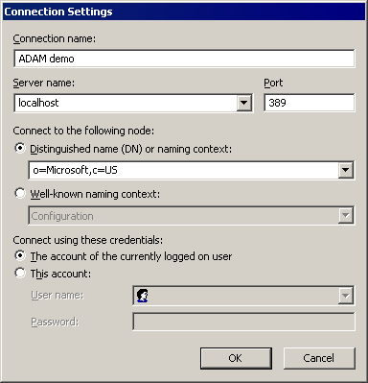

9. Click OK. The ADAM ADSI Edit snap-in looks like the following:
ADAM ADSI Edit, connected
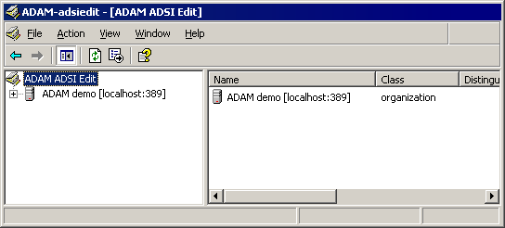

10. In the console tree, double-click ADAM demo, and then double-click O=Microsoft,c=US. The ADAM ADSI Edit snap-in now looks like the following:
ADAM ADSI Edit application directory partition
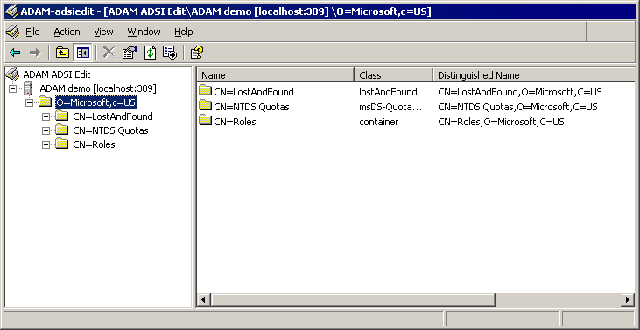

11. In the console tree, click any container to view the objects in that container. For example, click CN=Roles.
12. To open a different directory partition on the ADAM instance, in the console tree, click ADAM ADSI Edit, and then, on the Action menu, click Connect to.
13. Fill out the Connection Settings dialog box as shown below, and then click OK.
ADAM ADSI Edit, connecting to the configuration container
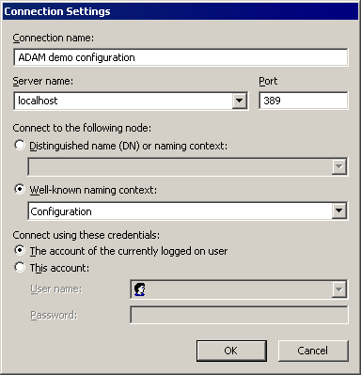

The Connection Settings dialog box now looks like the following:
ADAM ADSI Edit configuration container
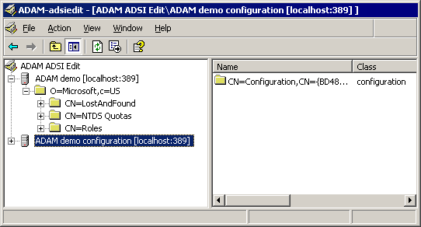

You can now browse the contents of the configuration directory partition of your ADAM instance.
14. To close ADAM ADSI Edit, on the File menu, click Exit.

Configuring the ADAM Schema Snap-in Administration Tool
You can use another ADAM administration tool, the ADAM Schema snap-in, to administer the ADAM schema. If you have ever used the Active Directory Schema snap-in, the ADAM Schema snap-in should look very familiar to you. Before you can use the ADAM Schema snap-in, you need to create an MMC file for it, as described in this procedure.
To create an MMC file for the ADAM Schema snap-in
1. Click Start, click Run, type mmc /a, and then click OK.
2. On the File menu, click Add/Remove Snap-in, and then click Add.
3. In Available Standalone Snap-ins, click ADAM Schema, click Add, click Close, and then click OK.
4. To save this console, on the File menu, click Save.
5. In File name, type \%windir%\system32\adamschmmgmt.msc, and then click Save. The ADAM Schema snap-in looks like the following:
ADAM Schema snap-in
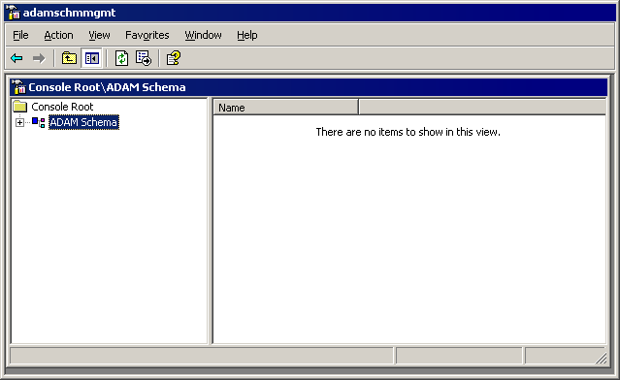

6. To connect to your ADAM instance through ADAM Schema, in the console tree, right-click ADAM Schema, click Change ADAM Server, and then complete the dialog box as follows:
ADAM Schema snap-in connection
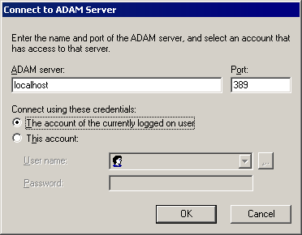

7. Click OK. The ADAM Schema snap-in now looks like the following .You can browse and view the ADAM schema classes and attributes:
ADAM Schema snap-in classes and attributes
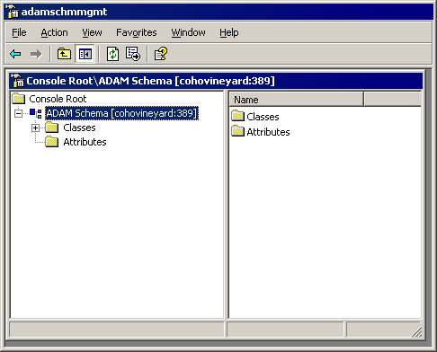

8. To create a shortcut for the ADAM Schema snap-in on your Start menu:
• Right-click Start, click Open All Users, double-click the Programs folder, and then double-click the ADAM folder.
• On the File menu, point to New, and then click Shortcut.
• In the Create Shortcut Wizard, in Type the location of the item, type adamschmmgmt.msc, and then click Next.
• On the Select a Title for the Program page, in Type a name for this shortcut, type ADAM Schema, and then click Finish.

Setting Up Application Data
In most cases, you extend the ADAM schema with object class and attribute definitions for the kinds of data that your application will be storing. Just as with Active Directory, the schema in Active Directory Application Mode is extensible. You can extend the ADAM schema programmatically or with the Ldifde.exe command-line tool. In the following exercises, you extend the ADAM schema to support the Windows Address Book application, and then you import some sample application data into your ADAM instance.
Note:
You will use the application data that you import in these exercises later with the Windows Address Book application.

Adding Optional User Classes to the ADAM Schema
You can add the optional user classes that are provided with Active Directory Application Mode during ADAM setup, or you can add them manually using the Ldifde.exe command-line tool. If you imported the user class definition .ldf files when you ran the Active Directory Application Mode Setup Wizard, you can skip this procedure.
To manually add optional user classes to the ADAM schema
1. Click Start, point to All Programs, point to ADAM, and then click ADAM Tools Command Prompt.
2. At the command prompt, type the following command, and then press ENTER:
ldifde -i -f ms-inetorgperson.ldf -s servername:portnumber -k -j . -c "CN=Schema,CN=Configuration,DC=X" #schemaNamingContext
where servername:portnumber represents the computer name and LDAP communication port of your ADAM instance. Because the ADAM instance is running on your local computer, you can also use localhost as the computer name.
Note:
Be sure to use the copy of Ldifde.exe that came with Windows Server 2003 R2, rather than a copy that came with an earlier ADAM release or with Windows Support Tools.
The ADAM Tools Command Prompt window should now look like the following:
Active Directory Application Mode ldifde ms-inetorgperson.ldf
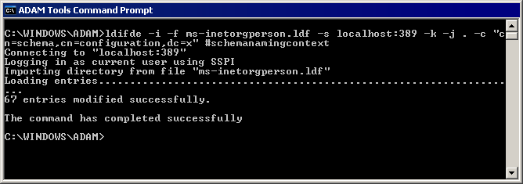

3. Next, type the following command, and then press ENTER:
ldifde -i -f ms-user.ldf -s servername:portnumber-k -j . -c "CN=Schema,CN=Configuration,DC=X" #schemaNamingContext
The ADAM Tools Command Prompt window now looks like the following:
Active Directory Application Mode ldifde ms-user.ldf
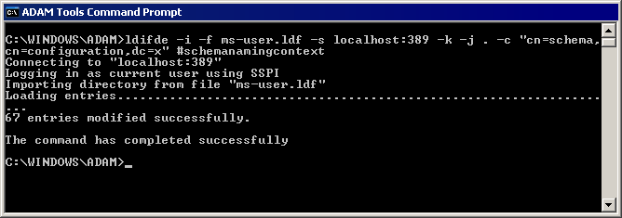

After you run these commands, the ADAM schema includes the ADAM and inetOrgPerson user object classes. You can verify this by viewing the ADAM schema with the ADAM Schema snap-in.

Extending the ADAM Schema
In this exercise, you extend the ADAM schema again by adding a contacts object class, again by using the ldifde command-line tool.
To extend the ADAM schema
1. Click Start, point to All Programs, point to ADAM, and then click ADAM Tools Command Prompt.
2. At the command prompt, type the following, and then press ENTER:
ldifde -i -f drive:\path\labs_demo\labs\contact.ldf -sservername:portnumber-k -j . -c "CN=Schema,CN=Configuration" #schemaNamingContext
where drive:\path represents the location where you saved the ADAM download, and servername:portnumber represents the computer name and LDAP communications port of your ADAM instance. Because the ADAM instance is running on your local computer, you can also use localhost as the computer name.
Note:
Be sure to use the copy of Ldifde.exe that came with the ADAM release, rather than a copy that came with an earlier ADAM release or with Windows Support Tools.
After the command runs, the ADAM Tools Command Prompt window looks like the following:
Active Directory Application Mode ldifde contact.ldf
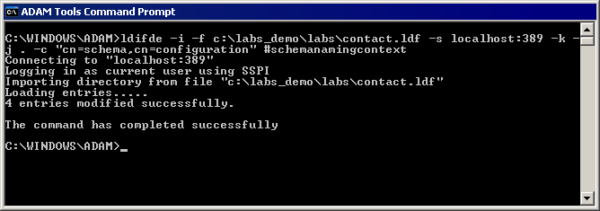

Now your ADAM schema also includes the contacts object class, and it is ready for some application data.

Importing Application Data
In this exercise, you import some sample data into your ADAM instance using the ldifde command-line tool. This data is provided with the ADAM download.
To import application data
1. Click Start, point to All Programs, point to ADAM, and then click ADAM Tools Command Prompt.
2. At the command prompt, type the following:
ldifde -i -fdrive:\path\labs_demo\labs\contactimport.ldf -sservername:portnumber-k -j .
where drive:\path represents the location where your ADAM files are located, and servername:portnumber represents the computer name and LDAP communications port of your ADAM instance.
Note:
Be sure to use the copy of Ldifde.exe that came with the ADAM release, rather than a copy that came with an earlier ADAM release or with Windows Support Tools.
After the command runs, the ADAM Tools Command Prompt window looks like the following:
Active Directory Application Mode ldifde contactimport.ldf
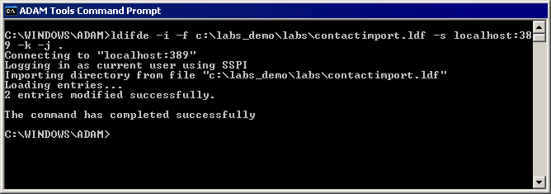

Note:
Ldifde always reports the number of entries that are imported into the directory. In this case, you can see from the ldifde output that contactimport.ldf contains two records. For more information about ldifde, type ldifde /? at the command prompt.

Using an Application with ADAM
In this exercise, you use Windows Address Book, an LDAP-based application, to query and retrieve the application data that you imported into your ADAM instance.

Querying Data with Windows Address Book
To query data with Windows Address Book
1. Click Start, click Run, type wab.exe, and then click OK.
2. On the Tools menu, click Accounts, and then click Add. The Internet Connection Wizard appears.
3. In Internet directory (LDAP) server, type localhost, click Next, and then click Finish.
4. In the Internet Accounts dialog box, on the Directory Service tab, double-click localhost, as shown below.
Windows Address Book Internet Accounts
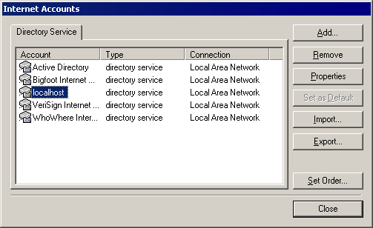

5. Complete the General tab in the localhost Properties dialog box as shown below, using the account with which you are currently logged on to the computer. Be sure to select both the This server requires me to log on check box and the Log on using Secure Password Authentication check box.
Windows Address Book connection
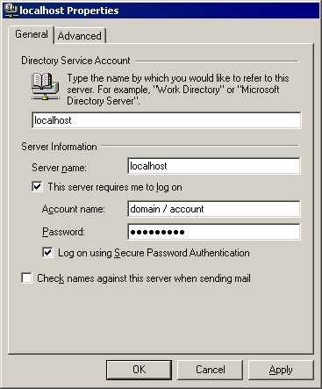

6. Click the Advanced tab, and then select the Use simple search filter check box. In Search base, type o=Microsoft,c=US as shown below, click OK, and then click Closein the Internet Accounts dialog box.
Windows Address Book advanced
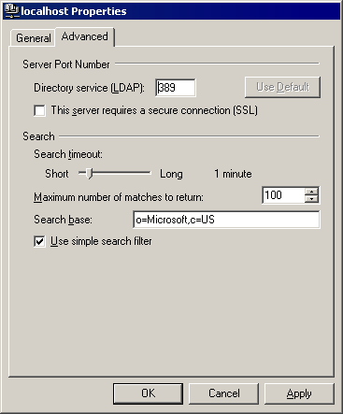

7. In Windows Address Book, click Find People on the toolbar. In Look in, click localhost, and then, in Name, type kim. The localhost Properties dialog box looks like the following:
Windows Address Book Find People
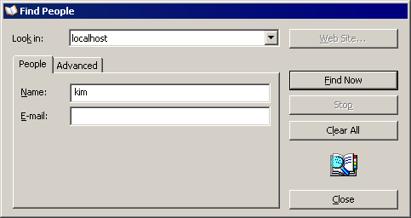

8. Click Find Now. Your search should return one entry from the ADAM directory, as shown below:
Windows Address Book Find Now results
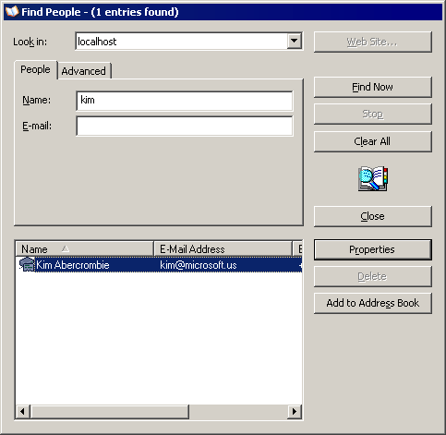

9. Double-click the name to view the search result details.
10. On the Organization tab, you can view the reporting relationship. Double-click the manager’s name to view the associated contact details, which looks like the following:
Windows Address Book View Manager
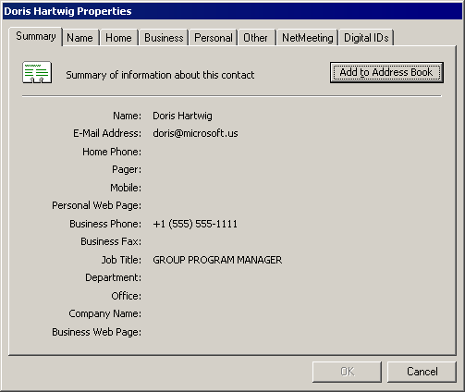

Managing OUs, Groups, and Users in ADAM
In these exercises, you create organizational units (OUs) and groups in Active Directory Application Mode, and you create ADAM users with the user object classes that you imported earlier. Using ADAM ADSI Edit, you create an OU called “ADAM users” in the o=Microsoft,c=US application directory partition, and you add a group called “ADAM testers” to the new OU. You then add an ADAM user to the ADAM users OU.

Creating OUs and Groups
In this exercise, you create an OU and add a group to that OU.
To create an OU and add groups
1. If it is not open already, open ADAM ADSI Edit, and then connect to the o=Microsoft,c=US application directory partition, as discussed earlier in the procedure “To bind to, view, and browse an ADAM instance using ADAM ADSI Edit.”
2. In the console tree, right-click O=Microsoft,c=US, point to New, and then click Object. The Create Object dialog box looks like the following:
ADAM, creating an OU
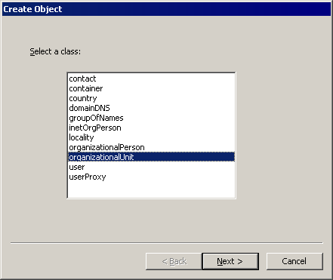

3. In the Select a class list, click organizationalUnit, and then click Next.
4. In Value, type ADAM users, and then click Next.
5. On the next page, you can click More attributes to edit additional attributes on the object that you are creating. For this exercise, simply click Finish.
6. In the console tree, double-click O=Microsoft,c=US. The ADAM ADSI Edit snap-in looks like the following:
Active Directory Application Mode, viewing an OU
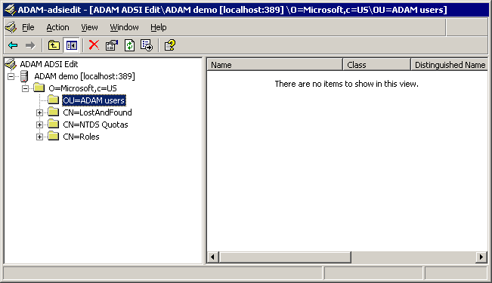

7. To create a new group in the ADAM Users OU, in the console tree, right-click OU=ADAM Users, point to New, and then click Object.
8. In Select a class, click group, and then click Next.
9. In Value, type ADAM testers, and then click Next.
10. In Value, type 2147483650 (equivalent to 0x80000002 hexadecimal, which signifies an account group), click Next, and then click Finish.
Note:
For more information on the groupType attribute, see Group-Type on the MSDN Web site.
The ADAM ADSI Edit snap-in looks like the following:
Active Directory Application Mode, creating a group
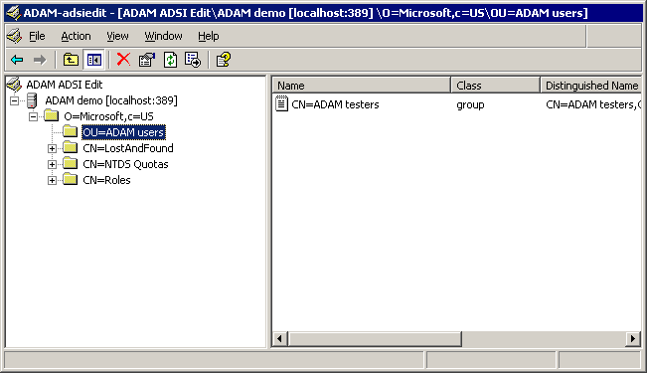

Creating an ADAM User
In this exercise, you create an ADAM user in the ADAM Users OU, and then you add the user to the ADAM Testers group.
1. If it is not already open, open the ADAM ADSI Edit snap-in.
2. Connect and bind to your ADAM instance, as described earlier in the procedure “To bind to, view, and browse an ADAM instance using ADAM ADSI Edit.” Then, in the console tree, double-click the ADAM instance.
3. Double-click the O=Microsoft,c=US application directory partition.
4. Right-click the OU=ADAM Users container that you created previously, point to New, and then click Object.
5. In Select a class, click user, as shown below, and then click Next.
Note:
If you did not close ADAM ADSI Edit before importing the Adamuser.ldf user class object definitions, you may receive the following warning message during this step: “An invalid directory pathname was passed.”
6. In Value, type Mary Baker as the common name (cn) for the new user, as shown below, and then click Next.
Active Directory Application Mode, creating a user
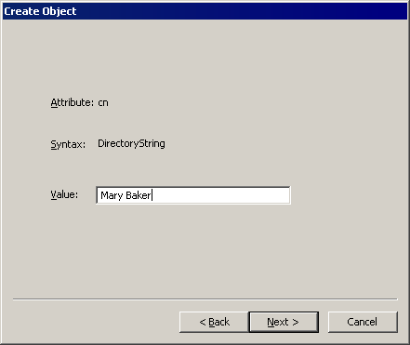

7. Click Finish. The ADAM ADSI Edit snap-in looks like the following:
ADAM ADSI Edit, viewing a user
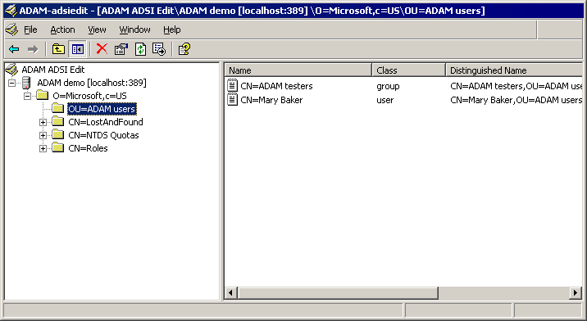

Adding Users to Groups
You can add both ADAM users and Windows users to ADAM groups, as described in this exercise. First, you add Mary Baker, the user that you just created, to the ADAM testers group.
To add a user to a group
1. In the details pane of ADAM ADSI Edit, right-click CN=ADAM testers, and then click Properties. The CN=ADAM testers Properties dialog box looks like the following:
Active Directory Application Mode, editing group membership
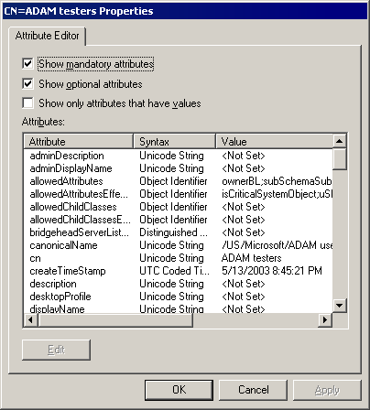

2. In Attributes, click Member, and then click Edit.
3. Click Add ADAM Account, type the following as the distinguished name, and then click OK:
CN=Mary Baker,OU=ADAM users,O=Microsoft,C=US
The Multi-valued Distinguished Name with Security Principal Editor dialog box looks like the following:
ADAM ADSI Edit security principal editor
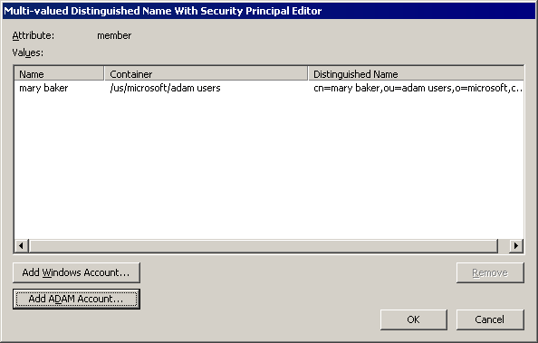

4. You can also add Windows users to an ADAM group. In the Multi-valued Distinguished Name With Security Principal Editor dialog box, click Add Windows Account. The Select Users or Groups dialog box looks like the following:
ADAM ADSI Edit Select Users or Groups
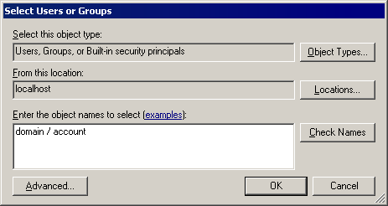

5. In the Select Users or Groups dialog box, add a Windows user from your computer or domain to the ADAM testers group. In Enter the object names to select (examples), type an account name using the machine\account or domain\account format.
6. Click OK. The new user name appears in the Multi-valued Distinguished Name With Security Principal Editor dialog box as a member of the group.
7. Click OK twice to return to ADAM ADSI Edit.

Disabling and Enabling ADAM User Accounts
You can disable and enable ADAM user accounts by using the ADAM ADSI Edit snap-in. In this exercise, you disable the Mary Baker account and then enable it again.
To enable or disable an ADAM user account
1. In ADAM ADSI Edit, connect and bind to an ADAM instance as described earlier in the procedure “To bind to, view, and browse an ADAM instance using ADAM ADSI Edit.”
2. In the console tree, double-click the O=Microsoft,c=US application directory partition.
3. In the console tree, click the OU=ADAM Users container.
4. In the details pane, right-click CN=Mary Baker, and then click Properties.
5. In Attributes, click msDS-UserAccountDisabled, and then click Edit.
6. Click True, and then click OK. The Mary Baker account is now disabled.
7. To enable the Mary Baker account, edit msDS-UserAccountDisabled again, and this time set the attribute to False.

Managing Directory Partitions in ADAM
In the following exercises, you manually add and then delete an application directory partition. (Remember, you can also create an application directory partition during ADAM setup.) These exercises help you become familiar with an additional Active Directory Application Mode administration tool, Ldp.exe. Ldp is installed as part of the ADAM administration tool set.

Connecting and Binding to an ADAM Instance Using Ldp.exe
To begin this exercise, you connect and bind to your ADAM instance using Ldp.exe.
To connect and bind to an ADAM instance using Ldp.exe
1. Click Start, point to All Programs, point to ADAM, and then click ADAM Tools Command Prompt.
2. At the command prompt, type ldp, and then press ENTER.
3. On the Connection menu, click Connect.
4. In Server, type the host or DNS name of the computer running Active Directory Application Mode. When the ADAM instance is running locally, you can also type localhost.
5. In Port, type the LDAP or SSL communication port number for the ADAM instance to which you want to connect, and then click OK.
Active Directory Application Mode Ldp connect
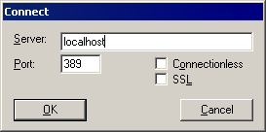

6. On the Connection menu, click Bind.
7. In User, type the account name with which you are logged on to the computer.
8. In Password, type your password.
9. To bind using a Windows domain account, select the Domain check box. In Domain, type the domain name (or the computer name, if you are using a local workstation account) of the account that you are using, and then click OK, as shown below.
Active Directory Application Mode Ldp bind
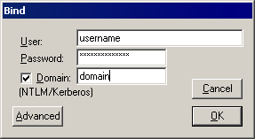

Adding an Application Directory Partition
Now, you are ready to add an application directory partition.
To add an application directory partition using Ldp.exe
1. On the LdpBrowse menu, click Add child.
2. In Dn, type cn=test,o=testpartition,c=us as the distinguished name for the new application directory partition.
3. Under Edit Entry, type the following, and then click Enter:
• In Attribute, type ObjectClass.
• In Values, type container.
4. Under Edit Entry, type the following, and then click Enter:
• In Attribute, type InstanceType.
• In Values, type 5.
The Add dialog box looks like the following:
Active Directory Application Mode Ldp, adding an application directory partition
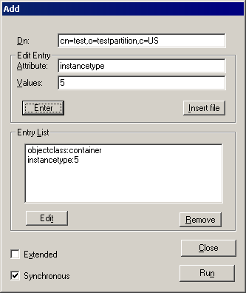

5. Click Run. After the new application directory partition is added, the following result appears in the details pane:
***Calling Add...
ldap_add_s(ld, "cn=test,o=testpartition,c=us", [2] attrs)
Added {cn=test,o=testpartition,c=us}.

6. Click Close.
7. To refresh Ldp and view your new directory partition, you must disconnect and then bind again to the ADAM instance. On the Connection menu, click Disconnect.
8. Now, bind to your ADAM instance as you did previously: on the Connection menu, click Bind.
9. To view the directory tree in Ldp, on the View menu, click Tree.
10. To view all directory partitions on the ADAM instance, leave BaseDN blank, and then click OK. The Ldp window looks like the following:
Active Directory Application Mode Ldp, viewing the tree
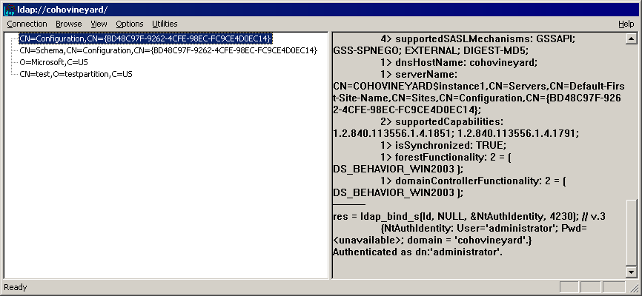

11. To view your new directory partition and its default containers and objects, double-click CN=test,O=testpartition,C=US in the console tree. The Ldp window looks like the following:
Active Directory Application Mode Ldp, viewing the new partition
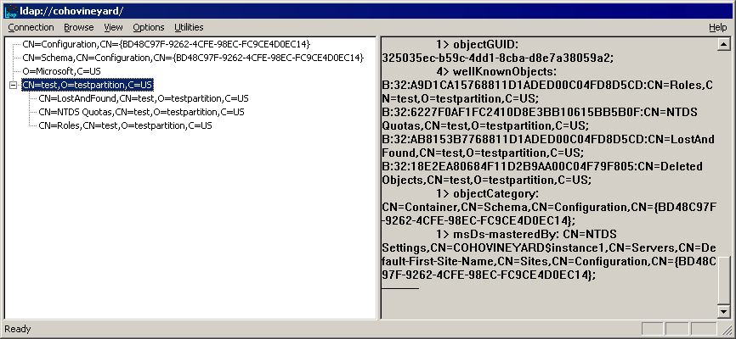

Deleting an Application Directory Partition
In this exercise, you delete the application directory partition that you just created.
To delete an application directory partition using Ldp.exe
1. In the Ldp console tree, double-click the configuration directory partition CN=Configuration,CN={GUID}, where GUID is the unique identifier that is assigned by Active Directory Application Mode.
2. To view the cross-reference objects for the directory partitions on your ADAM instance, in the console tree, double-click the partitions container CN=Partitions. The Ldp window looks like the following:
Active Directory Application Mode Ldp directory partition cross-references
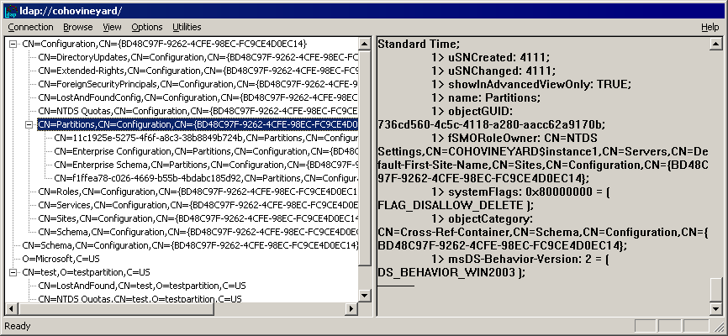

3. In the console tree, under the partitions container CN=Partitions, double-click the cross-reference object for which the value of nCName (as viewed in the details pane) is equal to CN=test,O=testpartition,C=US, as shown below.
Note:
To clear the details pane in Ldp without disturbing your bind or connection, on the Connection menu, click New.
Active Directory Application Mode Ldp, identifying directory partition cross-reference
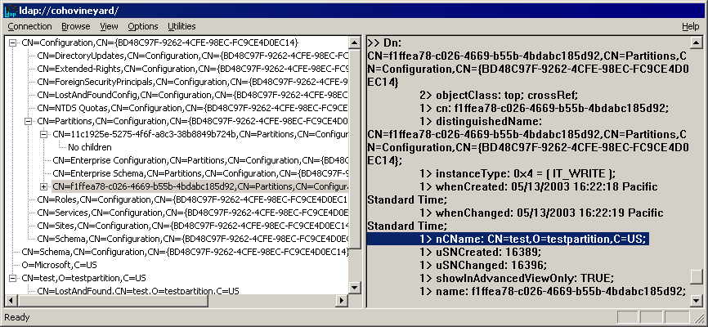

4. To delete this cross-reference object (and, therefore, the associated directory partition), in the console tree, right-click the appropriate cross-reference object in the partitions container, click Delete, and then click OK.
Caution:
You cannot undo a partition deletion after you click OK.
After you delete the cross-reference object, output similar to the following appears in the details pane:
ldap_delete_s(ld, "CN=56c5aea2-5cb1-450a-96f0-5622cd949791,CN=Partitions,CN=Configuration,CN={90BF4692-0FF5-4410-8835-DCBBEE6E08B1}");
Deleted "CN=56c5aea2-5cb1-450a-96f0-5622cd949791,CN=Partitions,CN=Configuration,CN={90BF4692-0FF5-4410-8835-DCBBEE6E08B1}"

Note:
For more information about Ldp, see ADAM Help. To open ADAM Help, click Start, point to All Programs, point to ADAM, and then click ADAM Help.

Managing Authorization in ADAM
Authorization refers to the process of determining which users have access to which directory objects. As with Active Directory, access control lists (ACLs) on each directory object determine which users have access to that object. By default, the only ACLs in Active Directory Application Mode reside in the top-level container of each directory partition. All objects in a given directory partition inherit these ACLs. Using the Dsacls.exe command-line tool, you can view and modify the default ACLs in Active Directory Application Mode, and you can add additional ACLs. In the following exercises, you view and modify ADAM ACLs.
Note:
You may have directory-enabled applications that implement their own custom authorization schemes. These applications generally disregard the ACLs on Active Directory Application Mode directory objects.

Viewing Effective Permissions
In this exercise, you view the effective permissions on the o=Microsoft,c=US directory partition.
To view effective permissions
1. Click Start, point to All Programs, point to ADAM, and then click ADAM Tools Command Prompt.
2. At the command prompt, type the following, and then press ENTER:
dsacls \\servername:portnumber\O=Microsoft,C=US
where servername:portnumber is the computer name and the LDAP communications port of your ADAM instance.
This command lists all the permissions that are currently set on the directory partition object. Your screen should contain output similar to the following:
Access list:
Effective Permissions on this object are:
Allow CN=Instances,CN=Roles,CN=Configuration,CN={C98CA450-AC25-4BC1-AC3C-C3BEC88B335E}
SPECIAL ACCESS
READ PERMISSONS
LIST CONTENTS
READ PROPERTY
LIST OBJECT
Allow CN=Readers,CN=Roles,O=Microsoft,C=US
SPECIAL ACCESS
READ PERMISSONS
LIST CONTENTS
READ PROPERTY
LIST OBJECT
Allow CN=Administrators,CN=Roles,O=Microsoft,C=US
FULL CONTROL
Allow CN=Instances,CN=Roles,CN=Configuration,CN={C98CA450-AC25-4BC1-AC3C-C3BEC88B335E}
Replicating Directory Changes
Allow CN=Instances,CN=Roles,CN=Configuration,CN={C98CA450-AC25-4BC1-AC3C-C3BEC88B335E}
Replication Synchronization
Allow CN=Instances,CN=Roles,CN=Configuration,CN={C98CA450-AC25-4BC1-AC3C-C3BEC88B335E}
Manage Replication Topology
Allow CN=Instances,CN=Roles,CN=Configuration,CN={C98CA450-AC25-4BC1-AC3C-C3BEC88B335E}
Replicating Directory Changes All

Permissions inherited to subobjects are:
Inherited to all subobjects
Allow CN=Readers,CN=Roles,O=Microsoft,C=US
SPECIAL ACCESS
READ PERMISSONS
LIST CONTENTS
READ PROPERTY
LIST OBJECT
Allow CN=Administrators,CN=Roles,O=Microsoft,C=US
FULL CONTROL

The command completed successfully

Granting Permissions
In this exercise, you grant the Delete permission on the ADAM testers group object to the Mary Baker account.
To grant the delete permission
1. Click Start, point to All Programs, point to ADAM, and then click ADAM Tools Command Prompt.
2. At the command prompt, type the following:
dsacls “\\servername:portnumber\CN=ADAM testers,OU=ADAM users,O=Microsoft,C=US” /G “CN=Mary Baker,OU=ADAM users,O=Microsoft,C=US”:SD;;
where servername:portnumber represents the computer name and LDAP communications port of your ADAM instance. Be sure to use an uppercase G when typing the /G parameter, and use quotation marks as shown.
Your screen should contain output similar to the following:
Access list:
Effective Permissions on this object are:
Allow CN=Mary Baker,OU=ADAM users,O=Microsoft,C=US
SPECIAL ACCESS
DELETE
Allow CN=Readers,CN=Roles,O=Microsoft,C=US
SPECIAL ACCESS <Inherited from parent>
READ PERMISSONS
LIST CONTENTS
READ PROPERTY
LIST OBJECT
Allow CN=Administrators,CN=Roles,O=Microsoft,C=US
FULL CONTROL <Inherited from parent>

Permissions inherited to subobjects are:
Inherited to all subobjects
Allow CN=Readers,CN=Roles,O=Microsoft,C=US
SPECIAL ACCESS <Inherited from parent>
READ PERMISSONS
LIST CONTENTS
READ PROPERTY
LIST OBJECT
Allow CN=Administrators,CN=Roles,O=Microsoft,C=US
FULL CONTROL <Inherited from parent>

The command completed successfully

Denying Permissions
In this exercise, you deny Delete permissions for the currently logged on user in the ADAM testers group.
To deny the Delete permission
1. Click Start, point to All Programs, point to ADAM, and then click ADAM Tools Command Prompt.
2. The first step is to deny the Delete, Delete Child, and Delete Tree permissions on the parent container of the ADAM testers group, which is the ADAM users OU. At the command prompt, type the following:
dsacls “\\servername:portnumber\OU=ADAM users,O=microsoft,C=US” /Ddomain\administrator:SDDCDT;;
where servername:portnumber represents the computer name and LDAP communications port of your ADAM instance, and domain\administrator represents the account with which you are currently logged on. Be sure to use an uppercase D when typing the /D parameter, and use quotation marks as shown.
Your screen should contain output similar to the following:
Access list:
Effective Permissions on this object are:
Deny SPECIAL ACCESS
DELETE
DELETE CHILD
DELETE TREE
Allow CN=Readers,CN=Roles,O=Microsoft,C=US
SPECIAL ACCESS <Inherited from parent>
READ PERMISSONS
LIST CONTENTS
READ PROPERTY
LIST OBJECT
Allow CN=Administrators,CN=Roles,O=Microsoft,C=US
FULL CONTROL <Inherited from parent>

Permissions inherited to subobjects are:
Inherited to all subobjects
Allow CN=Readers,CN=Roles,O=Microsoft,C=US
SPECIAL ACCESS <Inherited from parent>
READ PERMISSONS
LIST CONTENTS
READ PROPERTY
LIST OBJECT
Allow CN=Administrators,CN=Roles,O=Microsoft,C=US
FULL CONTROL <Inherited from parent>

The command completed successfully

1. The second step is to deny the Delete permission on the ADAM testers group for the currently logged on user. At the command prompt, type the following:
dsacls “\\servername:portnumber\CN=ADAM testers,OU=ADAM users,O=microsoft,C=US” /D domain\administrator:SDDCDT;;
where servername:portnumber represents the computer name and LDAP communications port of your ADAM instance, and domain\administrator represents the account with which you are currently logged on. Be sure to use an uppercase D when typing the /D parameter, and use quotation marks as shown.
Your screen should contain output similar to the following:
Access list:
Effective Permissions on this object are:
Deny SPECIAL ACCESS
DELETE
Allow CN=Readers,CN=Roles,O=Microsoft,C=US
SPECIAL ACCESS <Inherited from parent>
READ PERMISSONS
LIST CONTENTS
READ PROPERTY
LIST OBJECT
Allow CN=Administrators,CN=Roles,O=Microsoft,C=US
FULL CONTROL <Inherited from parent>

Permissions inherited to subobjects are:
Inherited to all subobjects
Allow CN=Readers,CN=Roles,O=Microsoft,C=US
SPECIAL ACCESS <Inherited from parent>
READ PERMISSONS
LIST CONTENTS
READ PROPERTY
LIST OBJECT
Allow CN=Administrators,CN=Roles,O=Microsoft,C=US
FULL CONTROL <Inherited from parent>

The command completed successfully

Managing Authentication in ADAM
With Active Directory Application Mode, you can bind as a Windows principal, as an ADAM principal, or through an ADAM proxy object. In the following exercises, you complete a bind using each of these methods. You also set a password for the ADAM user account Mary Baker, which you created earlier. In addition, you test the permissions that you set using dsacls in the previous exercises.

Binding as a Windows Principal
In this exercise, you bind to an ADAM instance as a Windows principal and then test the bind.
To bind as a Windows principal and test the bind
1. Click Start, point to All Programs, point to ADAM, and then click ADAM ADSI Edit.
2. Using ADAM ADSI Edit, bind to your ADAM instance using the Windows principal that you are logged on as, and connect to the O=Microsoft,c=US directory partition.
3. In the details pane, browse to the ADAM testers group, on which you denied the Delete permission to your current Windows account.
4. Right-click the ADAM testers group, and then click Delete. An “Access denied” message appears, confirming that the Delete permission has been successfully denied to your Windows account.

Setting the Password of an ADAM User
Before logging on to the ADAM instance with the Mary Baker user account, you first set a password on the account.
Note:
In addition to using Ldp as described in this procedure, you can also use ADAM ADSI Edit to set or modify passwords: right-click the directory object representing the ADAM security principal in ADAM ADSI Edit, and then click Reset Password.
To set a password on an ADAM user account
1. Click Start, point to All Programs, point to ADAM, and click ADAM Tools Command Prompt.
2. At the command prompt, type ldp, and then press ENTER.
3. On the Connection menu, click Connect, and then connect to your ADAM instance.
4. On the Options menu, click Connection Options.
5. In Option Name, click LDAP_OPT_SIGN, type 1 in Value, and then click Set.
6. In Option Name, click LDAP_OPT_ENCRYPT, type 1 in Value, click Set, and then click Close.
7. On the Connection menu, click Bind, and then bind to your ADAM instance.
8. On the View menu, click Tree, leave BaseDN blank, and then click OK.
9. In the console tree, locate the O=Microsoft,C=US directory partition. Double-click O=Microsoft,C=US, and then double-click OU=ADAM Users,O=Microsoft,C=US.
10. Right-click the CN=Mary Baker user object, and then click Modify. The following dialog box appears:
Active Directory Application Mode Ldp, modifying user
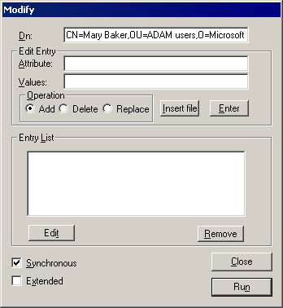

11. In Attribute, type userpassword, and then, in Values, type a password for the account.
12. Click Enter, and then click Run. The details pane in Ldp should contain output similar to the following:
***Call Modify...
ldap_modify_s(ld, 'CN=Mary Baker,OU=ADAM users,O=Microsoft,C=US',[1] attrs);
Modified "CN=Mary Baker,OU=ADAM users,O=Microsoft,C=US".

Note:
When Active Directory Application Mode runs on a computer running Windows Server 2003, it enforces the password policy and account lockout settings of the computer or domain, whichever is in effect.

Binding as an ADAM Principal
In this exercise, you bind to an ADAM instance as an ADAM principal and then test the bind.
To bind as an ADAM principal and test the bind
1. Using Ldp, bind to your ADAM instance using CN=Mary Baker,OU=ADAM users,O=Microsoft,C=US as the account, along with the password that you just assigned to this account.
2. To confirm that you are logged on as Mary Baker and that the Delete permission that you granted earlier is effective, in the Ldp console tree, browse to the ADAM testers group and delete it. To delete the ADAM testers group, right-click the CN=ADAM testers object, and then click Delete.
Note:
By default, new ADAM users (such as Mary Baker) are granted Read access to the top-level container of a given directory partition, a permission which is inherited by all objects on the partition. But, because you explicitly assigned the Delete permission to Mary Baker on the ADAM testers group object, the delete operation succeeded. For more information about access control and default permissions in Active Directory Application Mode, see ADAM Help. To view ADAM Help, click Start, point to All Programs, point to ADAM, and then click ADAM Help.

Binding Through an ADAM Proxy Object
In addition to binding as a Windows user or as an ADAM user, you can also bind to an ADAM instance using ADAM bind redirection. Through bind redirection, Active Directory Application Mode can accept and process bind requests to an ADAM proxy object that contains as one of its attributes the security ID (SID) from an Active Directory security principal. With Active Directory Application Mode, you can use bind redirection to provide Active Directory users with access to both ADAM data and Active Directory data, using Active Directory domain credentials as a single sign on (SSO). In addition, you can use ADAM proxy objects to store user data that is specific to a particular application in Active Directory Application Mode, while using Active Directory to store more widely used directory data.
The Active Directory Application Mode .ldf files, which you can import into the ADAM schema during ADAM setup, contain an object definition for the object userProxy, which can be used for bind redirection. This object contains attributes that include a distinguished name and a SID. By creating a userProxy object in ADAM—specifying a distinguished name to be used for binding—and by using a valid SID from an Active Directory user account, you can bind to ADAM using bind redirection.
For the following exercises, it is assumed that you have already imported the optional user classes into the ADAM schema.
Note:
If you are running Active Directory Application Mode on Windows XP Professional, to complete this exercise you must install the QFEs described in article 817583, “Active Directory Services Does Not Request Secure Authorization Over an SSL Connection,” in the Microsoft Knowledge Base (http://go.microsoft.com/fwlink/?LinkId=45786).

Binding Security and ADAM Proxy Objects
By default, binding to Active Directory Application Mode with bind redirection requires an SSL connection. SSL requires the installation and use of certificates on the computer running Active Directory Application Mode and on the computer connecting to ADAM as a client. If you do not have certificates installed in your ADAM test environment, you can, as an alternative, disable the requirement for SSL, as described in the following procedure.
Note:
Disabling the requirement for SSL for bind redirection causes the password of a Windows security principal to be passed to the computer running Active Directory Application Mode, without first being encrypted. Therefore, you should only disable the SSL requirement in a test environment.Text
To disable the SSL requirement for bind redirection
1. As described earlier in the procedure “To bind to, view, and browse an ADAM instance using ADAM ADSI Edit,” connect and bind to your ADAM instance using ADAM ADSI Edit, and then, in the console tree, browse to the following container object in the configuration partition: CN=Directory Service,CN=Windows NT,CN=Services.
2. Right-click CN=Directory Service, and then click Properties.
3. In Attributes, click msDS-Other-Settings, and then click Edit.
4. In Values, click RequireSecureProxyBind=1, and then click Remove.
5. In Value to add, type RequireSecureProxyBind=0, click Add, and then click OK.

Creating and Binding with an ADAM Proxy Object
In these exercises, you create a proxy object for an Active Directory user, and you bind to Active Directory Application Mode using the proxy object.
To bind to ADAM through an ADAM proxy object
1. As described earlier in the procedure “To connect and bind to an ADAM instance using Ldp.exe,” connect and bind to your ADAM instance using Ldp, and then browse to O=Microsoft,C=US.
2. On the Ldp Browse menu , click Add child.
3. In Dn, type cn=testproxy,o=microsoft,c=us as the distinguished name for the new userProxy object to be created in the O=Microsoft,C=US container.
4. Under Edit Entry, type the following, and then click Enter:
• In Attribute, type ObjectClass.
• In Values, type userProxy.
5. Again, under Edit Entry, type the following, and then click Enter:
• In Attribute, type objectSID.
• In Values, type the valid SID of a user in Active Directory.
Note:
The \LABS_DEMO\LABS\bindredirect directory in the Active Directory Application Mode download contains two commands from the Windows Server 2003 Administration Tools Pack, Dsquery.exe and Dsget.exe, to help you retrieve the SID of an Active Directory user. You can run these commands on a computer running Windows Server 2003 or on a computer running Windows XP Professional.
To retrieve the SID of an Active Directory user with these commands, type the following (as a single command) at a command prompt:
dsquery user -samid domain\account | dsget user -sid
where domain\account represents the user whose SID you want to retrieve. In this command, the results of dsquery are piped to dsget.
The Windows Server 2003 Administration Tools Pack is available for download at the Microsoft Download Center (http://go.microsoft.com/fwlink/?LinkId=30057).
You can retrieve the SID of the currently logged on user on a computer running Windows Server 2003 by typing the following at a command prompt:
Whoami /user
• Click Run. This adds the userProxy object, with the attributes that you specified, to the ADAM directory store.
6. To disconnect from your ADAM instance, on the Connection menu, click Disconnect.
Now, you can bind to your ADAM instance using the ADAM proxy object and bind redirection.
To bind as an ADAM proxy object through bind redirection
1. On the Connection menu, click Connect, and then connect to your ADAM instance on a new connection.
2. On the Options menu, click Connection Options.
3. In Option Name, click LDAP_OPT_SIGN, type 1 in Value, and then click Set.
4. In Option Name, click LDAP_OPT_ENCRYPT, type 1 in Value, click Set, and then click Close.
5. To bind to your ADAM instance again with Ldp, on the Connection menu, click Bind.
6. In User, type cn=testproxy,o=Microsoft,c=us. This represents the proxy object that you just created.
7. Make sure that the Domain option is not selected.
8. In Password, type the password that is associated with the Active Directory user that you specified in step 5 in the previous procedure, and then click OK.

Demonstrating ADAM Proxy Object Functionality
By default, a Windows user binding to an ADAM instance receives membership only in the ADAM groups to which that user has been explicitly added as member. When a user binds to an ADAM instance through a proxy object, the user receives membership in the Users group on each naming context that is held by the ADAM instance. You can use this difference in group memberships to demonstrate the functional difference between binding to an ADAM instance as a Windows user and binding to an ADAM instance through a proxy object. The following exercise demonstrates this difference.
To demonstrate binding to ADAM through a proxy object
1. In the O=Microsoft,C=US directory partition, add the Users group as a member of the Readers group, following the general directions for adding members to groups as described earlier in the procedure “To add a user to a group.”
2. Bind to your ADAM instance (using Ldp or ADAM ADSI Edit) as an Active Directory user (other than the ADAM administrator, which receives full access to all partitions by default).
3. Attempt to read any object in the O=Microsoft,C=US directory partition. Your attempt should fail, because the Active Directory user does not have access to the partition by default.
4. Bind to your ADAM instance (using Ldp or ADAM ADSI Edit) using the proxy object that you created.
5. Attempt to read any object in the O=Microsoft,C=US directory partition. This time, your attempt should succeed; because users who bind to an ADAM instance through a proxy object automatically receive membership in the Users group. And, because you added the Users group to the Readers group in step 1 of this procedure, binding to the ADAM instance through the proxy object enables you to successfully read the partition.
Note:
For more information about bind redirection, see ADAM Help. To view ADAM Help, click Start, point to All Programs, point to ADAM, and then click ADAM Help. For information about administering proxy objects programmatically, see “Administering ADAM Proxy Objects Programmatically” later in this guide.

Backing Up and Restoring Active Directory Application Mode (ADAM)
In the following exercises, you back up your ADAM instance. Then, you remove Active Directory Application Mode completely from your computer. Finally, you restore your ADAM instance back to your computer.

Backing Up an ADAM Instance
In this exercise, you back up your ADAM instance.
To back up an ADAM instance
1. Click Start, point to All Programs, point to Accessories, point to System Tools, and then click Backup.
2. In the Backup or Restore Wizard, click the Advanced Mode link.
3. Click the Backup tab, and then, on the Job menu, click New.
4. Select the check box to the left of your ADAM instance folder, which is, by default, %programfiles%\Microsoft\ADAM\instance1.
5. To back up the ADAM files to a file, in Backup destination, click File. (If you do not have a tape drive in your computer, File is selected by default.) Then, in Backup media or file name, type a path and file name for the backup (.bkf) file. Your screen should now appear similar to the following:
Active Directory Application Mode, backing up
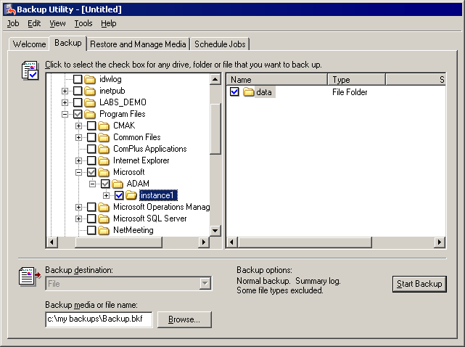

6. Click Start Backup, and then make any desired changes in the Backup Job Information dialog box.
7. If you want to set advanced backup options, such as data verification or hardware compression, in the Backup Job Information dialog box, click Advanced. When you have finished setting advanced backup options, click OK.
8. Click Start Backup. After the backup operation is complete, close the backup application.

Removing an ADAM Instance
To simulate an accidental loss of an ADAM instance, you can uninstall your ADAM instance, which removes both the ADAM program files and the ADAM data files.
To uninstall an ADAM instance
1. Click Start, point to Control Panel, click Add or Remove Programs, and then click ADAM Instance instance1. If it is the first item in the list, ADAM Instance instance1 will already be selected.
2. Click Remove, and then click Yes. Active Directory Application Mode is now removed from your computer.

Restoring an ADAM Instance
In this exercise, you restore your ADAM instance from the backup that you made in the previous exercise.
To restore an ADAM instance
1. Reinstall the ADAM program files from the ADAM download. Use the same settings as you did during your first ADAM installation except, in this case, do not create an application directory partition during setup. You can restore your original application directory partition from your backup. Therefore, on the Application Directory Partition page in the Active Directory Application Mode Setup Wizard, click No, do not create an application directory partition.
2. Click Start, point to All Programs, point to Accessories, point to System Tools, and then click Backup.
3. Click the Advanced Mode link in the Backup or Restore Wizard.
4. Click the Restore and Manage Media tab. To select the ADAM instance that you want to restore, in the details pane, select the check box to the left of the instance1 folder, as shown below.
Restoring an ADAM instance
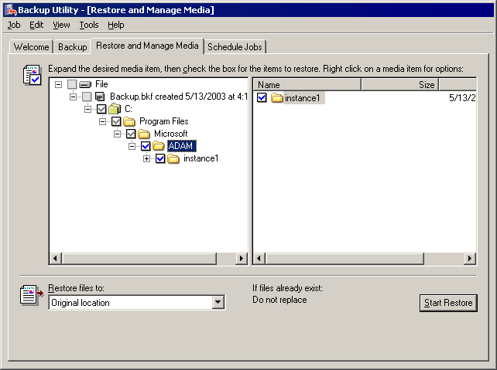

5. In Restore files to, click Original location.
6. On the Tools menu, click Options, click the Restore tab, click Always replace the file on my computer, and then click OK.
7. Click Start Restore.
8. If you receive a message asking if you want to restart your computer, click Yes.
9. After the restore is complete, close the Backup application.
10. To confirm that the data from your original ADAM instance is successfully restored, use ADAM ADSI Edit to confirm that the O=Microsoft,C=US directory partition is restored and that the OU=ADAM users OU and the Mary Baker user account exist in the partition.

Managing Configuration Sets
In the following exercises, you create new ADAM instances by replicating your existing ADAM instance. By doing so, you also create an ADAM configuration set. ADAM instances in a configuration set replicate a common schema partition and configuration partition, and they can also replicate application directory partitions (such as O=Microsoft,C=US) to each other. In the following exercises, you install two replica ADAM instances. You create the first replica instance using the Active Directory Application Mode Setup Wizard. You create the second replica instance using unattended install. You then schedule replication for your configuration set.
Note:
In a production environment, ADAM instances belonging to the same configuration set cannot reside on the same computer. You can have multiple ADAM instances running on a computer, but they must belong to different configuration sets. However, for the purposes of this guide, if you do not have a second computer available, you can install your replica ADAM instances on to your first computer.

Installing a Replica Using the Active Directory Application Mode Setup Wizard
You can install an ADAM replica instance using the Active Directory Application Mode Setup Wizard.
To install an ADAM instance replica using the Active Directory Application Mode Setup Wizard
1. Start the Active Directory Application Mode Setup Wizard, either on your second computer (if you have one) or on your first computer: click Start, click Run, and then type drive:\path\adamsetup.exe, where drive:\path represents the location of the ADAM download files. Follow the steps in the wizard until you reach the Setup Options page.
2. On the Setup Options page, click A replica of an existing instance, and then click Next.
3. On the Instance Name page, accept the default name instance2 (or instance1, if you are installing ADAM on a second computer), and then click Next.
Note:
ADAM instance names need to be unique only on a given computer.
4. On the Ports page, accept the default values of 50000 and 50001 (if you are installing onto the first computer) or 389 and 636 (if you are installing onto a second computer), and then click Next.
5. On the Joining a Configuration Set page, in Server, type the host name or DNS name of the computer where the first ADAM instance is installed. Then, type the LDAP port number in use by the first ADAM instance (which is 389 by default), and then click Next.
Note:
You must use a valid host name or DNS name, rather than an IP address or localhost when specifying a server on the Joining a Configuration Set page of the Active Directory Application Mode Setup Wizard.
6. On the Administrative Credentials for the Configuration Set page, click the account that is used as the ADAM administrator for your first ADAM instance.
7. On the Copy Application Partition page, select the application directory partitions that you want to replicate to the new ADAM instance. (The schema and configuration partitions will be replicated automatically.) To select the O=Microsoft,C=US directory partition for replication, in Available partitions, click O=Microsoft,C=US, and then click Add. The Active Directory Application Mode Setup Wizard looks like the following:
Active Directory Application Mode Setup Wizard Copy Application Partition
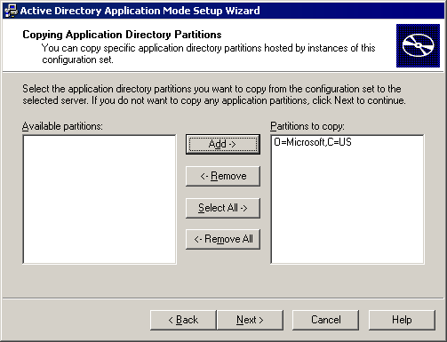

8. Click Next.
9. Accept the default values on the remaining Active Directory Application Mode Setup Wizard pages by clicking Next on each page, and then click Finish on the Completing the Active Directory Application Mode Setup Wizard page.
10. After the installation is complete, use ADAM ADSI Edit to confirm that the O=Microsoft,C=US directory partition has been replicated to your second ADAM instance.

Installing a Replica from Media Using Unattended Install
In addition to using the Active Directory Application Mode Setup Wizard, you can also install an ADAM instance replica from media. For this type of installation, you must use a restored copy of an ADAM backup as the media and unattended install as the installation method.
First, you restore your ADAM instance backup to an alternate location, rather than to the original location, which would overwrite your first ADAM instance.
To restore a backup of an ADAM instance to an alternate location
1. Click Start, point to All Programs, point to Accessories, point to System Tools, and then click Backup.
2. Use the Backup application to restore the backup of your original ADAM instance, as you did previously. But this time, in Restore files to, click Alternate location instead of Original location, and then type or browse to an alternate directory path to which you want to restore the files, as shown below.
Installing a replica ADAM instance from media
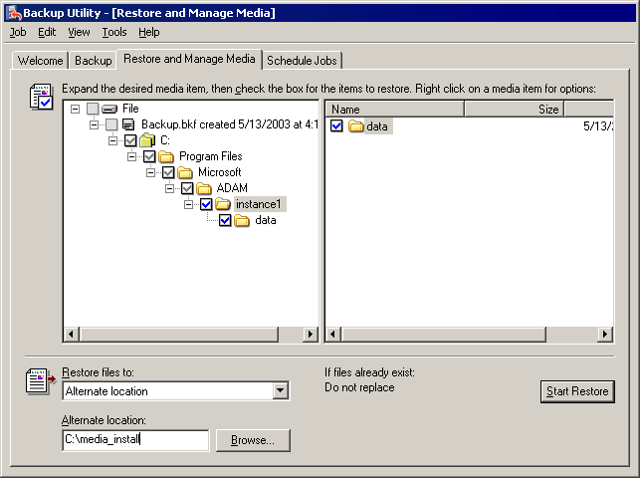

3. After restoring the backup files, create an answer file for the ADAM unattended install. An answer file provides the values for the ADAM setup options (the same options that are provided in the Active Directory Application Mode Setup Wizard). Using any text editor, create a text file called Answer.txt, and then add the following contents to the file. Be sure to replace servername with the host name or DNS name of the computer on which your first ADAM instance is running. Replace C:\media_install\Program Files\Microsoft\ADAM\instance1\data with the path to your restored copy of the first ADAM instance.
[ADAMInstall]
; The following line specifies to install a replica ADAM instance.
InstallType=Replica
; The following line specifies the name to be assigned to the new instance.
InstanceName=instance3
; The following lines specify the communication ports to use for LDAP and SSL.
LocalLDAPPortToListenOn=50002
LocalSSLPortToListenOn=50003
; The following lines specify the directory location of the restored files.
ReplicationDataSourcePath=C:\media_install\Program Files\Microsoft\ADAM\instance1\data
ReplicationLogSourcePath=C:\media _install\Program Files\Microsoft\ADAM\instance1\data
; The following lines specify a computer name and ADAM port of an ADAM instance in the; configuration set you want to join
; Replace servername with the name of the computer on which your first ADAM; instance is running
SourceServer=servername
SourceLDAPPort=389

4. After saving your Answer.txt file, you are ready to run the unattended install. At a command prompt, type the following:
Drive:\path\adamsetup /c:"adaminstall.exe /answer:drive:\pathname\answer.txt"
where the first drive:\path is the location of your ADAM download and the second drive:\pathname is the location of the Answer.txt file that you created.
5. After running this command, you can confirm through the Services snap-in that a new ADAM instance is installed and running.

Scheduling Replication
Now that you have multiple ADAM instances joined in a single configuration set, you can schedule replication. Scheduling replication is optional. As with Active Directory, Active Directory Application Mode always provides a default replication schedule.
1. Click Start, point to All Programs, point to ADAM, and then click ADAM ADSI Edit.
2. Connect and bind to one of your ADAM instances.
Note:
Because all of your ADAM instances belong to the same configuration set, you can schedule replication on any one of them.
3. In the console tree, double-click the configuration partition CN=Configuration,CN={GUID}, where GUID is the unique identifier assigned during ADAM setup; double-click the sites container, CN=Sites; and then double-click the default sites container, CN=Default-First-Site-Name. The ADAM ADSI Edit snap-in looks like the following:
Active Directory Application Mode Default-First-Site-Name
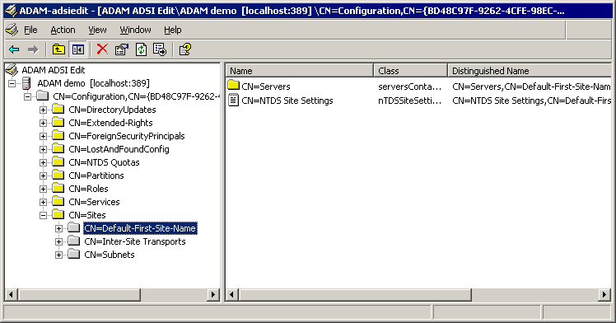

Note:
By default, all ADAM instances that you create belong to a single site, Default-First-Site-Name. In this exercise, all your ADAM instances belong to a single site. Therefore, you are scheduling replication within a site, which is called intrasite replication. For more information about ADAM sites, configuration sets, and replication, see the Active Directory Application Mode Administrator’s Guide. To view the Active Directory Application Mode Administrator’s Guide, click Start, point to All Programs, point to ADAM, and then click ADAM Help.
4. In the details pane, right-click CN=NTDS Site Settings, and then click Schedule.
5. In the Schedule dialog box, select the block of time that you want to schedule; click None, Once per Hour, Twice per Hour, or Four Times per Hour as the replication frequency; and then click OK. The Schedule dialog box looks like the following:
Active Directory Application Mode, scheduling replication
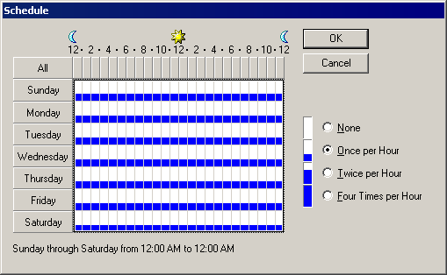

Note:
For intrasite replication, ADAM instances replicate changes through update notifications. The replication frequency schedule only affects intrasite replication when no update notifications occur in the specified time.

Forcing Immediate Replication of a Directory Partition
The Active Directory Application Mode Setup Wizard installs an Active Directory Application Mode version of Repadmin.exe, which includes the same functionality as the Active Directory version of Repadmin.exe. As with Active Directory, you can force the immediate synchronization of a directory partition with replication partners by using Repadmin.exe, as described in this exercise.
To force immediate replication of a directory partition using Repadmin.exe
1. Click Start, point to All Programs, point to ADAM, and then click ADAM Tools Command Prompt.
2. At the command prompt, type the following:
repadmin /syncallservername:portnumbero=Microsoft,c=us /u:username/pw:password
where servername:portnumber is the computer name and LDAP communications port of your ADAM instance, o=Microsoft,c=us is the distinguished name of the directory partition that you want to synchronize, and username and password are the authentication credentials of an ADAM administrator.
Note:
For more information about repadmin syntax, at the ADAM Tools Command Prompt, type repadmin /?.

Administering ADAM Programmatically
You can accomplish programmatically many of the tasks that you can complete manually using the ADAM administration tools. The ADAM download includes several sample scripts and some sample code to help get you started.

Administering ADAM Programmatically Through Visual Basic Scripts
The \LABS_DEMO\LABS\VBScript directory in the ADAM download includes sample scripts that are produced in Microsoft® Visual Basic®, Scripting Edition (VBScript) for the following common operations:
• Extend schema to include the contact class. (Adamcontact.vbs)
• Import two contacts. (AdamContactImport.vbs)
The following scripts assume that Adamuser.ldf was imported in a previous exercise:
• Add OU.
• Add user.
• Add group.
• Add user to group.
• Delete user.
• Get a list of specific objects in a path (Filter_adam.vbs).
• Enumerate users and groups.
• Set password.
For example, the script for enumerating members contains the following code:
'**************************************************
'
' This script enumerates the users and groups in the passed in OU
' To run: cscript member_adam.vbs [OU] [Group]
' Examples: cscript member_adam.vbs ou=testou,c=us testuser
'
'**************************************************
set Args = Wscript.Arguments
ouName = Args(0)
' If the application OU DN is "ou=adamou,c=us" and the server is "adamhost" and the port is 389. Then this parameter should be passed
' as follows: "LDAP://adamhost:389/ou=adamou,c=us"

set ou = GetObject(ouName )
wscript.echo "Displaying Groups and Group membership..." & vbcrlf

ou.Filter = Array("group")
for each obj in ou
wscript.echo "Group : " & obj.Name
for each member in obj.Members
wscript.echo " |"
wscript.echo " -- " & member.Name
Next
wscript.echo vbcrlf

You can run any of these scripts from a command prompt, using the cscript command. (For help with cscript, at a command prompt, type cscript /?.) Each script requires that the distinguished names of both the provider and the host be passed, along with the port specifier.
Note:
The Adamcontact.vbs script only requires servername:portnumberto be passed, because it extends the schema. You can open the file in Notepad to see the specific syntax. (If you run a script without parameters, the following error message is returned: “Subscript out of range.”)
For example, to run the Member_adam.vbs script to enumerate users and groups of an object with a distinguished name of O=Microsoft,C=US, type:
cscript member_adam.vbs "LDAP://servername:portnumber/o=Microsoft,c=us"
where servername:portnumber represents the computer name and LDAP communications port of your ADAM instance.

Administering ADAM Programmatically Through System.DirectoryServices.dll
The following exercise requires that you have Microsoft® Visual Studio® .NET installed.
To access ADAM through System.DirectoryServices.dll
1. Start Visual Studio .NET.
2. On the File menu, click New, and then click Project.
3. In Project Types, click a project type (C#, VB.NET, and so on).
4. In Templates, click a project template (Console, Windows, and so on).
5. In Name, type a name for your project.
6. After the project is created, click Add Reference on the Project menu.
7. In the Component Name column, click System.DirectoryServices.dll, as shown below.
Configuring Visual Studio .NET System.DirectoryServices.dll
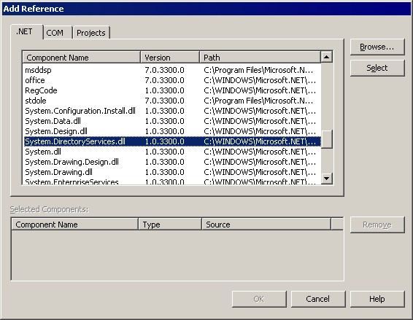

8. Add the following line at the top of your code:
C#:
using System.DirectoryServices;
VB.NET:
Imports System.DirectoryServices;

Note:
Adding the namespace name is not mandatory, but it is easier than typing a long name. For example instead of System.DirectoryServices.DirectoryEntry, use DirectoryEntry.
9. To read an ADAM object, add the following code:
int portNumber=1025; // put the correct port number here.
String serverName="adam01"; // put the correct servername here.
String partitionDir = "O=Fabrikam"; //put the correct partition DN.
DirectoryEntry ent = new DirectoryEntry("LDAP://"+serverName+":"+portNumber+"/"+partitionDir);
Console.WriteLine("Hello World, {0}, with Guid {1}", ent.Name, ent.Guid);

Administering ADAM Proxy Objects Programmatically
The \LABS_DEMO\LABS\bindredirect directory in the ADAM download includes sample code for creating, populating, and testing ADAM proxy objects. In addition, the directory includes a compiled, ready-to-run version of this sample code. This sample code illustrates how you can automate the creation of proxy objects, and it completes the steps in the “To bind to ADAM through an ADAM proxy object” procedure earlier in this guide.
Note:
For more information about ADAM bind redirection, see the Active Directory Application Mode Administrator’s Guide. To view the Active Directory Application Mode Administrator’s Guide, click Start, point to All Programs, point to ADAM, and then click ADAM Help.
The code in sampleBindRedirect.c completes all of the following operations programmatically:
• Binds to an ADAM instance using a Windows user account that you provide.
• Reads the tokenGroups attribute for the Windows user to retrieve the user's SID.
• Binds to an ADAM instance using the ADAM Administrator’s account that you provide.
• With the ADAM administrator account, creates a userProxy object for the Windows user.
• Adds the Users group from any given application directory partition to the Readers group of the same partition.
• Binds to an ADAM instance as the Windows user, to demonstrate that the Windows user cannot read the application directory partition.
• Binds to an ADAM instance through the proxy object, to demonstrate that the application directory partition can be read.
• Deletes the userProxy object.
You can run the compiled version of this sample code, BindRedirect.exe, by typing the following at a command prompt. For help running the BindRedirect.exe sample program, at a command prompt, type bindredirect /?.
Note:
This sample code runs with the following requirements:
To run properly, SSL connections to ADAM must be available (which requires the installation of certificates), or the RequireSecureProxyBind attribute on the msds-Other-Settings attribute of nTDsService object must be set to 0. For more information, see “Binding Security and ADAM Proxy Objects” earlier in this guide.
No foreign security principal object should exist in ADAM for the Windows user that you specify.
When using an SSL connection and binding, you must provide the full DNS name of the computer running ADAM.

Integrating ADAM with DSML Services for Windows
Directory Services Markup Language (DSML) provides a means of representing directory structural information and directory operations as an XML document. The intent of DSML is to enable XML-based enterprise applications to utilize profile and resource information from a directory in their native environment. With DSML, XML and directories can work together and provide a common ground for all XML-based applications, so that they can make better use of the directories. In this exercise, you integrate Active Directory Application Mode with DSML Services for Windows (DSFW).
Note:
For simple ADAM installations, DSFW Server can run concurrently on the same computer as ADAM.
With DSFW, the DSML gateway requires that you set the ADAM communications port for SSL to either 636 or 3269.
To integrate Active Directory Application Mode with DSFW
1. Install DSFW. DSFW is available on the Microsoft Web site at http://go.microsoft.com/fwlink/?LinkId=20046.
2. Click Start, click All Programs, click Microsoft DSML, and then click Configuring DSML Services.
In the DSML Configuration Tool, make sure that you type the correct distinguished name (for example, O=Microsoft,C=US in previous exercises) if you want to modify the samples.
1. Add the ADAM port number to your DSMLv2 configuration. The DSMLv2 configuration can be found on %windir%\system32\dsmlv2.config. In the example below, the port number is 389. (You can have as many as virtual directories dedicated for DSML Server as you want.)
<extensionConfiguration>
<virtualDirectory url="/dsml/adssoap.dsmlx">
<server>your-ADAM-Server-Name-Here</server>
<port>389</port>
<connectTimeout>30</connectTimeout>
<operationTimeout>30</operationTimeout>
<maxConnections>10</maxConnections>
</virtualDirectory>
</extensionConfiguration>

2. Restart Internet Information Services (IIS) for the new configuration to take effect.
3. Perform an empty DSML request using the Web page test that is provided in C:\DSfW\Documents\Samples\default.html.
Note:
Make sure that the DSML Virtual Directory in the Web page has the correct name. The name should be the same virtual directory name that you configured.
<se:Envelope xmlns:se="http://schemas.xmlsoap.org/soap/envelope/">
<se:Body xmlns="urn:oasis:names:tc:DSML:2:0:core">
<batchRequest/>
</se:Body>
</se:Envelope>

DSML Server should respond with an empty DSML request, as in the following example:
<se:Envelope xmlns:se="http://schemas.xmlsoap.org/soap/envelope/">
<se:Body xmlns="urn:oasis:names:tc:DSML:2:0:core">
<batchRequest/>
</se:Body>
</se:Envelope>

Now, you can try another operation, such as reading an object.
Note:
You can use the information in Event Viewer for troubleshooting DSFW issues.

